CHALLENGES FACING IMPLEMENTATION OF THE EDUCATION SECTOR POLICY ON HIV AND AIDS EDUCATION AND PROVISION OF CARE AND SUPPORT TO ORPHANED AND VULNERABLE LEARNERS IN PUBLIC SECONDARY SCHOOLS IN KENYA

BY

LUCY WANJIRA

A THESIS SUBMITTED TO THE SCHOOL OF EDUCATION IN THE DEPARTMENT OF CURRICULUM, INSTRUCTION AND EDUCATIONAL MEDIA IN PARTIAL FULFILMENT OF THE REQUIREMENTS OF THE AWARD OF DOCTOR OF PHILOSOPHY DEGREE IN EDUCATIONAL COMMUNICATION AND TECHNOLOGY

MOI UNIVERSITY

2014

DECLARATION

DECLARATION BY THE CANDIDATE
This thesis is my original work and has not been submitted for a degree in this or any other university.

Lucy Wanjira ______________________________________Date_________________
EDU/D. PHIL/22/04

DECLARATION BY SUPERVISORS
This thesis has been submitted with our approval as university supervisors
Prof. Jackson. K Too ______________ Date _______________
Department of Curriculum, Instruction and Educational Media
Moi University

Dr. Kisilu M. Kitainge_______________ Date_______________
Department of Technology Education
University of Eldoret

DEDICATION

To my husband Dave and our beloved children Chris, Greg and Joe; and to my Mother Margaret Mwihaki Ngunjiri,

ACKNOWLEDGEMENTS

This work would not be complete without the assistance and critical criticism
offered by my supervisors Prof. Too and Dr. Kitainge. I would also like to acknowledge Rev. Prof. Walaba, Prof. Kamaara and Prof. Kafu, lecturers of Moi University and The University of Eldoret for their support and contribution in the initial stage of this work. I wish to acknowledge the support of my classmates for shared experiences. To the research respondents, I greatly appreciate your contribution to this study. To my beloved sisters, Liz, Kate and Pep, thanks a lot for your unwavering encouragement. Last but not least, to you all mentioned or not, in whichever way you contributed, I register my sincere gratitude. To God, all glory and honor.

ABSTRACT
The Ministry of Education Science and Technology (MoEST) developed the Education Sector Policy on HIV and AIDS in 2004 and tasked school managers amongst other stakeholders with implementation. Provision of HIV & AIDS education is aimed at prevention and management of HIV & AIDS. Care and support of learners made vulnerable by HIV & AIDS in academic institutions aimed at ensuring that their academic journeys are not interrupted. The study investigated the challenges facing implementation of the Education Sector Policy on HIV & AID Sand provision of care and support to orphaned and vulnerable learners (OVLs) in public secondary schools in Kenya. The objectives of the study were to find out effects of teacher preparedness, external circumstances, time, resources, policy content and organizational factors on implementation of the Education Sector Policy on HIV & AIDS. The study was guided by Gunn’s argument which advanced the independent variables of this study. The independent variables were teacher preparedness, external circumstances, time, resources, policy content and organizational factors while the dependent variable was implementation of the Education Sector policy on HIV & AIDS. The research methodology was both qualitative and quantitative and the study employed survey research design. It was carried out in Kajiado County in Kenya. The study targeted public secondary schools in the County. Stratified and simple random sampling methods were used to select schools across the five sub counties of Kajiado County. Purposive sampling method was used to select head teachers, deputy head teachers, class teachers and guidance and counseling teachers. Data was collected using questionnaires and interviews. Descriptive statistics was used to analyze data which was presented in charts, tables, percentages, means and standard deviations. Correlation and regression analyses determined the relationship between the independent and dependent variables and the strength of that relationship respectively. The study findings indicated that teacher preparedness, organizational factors, time, resources, policy content and external circumstances influence implementation of the Education Sector Policy on HIV & AIDS in providing HIV & AIDS education and care and support to OVLs. Correlation and regression analyses established that there was a relationship between the independent and the dependent variable and this relationship was strong. The study recommended that these factors need to be considered in any effort to boost implementation of the policy on HIV & AIDS education and provision of care and support to OVLs in public secondary schools. The study further recommended that teachers be trained on the content of the policy and guidance and counseling programs and activities in schools be strengthened to address education on HIV & AIDS adequately. In addition, the study recommended that HIV & AIDS education programs and activities be allocated more time in the school curriculum and adequate resources and funds be availed. The study recommended that the teachers be given support to enable their participation in HIV & AIDS education programs and activities in schools and providing care and support to OVLs.

TABLE OF CONTENTS

DECLARATION ii
DEDICATION iii
ACKNOWLEDGEMENT iv
ABSTRACT v
TABLE OF CONTENTS vi
LIST OF TABLES x
LIST OF ABBREVIATIONS AND ACRONYMS xii
CHAPTER ONE 1
INTRODUCTION TO THE STUDY 1
1.1 Introduction 1
1.2 Background to the study 1
1.3 Statement of the Problem 9
1.4 Research purpose 10
1.5 RESEARCH OBJECTIVES 11
1.6 Research Hypotheses 11
1.7 Significance of the Study 12
1.8 Scope of the Study 13
1.9 Assumptions of the Study 14
1.10 Limitations of the Study 15
1.11 Theoretical Framework 16
1.12 Conceptual Framework 17
1.13 Operational Definition of Terms 20
CHAPTER TWO 25
LITERATURE REVIEW 25
2.1 Introduction 25
2.2 The Education Sector Policy On HIV and AIDS 25
2.3The Process of Policy Implementation In Schools 29
2.3.2 External Circumstances 33
2.3.3 Time and Resources 35
2.3.4 Policy Content 36
2.3.5 Organizational Factors 38
2.4 Related Studies 39
2.5 Research Gaps 44
CHAPTER THREE 49
RESEARCH DESIGN AND METHODOLOGY 49
3.1 Introduction 49
3.2 Research Philosophy 49
3.3 Research Methodology 51
3.4 Research Design 52
3.5 Description of Study Area 54
3.6 Sample Size and Sampling Techniques 56
3.7 Data Collection Instruments 58
3.8 Validity and Reliability of the Research Instruments 60
3.8.1 Validity 61
3.8.2 Reliability 61
3.9 Ethical Considerations 62
3.10 Procedure for Data Collection 63
3.11 Procedures for Data Analysis 64
CHAPTER FOUR 67
DATA ANALYSIS, PRESENTATION AND INTERPRETATION 67
4.1 Introduction 67
4.2 General Background Information 67
4.2.1 Response Rate 68
4.2.2 Demographic Information 69
4.3 Influence of Teacher Preparedness on Implementation of the Education Sector Policy on HIV & AIDS 71
4.3.7 Responses on the kind of care and support provided to OVLs. 85
4.4 Effect of External Circumstances on Implementation of the Education Sector Policy on HIV & AIDS 88
4.4.3 Responses on inhibitors in provision of HIV & AIDS education and provision of care and support of OVLs 92
4.5 Effect of Time on Implementation of the Education Sector Policy on HIV & AIDS 99
4.6 Effect of Resources on Implementation of the Education Sector Policy on HIV & AIDS 106
4.7 Relationship between Policy Content and Implementation of the Education Sector Policy on HIV & AIDS 112
4.8 Effects of Organizational Factors and Implementation of the Education Sector Policy on HIV & AIDS 119
4.8.2 Responses on schools implementation of the Education Sector Policy on HIV & AIDS 121
4.9 Correlation Analysis 126
4.10 Regression Analysis 128
CHAPTER FIVE 136
SUMMARY OF FINDINGS, CONCLUSIONS AND RECOMMENDATIONS 136
5.1 Introduction 136
5.2 Summary of Findings 136
5.2.1 Influence of Teacher Preparedness on the Implementation of the Education Sector Policy on HIV & AIDS 136
5.2.2 Effect of External Circumstances on the Implementation of the Education Sector Policy on HIV & AIDS 137
5.2.3 Effects of Time on the Implementation of the Education Sector Policy on HIV & AIDS 138
5.2.4 Effects of Resources on Implementation of the Education Sector Policy on HIV & AIDS 139
5.2.5 Relationship between Policy Content on Implementation of the Education Sector Policy on HIV & AIDS 139
5.2.6 Effect of Organizational Factors on Implementation of the Education Sector Policy on HIV & AIDS 140
5.3 Conclusion 142
5.4 Recommendations 144
5.5 Suggestions for further Research 148
References 149
APPENDICES 159
Appendix I: Letter of Introduction 159
Appendix II: Teachers Questionnaire 160
Appendix III: Interview Schedule 173
Appendix IV: Public Secondary Schools in Kajiado County: 2013 176
Appendix V: The Education Sector Policy on HIV and AIDS 181
Appendix VI: Letter of Research Authorization 206
Appendix VII: Research Clearance Permit 207
Appendix VIII: Location of Kajiado County 208

LIST OF TABLES
Table 3.1: No. of secondary schools in Kajiado County 55
Table 3.3 Sampled public secondary schools in kajiadocounty 56
Table 3.2: Public Secondary Schools in Kajiado County by Sub County 55
Table 3.3 Sampled public secondary schools in kajiadocounty 56
Table 3.5 Sample Size 58
Table 4.2: Demographic Information 70
Table 4.1: Response Rate 69
Table 4.3: Kind of Care and Support Provided to OVLS 85
Table 4.4: Factors Constraining Discussion of Sex and Sexual Relationships 91
Table 4.5: Inhibitors in Provision of HIV & AIDS Education and Provision of Care and Support Of OVLS 93
Table 4.6: Local Authorities’ Constraints in Teaching HIV & AIDS 95
Table 4.7: Extent Which Local Authorities Impose Constraints 96
Table 4.8: Time Dedicated to HIV & AIDS Education Programs 102
Table 4.9: Factors Inhibiting Education on HIV & AIDS and Provision of Care and Support of OVLS 104
Table 4.10: Funding for Implementation of Policies on HIV & AIDS 108
Table 4.11: Sources of Funding 109
Table 4.12: Provisions Conforming to Provision of Care and Support to OVLS 115
Table 4.13: Qualities of Education Sector Policy on HIV & AIDS 117
Table 4.14: Staff Willing Participation in School HIV & AIDS Program 120
Table 4.15: Schools Implementation of Education Sector Policy on HIV & AIDS 122
Table 4.16: Conformity with Education Sector Policy on HIV & AIDS and Provision of Incentives 124
Table 4.17 Correlation between External Circumstances, Time, Resources, Policy Content, Organizational Factors & Policy Implementation 127
Table 4.18: Multiple Regression Analysis, External Circumstances, Time, Resources, Policy Content, Organizational Factors and Policy Implementation 130
Table 4.19: Coefficient of Determination (Regression) 131
LIST OF FIGURES
Figure 1.1 Conceptual framework 19
Figure 4.1: Guidance and Counseling in school 73
Figure 4.2: Specialized training in guidance and counseling 76
Figure 4.3: Availability of a copy of the education sector policy on HIV & AIDS in your school 78
Figure 4.4: Training on content of the education sector policy on HIV & AIDS 80
Figure 4.5: Organizers of training on content of the education sector policy on HIV & AIDS 82
Figure 4.6 Availability of a school policy on HIV & AIDS and provision of care and support to OVLS. 83
Figure 4.7: Openness in discussing sex and sexual relationships 89
Figure 4.8: Approach to teaching HIV & AIDS in the school 100
Figure 4.9: Adequacy of time dedicated to HIV & AIDS programmes and activities 103
Figure 4.10: Coverage of HIV & AIDS education and provision of care and support to OVLS 110
Figure 4.11: Clarity of the education sector policy on HIV & AIDS objectives 116

LIST OF ABBREVIATIONS AND ACRONYMS

AIDS Acquired Immune Deficiency Syndrome
EFA Education For All
HIV Human Immunodeficiency Virus
KAIS Kenya AIDS Indicator Survey
KDHS Kenya Demographic and Health Survey
KESSP Kenya Education Sector Support Programme
MOEST Ministry of Education, Science and Technology
MOE Ministry of Education
NACC National Aids Control Council
NGO Non-Governmental Organization
NPA National Plan of Action for orphans and vulnerable children
NASCOP National AIDS and STI Control Programme
OVC Orphaned and Vulnerable Children
OVLs Orphaned and Vulnerable Learners
ROK Republic of Kenya
UNAIDS Joint United Nations Programme on HIV and AIDS
UNESCO United Nations Educational, Scientific and Cultural Organization
UNGASS United Nations General Assembly Special Session
UNICEF United Nations Children’s Education Fund
USAID United States Agency for International Development

CHAPTER ONE

INTRODUCTION TO THE STUDY\

1.1 Introduction

This chapter gives a background to the study, statement of the problem, research objectives, research hypotheses, assumptions of the study, significance of the study, scope of the study, theoretical framework, conceptual framework, limitations of the study, operational definition of terms and organization of the rest of the study.

1.2 Background to the study

Acquired Immune Deficiency Syndrome or Acquired Immunodeficiency Syndrome (AIDS) is a collection of symptoms and infections resulting from the specific damage to the immune system caused by the Human Immunodeficiency Virus (HIV). HIV is transmitted through direct contact of a mucous membrane or the bloodstream with a bodily fluid containing HIV, such as blood, semen, and breast milk. This may occur through a myriad of ways from anal, vaginal or oral sex, blood transfusion, contaminated sharps, childbirth, breastfeeding or other exposure to one of the above bodily fluids. Although treatment for AIDS and HIV exist to decelerate the virus's progression, there is currently no known cure (SIDA, 1999; Willis, 2005).

AIDS cases were first identified in the United States of America in 1981 (Republic of Kenya (RoK), 2005). In 1982, Uganda reported similar cases with the name ‘slim disease’ being used to refer to a condition in which the immune system was impaired accompanied by rapid weight loss (Kamaara, 2005).

The first AIDS case in Kenya was identified in 1984 (Forsythe, Rau and Aoko, 1996; National AIDS Control Council (NACC) and National AIDS and STI Control Programme ((NASCOP), 2012). On 25th November 1999, the then president Moi declared AIDS a national disaster and on the same day, he ordered the immediate setting up of the National AIDS Control Council (NACC) to coordinate the fight against the disease. Prior to this, in Sessional Paper No.4 of 1997, the government had proposed the establishment of a national body to coordinate multi-sectoral national response to HIV & AIDS in the country.

NACC was established on November 26, 1999 through a Presidential Order in Legal Notice No. 170 of the States Corporations Act Cap 446 (NACC, 2013). NACC was mandated to provide strong leadership and coordination of all HIV & AIDS programs nationally using a multi sectoral approach. Further, it was mandated to mobilize resources channeled through it for advocacy and other institutional functions in order to avert the spread and to mitigate the impact of HIV & AIDS. NACC was to provide policy and strategic framework for mobilizing and coordinating resources for prevention of HIV transmission and provision of care and support of the infected and affected persons.

NACC was expected to mobilize government ministries and institutions, nongovernmental organizations (NGOs), community based organizations (CBOs), the private sector and universities to participate in HIV & AIDS prevention and control (NACC, 2005).The Government also put in place a National Strategic Framework for HIV & AIDS for 2005-2010 (World Bank, 2011). In place currently is the Kenya National AIDS Strategic Plan 2009/10 – 2012/2013(NACC, 2009).President Kibaki took over from former President Moi in 2002 and continued the efforts on the fight against HIV & AIDS and as reported in NASCOP(2005) one of the first acts of President Kibaki was a declaration of total war on AIDS.

Kenya has an estimated population of 38.6 million people (Kenya National Bureau of Statistics (KNBS), 2010) a majority (78%) of who live in rural areas (World Bank, 2010). The Kenya Demographic and Health Survey (KDHS) 2008-2009 estimate theHIV prevalence rate in Kenya at 6.3% (KDHS, 2010). NACC and NASCOP (2012) put the prevalence rate at approximately 6.2% with 1.6 million Kenyans living with the virus by 2011. In addition, there were 91,000 new infections among people aged 15 years and above and 12, 894 new infections for children under the age of 15 years in 2011. This translates to an estimated 104, 137 Kenyans becoming infected in 2011 (ibid). Kenya has the third largest population of people living with HIV in the sub-Saharan Africa and the highest national HIV prevalence of any country outside Southern Africa (UNAIDS, 2008). Recent data indicate that the country’s HIV prevalence rate is on the decline in some areas (NACC, 2010). Though the prevalence rate is on the decline, with new infections roughly one third the number in 1993 when the epidemic peaked, the number of new infections remains high (NACC & NASCOP, 2012).

HIV has spread throughout the Kenyan public, affecting men and women, children and adults and across all the eight provinces (now the forty seven counties) in the Republic (NACC & NASCOP, ibid). NACC (2010) show prevalence rates across the eight provinces (now forty seven counties) as follows: North Eastern 0.9%, Eastern 3.5%, Coast 4.2%, Central 4.6%, Rift Valley 4.7%, Western 6.6%, Nairobi 7% and Nyanza 13.9%.

Schools have not been spared by the epidemic as teachers and learners are infected and affected. Teachers continue to fall ill and die due to AIDS related illnesses. Children have been infected, left orphaned, or are affected when parents fall ill. According to World Bank (2000, cited in Ed-SIDA, 2000)
HIV/AIDS is eroding the supply of education, eroding its quality, weakening its demand and access, drying up countries pools of skilled workers, and increasing sector costs. More than 113 million school age children are out of school in developing countries, two thirds of them girls’ (p.11).

Research findings by UNICEF in Kenya, Tanzania and Zambia indicate that even when orphaned children attended school, they were less likely to be at the correct grade level for their age group, and were frequently deprived of quality and relevant education, which they required in order to perform equally with their peers and gain life skills that would empower them to protect themselves from HIV infection, or to live with the infection (UNICEF, 2004). Children orphaned by AIDS have the potential and right not only to survive to adulthood but also develop their abilities to play a useful role in the society (Mukoggoyo & William, 1991).
In UNAIDS (2001)
“Children have full and equal worth, and their vulnerability requires special support in order to enable them enjoy full human dignity”(p. 16).

According to UNESCO (2008) the education sector can and does contribute significantly to national and international responses to the HIV epidemic. Through formal education settings, the sector can reach children and young people and educate them about HIV & AIDS. Furthermore, education on HIV & AIDS can be an important force for addressing socio-economic, cultural and development issues including gender inequities, health challenges, poverty, social exclusion and stigmatization. In an effective education sector response to issues that impact on learning, schooling and the school environment require a comprehensive policy and strategic approach as HIV & AIDS impact on all these aspects of quality education. School policies, environments, services and skills-based education are essential to address the impact of HIV & AIDS in schools (Ed-SIDA, 2000).

In 2000, the World Education Forum was held in Dakar Senegal. The International Education Community, of which Kenya is part, adopted the Dakar Framework for Action for Education For All (EFA). It was however evident that attaining EFA goals would be threatened by HIV &AIDS hence the forum also drew attention to the need to combat HIV &AIDS. In addition, the United Nations General Assembly Special Session on HIV &AIDS (UNGASS) was held in 2001. A Declaration of commitment called on governments to develop by 2004 and implement by 2005, national policies and strategies to provide a supportive environment for orphans and children affected and infected by HIV &AIDS. In Kenya, the Ministry of Education Science and Technology (MoEST) with the technical support of United States Agency for International Development (USAID) and United Nations Educational Scientific Cultural Organization (UNESCO) responded by formulating the Education Sector Policy on HIV &AIDS in 2004.The policy spells out policy provisions in four major areas; Prevention, Care and Support, HIV & AIDS and the Workplace and Managing the Response (RoK, 2004).

The Education Sector Policy on HIV & AIDS prepares learning institutions on the impact of HIV & AIDS as teachers, learners, non-academic staff and parents are infected or affected. It provides an agreed framework on which action is based. It confirms the rights, roles and responsibilities of all those involved in the education sector and gives guidelines on how HIV & AIDS need to be handled in schools. Institutions managers are on their part expected to demonstrate their commitment to fighting HIV&AIDS and mitigate its impact on the education sector. In support, the Sessional Paper No. 1 of 2005 being operationalized through the Kenya Education Sector Support Programme (KESSP) prioritized implementation of this policy (RoK, 2005). At the secondary school level, it is the responsibility of the school management to ensure that this policy is implemented through the school curriculum (RoK, 2004).

Under the Education Sector Policy on HIV & AIDS, the MoEST sought to infuse/integrate HIV & AIDS education into the school curriculum, thus accelerating the efforts to curb the spread of HIV among young people in general and children in particular (RoK, 2004). The successful implementation of this approach presupposed adequate preparation in terms of teacher capacity development, child responsive pedagogy and development of appropriate learning materials. Makoa (2004) observes that the success of any public policy or national development plan rests on the capacity to implement it, particularly, the availability of resources that enable the delivery of stated commitments. Unfortunately the translation of policy into practice is more complex than is usually apparent to those responsible for its formulation. Hunter (2002) says that there are serious and sometimes neglected issues about whether, and how, the national policy can be effectively implemented locally and what needs to be put in place for this to occur. He further says that whereas policy success can result from successful implementation, policy failure can result from non-implementation or from unsuccessful implementation. Furthermore external circumstances may be so adverse that they lead to failure or the policy itself may be defective in the sense of being based on inadequate information, poor reasoning, or unrealistic assumptions (ibid).

Gunn (1978, cited in Hunter, 2002) identified reasons why implementation is so difficult. He argues that the circumstances external to the implementing agency may impose crippling constraints. Adequate time and sufficient resources may also not be made available to the program or policy or the required combination of resources might not be available. Concurrently the policy to be implemented may not be based on a valid theory of cause and effect or the relationship between cause and effect may be indirect and there are multiple intervening links. Multiple dependency relationships could also complicate implementation. At the same time poor understanding of, and disagreement on, objectives or tasks not being fully specified in correct sequence and imperfect communication and co-ordination may leave those in authority unable to demand or obtain perfect or total compliance.

Studies show that it is more likely that what happens at the implementation stage will influence the actual policy outcome in ways that might not have been anticipated or foreseen (Chillag, Bartholomew, Cordeiro, Swanson, Patterson, Stebbins, Woodside, and Sy2002; Brynard, 2005). Conversely, the likelihood of a successful outcome will be increased if thought is given at the policy design stage to potential problems of implementation. This might suggest the need for a policy impact statement to identify possible implementation problems or barriers to success.

The Education Sector Policy on HIV & AIDS places the responsibility of identifying OVLs in schools on school managers and teachers amongst other stakeholders and of mitigating the impact of HIV & AIDS on the said learners. The policy says that:-

The (Education) sector and its institutions are expected as much as possible, to assist OVC, learners who are ill, or with special needs so that they are able to continue with their education’ (Rok, 2004, p. 21).

The head teacher, deputy head teacher, class teachers and guidance and counseling teachers are best placed to identify OVLs. School managers and teachers are expected to not only provide care and support to these learners within the school environment but to also extend the same to their homes and to mobilize community resources in their aid (RoK, 2004). Care and support of OVLs in academic institutions has been advanced by the government as a realization that there is need to tackle the apparent stigmatization in society to ensure that their academic progression is not interrupted
With the formulation of the Education Sector Policy on HIV & AIDS in 2004, schools amongst other stakeholders were mandated with the responsibility of implementation. This study investigated the challenges that schools may be facing in implementation of this policy particularly on provision of care and support to OVLs.

1.3 Statement of the Problem

NACC and NASCOP (2012) estimate that AIDS has claimed at least 1.7 million people in Kenya since the epidemic began and that in 2011 an estimated 49,126 people died of AIDS related causes in Kenya. NACC (2010) estimates that 2.5 million children in Kenya are orphans and half of that number have been orphaned as a result of HIV.NACC and NASCOP (2012) estimate that in Kenya, 1.1 million children under the age of 18, have lost one or both parents to AIDS.

Saoke, Mutemi and Blair (1996) established that only 5% of orphans completed form four. The implication is that a great majority of OVLs will be uneducated, poor, poorly socialized and in some cases, homeless. Policy responses can however mitigate the impact of HIV & AIDS on such learners that require that their food, housing, medical, psychosocial and educational needs be addressed. According to UNICEF (2004) response to the orphans’ crisis is increasing but lacks the necessary urgency and remains unfocussed and limited in scope. According to NACC (2010)the vast majority of households caring for children orphaned or made vulnerable by AIDS in Kenya have received no free assistance of any kind and only 21.4% of such homes obtained support to address the needs of the children. Between the periods2007- 2008, programmes directed at assisting such children represented less than 3% of all HIV expenditures (NACC, 2009). Many orphans in Kenya therefore remain unreached and interventions and provision of quality services remain a major area of concern. However, the Education Sector Policy on HIV & AIDS was a timely intervention which provided a framework through which schools (through school managers) would be able to deal with HIV and AIDS. The policy placed the responsibility of implementation on schools and consequently on school managers amongst other stakeholders. However as argued by Gunn (1978, cited in Hunter, 2002) policy formulation does not necessarily translate to successful implementation. The question then arises as to how secondary schools managers in Kenya are implementing the Education Sector Policy on HIV &AIDS.

This study investigated the challenges facing implementation of the Education Sector Policy on HIV & AIDS and in provision of care and support to OVLs in public secondary schools in Kajiado County.

1.4 Research purpose

The purpose of this study was to investigate the challenges facing implementation of the Education Sector Policy on HIV & AIDS and in provision of care and support to OVLs in public secondary schools in Kajiado County.

1.5 RESEARCH OBJECTIVES
The objectives of the study were to:
- Find out how teachers’ preparedness influences implementation of the Education Sector Policy on HIV & AIDS.
- Establish the effects of external circumstances on the implementation of the Education Sector Policy on HIV & AIDS.
- Determine how time is planned towards implementation of the Education Sector Policy on HIV & AIDS.
- Determine how resources affect the implementation of the Education Sector Policy on HIV & AIDS.
- Establish the relationship between policy content and the implementation of the Education Sector Policy on HIV & AIDS.
- Examine how school organizational factors affect implementation of the Education Sector Policy on HIV & AIDS.

1.6 Research HYPOTHESES

This study tested the following null hypotheses:
H01: There is no significant relationship between external circumstances and implementation of the Education Sector Policy on HIV & AIDS and in provision of care and support to OVLs.
H0 2: There is no significant relationship between time and resources and implementation of the Education Sector Policy on HIV & AIDS and in provision of care and support to OVLs.
H0 3: There is no significant relationship between policy content and implementation of the Education Sector Policy on HIV & AIDS and in provision of care and support to OVLs.
H0 4: There is no significant relationship between school organizational factors and implementation of the Education Sector Policy on HIV & AIDS and in provision of care and support to OVLs.

1.7 Significance of the Study
This study investigated the challenges facing implementation of the Education Sector Policy on HIV & AIDS and in provision of care and support to OVLs in public secondary schools in Kenya. The study was carried out in Kajiado County. Care and support of OVLs is fundamental to understanding the general outlook and perceptions in regard to care and support of HIV & AIDS persons in the broader community (Gostin, 1990). Moreover, these learners at a later stage of their lives are going to be part and parcel of the human resource of the nation and thus the need to address some of the challenges that they face at this stage of their lives. The most important factor is the need to address this issue at the best possible level; that is the high school level, and as a result a trickle effect will occur through the knowledge acquired, to the community level.

It is anticipated that the study results will generate discussions among stakeholders, resulting in the formulation of working strategies for implementing the Education Sector Policy on HIV & AIDS and improving and bettering delivery of provision of care and support to OVLs. Furthermore, the study analyses the advances of some of the initiatives, and identifies possibilities that exist for human action and intervention. The study gives explanatory possibilities for care and support, within the acceptable ethical and practical horizons. Information generated from this study will add to the pool of research knowledge available on the implementation of the Education Sector Policy on HIV & AIDS. The research findings will constitute new literature which can be incorporated in discussion on policy implementation.

The information acquired from this study will also be useful to policy makers in strengthening policy considerations in the mitigation of the impact of the HIV & AIDS in the education sector. Such policy improvement may enhance the guidelines on how to improve the performance and effectiveness of the Education Sector Policy on HIV & AIDS. Information on the challenges facing the implementation of the Education Sector Policy on HIV & AIDS will ensure effective prioritization of efforts and resources for successful implementation of the policy. Consequently, schools and government agencies may be on the right track in the achievement of the objectives stipulated in the policy document. Finally, the study opens opportunities for further research in the area of public policy implementation in Kenya and especially on HIV & AIDS. Though the study was carried out in Kajiado County, the topic under study is of national interest. The study findings propose recommendations for government agencies and school managers.

1.8 Scope of the Study

This study investigated the challenges facing implementation of the Education Sector Policy on HIV & AIDS and in provision of care and support to OVLs in public secondary schools in Kenya. The study was carried out in Kajiado County of the Rift Valley region, Kenya. The study targeted all public secondary schools in the county. This study was confined to challenges facing implementation of the Education Sector Policy on HIV & AIDS and on provision of care and support to OVLs in secondary schools, which is only one of the many facets of the HIV & AIDS problem. Data collection was restricted to head teachers, deputy head teachers, class teachers and guidance and counseling teachers in those schools.

There are many factors that affect implementation of policy. This study investigated only six such factors which were the independent variables for the study. For those factors not investigated in this study, it was suggested that further research could investigate their effects on policy implementation.

1.9 Assumptions of the Study

This study was based on the following assumptions
- Schools are implementing the Education Sector Policy on HIV & AIDS.
- There are OVLs in secondary schools in Kenya.
- Teachers would be willing to share information not only on challenges facing implementation of the Education Sector Policy on HIV & AIDS in secondary schools but also on OVLs.
- Respondents would give honest answers and as requested in the research instruments.
- Head teachers, deputy head teachers, class teachers and guidance and counseling teachers are best placed to identify OVLs in secondary schools.
Viii. Successful implementation of the Education Sector Policy on HIV & AIDS will address the needs and interests of OVLs in secondary schools.

1.10 Limitations of the Study

This study investigated the challenges facing implementation of the Education Sector Policy on HIV & AIDS and in provision of care and support to OVLs in public secondary schools in Kenya. Twenty four public secondary schools in Kajiado County were used for the study. Whereas a lot of literature exists on HIV & AIDS generally, there is limited literature on implementation of the Education Sector Policy on HIV & AIDS and on care and support of OVLs in secondary schools in Kenya. The study however used literature from studies carried out in other countries to supplement literature available on the situation in Kenya. HIV & AIDS issues are sensitive and getting related information can present ethical challenges. To this end, consent to participate in the study was sought from the respondents. All respondents were assured of confidentiality and anonymity. They were also informed of their right to withdraw from the research at any time without having to give any reason. Data was collected from head teachers, deputy head teachers, class teachers and guidance and counseling teachers. Research instruments were designed to provide data that would capture information on challenges facing implementation of the Education Sector Policy on HIV & AIDS and in provision of care and support to OVLS. Kajiado County is expansive and in the absence of research funding, finances were a constraint on the part of the researcher. The availability of enough time to cover all the aspects of the topic limited the research. The study therefore concentrated on challenges facing implementation of the Education Sector Policy on HIV & AIDS and in provision of care and support for OVLs.

1.11 Theoretical Framework
This study investigated the challenges facing the implementation of the Education Sector Policy on HIV & AIDS and in provision of care and support to OVLs in public secondary schools in Kenya. The study was carried out in Kajiado County. Implementation is the process of turning policy into practice but it is common to observe a gap between what was planned and what actually occurred as a result of a policy (Steinbach, 2009). In an attempt to explain the gap, Gunn (1978, cited in Hunter, 2002) explained challenges and barriers to effective policy implementation. According to Gunn (ibid) the circumstances external to the implementing agency impose crippling constraints to policy implementation. So does lack of adequate time and sufficient resources. Policy implementation is also constrained when the required combination of resources is not available. Other constraints are when the policy to be implemented is not based on a valid theory of cause and effect or the relationship between cause and effect is indirect and there are multiple intervening links. Implementation is also hampered when dependency relationships are multiple; there is a poor understanding of, and disagreement on objectives; tasks are not fully specified in correct sequence; there is imperfect communication and coordination or those in authority are unable to demand or obtain perfect compliance.

This study used Gunn’s argument on the challenges and barriers that hinder successful implementation of a policy. According to Gunn, external circumstances, time, resources, policy content and organizational factors have a relationship with successful implementation of a policy (Gunn, ibid). In this study, the independent variables were teacher preparedness, external circumstances, time, resources, policy content and organizational factors. The dependent variable was implementation of the Education Sector Policy on HIV & AIDS. This theory was used to provide an explanation on the relationship between the independent and the dependent variables and determined whether teacher preparedness, external circumstances, time, resources, policy content and organizational factors influenced implementation of the Education Sector Policy on HIV & AIDS and in provision of care and support to OVLs in public secondary schools in Kenya.

1.12 Conceptual Framework

This study investigated the challenges facing implementation of the Education Sector Policy on HIV & AIDS and in provision of care and support to OVLs in public secondary schools in Kenya. The study derived its conceptual framework from the challenges to policy implementation identified by Gunn (1978, in Hunter, 2002). He categorizes the challenges into external circumstances, time and resources, policy content and organizational factors. The dependent variable for this study was policy implementation of the Education Sector Policy on HIV & AIDS. The model for this concept was PI= f (TP, EC, TR, PC, OF) where PI is Policy Implementation, TP is Teacher Preparedness, EC is the External Circumstances, TR is Time and Resources, PC is Policy Content and of is Organizational Factors. It proposed that policy implementation is determined by teacher preparedness, external circumstances, time and resources, policy content and organizational factors. The conceptual framework is as illustrated in figure 1.1

DEPENDENT VARIABLE
INDEPENDENT VARIABLES
Teacher preparedness

External Circumstances
Time

Policy Implementation
(The Education Sector Policy on HIV & AIDS)

on HIV & AIDS
Resources

Policy Content
Organizational Factors

Figure 1.1 Conceptual framework
(Adapted from Gunn, 1978)

1.13 Operational Definition of Terms

External Circumstances The main components of external circumstances include social, cultural, legal and economic conditions that affect the implementation of policy. These constraints manifest themselves in the practice of ‘selective teaching’ in which messages on HIV & AIDS are either not communicated at all, or restricted to overly scientific discussions without direct reference to sex or sexual relationships. The characteristics of external circumstances are values and beliefs about sexuality, perceptions of risk of HIV, social and cultural restraints in discussing HIV & AIDS, sexual relations and power inequalities. They also include attitudes about health care professionals and other authority figures, selective teaching and stigmatization (Cruise & Dunn, 1994; Chillag et al., 2002).. In this study external circumstances are circumstances that are beyond the control of the school managers and teachers who are tasked with the implementation of the Education Sector Policy on HIV & AIDS policy.
Organizational Factors The characteristics of the organization or institution responsible for the implementation of the policy are crucial in determining the success of the policy goals and objectives. If aspects of the implementing institution are not concurrent with the preconditions necessary for the implementation of the policy specifications, then the policy is bound to fail in its execution.Organizational factors are characterized by the implementing organization’s mission, commitment of the organizations personnel and communication within the institution. Previous training, self-efficacy, student-centeredness, beliefs about controllability and the outcome of HIV & AIDS education of the teachers as implementers of the policy is also important. Organizational factors also include existence of a school HIV & AIDS policy, a climate of equity and fairness and good school-community relations(Spratt, 2009; Brynard, 2005). In this study, organizational factors are the characteristics of a school as an organization.
Orphan An orphan is a person below 18 years who has lost one or both parents. One who has lost the mother is a maternal orphan, one who has lost a father is a paternal orphan while one who has lost both parents is a complete orphan (UNAIDS, 2004). In this study a learner who has lost one or both parents is referred to as an orphan.
Policy Content It is imperative that policy implementation would be difficult unless what is contained in the policy is realistic and achievable. The content of the policy must also identify with the situation that it is aimed to address. Content is characterized by the means it employs to achieve its ends and how it determines its ends. Stakeholder involvement in its formulation also determines the authenticity of the content. Other characteristics of the content that determine policy implementation include length of detail, Clarity of, and agreement on objectives (Hardee et al., 2004; Brynard 2005). In this study, policy content is the information contained in the Education Sector Policy on HIV & AIDS.
Policy Implementation This refers to the level to which systems and structures have been put in place to ensure that the specifications of the policy statement are being achieved in the implementing organization. The parameters by which policy implementation is measured include establishment of structures to implement the policy, facilitation of the policy implementation process and monitoring of the progress
Resources Adequate resources need to be availed if policies are to be successfully implemented. Schools also usually operate on strict financial budgets to the extent that programs and activities that are outside the academic agenda are rarely given priority. Resources necessary for implementing policy may include human, financial, material, technological and logistical resources (Brynard, 2005). In schools material and financial support needs to be allocated towards HIV & AIDS programs and activities.
School managers In this study, this refers to head teachers and deputy head teachers in secondary schools.
Teacher preparedness Refers to teacher preparation for handling HIV & AIDS in our schools. Though this has been injected in Teacher Education, it is necessary for serving teachers whose Teacher Education did not cover HIV & AIDS. This is because HIV & AIDS are relatively recent phenomena. In addition attention to HIV& AIDS is also relatively recent. To this end as used in this study, teacher preparation refers to in service courses developed for teachers to educate them not only on HIV & AIDS education but also on the content of the Education Sector Policy on HIV and AIDS. Forums include seminars, workshops and conferences.
Time Policies are bound to fail without the necessary prioritization of policy related activities in terms of provision of and allocation of sufficient time. Time refers to the duration dedicated to HIV & AIDS programmes. In a school setting there is often competition between time allocated to academic curriculum and other co-curricular activities. Time factors affecting policy implementation are characterized by curriculum priorities, timely provision of program materials and structural and functional ability. In this study time refers to the duration allocated to HIV & AIDS programmes and activities in schools

1.14 SUMMARY
HIV & AIDS has impacted all sectors of the Kenyan public and the education sector is no exception. Implementation of the Education Sector Policy formulated in 2004 was expected to mitigate the impact of HIV & AIDS in institutions of higher learning. The four key areas addressed by the policy are Prevention, Care and Support, HIV & AIDS and the Workplace and Management of Response. Education on HIV& AIDS is aimed at prevention and management while provision of care and support of OVLs is aimed at ensuring that their dignity as human beings is not compromised and that they continue with their academic journeys
This study investigated the challenges facing implementation of the Education Sector Policy on HIV & AIDS and in provision of care and support to OVLs in public secondary schools in Kenya. The study was guided by Gunn’s theory which advanced the independent variables of this study. The independent variables in this study were teacher preparedness, external circumstances, time, resources, policy content and organizational factors. The dependent variable was implementation of the Education Sector Policy on HIV & AIDS. These variables formed the basis of research objectives and the conceptual framework. The study was carried out in Kajiado County.

CHAPTER TWO

2.0 LITERATURE REVIEW

2.1 Introduction
This chapter reviews literature related to the implementation of public policy and especially on the implementation of the Education Sector Policy on HIV & AIDS. It looks into literature related to the objectives stipulated in the previous chapter. Finally it gives research gaps and a summary of the literature.

2.2 THE EDUCATION SECTOR POLICY ON HIV AND AIDS

HIV & AIDS is a pandemic that has and continues to wreak havoc on the education sector. As HIV & AIDS continues to affect many families in Kenya, the issue of orphans and children made vulnerable by HIV & AIDS and their care generates concern. Estimates put the number of orphans in Kenya at 2.5 million. Of these, half have been orphaned by AIDS as an estimated 1.1 million children under the age of 18 have lost one or both parents to AIDS (NACC & NASCOP, 2012).These children are in school at different levels and classes according to age. The cumulative impact of HIV & AIDS in schools is that there are learners who are infected, orphaned or with ailing parents and therefore made vulnerable by HIV & AIDS at all levels of the school system. According to estimates, more than 1000 children are newly infected with HIV every day (NACC, 2013). Approximately 12, 894 children under the age of 15 became newly infected in 2011 (NACC & NASCOP, 2012). Those born with the virus and who did not succumb in their early years joined school. Initially, they were limited to the preschool level but as they grew, they progressed through the academic ladder, joined lower primary and on to upper primary. Some of these learners joined secondary schools. In addition, at all these levels of education, new infections among children (learners) in school continue. Schools have therefore had to deal with not only an increasing number of learners orphaned and made vulnerable by AIDS but also learners infected with HIV. Attention therefore needs to be given to these learners including providing care and support especially at school where they spend most of their time. The teacher then becomes the best-placed person to do so. According to UNAIDS (2001)
‘Teachers should be aware of what is happening in a child’s life…By reaching out and communicating effectively, a teacher can have a stronger and more lasting effect on their lives. The teacher can serve as a confidant and a role model by providing love and guidance to the children, resulting in higher self-esteem, direction and good behavior’ (p.30).

As AIDS continues to unfold, a new burden has been placed on the learning institutions, educating managers, and other stakeholders in the education sector to which they must respond to mitigate the suffering of orphaned and vulnerable learners. AIDS deepens social economic and gender inequalities and leads to human rights abuses (NACC & NASCOP, 2012). In addition, inadequate public awareness can lead to stigmatization, personal fears and anxiety, unwillingness to discuss sexuality to challenge norms and entrenched gender structure and ignorance of the implications of the scourge (UNGASS, 2006).

Not to be left behind in the fight against the AIDS pandemic, MoEST with the technical assistance of USAID and UNESCO formulated the Education Sector Policy on HIV &AIDS in 2004. The policy was in response to the adverse impact of HIV & AIDS on the education sector as a whole and its effects on quality, access, equity, and supply and demand for education services (RoK, 2004).In its preamble, the policy acknowledges the role the education sector can play in not only preventing HIV & AIDS but also in mitigating its effects on individuals, families, communities and society. The implementation of this policy requires school managers make it operational so that programs and strategies are put in place in schools. School managers also need to draw assistance from relevant expertise and experience hence the need for community mobilization. According to the policy,
‘All heads of education institutions and workplaces are responsible and accountable for a) implementing this policy; and b) appropriate HIV and AIDS prorammes…’ (RoK, 2004, p.31).

The policy reflects the MOE’s commitment in fighting the scourge. The policy formalizes the rights and responsibilities of every person involved directly or indirectly in the education sector with regard to HIV & AIDS. These include the learners, their parents and care givers, educators, managers, administrators and civil society (RoK, 2004). The policy addresses four key issues relating to HIV & AIDS. They include Prevention, Care and Support, HIV & AIDS and the Workplace and Management of Response. According to the policy, prevention aims at creating an environment in which all learners and personnel in the education sector be made free from HIV infection through education on HIV & AIDS, access to information on HIV & AIDS, peer education and to fully embrace all duties and responsibilities on issues relating to HIV & AIDS. Care and support aims at having an education sector in which care and support is available for all, particularly, orphaned and vulnerable children (OVC) and those with special needs. Such care and support includes access to health services, psycho- social support, community mobilization and financial support.HIV & AIDS and the work place aim at non-discriminatory labor practices, and putting in place terms and conditions of service frameworks that are sensitive and responsive to the impact of HIV & AIDS. Management of response involves putting in place management structures and programs at all levels in the education sector to ensure and sustain quality education in the context of HIV & AIDS (RoK, ibid).

Piot and Bellamy in their foreword in UNAIDS/UNICEF (2004) in support of the impact of HIV & AIDS on education say that
‘One of the most tragic and difficult challenges of the HIV & AIDS epidemic is the growing number of children who have lost parents to AIDS or whose lives will never be the same because of it. The crisis is both enormous and complex, affecting many millions of children. Though nothing can take away the pain that these children have already endured, a conscious shift in attention and efforts can help alleviate the suffering that many of them still face and provide better prospects for their future’ (p. 4).

Children like everyone else are victims of HIV &AIDS, having been affected or infected. Children are affected when parents are sick or having lost one or both parents to AIDS. Children can be infected and living with HIV & AIDS. Children may contract HIV at birth (Saoke et al., 1996), after birth through rape or through engaging in unprotected sex, through blood coming into contact with contaminated sharps or through blood transfusions by contaminated blood (Kafura, 2005; Willis, 2005).These children are in school at different levels and classes according to age. These children are referred to as OVC. Such children (learners) need to be enabled to pursue their lives with quality and dignity through care and support. This dignity and quality entails being able to continue going to school, having their fees paid, accessing adequate nutrition and having their physical needs met (SIDA, 1999). They require financial assistance if EFA goals are to be achieved

On OVC, the policy clearly states that institutions are expected to assist OVLs so that they are able to continue with their education. The responsibility of identifying and assessing OVLs, of identifying resources and of developing mechanisms to meet their needs is placed on institutions. The policy expects learning institutions to have flexible programmes so as to accommodate the needs of OVLs. In addition, institutions are expected to create enabling and gender responsive environments that cater for the physical and emotional needs of OVLs. Further, it is expected that not only should bursary schemes adequately cover the needs of OVLs but also that institutions mobilize resources from other sectors to support bursaries for these learners. (See Appendix V). In extension, this responsibility placed on institutions is the responsibility of school managers.

2.3tHE PROCESS OF POLICY IMPLEMENTATION IN SCHOOLS

This section covers literature related to the effect of teacher preparedness, external circumstances, time and resources, policy content and organizational factors on the implementation of the Education Sector Policy on HIV & AIDS. What follows is a review of literature in relation to the research objectives.

2.3.1 Teacher Preparedness for the implementation of the Educations Sector Policy on HIV & AIDS in schools
Teacher training is viewed as an essential element of program integrity (Payton Graczyk, Wardlaw, Bloodworth &Weissberg, 2000) and as essential to promoting successful implementation of prevention curricula (Dusenbury & Falco, 1995). Adequate teacher professional preparation for any subject is necessary. This preparation should involve understanding by the teacher of the content, nurturing of positive attitudes to subject matter and acceptable understanding on what it means to teach (Akyeampong, 2000). According to Tijuana, Finger, Rulandand and Savariud (2004), teacher training is fundamental to the successful delivery of HIV & AIDS education in schools because teachers are gatekeepers of knowledge and skills for the large majority of young people most who attend school, at an age during which HIV infections are highest (UNAIDS, 2006).

Oshi, Nakalema and Oshi (2005) examined the social and cultural determinants of the teaching of HIV & AIDS and sex education among secondary school teachers in Eastern Nigeria. They found out that other than cultural and social inhibition, teachers had not been receiving adequate training and motivation on information, education and communication for HIV & AIDS and sex education. Mathews, Boon, Flisher and Schaalma (2006) investigated the factors influencing whether high school teachers implemented HIV & AIDS education and established that an important teacher characteristic associated with teaching HIV & AIDS were previous training. Ruto, Chege and Wawire (2009) investigated the practical implications of the policy document in addressing provisions related to orphaned and vulnerable children and the teaching and learning of HIV & AIDS education. They established that teachers required capacity development in the area of HIV & AIDS education.

Onyango (2009) reports preliminary findings on how a primary teacher-training college in Kenya is preparing teacher trainees to teach about HIV & AIDS. The study established that there were awareness programs at the college. However, interviewees felt trainees’ preparation to teach about HIV & AIDS was superficial. It therefore recommended that there was need to improve and intensify the cascade model employed by the Ministry of Education to prepare teacher trainers to teach about HIV & AIDS. The starting point at the college should be the completion of an HIV & AIDS policy, which was still in draft form, so that it could be used to provide guidance on HIV & AIDS education.

Njue, Nzioka, Ahlberg, Pertet and Voeten (2009) explored constraints of implementing AIDS education in public schools in Kenya. They found out that teachers lacked training and support and felt uncomfortable with the topic. They were not used to interactive teaching methods and sometimes breached confidentiality. Teachers’ negative attitudes also constrained learners from seeking information. The study recommended that training interventions should be provided to teachers to increase their self-confidence, foster more positive attitudes, and stimulate interactive teaching methods.

The Education Sector Policy on HIV & AIDS was implemented in 2004. Institutions amongst other stakeholders were charged with the responsibility of implementation with school managers bearing greatest responsibility. Thus, the head teachers and deputy head teachers with the support of teachers and support staff were expected to implement the policy. Further the school heads and their deputies were expected to mobilize for resources for successful implementation. In addition, head teachers, their deputies and teachers in their schools were expected to ensure that the needs of OVLs were met to ensure that their academic journeys were not interrupted. On the same note, head teachers were expected to mobilize for all forms of support to OVLs.

Learners in secondary schools spend much time in school. For day schools, they spend at least eight hours of the day in school from 8.00 am to 5.00 pm. For boarding schools, the learners are in school throughout the school term and only leave for home at the end of that term. Some schools, both day and boarding, have mid-term breaks which go for between three to five days. The implication of this academic arrangement is that the learner spends much of his/her time in school. That being so, the teacher becomes the best placed person to provide for diverse needs of the learner including their intellectual, physical, moral, psychological and social needs. The teacher therefore must ensure that they meet their responsibility as set out in the Education Sector Policy on HIV & AIDS and ensure that it is implemented as mandated. Teachers will however play their role and fulfill their responsibilities as set out in the policy if they were adequately prepared to do so.

All teachers in schools were expected to be fully aware of this policy and of their role and responsibilities as spelt out in the policy. School managers were expected to further ensure that guidance and counseling was effective in their schools. All teachers were to receive training on the policy in order to understand its content and to carry out their responsibilities effectively. It was expected that all schools would have copies of the policy in their schools and serve as a point of reference in implementing the policy. The policy requires that, creating awareness on the policy implied that teachers go through training on the content of the policy. It was expected that the MOE would be at the fore front in organizing for such training. School managers were expected to use the policy as a framework from which they would develop tailor made policies in line with the social, economic and cultural environments of the schools they managed. In addition school managers were expected to mobilize resources for provision of care and support of OVLs in their schools. These demonstrate the value of teacher training and consequently teacher preparedness.

2.3.2 External Circumstances and implementation of the Education Sector Policy on HIV & AIDS in schools

This study used Gunn’s theory on the challenges and barriers that hinder successful implementation of a policy. Gunn (1978, in Hunter, 2002) argued that circumstances external to the implementing agency may impose crippling constraints to implementation. Chillag, Bartholow, Cordeiro, Swanson, Patterson, Stebbins, Woodside, and Sy (2002) identify external circumstances that act as barriers to policy implementation. They point out that these factors include legal, political, and broad economic issues and are frequently outside the direct control of the clients they serve. On the other hand socio- cultural factors in general concern norms and issues associated with ethnicity, stigma, and bias toward behaviors or groups; values and beliefs about sexuality; and attitudes about health care professionals and other authority figures (Cruise & Dunn, 1994).

Johnson, Vergnani and Chopra (2002) identify cultural issues as one of the factors that hamper the implementation of programmes. Boler, Ibrahim, Adoss and Shaw (2003) also identified social and cultural restraints in discussing HIV & AIDS as a major constraint. They claim that attempts to deliver HIV & AIDS education in schools are severely constrained by social and cultural restraints in discussing HIV & AIDS, sexual relations and power inequalities. These constraints manifest themselves in the practice of ‘selective teaching’ in which messages on HIV & AIDS are either not communicated at all, or restricted to overly–scientific discussions without direct reference to sex or sexual relationships. The research indicates that in both Kenya and India teachers and schools play pivotal roles in teaching young people about HIV & AIDS. On the whole, parents appear to support schools in this endeavor, partly as it relieves their own responsibilities for discussing HIV & AIDS. However, perceptions of risk of HIV appear not to be ‘personalized’ with an underlying attitude that HIV only happens to ‘them’ and not ‘us’.

Brynard (2005) considers context as a key variable for policy implementation. He cites O’Toole (1986) who noted that context poses a challenge to researchers in the field of policy implementation. More attention is required from policy makers, implementers, and researchers to pay attention to the social, economic, political, and legal setting. The institutional context is shaped by the larger context of social, economic, political and legal realities of the system. Oshi, Nakalema and Oshi (2005) examined the social and cultural determinants of the teaching of HIV & AIDS and sex education among secondary school teachers in Eastern Nigeria. The findings showed high level knowledge of HIV & AIDS preventive measures among teachers. However, teachers were not passing on this knowledge because of cultural and social inhibitions. The study called for serious policy intervention.

Spratt (2009) identifies stigma, discrimination, and gender as barriers to policy implementation. These issues often are not considered in policy development, and yet they contribute significantly to the success or failure of policy implementation. Kwedho and Simatwa (2010) identified bureaucracy in securing learning materials, stigmatization, negative cultural practices and legal issues pertaining to confidentiality as external challenges facing the implementation of AIDS education in secondary schools.

2.3.3 Time and Resources and implementation of the Education Sector Policy on HIV & AIDS in schools

Gunn (1978, in Hunter, 2002) identified time and resources as a challenge to policy implementation and argued that adequate time and sufficient resources may not be made available to the programme or policy. Further, he argued that the required combination of resources may not be available for implementation of the programme or policy According to Chillaget al. (2002) lack of resources is an organizational barrier to policy implementation. Johnson, Vergnani and Chopra (2002) identified competing curriculum priorities and lack of program materials as some of the factors that hampered the implementation of the HIV & AIDS program in primary schools. They made a recommendation that successful program implementation requires supplementation of program materials to meet particular needs as well as adequate supply and translation of material.

Brynard (2005) included capacity as a key variable for program implementation. The capacity of the public sector is conceptualized in general systems thinking terms as the structural, functional and cultural ability to implement the policy objectives of the government. This is the ability to deliver those public services aimed at raising the quality of life of citizens, which the government has set out to deliver, effectively as planned over time and in a durable way. It refers to the availability of and access to concrete or tangible resources which include human, financial, material, technological and logistical resources. Kwedho and Simatwa (2010) found that the main challenges in the implementation process include time limitation and inadequate curriculum material.

2.3.4 Policy Content and implementation of the Education Sector Policy on HIV & AIDS in schools

Gunn (1978, in Hunter, 2002) argued that where there is poor understanding of the policy, implementation is hampered. According to Brynard (2005) one of the key variables for policy implementation is the policy content. Content of policy is important not only in the means it employs to achieve its ends, but also in its determination of the ends themselves and in how it chooses the specific means to reach those ends.

London (2005) reviewed the levels of management commitment and involvement in four small pharmaceutical companies and the nature and extent of structured programs for policy implementation. He found that quality policies play an important role in the understanding of the operational principles and practices. The most successful policy implementation in the companies studied relied on policies being drafted internally with the cooperation of not only the nominated quality management but also the supporting non-quality management functions. Policies should be brief, defining the expected results, key requirements and boundaries and include a rationale of why it is necessary (Escoe, 2001). Several authors have reinforced that too much detail can kill a good policy, because employees will simply not read it, let alone use it (Page, 2000; Wright, 2001). Although it is possible to express the intent of a policy succinctly in less than a page, rarely have policies that are ten pages long been shown to be effective, assuming they can be understood or implemented (Escoe, 2001).

Spratt (2009) identifies conflicting/intersecting policies as a barrier to policy implementation. National policies include broad and general language and are not always supported by operational or local policies and guidelines According to Bhuyan, Jorgensen and Sharma (2010), the starting point for a policy implementation assessment is the policy itself. The policy’s content, formulation process, and extent of its dissemination influence whether the necessary groundwork is in place to support effective implementation. Policy content should clearly frame the underlying problem area, the policy’s goals and objectives, and the population to be benefited, along with the broad actions and strategies to address the problem. Other crucial elements include time horizons, rationale, and language used. Unclear or confusing policy objectives or actions may be one reason why some policies are not implemented (Hardee, et al., 2004).

2.3.5 Organizational Factors and implementation of the Education Sector Policy on HIV & AIDS in schools

Gunn (1978, in Hunter, 2002) also argued that disagreement on objectives, tasks not fully specified in correct sequence, there is imperfect communication and coordination and those in authority are unable to demand or obtain perfect or total compliance, hinder successful implementation of policy. According to Chillaget al. (2002), organizational factors include characteristics associated with infrastructure, such as budget, relationships with communities and populations of interest, location, staff satisfaction, and scope of the implementing organization’s mission. Brynard (2005) identifies commitment, clients/coalitions and communication as some of the key variables related to the implementing organization determining policy implementation. He argues that governments may have the most logical policy imaginable; the policy may pass cost/benefit analyses with honors, and it may have an excellent bureaucratic structure, but if those responsible for carrying it out are unwilling or unable to do so, little will happen. He also argues that communication is an integral part of all the variables, but is also worthy to single out because of its importance.

Mathews, Boon, Flisher and Schaalma (2006) investigated whether high school teachers implemented HIV & AIDS education. Other than teacher training, teacher characteristics associated with teaching HIV & AIDS were, self-efficacy, student-centeredness, beliefs about controllability and the outcome of HIV & AIDS education, and their responsibility. The existence of a school HIV & AIDS policy, a climate of equity and fairness, and good school-community relations were the school characteristics associated with teaching HIV & AIDS. These findings demonstrate the value of school policy formulation.
Spratt (2009) exemplifies that low motivation and commitment is a barrier to policy implementation. Personal, organizational, or institutional motivation and commitment can facilitate the policy implementation process. Numerous factors can result in low motivation or commitment, such as different priorities, a lack of incentives, and limited resources.

2.4 RELATED STUDIES

The most common meaning of implementation is to carry out, to accomplish, to fulfill, produce or to complete (Brynard, 2005). Khosa (2003) found that the discrepancies between policy and implementation are largely caused by unrealistic policies and a lack of managerial expertise. Another key finding by Khosa (2003) was that policy implementation has suffered from the absence of a people driven process. Insufficient coordination of policy implementation is cited in virtually all sectors, and has significantly hampered the implementation of policies. In addition, insufficient staffing and capacity of all three spheres of government, as well as the linkages between them, have largely worked against the successful implementation of policies (Khosa ibid).

Chillaget al. (2002) illustrate that structural, socio-cultural, organizational, and individual client factors facilitate and act as barriers to delivery of HIV prevention services. These challenges and successes help identify critical technical assistance needs. Johnson, Vergnani and Chopra (2002) determined the challenges of implementing the National Life Skills and HIV & AIDS Program in primary schools in Cape Town, South Africa. They found out that factors that facilitated the implementation of the program included active participation and involvement of the principal, positive training experiences, support from health and related services, a school-based HIV & AIDS policy and parent/community support. Factors that hampered the implementation of the program included competing curriculum priorities, lack of program materials, and lack of confidence to teach certain aspects of the work, minimal district level support and cultural issues. They recommended that successful program implementation requires active participation of the principal, increased district-level support, supplementation of program materials to meet particular needs, adequate supply and translation of materials and regular in-service training.

Brynard (2005) focuses on key issues regarding the implementation of policy and service delivery in the South African public sector and identifies key variables for implementation. He observes that some variables are likely to be more manifestly complex in some situations than in others. According to Brynard (ibid) the five key variables for policy implementation include Content, Context, Commitment, Capacity and Clients/Coalitions (5 C Protocal). In addition to the 5 C Protocol, communication could easily be regarded as a variable for implementation.

Ruto, Chege and Wawire (2009) investigated the practical implications of the policy document in addressing provisions related to orphaned and vulnerable children and the teaching and learning of HIV & AIDS education. The study findings showed that the basic needs of vulnerable children remained unmet, curtailing their full participation in the schooling process. This notwithstanding, most children had detailed factual knowledge of HIV & AIDS even though it was not apparent how such knowledge was translated into skills of life. Although some head teachers were aware of the HIV & AIDS education policy, relatively few teachers were conversant with its content. The study concluded that national educational targets would be difficult to attain unless capacity development for teachers and school administrators was improved in the area of HIV & AIDS education and policy. It recommended that there was need to locate the OVC at the center of child well-being strategies that are sensitive and responsive to their special circumstances.

Spratt (2009) conducted a Policy Implementation Barriers Analysis as a contribution to a better understanding of fundamental barriers to policy implementation. Recommendations included a targeted approach to strengthen and focus on weak areas of national programs, such as information systems and planning processes; and suggested educational campaigns about specific legislation. According to Spratt (ibid) it is risky to assume that putting good policies in place will guarantee their automatic flow into successful ground-level implementation. Further, that each implementation decision can affect the quality and the impact of the policy, hence the importance to emphasize key differences between policy formulation and implementation.\

Ongunya, Indoshi and Agak (2009) sought to determine the gap between the objectives and actual HIV & AIDS education program delivery in public secondary schools in Siaya District, Kenya. The study established that whereas learners believed they had begun exhibiting the expected change of behavior, teachers felt that this was minimal to enable them prevent and control the spread of HIV amongst the youth. This suggested that there was a gap between objectives and actual HIV & AIDS education program delivery and behavioral changes among the youth in secondary schools in Siaya district.

Kwedho and Simatwa (2010) investigated challenges facing head teachers in the implementation of AIDS education in secondary school curriculum in Busia, Bunyala and Samia Districts and sought to find out how they were coping. They focused on challenges in induction of teachers, provision of teaching and learning materials, supervision and evaluation of the teaching of AIDS education. The study found that in the implementation process the main challenges experienced were intricacies in integration of AIDS education in the curriculum, lack of specific objectives for AIDS education, time limitation, bureaucracy in securing learning materials, stigmatization, inadequate curriculum materials, negative cultural practices, legal issues pertaining to confidentiality and increased demand for performance. In coping with these challenges, the head teachers used the guidance and counseling personnel and sourced for funds from Non-governmental organizations and government agencies. Based on the findings, the study concluded that in spite of lack of objectives for AIDS Education, the head teachers have the teacher personnel and the infused components of AIDS education which they should exploit for successful implementation of AIDS Education. The study recommended that the Ministry of Education needs to incorporate specific objectives for AIDS Education in the curriculum to facilitate efforts in implementation.

Kielstra (2010) sought to identify the challenges and opportunities faced by the public sector officials and corporate executives alike in the area of policy implementation from a change in strategic direction in the face of new opportunities to the risks involved in adjusting processes to fit new compliance requirements. He argued that policy implementation, and its ongoing application, is important because inconsistency in both the public and private sectors can result in regulatory non-compliance, exposing organizations to legal problems. Key findings revealed that poor implementation is widespread and damaging to a large majority of companies. While implementation tends to be reactive and under-resourced, policy implementation can lead to the interests of senior management taking precedence over those of other stakeholders. In addition people are seen as a problem rather than a solution and therefore a holistic approach is needed.

Ngarari (2010) examined the policy, provision and practice of HIV & AIDS education in secondary schools in Kenya with the view to informing policy and providing options for re-designing and scaling up the HIV & AIDS program. Results revealed that there are discordances between national HIV & AIDS policy rhetoric and school realities. There is a general failure of schools to implement the type of detailed HIV & AIDS policy described despite the fact that the demand is high. Although there are merits that the study did not cover a wide enough population to warrant the generalizations it makes, the research findings and recommendations that do exist from previous investigations largely confirm rather than refute these results.

2.5 RESEARCH GAPS

Chillaget al. (2002) qualitatively identify factors affecting the delivery of a HIV & AIDS program. Their study being qualitative does not give quantitative parameters for measuring neither program implementation nor the independent variables. Their study also does not investigate HIV & AIDS policy implementation in schools but HIV & AIDS prevention programs in communities by Christian Based Organizations. Their study related external factors, resources and organizational factors with program implementation but did not identify policy content. Johnson, Vergnani and Chopra (2002) investigated factors affecting the implementation of the National Life Skills and HIV & AIDS Program in primary schools in South Africa. The study qualitatively showed that external circumstances, time and resources were related to program implementation but it did not identify policy content and organizational factors.

The gap in relation to the current study is that policy implementation on HIV & AIDS requires to be investigated. Furthermore, more variables related to implementation of policy need to be included in such a study. This study investigated the challenges facing implementation of the Education Sector Policy and in provision of care and support to OVLs in public secondary schools in Kenya. The study used Gunn’s theory which advanced that circumstances external to the implementing agency, time, resources, policy content and organizational factors all have a relationship with successful implementation of policy, (Gunn, 1978 in Hunter, 2002).

Boler, Ibrahim, Adoss and Shaw (2003) explain how HIV & AIDS education is implemented and received by schools in India and Kenya. Their study employs both qualitative and quantitative analysis. The study however does not give quantitative measures of relationships between the variables. The study identifies external circumstances and in particular socio-cultural factors as related to policy implementation but does not investigate time and resources, policy content and organizational factors.

The gap is that in their study, Boler, Ibrahim, Adoss and Shaw (2003) investigated implementation of HIV & AIDS education as set out in the curriculum and did not refer to the Education Sector Policy on HIV & AIDS. Though the study used quantitative data analysis, it did not go further to measure relationships between those variables and implementation of HIV & AIDS education in Kenya.

The independent variables in the current study are teacher preparedness, external circumstances, time, resources, policy content and organizational factors. The dependent variable was implementation of the Education Sector Policy. Though the current study also used quantitative data analysis it also determined the relationship between the independent variables and the dependent variable. Correlation and regression analyses were used to determine the relationship between the independent and dependent variables and the strength of that relationship respectively.

Brynard (2005) focuses on key issues regarding the implementation of policy and service delivery in the South African public sector. The study explains that the set of variables proposed is more sparing and therefore complex than many alternative sets. It is however shown that all four factors are related to policy implementation though the study is qualitative. Oshi, Nakalema and Oshi (2005) examined the social and cultural determinants of the teaching of HIV & AIDS and sex education among secondary school teachers in Eastern Nigeria. The study is qualitative and relates only external circumstances and in particular socio-cultural factors to program implementation.

The gap here is that both these studies are qualitative and fail to establish relationships between the independent variables and the dependent variable. In addition they used limited variables in their studies narrowing the scope of the studies. Furthermore these studies mainly investigated HIV & AIDS education with limited research on provision of care and support to OVLs becoming evident. The current study looked into implementation of the Education Sector Policy on HIV & AIDS with particular reference to OVLs.

Spratt (2009) conducted a Policy Implementation Barriers Analysis for a USAID health policy initiative. The study is qualitative and identifies external circumstances and in particular socio-cultural factors as related to policy implementation. It also relates policy content and organizational factors to implementation but does not identify time and resources. Like in the other studies reviewed, the independent variables were limited.

Mathews, Boon, Flisher and Schaalma (2006) investigated whether high school teachers in Cape Town, South Africa implemented HIV & AIDS education. The gap here is that the study only related organizational factors to teaching of HIV & AIDS in schools. It ignored external circumstances, policy content and resources. The study is both quantitative and qualitative but it does not qualitatively establish the degree and measure of relationship between the variables. The current study included these variables in the study and in data analysis, went further to establish the relationship that exists between the independent variables and the dependent variable

Kwedho and Simatwa (2010) investigated challenges facing head teachers in the implementation of AIDS education in secondary school curriculum in Busia, Bunyala and Samia Districts and sought to find out how they were coping. The study is both qualitative and quantitative. It however only uses descriptive statistics to analyze the quantitative data. The study identifies only external circumstances, time and resources as challenges to AIDS education.

2.6 SUMMARY
The Education Sector Policy was formulated in 2004 to mitigate the impact of HIV & AIDS in institutions of learning (RoK, 2004). The policy covers four key areas of Prevention, Care and Support, HIV and AIDS and the Workplace and Management of Response. HIV & AIDS education is aimed at prevention and management while care and support of OVLs ensures their dignity is protected and that they are able to continue with school. Responsibility for implementing the policy is placed on institutions managers amongst other stakeholders. In schools, this responsibility lies with school managers and with teachers.
This study investigated the challenges facing implementation of the Education Sector Policy on HIV & AIDS and on provision of care and support to OVLs in public secondary schools in Kenya. The study was carried out in Kajiado County. Review of literature was guided by research objectives.

Literature review revealed that studies had been carried out on HIV & AIDS education. This study sought to study in a new site and with different participants. In addition, such studies had investigated limited variables. This study sought to bridge that gap by investigating six challenges facing implementation of the Education Sector Policy on HIV & AIDS. These challenges were derived from Gunn’s argument which advanced that external circumstances, time, resources, policy content and organizational factors. The independent variables were teacher preparedness, external circumstances, time, resources, policy content and organizational factors. The dependent variable was implementation of the Education Sector Policy on HIV & AIDS.

The studies reviewed revealed a gap in data analysis as they did not determine relationships between the independent variables and dependent variable. The current study intended to bridge that gap by using correlation and regression analyses to determine the relationship between the independent variables and the dependent variable.
Research on provision of care and support to OVLs in secondary schools is wanting. This study paid particular reference to provision of care and support to OVLs.

CHAPTER THREE

RESEARCH DESIGN AND METHODOLOGY

3.1 INTRODUCTION

This chapter deals with research methodology. It describes research philosophy, research design, description of the study area, sample size and sampling techniques, data collection instruments, validity and reliability of instruments, data collection procedures and data analysis and ethical issues.

3.2 RESEARCH PHILOSOPHY

This study was based on post-positivism philosophy. Post-positivism philosophy aims to describe and explore in-depth phenomena from a quantitative perspective. According to Neuman (2000) post-positivist approaches ‘give way’ to both qualitative and quantitative methods. This is described as critical multiplism (Patton, 2002). ‘Critical’ implies that, as in positivism, the need for rigor, precision, logical reasoning and attention to evidence is required, but unlike positivism, this is not confined to what can be physically observed. Multiplism refers to the fact that research can generally be approached from several perspectives. Multiple perspectives can be used to define research goals, to choose research questions, methods, and analyses, and to interpret results (Neuman, 2000).

Post-positivism purports that reality is not rigid but is instead a creation of those individuals involved in the research. Reality does not exist within a vacuum and its composition is influenced by its context, and many constructions of reality are therefore possible (Creswell, 2003). Patton (2002) suggests that post-positivism is concerned with establishing and searching for evidence that is valid and sound proof for the existence of phenomena.

This study was informed by the post positivist approach as it sought to understand the challenges that face the implementation of the Education Sector Policy on HIV & AIDS in secondary schools in Kenya. This approach further informed the research methodology which was both qualitative and quantitative and research design which was survey. The study used descriptive and quantitative statistics which is accommodated within this approach. The positivist approach provides for a theoretical basis on which the study argument is based. This study used Gunn’s argument which advanced that external circumstances, time and resources, policy content and organizational factors pose challenges to implementation of policy (Gunn 1978, in Hunter, 2002). The independent variables for this study were teacher preparedness, external circumstance, time, resources, policy content and organizational factors while the dependent variable was implementation of the Education Sector Policy on HIV & AIDS. The independent variables constituted the content of the research tools. This study used questionnaires and interview schedule which are appropriate for collecting data for a study using quantitative methodology and descriptive survey design. Post positivism allows for examination of causes that influence outcomes. The study sought to determine the relationship and the strength of that relationship between the independent variables and the dependent variable. The post positivist approach is objective and to that end, the research tools were tested for validity and reliability. Research supervisors from the School of Education of Moi University validated the research instruments while a pilot study was carried out to determine reliability. Two schools from the neighboring Narok County were used and head teachers, deputy head teachers, class teachers and guidance and counseling teachers in those schools were used in the pilot. Pearson’s Product Moment formula was calculated to test reliability of the research instruments.

3.3 RESEARCH METHODOLOGY

The methodology used in this study was both qualitative and quantitative with an inclination towards quantitative. Quantitative research is based on the measurement of quantity or amount and uses numeric data to explain a particular phenomenon (Kothari, 2004). The philosophy behind this study was post positivist. Quantitative approach is best suited for a study that sets out to identify factors that influence an outcome and that test a theory, uses post positivist claims of developing knowledge and therefore post positivist approach is also called quantitative research (Creswell, 2003).

This study used the survey design. A survey design provides for quantitative or numeric description of trends, attitudes or opinions of a population by studying a sample of that population (Creswell 2003; Kothari, 2004) Questionnaires and interviews were used to collect data. Data collected was numeric and was used to determine percentages and means. Correlation and regression analyses were also determined. The study used Gunn’s argument which advanced that external circumstances, time, resources, policy content and organizational factors have a relationship with successful implementation of policy (Gunn, 1978 in Hunter, 2002). These factors were external circumstances, time, resources, policy content and organizational factors. The independent variables for the study were teacher preparedness, external circumstances, time, resources, policy content and organizational factors while the independent variable was implementation of the Education Sector Policy on HIV & AIDS.

3.4 RESEARCH DESIGN

This study used survey research design. Descriptive research describes characteristics of a particular individual or group (Kothari, 2004). This method is appropriate for data collected for purposes of seeking information about a phenomenon. The method allows for the study of a sample of a population from which generalizations can be made. It is also appropriate for both qualitative and quantitative research. The survey design was considered appropriate as it enabled the researcher to reach many respondents within a short time. It also enabled the researcher to collect the required data.

This study investigated the challenges facing implementation of the Education Sector Policy on HIV & AIDS and in provision of care and support to OVLs in public secondary schools in Kenya. The independent variables were the challenges to implementation which were teacher preparedness, external circumstances, time, resources, policy content and organizational factors. The dependent variable was the implementation of the Education Sector Policy on HIV & AIDS. The nature of the survey was cross sectional since data was collected within a period of three weeks. A sample was selected using stratified sampling, simple random sampling and purposive sampling methods. The study targeted public secondary schools in Kajiado County. Stratified sampling was used to categorize schools according to Sub County. Simple random sampling was used to select twenty four schools across the five sub counties of Kajiado County. Purposive sampling was used to select head teachers, deputy head teachers, class teachers and guidance and counseling teachers in those schools and who were used as respondents in the study.

Self-administered questionnaires and an interview schedule were used to collect data to investigate the challenges facing implementation of the Education Sector Policy on HIV & AIDS and in provision of care and support to OVLs. The questionnaire was designed for the head teachers, deputy head teachers, class teachers and guidance and counseling teachers. An interview schedule was developed for head teachers which sought clarification and provided an in depth understanding on issues addressed by the research objectives. The questionnaire and interview schedule were developed by the researcher and validated by research supervisors in the School of Education of Moi University. The content of the questionnaire and interview schedule was informed by the research objectives and the independent variables which were teacher preparedness, external factors, time, resources, policy content and school organizational factors. The dependent variable was implementation of the Education Sector Policy on HIV & AIDS.

3.5 DESCRIPTION OF STUDY AREA
This study was carried out in Kajiado County of the Rift Valley region, Kenya. The town of Kajiado is the headquarters of Kajiado County. The indigenous people of the county are of the Maasai tribe. However, the towns within the county are cosmopolitan. Kajiado County is an expansive county covering an area of 21,900 square kilometers. Natural resources include wildlife, open grasslands, wooded bush lands, open bushes, woodlands and forests. The main economic activities are pastoralist livestock herding, tourism, agriculture, cattle trading and within the urban areas urban life activities such as trade.

According to the 2009 Population and Housing Census, the population of Kajiado County was approximately 687,312 with 345,146 being male and 342,166 being female (KNBS,2010)There are five sub counties within Kajiado County namely Isinya, Kajiado North, Kajiado Central, Loitokitok and Mashuuru. Their headquarters are in the towns of Isinya, Ngong Hills, Kajiado, Loitokitok and Maashuru respectively. Other major towns in this County include Ongata Rongai, Kitengela and Namanga. Educational administrative headquarters for each sub county are located in the sub county headquarters with the county headquarters located at Kajiado town which is also the county headquarters. There are one hundred and seventeen (117) secondary schools of which fifty six (56) are private and sixty one (61) are public. The total student population in secondary schools is fifteen thousand nine hundred and eighty three(15,983) of which nine thousand three hundred and thirty nine (9,339) are male and six thousand six hundred and forty four(6,644)are female. (County Education Office (CEO), Kajiado: 2013.)

Kajiado County was selected for this study because of the culture of the Maasai which is actively practiced. Some of these practices include polygamy, early marriages, and female genital mutilation. Not only do some of those practices predispose school going children to HIV & AIDS but also hinder efforts to fighting HIV & AIDS. In addition, literacy levels are low. The county was also selected because of its urban/ rural orientation. Around the towns are an urban environment and consequently an urbanized population. Outside the towns are a rural environment and a rural based population.

Table 3.1: No. of secondary schools in KajiadoCounty
Category  Private | No. available  56
Public | 61
Total | 117
Source: County Education Office; Kajiado: 2013
Table 3.2: Public secondary schools in Kajiado County by Sub County
County | Isinya | Kajiado North | Kajiado Central | Loitokitok | Mashuuru
No of schools | 9 | 22 | 13 | 13 | 3

Source: County Education Office; Kajiado: 2013
Table 3.3: Sampled public secondary schools in Kajiado County
Type No. present
Boys | 4
Girls | 6
Mixed | 14
Total | 24
Source: Researcher’s own, 2013

Table 3.4: Approximate secondary school student population in Kajiado County

Boys | 9,339
Girls | 6,644
Total | 15,983
Source: County Education Office; Kajiado: 2013.

3.6 SAMPLE SIZE AND SAMPLING TECHNIQUES

A sample was selected that was expected to provide reliable and detailed information. The study targeted public secondary schools in the county. Stratified sampling was used to categorize schools according to the five sub counties of Kajiado County Simple random sampling method was used to select twenty four secondary schools across the five sub counties. Purposive sampling method was then used to select head teachers, deputy head teachers, class teachers and guidance and counseling teachers from the sampled schools and who were the respondents in this study. Purposive sampling is a procedure in which items for the sample are selected deliberately by the researcher (Kothari, 2004). Ary (1972) suggests that in descriptive research, one can select from ten percent and above of the accessible population. Based on this, the researcher chose a sample of 40% of all public schools in Kajiado County. The researcher got a list of all secondary schools in the county from the CEO; Kajiado. The office had the list of secondary schools categorized as public or private and according to Sub County. There are 117 secondary schools in Kajiado County. Of these, 61 are public and 56 are private. This study targeted public secondary schools in the county. These schools were sixty one (61) in total. The researcher chose a sample of 40% of the 61 schools translating to 24 schools. To obtain a sample that would cut across all the five sub counties of Kajiado County, stratified sampling was used to categorize the public schools as follows; Isinya, nine (9); Kajiado North twenty two (22); Kajiado Central thirteen (13); Loitokitok thirteen (13) and Mashuuru four (3). Simple random sampling method was then used to select 40%of schools from each sub-county. A list of all schools in each sub county was drawn. Each school’s name was written on a piece of paper and pooled according to Sub County. The predetermined number of schools for each sub county was drawn randomly. The draw for Isinya was 4 schools, Kajiado North 9 schools, Kajiado Central 5 schools, Loitokitok 5 schools and Mashuuru 1 school.

The sample size was appropriate as all the target schools would be used. Secondary school level was felt as the most appropriate for the study as the learners would be at the adolescent stage and therefore implementation of the policy at this level would be critical as it would be of greatest benefit for learners at this age. The researcher felt that at the secondary school level is found the youthful population who are at their most vulnerable to HIV and other challenges. They are also mature and education on HIV & AIDS would be most meaningful at this level. Purposive sampling was used to select the head teacher, deputy head teacher, class teacher and guidance and counseling teacher in each of the sampled schools and who were used as respondents in the study. The total sample size of this study was ninety six respondents (24 x4 = 96 respondents).Data collected from the teachers would be adequate as they are the implementers of the Education Sector Policy on HIV & AIDS.

Table 3.5 Sample size
No. of schools No. of respondents per school total no. of respondents
24 4 96

3.7 DATA COLLECTION INSTRUMENTS
To collect data for this research, questionnaires and an interview schedule were used
3.7.1Questionnaire
A questionnaire is a data collection instrument that facilitates easy and quick derivation of information within a short time (Borg & Gall, 1989). It also gives respondents an allowance to give well thought opinions. It is an appropriate instrument for descriptive research. Information from a questionnaire can be used to generate both quantitative and qualitative data. The researcher developed a questionnaire that was used to collect data from the head teachers, deputy head teachers, class teachers’ and guidance and counseling teachers. The researcher developed the questionnaire with assistance from research supervisors. The questionnaire was self-administered and had both closed ended and open ended questions. Some of the items in the researcher designed questionnaire were of Likert type where the scoring was as follows: 1- Strongly Agree, 2- Agree, 3- Undecided, 4- Disagree, 5- Strongly Disagree. This scoring was maintained in chapter four. The questionnaire was designed to capture the research objectives and the variables. The independent variables were teacher preparedness, external factors, time, resources, policy content and organizational factors. The dependent variable was implementation of the Education Sector Policy on HIV & AIDS. This was reflected in the main parts of the questionnaire which covered teacher preparedness, external factors, time, resources, policy content and organizational factors. The test items on the questionnaire were tested for reliability. To ensure a higher return rate, the researcher administered the questionnaires in person.

3.7.2 Interview schedule
An interview schedule was also developed that was expected to not only provide clarification but also provide an in depth understanding of issues addressed by the research objectives. The researcher developed the interview schedule with assistance from research supervisors. A face to face interview following an interview schedule was held with the head teachers. This provided in-depth data as there was opportunity to explain the purpose of the study and get further clarification as required.For the interview, head teachers were respondents. In the absence of the head teacher the deputy head teacher was the respondent. The head teacher and deputy head teacher were used as they are the school managers. The Education Sector Policy on HIV & AIDS places the responsibility of implementation in learning institutions on their managers and on teachers. For schools, these managers are the head teachers and deputy head teachers. Class teachers were used as they are custodians of profiles of their learners. It was assumed that learners have very close relationships particularly with their class teachers whom they interact with every day as they take roll call and solve class problems on a daily basis. Class teachers would be a source of information on OVLs in their classes. They would also be in a good position to get information on the specific needs of these learners. Guidance and counseling teachers were used for the reason that they are charged with the responsibility of reaching out to these learners and provide the necessary psychosocial support. In view of these reasons these respondents would provide the data needed to address the research objectives and variables.

3.8 VALIDITY AND RELIABILITY OF THE RESEARCH INSTRUMENTS

The objectives of the study guided the development of the research instruments. Piloting was done to test for validity while the Pearson’s Product Moment formula was used to calculate reliability.

3.8.1 Validity

Validity of the questionnaires and interview schedule was assured through discussion with the supervisors and other senior lecturers in the School of Education of Moi University. The researcher’s supervisors validated the content of the data collection instruments.

3.8.2 Reliability

A pilot study was carried out to test the reliability of the research instruments. The pilot study was carried out in the neighboring Narok County. This county was selected because it has similar socio-cultural and economic environment to the county of study, Kajiado County. Two schools, head teachers, deputy head teachers, class teachers and guidance and counseling teachers from each of these schools were used in the pilot. The sample size for the pilot therefore was eight respondents. The same questionnaires and interview schedule were administered to the same pilot sample after two weeks. From the two responses, the Pearson’s Product Moment Formula for test- retest was used to compute the co- relation coefficient in order to establish the extent to which the items in the questionnaire were consistent in eliciting the same response every time they were to be administered. The following formula was used
$$vyx=∑xy$$
√$x^{2}∑y2$
Where; $vyx$ = is the correlation co-efficiency between $x$ and $y$
√=Square root
∑$xy$= sum of cross products deviation scores for $x$ and $y$
${∑x}^{2}$=sum of deviation scores for $x$ squared
${∑y}^{2}$=sum of deviation scores for $y$ squared

The formula above was used to measure the internal consistency of the items in the questionnaire. In this study, a minimum correlation index of ± 0.5 was taken to be a good measure of reliability (Kothari, 2004).Computation using the formula obtained a reliability coefficient of 0.74 for the questionnaire which was judged as sufficient.

3.9 ETHICAL CONSIDERATIONS

Ethical considerations in research refer to the measures taken to maintain human dignity while collecting information for research (Serem, Boit & Wanyama, 2013). HIV & AIDS issues are both emotive and sensitive (Willis, 2005). Emotive in the sense that OVLs have lost one or both parents or have ailing parents and sensitive in that the condition is unfortunately associated with sex which to most is a taboo subject. The researcher first visited the sampled schools and introduced herself to the head teachers. The researcher produced the research permit and letter of research authorization which approved the research and introduced the researcher to the school management and the respondents. This was intended to create trust and rapport with the respondents.

The researcher explained to the respondents the purpose of the study and sought their consent to participate in the study. The researcher encouraged the respondents to not only participate in the study but also informed them of their right to withdraw from the study without having to give any reason. In addition the researcher assured the respondents of confidentiality regarding the information they would give and their right to anonymity. The researcher assured the respondents that the purpose of the study was academic and the information they would give would only be used for academic purposes only. This was clearly indicated on the questionnaire and interview schedule. The respondents were requested to give accurate and honest information and to give responses to all items in the questionnaire and interview schedule. Data was collected from head teachers, deputy head teachers, class teachers and guidance and counseling teachers.

3.10 PROCEDURE FOR DATA COLLECTION

The researcher first obtained an introduction letter from the School of Education of Moi University to obtain a research permit from the Ministry of Education. The research permit (see appendix V1) approved and introduced the researcher to the schools and the respondents. Before data collection, the researcher paid an introductory visit to the County Commissioner of Education and presented the research permit and letter of research authorization. The researcher then sought an appointment with the school head teachers also for introductory visits and to make arrangements on when and how to conduct the data collection exercise. The researcher personally visited the schools, administered the questionnaires and conducted a face to face interview with the head teachers. This ensured a higher return rate. It also provided an opportunity for the researcher to assure the respondents that the information given would be used for academic purposes only and would be treated as confidential. The respondents were given enough time to complete the questionnaire after which the researcher collected the questionnaire the same day. Note taking was done during the interview. The interview schedule was made up of open ended questions which the researcher followed. This ensured all questions were asked. The interview lasted between thirty and forty minutes.

3.11 PROCEDURES FOR DATA ANALYSIS

Descriptive statistics were used in data analysis. Descriptive statistics analyze the distributional properties of a variable and give ways and means of interpreting data, condense information and give numerical graphical techniques of collecting, presenting, organizing, analyzing and making conclusions (Kerlinger, 1983). Percentages and means and standard deviations were determined. In order to assess the degree/strength of relationship that exists between the independent and dependent variables, correlation analysis and regression analysis were used. The coefficient of correlation (r), determine the degree (strength) of relationship and its value is between -1 and 1 (Patton, 2002). A value 0 implies no relationship, 1 implies a perfect positive relationship, -1 means a negative relationship. An absolute value of r between 0.5 and less than 1 implies a strong relationship between the variables. If the value r is greater than 0.3 and less than 0.5 then the relationship is moderate. The relationship is weak if the value of r is less than 0.3.

Further, regression was used to obtain an equation which describes the dependent variable in terms of the independent variable based on the regression model, (regression is used to determine the type of relationship). The study used the Pearson’s Product Moment Method to determine the strength of the relationship (Wuensch, 2009). The coefficient of correlation (r), determines the degree (strength) and nature of relationship. Where the correlation was very weak or none the variables were ignored in further analysis. Thereafter, a multiple regression analysis was carried out to determine how the independent variables best describe the implementation of the Education Sector Policy on HIV & AIDS. Thus, the study employed multiple linear regressions in its multivariate analysis. Software Package for Social Science (SPSS) was used to analyze data. Degree of error (α) value of 0.05 was used.

3.12 SUMMARY

This study investigated the challenges facing implementation of the Education Sector Policy on HIV & AIDS and in provision of care and support to OVLs in public secondary schools in Kenya. This chapter presented the research methodology and design. The study employed the post positivist approach. The research methodology was both qualitative and quantitative with an inclination to quantitative. The research design was descriptive survey. The study was carried out in Kajiado County in the Rift Valley region, Kenya. The study targeted all public schools in the county. Stratified and simple random sampling methods were used to select twenty four public schools across the five sub counties. Purposive sampling method was used to select head teachers, deputy head teachers, class teachers and guidance and counseling teachers in the sampled schools who were the respondents. Responses from the teachers including on OVLs were adequate as they are the implementers of the policy. Data was collected using questionnaires and interviews. Supervisors from the School of Education of Moi University validated the research instruments. The Pearson’s Product Moment Formula for test retest was used to determine reliability of the items in the questionnaire. The researcher administered the questionnaires and conducted the interviews. Descriptive statistics was used to analyze data which was presented in charts, tables, percentages, means and standard deviations. Correlation and regression analyses determined the relationship between the independent and dependent variables and the strength of that relationship respectively.

CHAPTER FOUR

DATA ANALYSIS, PRESENTATION AND INTERPRETATION

4.1 INTRODUCTION
The purpose of this chapter is to analyze the variables involved in the study and estimate the model described in the previous chapter. Data collected was quantitative in nature. Data was analyzed using descriptive statistics.Descriptive statistics determined percentages, means,and standard deviations. Correlation analysis and regression analysis were used to determine the relationship between the independent and dependent variables and the strength of that relationship..

4.2 GENERAL BACKGROUND INFORMATION

This study investigated the challenges facing implementation of the Education Sector Policy on HIV & AIDS and in provision of care and support to OVLs. The study was carried out in Kajiado County of the Rift Valley region in Kenya. The study targeted public secondary schools in Kajiado County. Stratified and simple random sampling methods were used to select twenty four secondary schools across the five sub counties of Kajiado County. Purposive sampling was used to select head teachers, deputy head teachers, class teachers and guidance and counseling teachers in the sampled schools and who were the respondents in this study. Questionnaires and an interview schedule were used to collect data. Items in the research instruments corresponded to the objectives. Objectives were informed by the independent and the dependent variables. The independent variables were teacher preparedness, external circumstances, time, resources, policy content and organizational factors. The dependent variable was implementation of the Education Sector Policy on HIV & AIDS. The independent variables were based on Gunn’s argument on challenges and barriers that impose constraints to successful implementation of policy. Gunn (1978, in Hunter, 2004) identified circumstances external to the implementing agency, time, resources, policy content and organizational factors have a relationship with successful implementation of policy.

The questionnaires were for the head teachers, deputy head teachers, class teachers and guidance and counseling teachers. The interview schedule was for the head teachers. Descriptive statistics was used to analyze data. Percentages, means and standard deviations were determined and presented in tables and charts. Correlation analysis was used to establish the relationship between the independent variables and the dependent variable. Regression analysis was used to determine the strength of the relationship between the independent and dependent variables.

4.2.1 Response Rate

A total of 96 questionnaires were given out to head teachers, deputy head teachers, class teachers and guidance and counseling teachers from the 24 public secondary schools sampled for this study. Out of the 96 questionnaires given out, 89 were returned giving a response rate of 92.7%. Table 4.1 shows the response rate.

Table 4.1: Response rate
Issued questionnaires | Returned | Response Rate
96 | 89 | 92.7%

According to Mugenda and Mugenda (2004) a 50% response rate is adequate, 60% good and above 70% very good. Based on this assertion the response rate for this study was very good at 92.7%. Although the results were interpreted to indicate a very good response rate, a failure of 7.3% to respond could be explained by lack of knowledge on the Education Sector Policy on HIV & AIDS, in HIV implementations strategies and provision of care and support to orphaned and vulnerable learners in public secondary schools in the county. It could also be explained by time constraints due to the detailed nature of the data collection tools.

4.2.2 Demographic Information

The study sought background information of the respondents covering gender, marital status, qualifications, teaching experience, school nature, school type and environmental settings. The responses are summarized in Table 4.2

Table 4.2: Demographic information
Gender | Frequency | Percent
Male | 61 | 68.5
Female | 28 | 31.5
Marital status
Single | 17 | 19.1
Engaged | 10 | 11.2
Married | 62 | 69.7
Qualifications
Post Graduate | 8 | 9.0
Graduate | 54 | 60.7
Diploma | 27 | 30.3
Teaching experience
1-5 years | 4 | 4.5
6-10 years | 11 | 12.4
11- 15 years | 23 | 25.8
Over 16 years | 51 | 57.3
School nature
Day | 14 | 58
Boarding | 10 | 42
School type
Mixed | 14 | 58.3
Girls only | 6 | 25
Boys only | 4 | 16.7
Environmental setting
Urban area | 15 | 62.5
Rural area | 9 | 37.5
Results on the background information of the respondents indicated that 68.5% were male with 31.5% female, 69.7% were married, 60.7% were graduates, 30.3% diploma holders and 9% were postgraduates. When asked to indicate their teaching experience, 57.3% had been teaching for over 16 years, 25.8% had been teaching for 11-15 years which indicated that most of the respondents had a long teaching experience. It was also revealed that of the sampled schools 41.6% were mixed, 33.7% girls only and 24.7%boys only. In addition, 62.5% were urban schools. Since the schools used in the study were public schools, the government was their main sponsor.

4.3 INFLUENCE OF TEACHER PREPAREDNESS ON IMPLEMENTATION OF THE EDUCATION SECTOR POLICY ON HIV & AIDS

Spelt out in the policy is the requirement to provide relevant and factual HIV & AIDS information, knowledge and skills that are appropriate for the learners age, gender, culture, language and context. HIV & AIDS education for young people is crucial because it plays a vital role in the global efforts to end the HIV & AIDS epidemic. In 2008, there were 2.7 million new HIV infections and almost 1-in-6 of these infections were among young people (UNAIDS, 2009). Young people are particularly vulnerable to sexually transmitted diseases and to HIV infection. Providing young people with HIV & AIDS education enables them to protect themselves from being infected by giving a clear picture based on accurate information and focusing on reducing sexual behavior which lead to pregnancy, sexually transmitted infections and HIV. Acquiring knowledge and skills encourages young people to avoid or reduce behavior that carry a risk of HIV infection (UNESCO, 2008). Moreover, Information on HIV & AIDS also helps to reduce stigma and discrimination by dispelling false information which leads to fear and blame. To OVLs, school environments devoid of stigma and discrimination would encourage them in their academic pursuits. It is also crucial in the fight against HIV & AIDS because stigma often makes people reluctant to be tested for HIV or even when tested, fail to disclose their HIV status, making it more likely for them to pass it on to others. HIV & AIDS education can help prevent this. Even for young people who are not yet engaging in risky behavior, HIV & AIDS education is important for ensuring that they are prepared for situations that will put them at risk as they grow older (UNESCO, ibid).
Related to the Goals of Education in Kenya, HIV & AIDS education aims at inculcating in the youth, the value for good health and knowledge in order to avoid indulging in activities that may lead to physical and mental illness. The general objectives of education state that the learner should improve body physical fitness and maintain good health and this can only be achieved through healthy living with ability to make informed decisions on sexual matters (K.I.E. 1999). One way to do this is through effective guidance and counseling programmes and activities in schools. According to Mutie and Ndambuki (1999) the need for guidance services include helping the total development of the leaner, enabling learners make proper choices, helping learners make adjustments to situations at school and at home and identify and motivate the disadvantaged They add that the objectives of counseling include
‘helping students gain insight into the origins and the development of emotional difficulties leading to an increased capacity to take rational control over their feelings and actions…and provide students with skills, awareness and knowledge which will enable them confront social inadequacies’ (ibid, p.115).

These services are provided for by teachers in those schools. In addition, all schools are expected to have a teacher in charge of guidance and counseling.

4.3.1 Responses on provision of Guidance and Counseling in the schools
The study sought to find out if guidance and counseling takes place in public secondary schools. The results are summarized in figure 4.1

Figure 4.1: Guidance and Counseling in school

Respondents were asked to indicate if they had guidance and counseling in their schools and 75.3% agreed that they had while 24.7%did not have. According to Boler and Aggleton (2005) most teachers in Kenya maintain very traditional teaching styles, where one speaker addresses several learners and interruption is not encouraged. Teaching in most classrooms tends to be didactic, non-participatory, inflexible and assessment driven. In a study carried out by Ackers and Hardman (2001) it was observed that classes in Kenya were overwhelmingly quiet, passive and with a strong apparent focus on the teacher. There was little interaction between teacher and pupils, and real discussion in which there was the exploration of a topic and interchange of ideas to enable higher order thinking seemed to be rarely practiced. This unquestioning obedience to the older person is typical of many African societies (Mirembe, 2002) and is viewed as discipline. Consequently, although majority of the classrooms were overcrowded, teachers did not spend a lot of time on control and command as there seemed to be an unspoken respect for the teacher. Sifuna (1997) traces the tradition of strict discipline within schools in Kenya back to British colonial days. He suggests that the passivity and self-discipline of the pupils is both strength and a challenge to the Kenyan education system in trying to get the pupils to take some responsibility for their own learning, and to think and work independently which calls for introduction of guidance and counseling.

Juma (2001) asserts that the school remains an integral part in nurturing and fruiting a systematic and long-term influence on attitude and behavioral change on issues of care and support of those affected and/ or infected by HIV & AIDS. The fact that the school as a learning institution brings together many people is apparent, and that the success of the levels of awareness lies in the number of the target audience that can be addressed. Such learners at the same time require special programs such as guidance and counseling. (UNICEF/UNAIDS 2004). Ng’weshemi, (1997) observes that counselling can be seen as both an HIV prevention activity and an AIDS care program. Counselling can prove effective as a proper medical and psychological care for HIV infected persons if the process involves multiple contacts between counsellor and patients. Sherry’s (2008) observation is similar to Ng’weshemi. Sherry (2008) says that counselling has become a core element in a holistic model of care and should therefore be an integral aspect to OVL management. She purports that counselling involves a person in their social context and many patients will derive crucial support and strengthening of coping mechanisms from this intervention during the vulnerable period. The importance of counselling then according to Sherry, should be encouraging and working towards coping strategies involving active participation to the extent that can be managed by the patient, in planning of care and in seeking appropriate social support. This approach encourages problem solving, participatory decision making by the client and the potential for personal control over manageable issues in their lives.
Counselling, as Muindi and Mueni (2003) advocate, should be linked with the community and statutory agencies to facilitate better provision of this care. They observe that counselling should never be provided without clear, working links with services for back-up and complimentary management. They argue that links should be planned as an integral part of any HIV & AIDS counselling initiative from the onset of its employment.
Moreover, they advance for group counselling which in their own opinion tend to reduce a sense of isolation in that it provides a serene environment to express feelings, to share experiences, and to learn successful coping styles from others.

4.3.2 Responses on teacher training in Guidance and Counseling

In as much as a majority of the schools had guidance and counseling programmes and had teachers in charge of guidance and counseling, the study sought to further establish whether these teachers in charge of guidance and counseling had specialized skills. This was important as it would imply there was an element of professionalism in guidance and counseling services offered. The results are summarized in figure 4.2

Figure 4.2: Specialized training in guidance and counseling

It was revealed from the study findings that 66.3% of the teachers do not have any specialized training in guidance and counseling with only 33.7% having some specialized training. With the introduction of guidance and counseling programmes in schools it was critical that teachers charged with this mandate undergo specialized training in guidance and counseling. For those who had already graduated, workshops, seminars and short courses were introduced. However as revealed from the study, only a few were able to access such training. Teacher training also required that with introduction of guidance and counseling in schools, teacher training colleges and universities would introduce more courses in their curricula to meet this need.

Mulama (2006) supports that with regard to this new role of teachers and the new teaching skills required in the face of HIV & AIDS, there is a need to improve in-service and pre-service HIV & AIDS teacher training programmes. Sexuality and HIV & AIDS education should be integrated into teacher education curricula to enhance teacher effectiveness. Similar findings were recorded in Kenya where, in six rural communities in western Kenya, from 1999 to 2003, about 100 teachers from primary and secondary schools were trained in content and participatory methods. Teachers in the school intervention areas reported that their training had enhanced their ability to carry out the government mandate of teaching life skills and HIV & AIDS education (Tijuana et al., 2004). In a world of HIV & AIDS, teacher training geared specifically on HIV & AIDS education is critical.

When HIV & AIDS education was integrated into the curriculum of all learning institutions in Kenya, the Ministry of Education adopted a cascade model to train teachers to teach about HIV & AIDS. The particular cascade model adopted involved teacher training sessions for one week and did not provide adequate modeling and practice sessions for the teachers (Maticka-Tyndale, Wildish & Gichuru. 2007). According to Christie, Harley and Penny, (2004) such one-off short workshops do not lead to professional development of teachers. Indeed research studies carried out in Kenya show that teachers are not only finding it difficult to communicate with their learners about HIV & AIDS and sexuality, but are also avoiding engagement with the learners in ways that can draw on their life experiences and contexts (Njueet. al.,2009; Boler, Ibrahim, Adoss & Shaw,2003). In these studies the teachers interviewed cited inadequate teacher preparation to teach about HIV & AIDS and the sensitivity surrounding sexuality education as barriers to teaching (Boler, Ibrahim, Adoss &Shaw, 2003;Farah, Kavuma, Mwingi & Onyango, 2009).

4.3.3 Responses on availability of a copy of the Education Sector Policy on HIV & AIDS in the school

The policy spells out that heads of schools ensure that there are copies of the policy in the school and that teachers have access to them. This would not only ensure that teachers are aware of what is expected of them but also serve as reference when required. Respondents were asked if there was a copy of the Education Sector Policy on HIV & AIDS in the school. The results were as shown in Figure 4.3

Figure 4.3: Availability of a copy of the education sector policy on HIV & AIDS in your school

The results revealed that 83.1% of the schools do not have a copy of the Education Sector Policy on HIV & AIDS, this implies that majority of teachers in schools do not understand what the policy contains and what is expected.

Findings by UNICEF in Kenya, Tanzania and Zambia indicate that even when orphaned children attended school, they were less likely to be at the correct grade level for their age group, and were frequently deprived of quality and relevant education, which they required in order to perform equally with their peers and gain life skills that would empower them to protect themselves from HIV infection, or to live with the infection (UNICEF, 2004). Documentation of the effects of training on fidelity shows that those teachers who received training were more likely to implement the curriculum with fidelity than teachers who did not receive training (Parcel et al., 1991). AIDS education requires detailed discussions of subjects such as sex, death, illness and drug use. Teachers are not likely to have experience dealing with these issues in class, and require specialized training so that they are comfortable discussing them without letting personal values conflict with the health needs of the learners (UNESCO, 2009). Availability of the policy in schools would empower teachers in dealing with HIV & AIDS within a legal framework as such a policy would serve as reference point. It would give teachers guidance and direction in regard to HIV & AIDS.

4.3.4 Responses on teacher training on the content of the Education Sector Policy on HIV & AIDS

Respondents were asked whether they had attended any forum to be trained on the content of the Education Sector Policy on HIV & AIDS. Their responses are presented in Figure 4.4

Figure 4.4: Training on content of the education sector policy on HIV & AIDS

Ideally, teachers are often viewed as trusted gatekeepers of information about HIV & AIDS because they are the main adults, other than family members, with whom young people interact on a daily basis. In an era of HIV & AIDS, teachers play an even more critical role of being a source of accurate information and a person with whom young people can raise sensitive and complicated issues about sexuality. Teachers can be instrumental in imparting knowledge and skills to young people. To meet these expectations, teachers need skills and knowledge as well as support from the educational system.

When asked if they had attended any education seminar on the content of the Education Sector Policy on HIV & AIDS, 74.2% of them had not attended any training regarding this policy. According to the Education Sector Policy on HIV & AIDS,

‘Teacher education curriculum (pre service and in service) must prepare educators to respond to HIV and AIDS within their own lives and as professionals to build positive attitudes and skills for HIV and AIDS prevention and control among all their learners.’ (RoK, 2004, p.14).

In service courses, seminars and workshops would have provided appropriate training for teachers whose Teacher Education curriculum had not prepared them for the presence of HIV & AIDS as these are emerging issues. Research has found that teacher training can positively affect teacher attitudes toward sexuality education and participatory techniques (Tijuana, Finger, Ruland & Savariud, 2004). In Thailand, 35 teachers received training that emphasized a better understanding of young people and their environment, the teachers’ own attitudes and values toward HIV & AIDS and sexuality, and learning and practicing key skills in facilitating HIV & AIDS and sexuality training. Using pre- and post-tests and interviews, researchers found that following the training, the teachers had more knowledge and understanding of HIV & AIDS, more positive attitudes toward young people‘s sexuality, an increased willingness to use participatory methods, stronger facilitation skills, increased communication and a greater commitment toward teaching HIV & AIDS (Aquino et al., 2003). In contrast, a project in Uganda that provided five days of training in HIV & AIDS prevention curriculum to teachers, found that such a short training had very little impact on the teachers and recommended that teachers be trained in participatory methods while still in teacher training college as this took a longer period (Kinsman et al., 2001).

4.3.5 Responses on organizers of training on content of the Education Sector Policy on HIV & AIDS

The teachers were asked about the organizers of training on the content of the Education Sector Policy on HIV & AIDS and responses were as shown in Figure 4.5

Figure 4.5: Organizers of training on content of the education sector policy onHIV & AIDS

Of those who had attended training on the content of the Education Sector Policy on HIV & AIDS (25.8%) it was also revealed that the organizers of training on content of the Education Sector Policy on HIV & AIDS were Ministry of Education officials according to 23.6% but also 2.2% agreed that Kenya National Union of Teachers organized the same training. The above scenario points to the need for re-thinking the HIV & AIDS policy and education curriculum response where policy and curriculum are merely handed down to the teacher to implement despite the lack of training in this area.

4.3.6 Responses on availability of a school policy on HIV & AIDS and on provision of care and support to OVLs.
In order to operationalize the Education Sector Policy on HIV & AIDS, school managers were expected to develop their own policies on HIV & AIDS drawn out 0f the Education Sector policy (RoK, 2004). This would tailor the policy to the unique needs, location and resources of every secondary school in Kenya. Social, economic and cultural environments of schools would be factored in to make such a policy not only appropriate but also acceptable to those it was meant to serve. Respondents were asked if the school had formulated its own policy on HIV & AIDS and in provision of care and support to OVLs; drawn out of the Education Sector Policy on HIV & AIDS.

Figure 4.6 Availability of a school policy on HIV & AIDS and on provision of care and support to OVLS.

Results on availability of policy on HIV & AIDS and on provision of care and support to OVLs are shown in figure 4.6. The respondents were asked if the school had a policy on HIV & AIDS, 56.2% agreed but 40.4% disagreed. This implies that although some schools had a school policy on HIV & AIDS, a substantial number of the schools did not have such a policy. The study further sought to establish if the schools provided care and support to orphaned and vulnerable learners. It was revealed that 40.4% of the schools supported while 59.6% did not support as shown in figure 4.6.

In the World Fact Book (2006), Kenya is ranked 6th on HIV & AIDS deaths, and yet the epidemic is mostly invisible. Most Kenyans living with HIV do not know that they are infected or show outward symptoms of the disease. As a result, many more people are exposed to the virus through risky behavior, continuously adding new cases of HIV to the reservoir of those already infected. The HIV & AIDS epidemic poses significant challenges to Kenya as in all low-income countries (UNAIDS, 2011). Its impact on learners and consequently on learning institutions is particularly grave as learners have been left orphaned and vulnerable and the number of learners infected have also risen significantly.

Children may contract HIV at birth (Saoke, Mutemi & Blair, 1996), after birth through rape or through engaging in unprotected sex, through blood coming into contact with contaminated sharps or through blood transfusions by contaminated blood (Kafura, 2005). These children are in school at different levels and classes according to age. In some cases, the children have not only lost their parents but also most of their adult relatives (SIDA, 1999).

Economically, this impact can be felt variously. Death of parents can leave unsettled debts and hospital bills, which can be settled by selling family assets leaving these children poorer. Moreover, these children may lose property to relatives and when this happens, orphans cannot access health care (Saoke, Mutemi & Blair., 1996).With nobody to pay their fees, there is an increase in the number of school dropouts. Children will also drop out of school to take care of their siblings in the absence of parents and adult relatives (UNAIDS/UNICEF, 2004; Bennell, Hyde & Swainson, 2002). This endangers their physical and psychological well-being (UNAIDS 2001). Where they do not drop out of school totally, they attend school irregularly due to absenteeism as they assume roles of breadwinners and caretakers of their siblings. Such children can be clearly isolated by the rest of society. Stigmatization can not only cause low self-esteem but also lead to undesirable behavior and in schools this can be manifested in indiscipline. This shows the need for provision of care and support for the OVLs.

4.3.7 Responses on the kind of care and support provided to OVLs.
Respondents were asked to indicate the kind of care and support provided to OVLs by the school as tasked by the Education Sector Policy on HIV & AIDS.
Table 4.3: Kind of care and support provided to OVLS
Kind of care and support | Frequency | Percent
Free uniform | 18 | 20.2
Learning Material | 12 | 13.5
Boarding facilities | 8 | 9.0
No response | 51 | 57.3
Total | 89 | 100.0
For those who agreed that they provided care and support for OVLs they were requested to further state the kind of support they offered. Results indicated that 20.2% offered them free uniform, 13.5% learning materials with 9% offering boarding facilities as shown in table 4.3. The MoEST developed the 2004 Education Sector Policy on HIV & AIDS, which spells out policy provisions in eight areas in regard to provision of care and support to orphaned and vulnerable children (OVC); access to education for all children including orphaned and vulnerable children access to relevant information, equality of rights to education, responsibilities and opportunities; privacy and confidentiality; access to care, treatment and support; safe workplace and learning institutions and gender responsiveness (RoK, 2004).

Swain (2002) outlines components of a comprehensive package of care and support for orphans and children made vulnerable by HIV & AIDS as including policies and laws embedded in a human rights framework, which prohibit discrimination of access to medical services, education, employment, and housing; and which protect the inheritance rights of widows and orphans. Medical care including clinical and preventive health care services, nutritional support and home based care, and relevant health care information. Socio-economic support which allows communities to identify children and households most in need and use local and external resources to increase their well-being especially child headed households, families headed by the elderly, and abandoned newborns. Psychosocial support to help children deal with the profound sense of loss, grief, helplessness, fear and anxiety which often follows the death of a parent and avoid long term consequences such as chronic depression, low self-esteem, learning disabilities and disturbed behavior. Education to ensure access to maintain quality in the face of decreasing numbers of teachers due to mortality and the growing number of children not able to attend or stay in school, or whose ability to take advantage of schooling is undermined by poor nutrition and psychological stress.

In summary, most schools offered guidance and counseling. This is in agreement with findings by Kwedho and Simatwa (2010) that head teachers used guidance and counseling teachers to run HIV & AIDS related programmes and activities in schools and that these teachers had not received any specialized training. This study established that a majority of guidance and counseling teachers had not received any specialized training that would enable them be better equipped for that role. This would imply that guidance and counseling services in schools lacked an aspect of professionalism and subsequently could be ineffective.

A majority of the teachers were also not conversant with the content of the Education Sector Policy on HIV & AIDS and a majority of the schools did not have a copy of the this policy. These findings correspond to findings by Ruto, Chege and Wawire (2009) that though some head teachers were aware of the existence of the Education Sector Policy on HIV & AIDS, they were not conversant with its content. Less than half of the schools provided care and support to OVLs. This support was mainly through provision of free uniform, learning materials and lastly free boarding facilities. This is in support to the study by Ruto, Chege and Wawire (ibid) who also found that basic needs of OVC remained unmet and curtailed their full participation in the schooling process. The study also established that in so far as the policy was implemented in 2004, little effort was made to prepare teachers to adequately implement it. Kwedho and Simatwa (2010) had similar findings when they found out that teachers were poorly prepared to implement AIDS education in schools.

These findings are in line with Gunn (1978, in Hunter, 2002) who argues that poor understanding of policy objectives is a barrier to successful implementation of policy. In addition, according to Bressers (2004) where the actors involved have inadequate information, success of implementation is compromised. Brynard (2005) in the same vein argues that commitment and skilled officials are required for policy to be implemented. Steinbach (2009) holds similar views when he argues that lower level actors play an important role in implementation and adequate understanding of policy is equally important.

Studies by Johnson, Vergnani and Chopra (2002) indicate that where teachers do not have positive training experiences, they lack confidence to teach certain aspects of the HIV & AIDS programme and recommended that those teachers already in schools undergo regular in service courses.

4.4 EFFECT OF EXTERNAL CIRCUMSTANCES ON IMPLEMENTATION OF THE EDUCATION SECTOR POLICY ON HIV & AIDS

Gunn (1978) identified circumstances external to the implementing agency as a crippling challenge to policy implementation. The main components of external circumstances include social, cultural, legal and economic conditions that affect the implementation of policy. According to Economist Intelligence Unit, (2010) the effectiveness of an organization is not only reflected in its ability to formulate policy, but also in its ability to execute such policies effectively. However there are circumstances outside the control of the implementing agency that may hinder successful implementation. Chillaget al.(2002) illustrate that, socio-cultural, and individual client factors both facilitate and act as barriers to delivery of HIV prevention services.

4.4.1 Responses on openness in discussing sex and sexual relationships

A major characteristic of external circumstances are values and beliefs about sexuality. Learners at the secondary school level are at the adolescent stage and consequently, the most vulnerable in relation to sex. The policy requires that all learning institutions address HIV & AIDS through education by developing skills and values, and changing attitudes to promote positive behavior that combat the scourge. Respondents were asked if they felt comfortable when discussing sex and sexual relationships.

Figure 4.7: Openness in discussing sex and sexual relationships

Findings indicated that 84.3% of them were not comfortable openly discussing matters of sex and sexual relationships with learners as shown in figure 4.7. According to SIDA (1999)
‘HIV and AIDS are highly stigmatized because of their close association with sex and death. The stigma discourages people from openly discussing the epidemic and the way it affects them’. (p. 23).

Previous studies support this finding that adolescents are more comfortable discussing matters of sex and sexuality with peers than with adults. Adolescents are more likely to discuss openly sexual practices with their peers than with adults whom they regard as authority figures (Visser, Schoeman, & Perold, 2004). Adolescents share their knowledge and experiences in a language understandable to young people because they share a common reality of teenage sexuality (Rashid, 2000). Adolescents are more likely to change their behavior if they observe liked and trusted peers changing their behavior (Daiute & Fine, 2003). Group discussions and debate can contribute to the development of new collective norms of behavior and relationships (Campbell & Mac Phail, 2002).

Increased participation in decision making contributes to young people taking ownership of their own health and taking the initiative to address some of the problems they experience. This contributes to higher levels of empowerment (Aggleton & Campbell, 2000; Finger et al., 2002) Peer education can improve relationships and the climate in a school (Campbell and Mac Phail, 2002). When peers work together, everyone is allowed to tell their own story and in the process, gender needs and inequality issues are raised and possible remedies recommended (Mirembe, 2002).

4.4.2 Responses on factors constraining discussion of sex and sexual relationships

The study sought to establish the factors that cause constraints in discussion of sex and sexual relationships and the teachers’ responses are summarized in Table 4.4
Table 4.4: Factors constraining discussion of sex and sexual relationships
 | To a very large extent |  | To a large extent |  | To some extent |  | To a little extent |  | To No extent
 | Freq | % | Freq | % | Freq | % | Freq | % | Freq | %
Age | 40 | 44.9 | 33 | 37.1 | 16 | 18.0
Gender differences | 16 | 18.0 | 7 | 7.9 | 64 | 71.9
Gender similarities | 39 | 43.8 |  |  | 48 | 53.9 | 2 | 2.2
Parental status |  |  |  |  | 8 | 9.0 | 29 | 32.6 | 52 | 58.4
Social status |  |  |  |  |  |  | 47 | 52.8 | 42 | 47.2
Religion | 6 | 6.7 | 62 | 69.7 | 2 | 2.2 | 16 | 18.0 | 3 | 3.4

Findings indicate that 44.9% felt that age constrained to very large extent 37.1% to large extent and therefore a majority (82%) felt that age did cause a constraint in discussion of sex and sexual relationships. The study further revealed that 71.9% agreed that gender differences caused constrain to some extent, 53.9% gender similarities constrained to some extent. However, 43.8% stated that gender similarities caused constrain to a large extent. The study also revealed that 69.7% agreed that religion causedconstrain to a large extent. However, 58.4% felt that parental status did not cause any constraint while 52.8% supported that social status caused constrain to little extent with 47.2% to no extent.

According to Nduati and Kiai,(1996) due to the myriad religious and cultural differences in Kenya, the curricula ought to be well thought out and sensitive to the passionate feelings of various religious groups in the teaching of sexuality in schools.

4.4.3 Responses on inhibitors in provision of HIV & AIDS education and provision of care and support of OVLs

Other than values and beliefs about sexuality, perceptions of risk of HIV and social and cultural restraints in discussing HIV & AIDS and stigmatization are other major characteristics of external circumstances as a challenge to policy implementation. The study sought to establish the inhibitors to provision of HIV & AIDS education and provision of care and support of OVLs in public secondary schools in Kenya. Responses are summarized in Table 4.5

Table 4.5: Inhibitors in provision of HIV & AIDS education and provision of care and support of OVLS
Inhibitors | Mean | Std. Deviation
Negative attitude of the teachers | 2.3563 | .52776
Attitudes about drug users and marginalized groups | 2.5517 | .78886
Stigmatization | 2.5517 | .50020
Negative cultural practices | 2.4828 | .92588
Legal issues pertaining to confidentiality | 4.4699 | .50213
Secretiveness about sexuality | 2.3034 | .57217
Poor social networks | 2.4828 | .50260

The analysis indicated that majority of the respondents were in agreement that negative attitudes of the teachers was an inhibitor in provision of HIV & AIDS education and in provision of care and support of OVLs (mean 2.3); implying that majority of the respondents coalesced around the same response without differing to a great extent across all the 89 respondents. This implied that negative attitudes contributed to poor provision of HIV & AIDS education and to provision of care and support of OVLs in the county. Further analysis indicated that attitudes about drug users and marginalized groups (mean ~2.5), stigmatization (mean ~2.5) and negative cultural practices (mean ~2.4), respectively were also inhibitors in provision of HIV & AIDS education and in provision of care and support of OVLs.

Also, secretiveness about sexuality (mean ~2.3) and poor social networks (mean ~2.45) respectively were cited as some of the inhibitors of provision of education on HIV & AIDS and in provision of care and support of OVLs in Kajiado County. However, according to (mean ~4.4) implied that majority of the respondents agreed that legal issues pertaining to confidentiality did not hinder provision of HIV & AIDS education and provision of care and support of OVLs.

Gordon and Turner (2003) observe that policy is not made for policy‘s sake and policies need to be disseminated, implemented and enforced. This however depends on whether the policies are understood by, are of practical value, and are made accessible to those that can implement them. Different individuals or groups implement policies differently, depending on how they engage with their practice, what they regard as important and meaningful, and what ideas and values shape their actions and judgments. In schools, for instance, teachers’ perceptions of the constraints of the context in which they operate could impact on how they put policy into practice.

Chillaget al. (2002) observe that external circumstances act as barriers to policy implementation. They point out that structural factors include legal, policy, and broad economic issues and are frequently outside the direct control of Christian Based Organizations (CBOs) and the clients they serve, a view also held by Gollub (1999). Cruise and Dunn (1994) also argue that socio- cultural factors concern norms and issues associated with ethnicity, stigma, and bias toward behaviors or groups; values and beliefs about sexuality; and attitudes about health care professionals and other authority figures Johnson, Vergnani and Chopra (2002) identify cultural issues as one of the factors that hamper the implementation of programs. Boleret al. (2003) also identified social and cultural restraints in discussing HIV & AIDS as a major constraint. They claim that attempts to deliver HIV & AIDS education in schools are severely constrained by a wider crisis in education, and more specifically by social and cultural restraints in discussing HIV & AIDS, sexual relations and power inequalities.
4.4.4 Response on local authorities’ constraints in teaching HIV & AIDS
In addition to values and beliefs, perceptions of risk to HIV & AIDS, social and cultural restraints to discussing HIV & AIDS and stigmatization is the attitude of authority figures including local authorities. In this study such local authority figures were the District Education Boards (DEB).
Table 4.6: Local Authorities’ constraints in teaching HIV & AIDS
Extent to which local authorities have imposed constraints in teaching of HIV & AIDS | Frequency | Percent
To a very large extent | 8 | 9.0
To a large extent | 16 | 18.0
To some extent | 18 | 20.2
To a little extent | 33 | 37.1
To no extent | 14 | 15.7
Total | 89 | 100.0

As shown in Table 4.6, 52.8% of the respondents agreed that local authorities imposed constraints in the teaching of HIV & AIDS to a very little extent. This implied that local authorities did not have much negative influence on teaching of HIV & AIDS in the schools. Glatter and Kydd (2003) observe that practice occurs at many levels within educational organizations. It occurs at individual, group and organizational levels; beyond them at district and national education ministry level. These ‘macro‘ and ‘micro‘ levels are increasingly intertwined and the provision experienced by learners is the result of a complex mix of policy, leadership and management activity at all the levels. The frequent tendency is to see policy in a top down way where the government makes it and its bureaucracies implement it. This kind of model assumes that once policy is made by the government, it is adopted as it is and implemented by those it is made for. Fulcher (1989) however, differs with this perception of what policy is and says that policy is made at different levels, with the various players adjusting or reformulating it to suit their individual needs. According to UNAIDS & UNICEF (2004),
‘Local leaders including traditional and religious leaders, administrators, women groups, prominent citizens, teachers and others need to be sensitized on the impact of HIV/AIDS and to the circumstances of OVC’ (p. 19).

4.4.5 Responses on extent to which local authorities impose constraints

The study further sought to determine the extent to which local authorities imposed constraints to HIV & AIDS.

Table 4.7: Extent to which Local Authorities impose constraints
 | To a very large extent |  | To a large extent |  | To some extent |  | To a little extent |  | To No extent
Teaching of contraceptive use | 41 | 46.1 | 48 | 53.9
Contraceptive distribution | 38 | 42.7 | 51 | 57.3
Care for orphaned and vulnerable children | 5 | 5.6 | 13 | 14.6 | 9 | 10.1 | 48 | 53.9 | 14 | 15.7

Results analysis showed that 53.9% agreed that local authorities’ influenced teaching of contraceptives use to a large extent while 46.1% agreed that it influenced to very large extent. Therefore all the respondents agreed that local authorities imposed constrain in the teaching of contraceptive use. Also 57.3% agreed that they influence contraceptive distribution to large extent while 42.7% agreed that they influence to very large extent. Therefore all the respondents agreed that local authorities imposed constrain in contraceptive distribution. However, 53.9% agreed that local authorities influenced provision of care and support of orphaned and vulnerable learners to little extent. Despite the proliferation of national HIV & AIDS strategies, central coordination mechanisms and increased funding in the fight against the HIV & AIDS epidemic, there is still a huge implementation gap (UN AMICAALL, 2005). There is a growing gap between HIV & AIDS planning and resources that exist at the national level, and the human resources and capacity available at the local government and community levels. For example the findings drawn from the responses of the key stakeholders at a data-gathering workshop in Kenya revealed that consultations about policy formulation and implementation had only been held at National, provincial and district levels rather than at grassroots levels, leading to a lack of ownership and support by the ultimate implementers and beneficiaries of the policy (Ndambukiet al., 2006). By using the ACU structure, the process had excluded other structures and departments who are key to the formulation, dissemination, interpretation and implementation of the HIV & AIDS policy.

In summary, a majority of teachers were not comfortable discussing sex and sexuality with learners. This was mainly due to age and religion. However parental status and social status imposed little constrain in discussing sex and sexuality with learners. Negative attitudes of teachers imposed the main constraint on discussion on sex and sexuality. Related were negative attitudes to drug users and marginalized groups, negative cultural practices, secretiveness about sexuality and poor social networks. Of least concern as constrains were legal issues and confidentiality. On local authorities, it was established that they did not impose constrains in the teaching of sex and sexuality in schools but influenced the teaching on the use and distribution of contraceptives. They also did not influence provision of care and support to OVLs.

This is in agreement with Gunn (1978, in Hunter, 2002) who argues that circumstances external to the implementing agency could cause crippling constraints to implementation. These include social, cultural, legal and economic circumstances. In the same vein, Chillaget al. (2002) posit that socio- cultural factors both facilitate and act as barriers to delivery of HIV preventive services. In agreement, Steinbech (2009) notes that socio-economic conditions cannot be ignored in policy implementation.

4.5 EFFECT OF TIME ON IMPLEMENTATION OF THE EDUCATION SECTOR POLICY ON HIV & AIDS

In order to determine the effect of time on the implementation of the Education Sector Policy on HIV & AIDS, this study sought to establish how HIV & AIDS is taught and the amount of time dedicated to HIV & AIDS education programsand activities in public secondary schools. According to Gunn (1978), lack of adequate time is a common challenge to policy implementation. Policy programmes and activities need to be prioritized and sufficient time allocated.

4.5.1 Responses on approaches used to teach HIV & AIDS in the school
Other than integration into subjects within the curriculum, time needs to be set aside specifically for HIV & AIDS education related programs and activities including teaching of HIV & AIDS on its own. According to the policy (RoK, 2004),

‘Co curricula activities such as clubs, drama clubs and sports events are important opportunities for HIV & AIDS education and should be encouraged in institutions and workplaces’. (p. 15)
The implication here is that even after being integrated in other subjects in the curriculum, time needed to be set aside for it to be taught ‘as a subject on its own’. It would then be possible to teach topics on HIV & AIDS in depth.
Respondents were asked to indicate how HIV & AIDS was taught in their school. Figure 4.8 presents a summary of the results.

Figure 4.8: Approach to teaching HIV & AIDS in the school

On the approach to teaching HIV & AIDS, in 68.5% of the schools, it was taught as a theme in co-curricular activities. In 55.6% of the schools, it was taught in occasional workshops and forums. In 20.2% as a subject of its own while in 15.7%, it was taught through clubs and societies as shown in figure 4.8. The current Kenyan educational curricula, commonly referred to as the 8-4-4 system, consists of eight years of primary education, four years of secondary, and four years of university education. In the curriculum for primary schools, HIV & AIDS education is integrated with other subjects in the syllabus and every teacher is expected to impart HIV & AIDS knowledge to the learners. Topics on HIV & AIDS include definition, transmission, prevention and protection. In secondary schools, these topics are integrated in various subjects related to the human body and behavior (KIE, 2002).

According to HIV & AIDS Control Bill (2002), the Ministry of Education has been bestowed with the responsibility of ensuring that teachers or instructors of HIV & AIDS prevention and control course are adequately trained and duly qualified to teach the course. This has led to the introduction of a programme in both primary and secondary school known as the Action for Better Health Project, which trains teachers in conjunction with the Ministry of Education Science and Technology (MoEST). The programme aims at equipping teachers with the knowledge and ability to teach pupils on HIV & AIDS education and healthy living (WHO, 2003). There is, however, need to examine the pedagogical traditions that exist in order to determine whether or not the Kenyan secondary school institutions can address the complex and enormous challenge of giving curricular attention to HIV & AIDS.

Njueet al., (2009) explored constraints of implementing AIDS education in public schools in Kenya. System/school-level constraints included lack of time in the curriculum, limited reach of secondary-school learners because AIDS education is embedded in biology, which is not compulsory, and disapproval of openness about sex and condoms by the Ministry of Education and parents. On the same vein, this study established that a majority of schools accorded limited time in teaching HIV & AIDS education as it was only taught as a theme in co-curricular activities, in occasional workshops and forums and through clubs and societies.

The implication of these findings is that teachers may be teaching HIV & AIDS education in a fragmented manner which may fail to give comprehensive and holistic information as required in the policy. Teachers need to be encouraged to set aside specific time to teach HIV & AIDS education sequentially, logically and in an orderly manner as with all other subjects in the curriculum.

4.5.2 Responses on time dedicated to HIV & AIDS education programmes and activities

Respondents were asked to indicate the number of hours per week set aside for HIV & AIDS education programmes and activities. Table 4.8 summarizes their responses.

Table 4.8: Time dedicated to HIV & AIDS education programs and activities
Time in hours | Frequency | Percent
Less than one hour | 68 | 76.4
Between 1 – 3 hours | 17 | 19.1
No response | 4 | 4.5
Total | 89 | 100.0

The results analysis indicated that 76.4% of the respondents agreed that schools dedicated less than one hour in a week for HIV & AID Seducation programs and activities with 19.1% dedicating 1-3 hours in a week. Gunn (1978 cited in Hunter, 2002) identified reasons why implementation is so difficult. He argues that not only do circumstances external to the implementing agency impose crippling constraints but that adequate time may also not be made available to the program or policy.

4.5.3 Responses on adequacy of time dedicated to HIV & AIDS education programs and activities

Respondents were further asked whether the time allocated to HIV & AIDS education programs and activities was adequate. Their responses are shown in Figure 4.9

Figure 4.9: Adequacy of time dedicated to HIV & AIDS education programs and activities

According to 77.5% the time dedicated to teaching of HIV & AIDS was not adequate in a week. This in turn implied there was inadequate exposure. Exposure refers to the amount of programme delivery which is the number of sessions completed, their duration and intensity. It‘s directly related to the amount of content received by the participants. This raises the question as to whether the programme has been implemented as often and for as long as prescribed. This finding is in agreement with an earlier study by Kwedho and Simatwa (2010) who found that the main challenges in the implementation process include time limitation and inadequate curriculum material. Based on the researchers understanding of the policy, this study recommended at least three hours per week for HIV & AIDS programmes and activities.

4.5.4 Responses on factors related to time prohibiting education on HIV & AIDS and provision of care and support of OVLs

Table 4.9 provides a summary on responses to factors prohibiting education on HIV & AIDS and provision of care and support to OVLs.
Table 4.9: Factors related to time inhibiting education on HIV & AIDS and provision of care and support of OVLS
 | Mean | Std. Deviation
Competing curriculum priorities | 2.3596 | .48259
Lack of Program materials | 2.5843 | .49564
Minimal local authority support | 2.5169 | .50255

In relation to factors that inhibit education on HIV & AIDS on time and resources, it was revealed that competing curriculum priorities (mean ~2.3), lack of programs materials (mean ~2.5) and minimal local authority support (mean ~2.5) all show that a majority of the 89 respondents were in support that all the indicated factors caused problems during implementation of education on HIV & AIDS and provision of care and support of OVLs in the region. These findings are in agreement with literature reviewed.

Kwedho and Simatwa (2010) investigated challenges facing head teachers in the implementation of AIDS education in secondary school curriculum in Busia, Bunyala and Samia Districts and sought to find out how they were coping. They focused on challenges in induction of teachers, provision of teaching and learning materials and supervision and evaluation of the teaching of AIDS education. The study found that in the implementation process, the main challenges experienced were intricacies in integration of AIDS education in the curriculum, lack of specific objectives for AIDS education, time limitation, bureaucracy in securing learning materials, stigmatization, inadequate curriculum materials, negative cultural practices, legal issues pertaining to confidentiality and increased demand for performance.

Ngarari (2010) examined the policy, provision and practice of HIV & AIDS education in secondary schools in Kenya with the view to informing policy and providing options for re-designing and scaling up the HIV & AIDS program. Results revealed that there is a general failure of schools to implement the type of detailed HIV & AIDS policy described despite the fact that the demand is high.

In summary, in most schools, HIV & AIDS education was taught as a theme in co-curricular activities, in occasional workshops and seminars. Only in very few schools was it taught as a subject on its own or in clubs and societies. In addition very little time was dedicated to HIV &AIDS education which many felt was inadequate in meeting the HIV & AIDS education objectives and the policy requirement. This was attributed to competing curriculum activities, inadequate program materials and little local authorities support. This confirms earlier studies by Kwedho and Simatwa (2010) that time set aside for HIV & AIDS education was limited and that there lacked specific objectives for AIDS education. Related to this, Ngarari (2010) established that there was a general failure in schools to meet in details the AIDS education objectives and that there was discordance between the Education Sector Policy on HIV & AIDS and school realities.

These findings are in line with Gunn (1978) who argued that where time is not available for policy implementation such implementation may not be successful.

4.6 EFFECT OF RESOURCES ON IMPLEMENTATION OF THE EDUCATION SECTOR POLICY ON HIV & AIDS

Gunn (1978, in Hunter, 2002) identified lack of sufficient resources as a constraint to policy implementation in addition to other constraints as time and circumstances external to the implementing agency.

According to NACC in its strategic plan “A call to action” (2005/6- 2009/10),care and support can only be successful if it’s administered in a continuum which emanates not only from well established institutional arrangements but also through management systems that are coordinative towards the initiative.

To NACC, there is need to mobile the education system to provide comprehensive prevention, care and support for its learners. Moreover, “the call to action” analyses the financial capability of learning institutions to implement change towards care and support in their institutions. Some of the challenges that they identify include inadequacy of funds, resource wastage and activity duplication, poor financial tracking systems, poor procurement systems for supplies such as reagents for STI’s and more importantly the political interference in program activities especially at the constituency levels such as in monies allocated for such HIV/ AIDS projects in schools.

4.6.1 Responses on funding for implementation of the Education Sector Policy on HIV & AIDS
The Education Sector Policy on HIV & AIDS requires that school managers mobilize community resources to ensure successful implementation of the policy particularly in providing for care and support to OVLs. The study therefore sought to establish whether the school received enough funds for the implementation of policy on HIV & AIDS as set out in the Education Sector Policy on HIV & AIDS

Table 4.10: Funding for implementation of policies on HIV & AIDS

Funding | Frequency | Percent
Disagree | 55 | 61.8
Strongly disagree | 30 | 33.7
No response | 4 | 4.5
Total | 89 | 100.0

As shown in Table 4.10, 61.8% of the respondents disagreed while 33.7% strongly disagreed when asked if funding was adequate. Therefore, a majority of the respondents (95.5%) felt that they did not receive enough funds for implementation of policies on HIV & AIDS as set out in the Education sector policy on HIV & AIDS.

Boler and Jollema (2005) observe that implementation of HIV & AIDS policies is influenced by a number of factors which include budgetary processes, tight control over implementation issues by Central governments and lack of trained manpower. In most developing countries, many institutions are already under considerable stress from other deep- seated structural problems such as classrooms that lack the essential ingredients for successful teaching and learning, classrooms that are too overcrowded, management systems that are too under resourced and teachers insufficiently trained to deliver HIV & AIDS messages effectively.

4.6.2 Responses on sources of funding for implementation of the policy on HIV & AIDS
Respondents were further asked to indicate the main source of funds for implementation of HIV & AIDS programmes and activities. Their responses are summarized in Table 4.11

Table 4.11: Sources of funding
Funding | Yes |  | No
 | Frequency | Percent | Frequency | Percent
Ministry of Education | 78 | 87.6 | 11 | 12.4
Parents and Learners | 37 | 41.6 | 52 | 58.4
Community | 37 | 41.6 | 52 | 58.4
School | 10 | 11.2 | 79 | 88.8
Donor  Organizations | 12 | 13.5 | 77 | 86.5

The analysis from the study results indicated that 87.6% of the respondents agreed that their sources of funds for HIV & AIDS and provision of care and support for OVLs was from government, 41.6% cited parents and learners and community respectively, 13.5% cited donor organizations while 11.2% cited schools as shown in table 4.11. The Education Sector Policy places the responsibility of identifying and providing care and support of OVC on the schools amongst other stakeholders. The results therefore suggest that schools are abdicating their roles as only ten (10) out of the eighty nine (89) respondents agreed to looking for funds to provide care and support for OVLs.

4.6.3 Responses on coverage of HIV & AIDS education and provision of care and support to OVLs
Respondents were asked the proportion of HIIV/AIDS education and OVLs care and support their school was able to cover. The responses are summarized in Figure 4.10

Figure 4.10: Coverage of HIV & AIDS education and provision of care and support to OVLS

The result showed that according to majority of the schools, 93.3% the schools were able to cover less than 25% of the HIV & AIDS education and provision of care and support of OVLs. As more and more programmes and approaches are being disseminated, the field of prevention programmes, such as HIV & AIDS education, now faces new challenges whether or not these programmes are indeed being implemented as planned. As Berman and McLaughlin (1976) rightly observe, the bridge between a promising idea and its impact on learners is implementation and that innovations are seldom implemented as planned. The key to understanding how successful research can be translated into successful practice lies in understanding how programmes and policies can be implemented so that quality is maintained and the objectives intended by the programme developers are achieved (Dusenbury, Brannigan, Hansen, Walsh & Falco,. 2003).

In summary, a majority of schools do not receive enough funds for implementation of the policy. The government was cited as the main source of funds with some schools soliciting funds from parents, learners and donors. Few schools provided funding for provision of care and support of OVLs. Most schools covered less than 25% of HIV & AIDS education and provision of care and support for OVLs due to limitation of resources. Kielstra (2010) agrees that where policy implementation is under sourced, then implementation is compromised. Johnson, Vergnani and Chopra (2002) argue that lack of programme materials influence policy implementation.

Gunn (1978, in Hunter, 2002)) identified resources as a critical determinant of policy implementation. Jenkin, Frommer and Rubin (2006) agree that interpretation of policy requires consideration of available local resources. Steinbach (2009) says that sufficient resources are pre requisites to successful implementation and the economic climate influences the organization’s ability to implement policy.

4.7 RELATIONSHIP BETWEEN POLICY CONTENT AND IMPLEMENTATION OF THE EDUCATION SECTOR POLICY ON HIV & AIDS

Gunn (1978, in Hunter, 2002) discussed challenges that hinder successful implementation. As discussed earlier, these factors are circumstances external to the implementing agency, lack of adequate time, insufficient resources or when the required combination of resources are not available. Another challenge identified by Gunn (ibid) is policy content.

Policies in HIV & AIDS are the foundations for any meaningful and sustained response to the epidemic. A policy provides an operating framework and generally covers directives or recommendations or even outcomes of systems struggles. Policies apply the concept of intentions which is the purposes and goals meant to shape the behavior of actors in the policy arena, a vehicle for realizing purposes and for initiating a response (Placieret al., 2000). Wearmouth (2000) describes policy as comprising of the philosophical beliefs underpinning the statement of principles which are intended to guide the actions of people within an institution, the plan drawn up to put these principles into operation. An education policy, for instance, furthers educational improvement by causing something to happen or reinforcing processes towards educational achievement.

An Education sector specific HIV & AIDS policy is vital in addressing the particular needs of education as they relate to the epidemic. Such a policy provides a comprehensive overview of issues in HIV & AIDS, and should be consistent with national laws, guidelines and regulations. The policy should also prioritize the key issues in regard to the effects of HIV & AIDS on Education, and ensure that every stakeholder in education understands their rights and responsibilities. The government of Kenya through the then Ministry of Education, Science and Technology formulated the Education sector policy on HIV & AIDS in 2004 (RoK 2004). This policy prepares learning institutions for the presence of HIV & AIDS. It provides an agreed framework on which action is based and confirms the rights, roles and responsibilities of all those involved in the education sector. The policy gives guidelines on how HIV & AIDS needs to be handled in schools. Institutions are on their part expected to demonstrate their commitment on fighting HIV & AIDS and mitigate its impact on the education sector.

Further, the Education Sector Policy on HIV & AIDS acknowledges the presence of infected and affected learners in schools and makes provisions for their care and support. The policy explains that care and support entails meeting psychosocial, physical, emotional, educational and spiritual needs of the interest group. It states that it is the duty of educators, managers, employees, employers, learners, parents and stakeholders to ensure that the rights and dignity of all the affected or infected persons are respected. The policy draws attention to the need to access health services and financial support to the infected. Access to health services entails facilitating, accessing information on health and assisting the infected seek treatment promptly for STI’S, tuberculosis and other opportunistic infections. The policy guides learning and teaching institutions on promoting the role of nutrition and feeding programs at the learning place and home. The policy insists that learning institutions have first aid kits available and educators and learners train to safely manage bleeding or injuries and that the universal infection control precautions be applied (ibid). The policy not only identifies key stakeholders but also outlines their roles and responsibilities.

4.7.1 Responses conforming to provision of care and support to OVLs.
Based on a predetermined list, respondents were asked to indicate provisions of the Education Sector Policy on HIV & AIDS that conformed to the respondent’s school’s HIV & AIDS policy on provision of care and support to OVLs. . Table 4.12 summarizes the results

Table 4.12: Provisions conforming to provision of care and support to OVLS
Conforming | Yes |  | No
 | Frequency | Percent | Frequency | Percent
Access to education for OVLs | 78 | 87.6 | 11 | 12.4
Equality of rights to education | 37 | 41.6 | 52 | 58.4
Responsibilities and roles | 0 | 0 | 89 | 100.0
Access to care treatment and support | 0 | 0 | 89 | 100.0
Safe workplace and learning institutions | 0 | 0 | 89 | 100.0
Gender responsiveness | 0 | 0 | 89 | 100.0

According to 87.6% the provision of education to OVLs conformed to the requirements of the Education Sector Policy on HIV & AIDS on access to education for OVLs. However 12.4% disagreed that their schools conformed to the requirement of access to education for OVLs. Whereas 41.6% agreed that they conformed to the requirement of equality of rights to education, all of the respondents felt that they did not conform to the requirement of responsibilities and roles, of access to care treatment and support, safe workplace in the learning institution and also of gender responsiveness.
4.7.2 Responses on clarity of the Education Sector Policy on HIV & AIDS objectives

Asked on whether the objectives of the Education Sector Policy on HIV & AIDS was clear to the respondents, their responses were as shown in Figure 4.11

Figure 4.11: Clarity of the education sector policy on HIV & AIDS objectives

Of those who were conversant with the content of the Education Sector policy on HIV & AIDS, results indicated that according to 59.6% of the respondents, objectives of the Education Sector Policy on HIV & AIDS were very clear. However, these objectives were not clear to 38.2% of the respondents. In their study, Ongunya, Indoshi and Agak (2009) sought to determine the gap between the objectives and actual HIV & AIDS education program delivery in Siaya District public secondary schools, Kenya. The study established that whereas learners believed they had begun exhibiting the expected change of behavior, teachers felt that this was minimal to enable them prevent and control the spread of HIV among the youth. This suggested that there seems to exist a gap between objectives and actual HIV & AIDS education program delivery and behavioral changes among the youth in secondary schools in Siaya district.

4.7.3 Responses on qualities of the Education Sector Policy on HIV & AIDS

Respondents were further required to state the extent to which the provisions of the policy were simple, measurable, attainable, realistic and time bound (SMART) and they responded as indicated by Table 4.13

Table 4.13: Qualities of the Education Sector Policy on HIV & AIDS
Extent to which provision of HIV & AIDS education sector policy fulfill following qualities | Mean | Std. Deviation
Simple (S) | 1.3176 | .46832
Measurable ((M) | 3.0581 | 1.40046
Attainable (A) | 2.7108 | .45613
Realistic (R) | 3.3095 | 1.02940
Time bound (T) | 4.0361 | .52836

The study further conducted means and standard deviation to establish the extent to which the HIV & AIDS policy objectives were specific, measurable, achievable, realistic and time bound (SMART) and from the results simple to very large extent (mean ~1.3), measurable to some extent (mean ~3.0), attainable to large extent (mean ~2.7), realistic to some extent and (mean ~3.0), time bound to little extent (mean ~4.0). Quality depends on the manner in which a teacher, volunteer, or staff member delivers a program (Mihalic, 2004). If the content of an intervention is delivered badly, then this may affect the degree to which full implementation is realized. In studies evaluating fidelity, the provision of extensive training, materials and support to those delivering an intervention is an implicit acknowledgement that effort is required to optimize the quality of the delivery of the intervention being evaluated (Hitt, Robbins, Galbraith, Todd, Patel-Larson, Macfarlane, Spikes &Carey, 2006).

In summary, though a majority of schools conform to the Education Sector Policy on HIV & AIDS on the requirement of access to education for OVLs, less than a half conform to that of equality of rights. Schools do not conform to the requirement of responsibilities and roles, access to care, treatment and support, safety in learning institutions and gender responsiveness. In relation to the extent to which the policy objectives were SMART it was felt that to a very large extent, they were simple while to some extent they were measurable. They were attainable to large extent, realistic to some extent and time bound to little extent According to Gunn (1978, in Hunter, 2002) implementation is hampered if there is poor understanding of and disagreement on objectives. According to O’ Toole (2004) any variable that influences the characteristics of the implementers also influences the implementation of policy. Consequently, clarity of objectives and the quality of the policy are important considerations in determining implementation. Brynard (2005) says that successful policy implementation requires clear and logically consistent objectives to enhance compliance by implementers. Steinbach (2009) is of the view that implementers at lower levels may have some discretion to reshape objectives of the policy and change the way it is implemented. In addition successful policy implementation is determined by whether the policy is simple or complex, ill define or clear. Simple and clear policies are easier to implement as they are well understood by the implementers.

4.8 EFFECTS OF ORGANIZATIONAL FACTORS AND IMPLEMENTATION OF THE EDUCATION SECTOR POLICY ON HIV & AIDS

This study sought to determine the effects of organizational factors and implementation of the Education Sector Policy on HIV & AIDS. Gunn (1978, in Hunter, 2002) discussed challenges that hinder successful implementation as circumstances external to the implementing agency, , lack of adequate time, insufficient resources or when the required combination of resources are not available and policy content. In addition, Gunn (ibid) argues that organizational factors impose constraints to policy implementation. Amongst other stake holders, schools are mandated to ensure implementation of this policy. School managers bear the greatest responsibility. In schools, these managers are the head teachers and their deputies. It is expected that they mobilize teachers under their management to obtain full compliance in implementation. School managers are themselves expected to fully comply with the requirements of the policy.

4.8.1 Staff willing participation in school HIV & AIDS education programs
Respondents were asked to state if staff in their school willingly participate in the school’s HIV education programs and activities. Their responses are shown on Table 4.14

Table 4.14: Staff Willing Participation in School HIV & AIDSeducation programs and activities

Staff willingly participation | Frequency | Percent
Strongly Agree | 4 | 4.5
Agree | 11 | 12.4
Disagree | 47 | 52.8
Strongly disagree | 25 | 28.1
No response | 2 | 2.2
Total | 89 | 100.0

The respondents were asked to indicate if the staff willingly participated in the school’s HIV & AIDS education programs and activities and 52.8% disagreed while 28.1% strongly disagreed. Therefore a majority of the respondents ((80.9%) were of the view that staff did not willingly participate in the school’s HIV & AIDS education programs and activities. These findings are in agreement with findings by Visser (2005) who established that HIV & AIDS programmes failed because of teachers’ non-commitment, poor teacher pupil relationships, negative attitudes of teachers about teaching sex as well as the understanding by the teachers that their role was to impart knowledge and not get emotionally involved with the learners. In their conclusion, Tijuana et al. (2004) say that an effective HIV & AIDS education training for teachers is fundamental in helping teachers gain the confidence needed to teach topics they consider sensitive and controversial. Moreover, teacher training enables teachers to recognize and address curricula and pedagogic approaches in the classroom that may, unwittingly, privilege boys over girls, dampen girls’ participation and motivation, condone the sexual harassment of girls, and reinforce existing gender stereotypes (Mensch, 2001). In this respect, teachers play a key role in development of skills and clarification of attitudes and if properly trained can help mitigate HIV infection among young people. Without capacity building of HIV prevention education in teacher training institutions where future teachers are produced, EFA is not likely to be attained.

4.8.2 Responses on schools implementation of the Education Sector Policy on HIV & AIDS

According to Gunn (1978, in Hunter 2002) implementation is hampered by organizational factors such as poor understanding of objectives, disagreement on objectives, tasks not fully specified, imperfect coordination and those in authority being unable to demand or obtain perfect compliance. Results from the respondents are shown in Table 4.15

Table 4.15: Schools implementation of Education Sector Policy on HIV & AIDS
Implementation | Mean | Std. Deviation
There is poor understanding of, and disagreement on, objectives | 1.3708 | .48575
Tasks are not fully specified in correct sequence | 1.7753 | .41976
There is imperfect communication and co-ordination | 1.3933 | .49124
Those in authority are unable to demand or obtain perfect or total compliance | 1.8989 | 1.46198

From the statistics it was revealed that all respondents were strongly in agreement that there was poor understanding of, and disagreement on, objectives (mean ~1.37), tasks were not fully specified in correct sequence (mean ~1.77), there was imperfect communication and co-ordination (mean ~1.39) and those in authority were unable to demand or obtain perfect or total compliance (mean ~1.8).

The findings from this study are in agreement with the reasons put forward by Gunn (1978, in Hunter, 2002) on implementation is so difficult amongst which are external circumstances. He argues that the circumstances external to the implementing agency may impose crippling constraints. This may be because of competing priorities arising from a modernization process which focuses on speed and ease of access rather than on structured variation in access and a performance management agenda which does not prioritize inequalities in health.
Adequate time and sufficient resources may also not be made available to the program or policy or the required combination of resources might not be available. Concurrently the policy to be implemented may not be based on a valid theory of cause and effect or the relationship between cause and effect may be indirect and there are multiple intervening links. Multiple dependency relationships could also complicate implementation. At the same time poor understanding of, and disagreement on, objectives or tasks not being fully specified in correct sequence and imperfect communication and co-ordination may leave those in authority unable to demand or obtain perfect or total compliance, this support the above findings of this study.

On information flow Barrett and Fudge (1981) argues that ‘Top-down’ versus ‘bottom-up’ perspectives on policy and action are at the heart of discourses on policy implementation. Top-down approach sees policy formation and policy execution as distinct activities. Steinbach (2009) observes that policies are set at higher levels in a political process and are then communicated to subordinate levels which are then charged with the technical, managerial, and administrative tasks of putting policy into practice.
4.8.3 Responses on school conformity with Education Sector Policy on HIV & AIDS and provision of incentives
Conformity refers to the way in which implementation of a programme‘s activities and/or methods are consistent with the way the programme is written. In other words, the extent to which the programme meet the objectives and what the critical elements of the programme are, and how they are addressed.
Table 4.16: Conformity with Education Sector Policy on HIV & AIDS and Provision of Incentives
Conforming | Yes |  | No
 | Frequency | Percent | Frequency | Percent
School conformity to the Education Sector Policy on HIV & AIDS | 16 | 73.0 | 6 | 14.6
Provision of incentives for staff to participate in Education Sector Policy on HIV & AIDS programmes and activities | 9 | 10.1 | 73 | 82.0
Types of incentives provided
Monetary | 9 | 10.1
Reduced workload | 18 | 20.2

From the analysis of those conversant with the Education Sector Policy on HIV & AIDS, 73% of the respondents agreed that their schools conform to the Education Sector Policy on HIV & AIDS and when asked if schools provide incentives for staff participation in HIV & AIDS education programs and activities 82% disagreed. However those who agreed to schools providing incentives were further asked the types of incentives and 20.2% reduce their teachers’ workload while 10.1% give monetary incentives to the teachers.

Spratt (2009) exemplifies that low motivation and commitment is a barrier to policy implementation. Personal, organizational, or institutional motivation and commitment can facilitate the policy implementation process. Numerous factors can result in low motivation or commitment, such as different priorities, a lack of incentives, and limited resources.

In summary, teachers are not willing to participate in HIV & AIDS education programs and activities, have poor understanding of the objectives, tasks are not specified in correct sequence and there is imperfect communication and coordination. In addition, those in authority are unable to obtain perfect or total compliance. However, a majority conform to the policy. Most schools do not provide incentives and the few that do so reduce teachers’ workload with even fewer giving monetary incentives. These findings are in line with Gunn (1978, in Hunter, 2002) who says that policy implementation is hampered when there is poor understanding of and disagreement of objectives, tasks are not fully specified in correct sequence, there is imperfect communication and coordination and those in authority are unable to demand or obtain perfect compliance. O’ Toole (2004) also says that outcome of policy is critically influenced characteristics of actors involved particularly their motivation, information and power. According to Steinbach (2009) it is important for the principals to provide for checks that ensure policy implementation.

4.9 CORRELATION ANALYSIS

This study aimed to establish the relationship between the five variables and policy implementation. As a way of establishing whether the relationships were significant, correlation analysis was determined. The level of significance testing was 0.05

Table 4.17 Correlation between external circumstances, time, resources, policy content, organizational factors & policy implementation
Variable | Policy Implementation
External circumstances Pearson Correlation  Sig. (2-tailed)  N | 0.419  0.030  89
Time and Resources Pearson Correlation  Sig. (2-tailed)  N | 0.601  0.013  89
Policy Content Pearson Correlation  Sig. (2-tailed)  N | 0.533  0.023  89
Organizational factors Pearson Correlation  Sig. (2-tailed)  N | 0.791  0.006  89

The analysis above shows that organizational factors has the strongest positive (Pearson correlation coefficient =.791; P value 0.006) influence on education sector policy implementation and provision of care and support to OVLs in public secondary schools in Kenya. In addition, time, resources as well as policy content are positively correlated to education sector policy implementation and provision of care and support to OVLs in public secondary schools in Kenya (Pearson correlation coefficient =.601 and .533). Further the study findings indicate that external circumstances is also positively correlated to policy implementation even though not strongly (Pearson correlation coefficient =.419), this shows a significant relationship between the variables and policy implementations.

4.10 REGRESSION ANALYSIS

Regression model was used to describe how the mean of the dependent variable changes with changing conditions. Regression Analysis was carried out for External Circumstances, Time, Resources, Policy Content and Organizational Factors against Policy Implementation. To test for the relationship that the External Circumstances, Time and Resources, Policy Content, Organizational Factors have on the Policy implementation and provision of care and support to OVLs, the study did the linear regression analysis. The Policy implementation was the dependent variable and external circumstances, time and resources, policy content, organizational factors were the independent variables.

The model envisaged here takes the form;
POI= β₀+β₁*EC+ β₂TR + β₃PC + β₄OF +error term
Where, EC- External circumstances
TR – Time and Resources
PC- Policy Content
OF – Organizational factors
POI – Policy Implementation
β_{1,} β_{2,} β_{3,} are parameters or the regression coefficients
The study ran the procedure of obtaining the coefficients, and the results were as shown on Table 4.18

Table 4.18: Multiple regression analysis, external circumstances, time, resources, policy content, organizational factors and policy implementation

Model | Un-standardized Coefficients |  | Standardized Coefficients
 | B | Std Error | Beta | T | p-value
(Constant) | 0.417 | 0.325 |  | 1.285 | 0.023
External circumstances | 0.020 | 0.156 | 0.330 | 2.563 | 0.041
Time and Resources | 0.290 | 0.120 | 0.560 | 0.175 | 0.022
Policy Content | 0.021 | 0.115 | 0.214 | 3.671 | 0.038
Organizational Factors | 0.320 | 0.115 | 0.620 | 3.671 | 0.006

From the table of coefficients; the model is therefore fitted as;
POI= 0.417+0.020*EC+ 0.29TR +0.021PC + 0.320OF +error

Table 4.19: Coefficient of Determination (Regression)
Model | R | R Square | Adjusted R Square | Std. Error of the Estimate | Change Statistics
 |  |  |  |  | R Square Change | F Change | df1 | df2 | Sig. F Change
1 | .777ª | .785 | .776 | .43829 | .975 | 108.505 | 3 | 8 | .001
a. Predictors: (Constant), external circumstances, time and resources, policy content, organizational factors

Looking at the variables collectively, it is evident from the table that 77.6% of variation or change in policy implementation is explained by external circumstances, time, resources, policy content and organizational factors. This implies that these factors are very significant (since F 93, 8) =108.5, p-values< 0.05) and therefore need to be considered in any effort to boost implementation of the Education Sector Policy on HIV & AIDS and provision of care and support to OVLs in public secondary schools in Kenya.

H0₁: There is no significant relationship between external circumstances and implementation of the education sector policy on HIV & AIDS and in provision of care and support to OVLs
External circumstances have shown a p-value less than level of significance (0.041), this means that it is statistically significant in the model. Its regression coefficient is positive, though weak. The null hypothesis was rejected.

HO₂: There is no significant relationship between time and resources and implementation of the Education Sector Policy on HIV & AIDS and in provision of care and support to OVLs
In testing the significance of time and resources in the relationship, it depicts p-value of 0.022, making it much statistically significant. It has a regression coefficient of 0.560, a positive relationship. A unit of time and resources results to 56% change in policy implementation. The null hypothesis was rejected.

H0₃: There is no significant relationship between policy content and implementation of the Education Sector Policy on HIV & AIDS and in provision of care and support to OVLs.
In testing the significance of policy content in the relationship, it depicts p-value of 0.038, making it statistically significant. It has a regression coefficient of 0.214, a positive relationship. A unit of policy content results to 21% change in policy implementation. The null hypothesis was rejected and the alternative accepted.

H0₄: There is no significant relationship between organizational factors and implementation of the Education Sector Policy on HIV & AIDS and in provision of care and support to OVLs.
In testing the significance of organizational factors in the relationship, it depicts p-value of 0.006, making it much statistically significant. It has a regression coefficient of 0.620, a strong positive relationship. A unit of organizational factors results to 62% change in policy implementation. The null hypothesis was rejected. The alternative hypothesis was accepted.

4.11 SUMMARY

The study investigated challenges facing implementation of the Education Sector Policy on HIV & AIDS and in provision of care and support to OVLs in public secondary schools in Kenya. Data was analyzed using descriptive statistics. Percentages, means and standard deviations were computed. Correlation and regression analyses were used to establish the relationship between the independent variables and the dependent variable. The response rate to the data collection instruments was very good. Data was analyzed along the objectives of the study and along the stated hypotheses.

On the question as to how teacher preparedness influenced implementation of the Education Sector Policy on HIV & AIDS, the results indicated that schools offered guidance and counseling and guidance an d counseling teachers run HIV & AIDS education related programs and activities. However guidance and counseling teachers had no specialized training on guidance and counseling. A majority of teachers in schools were not conversant with the Education Sector Policy on HIV & AIDS and a majority of the schools did not have a copy of this policy.

On effects of external circumstances on the implementation of this policy the study established that a majority of the teachers were not comfortable discussing sex and sexuality with learners mainly due to age differences, religion, negative attitudes of teachers towards discussing sex and sexuality and negative cultural practices. However parental status and social status had little influence on discussing matters on sex and sexuality.

Further, on time planning towards implementation of the policy the study established that HIV & AIDS education was taught as an integrated subject as required by the HIV & AIDS curriculum. However, in few schools, extra time was allocated solely to HIV & AIDS education and related programs and activities. In addition, on effects of resources on implementation the study found out that a majority of the schools do not have adequate funding to provide care and support to OVLs with the government being the main source of funds. Some school managers’ solicited for funds from parents, learners and donors.

On the relationship between policy content and implementation of this policy the results indicated that a majority of the schools met the policy requirement on access to education to OVLs. However schools were not zealous on conforming to the requirement of equality of rights to education and the schools responsibility and role to provision of care and support to OVLs, access to care, treatment and support for OVLs, safety in schools for the OVLs and gender responsiveness. Objectives of the policy were not clear to some teachers. Lastly, on effects of organizational factors the study established that teachers were not willing to participate in HIV & AIDS education programs and activities. Further tasks were not specified in a logical sequence and there was imperfect communication and coordination. Head teachers were not committed to obtain total compliance to implementation of the policy

Correlation analysis established that there was a positive relationship between external circumstances, time, resources, policy content and organizational factors and implementation of policy. Regression analysis established that this relationship was statistically significant. The null hypotheses were rejected. External circumstances, time and resources, policy content and organizational factors need to be considered in any effort to boost implementation of the Education Sector Policy on HIV & AIDS and in provision of care and support to OVLs.

CHAPTER FIVE

SUMMARY OF FINDINGS, CONCLUSIONS AND RECOMMENDATIONS

5.1 INTRODUCTION

The study investigated the challenges facing implementation of the Education Sector Policy on HIV & AIDS and in provision of care and support to OVLs in Secondary schools in Kenya. The study was carried out in Kajiado County in the Rift Valley region. Twenty four public secondary schools across the five sub counties of Kajiado County were sampled for the study. Head teachers, deputy head teachers, class teachers and guidance and counseling teachers were respondents in the study. Data was collected using questionnaires and an interview schedule. Questionnaires were for head teachers, deputy head teachers, class teachers and guidance and counseling teachers in those schools. The interview schedule was for the head teacher of each school. Data was analyzed using descriptive statistics and presented in tables and figures. Correlation and regression analyses were determined. The chapter presents a summary of findings, conclusions, recommendations and suggestions for further research.

5.2 SUMMARY OF FINDINGS

5.2.1 Influence of Teacher Preparedness on the Implementation of the Education Sector Policy on HIV & AIDS
Most of the schools have guidance and counseling programs for learners but those teachers offering guidance and counseling did not have any specialized training. A majority of the schools did not have a copy of the Education Sector policy on HIV & AIDS which implied that they do not understand what is expected of the policy document. Also, a majority of the respondents had not attended any training on the Education Sector Policy on HIV & AIDS through workshops, seminars or conferences. In addition for those who had attended seminars, the main facilitators were the MOE with very few organized by the Kenya National Union of Teachers. Further the study results showed that only half of the schools had a policy on HIV & AIDS with almost half without a policy on HIV & AIDS. Less than a quarter of the schools provided care and support for the OVLs in the county. Therefore teachers preparedness had an influence on implementation of the Education Sector Policy on HIV & AIDS and consequently on provision of care and support to OVLs

5.2.2 Effect of External Circumstances on the Implementation of the Education Sector Policy on HIV & AIDS

Results revealed that that majority of the respondents were not comfortable discussing matters of sex and sexuality in schools. The reasons why they did not discuss sex and sexuality were because of age and gender differences. Religion too did impose constraints in discussing sex and sexuality between teachers and learners. However, parental status and social status did not impose any constraints. The results also showed that the factors hindering implementation of provision of HIV & AIDS education and provision of care and support to OVLs were negative attitudes from teachers in discussing sex and sexuality, negative attitudes about drugs and marginalized groups, stigmatization, negative cultural practices in the society, secretiveness about sexuality and poor social networks. It was also found that the local authorities’ influenced teaching of contraceptives use and distribution but did not influence the provision of care and support of OVLs in the County. Therefore, circumstances external to schools hindered successful implementation of policy.

5.2.3 Effects of Time on the Implementation of the Education Sector Policy on HIV & AIDS

In relation to time the study revealed that time allocated to HIV & AIDS education as a subject on its own, and HIV & AIDS education related programs and activities were minimal.HIV & AIDS as a subject on its own had not been given as much attention own. Rather it was being taught as a theme in co-curricular activities and, in occasional workshops and forums. Only in few schools was it being taught as a subject on its own while in some schools, through clubs and societies. In addition, it was found that factors such as competing curriculum priorities, lack of materials and minimal support from the local authorities inhibited education on HIV & AIDS and provision of care and support to OVLs. Therefore inadequate time was a constraint to implementation of the Education Sector Policy on HIV & AIDS and on provision of care and support to OVLs.

5.2.4 Effects of Resources on Implementation of the Education Sector Policy on HIV & AIDS

With respect to funding, it was established that the schools do not receive enough funds for the implementation of HIV & AIDS education programs and activities in their schools in the region. The main sources of financial support were the government, parents and learners, community, donors and schools. Therefore insufficientresources was a hindrance to implementation of the policy in relation to HIV & AIDS education and in provision of care and support to OVLs.

5.2.5 Relationship between Policy Content on Implementation of the Education Sector Policy on HIV & AIDS

Results on schools’ conformity to the requirements of the Education Sector Policy on HIV & AIDS in relation to provision of care and support to OVLs showed that the schools met the requirement on access to education. Further, schools conformed to HIV & AIDS education but did not conform to the requirement of equality of rights to education, of responsibilities and roles, of access to care treatment and support, safety in the learning institutions and also of gender responsiveness. On clarity, results indicated that the objectives of the Education Sector Policy on HIV /AIDS were not clear to all the respondents. On whether objectives of the Education Sector Policy on HIV & AIDS were SMART, results revealed that though simple and attainable they were not very measurable, realistic and not time bound. Therefore policy content hindered implementation of the policy.

5.2.6 Effect of Organizational Factors on Implementation of the Education Sector Policy on HIV & AIDS

Willingness is key in implementation of any policy and from the results, there spondents indicated that the teachers did not willingly participate in HIV & AIDS education programs and activities in the schools. Results on factors causing hindrance in the implementation of Education Sector Policy on HIV & AIDS and on provision of care and support to OVLs, revealed that there was poor understanding and disagreement on objectives, the schools did not have any specified sequence of events in implementation process, lacked proper communication and coordination and those in authority were unable to demand or attain perfect compliance in implementation. It was further revealed that although the schools objectives conformed to the Education Sector Policy on HIV & AIDS, they did not give incentives to all the teachers for participation in HIV & AIDS education programs and activities. For those who gave incentives, such incentives included reducing teachers’ workload with a few giving out monetary benefits. Therefore organizational factors were a constraint to implementation.

5.3 CORRELATION AND REGRESSION ANALYSIS

Hypotheses were tested and the results summarized below.
5.3.1 H0₁: There is no significant relationship between external circumstances and implementation of the education sector policy on HIV & AIDS and in provision of care and support to OVLs
Correlation analysis showed a positive relationship though not strong of .419. Regression analysis showed that this relationship was statistically significant though weak with a regression coefficient of .330( p < 0.05) . The null hypothesis was rejected.
5.3.2 HO₂: There is no significant relationship between time and resources and implementation of the Education Sector Policy on HIV & AIDS and in provision of care and support to OVLs

Correlation analysis showed a positive relationship of .601.Regression analysis showed a coefficient of .560 ( p < 0.05) Indicating that this relationship was statistically significant. The null hypothesis was rejected

5.3.3 H0₃: There is no significant relationship between policy content and implementation of the Education Sector Policy on HIV & AIDS and in provision of care and support to OVLs.

Correlation analysis showed a positive relationship with a correlation coefficient of .533 Regression analysis showed regression coefficient of .214 (p < 0.05), indicating a statistically significant relationship. The null hypothesis was rejected.
5.3.4 H0₄: There is no significant relationship between organizational factors and implementation of the Education Sector Policy on HIV & AIDS and in provision of care and support to OVLs.
Correlation analysis established a coefficient of .791: a positive relationship with implementation of the policy. Regression analysis established a coefficient of .620 ( p < 0.05) , indicating a statistically significant relationship. The null hypothesis was rejected.
Collectively, regression analysis obtained a value of .776 ( p < 0.05) This showed that these factors are very significant and need to be considered in any effort to boost implementation of . This explains that external circumstances, time, resources, policy content and organizational factors affect implementation of the Education Sector Policy on HIV & AIDS and in provision of care and support to OVLs.

5.4 Conclusion

In conclusion external circumstances do affect implementation of the Education Sector Policy on HIV & AIDS. Teachers are not comfortable discussing maters of sex and sexuality because of issues like age and gender differences and religion. Factors inhibiting implementation include negative attitudes from teachers on sex and sexuality, negative attitudes about drugs and marginalized groups, stigmatization, negative cultural practices, secretiveness about sexuality and poor social networks. In addition, local authorities’ influence teaching of contraceptives and their use.

Time too affects implementation of the Education Sector Policy on HIV.AIDS. Schools give very minimal time to teaching of HIV & AIDS education as a subject on it own and to HIV & AIDS related programmes and activities. Furthermore, the teaching of HIV &AIDS education has been inhibited by competing curriculum priorities, lack of materials and minimal support from the local authority.

Schools also face the challenge of funds and get most of their funds from the government followed by parents and learners, community, donors and schools. This has resulted to non compliance to the Policy’s requirement that schools initiate programmes and activities aimed at not only imparting requisite knowledge, skills and attitudes that will lead to behavior change but also in providing care and support to OVLs.

In relation to conforming to the Education Sector Policy on HIV & AIDS, schools conformed to the requirement of HIV & AIDS education but do not conform to the requirement of equality of rights to education, of responsibilities and roles, of access to care treatment and support, safe workplace and learning institution and also of gender responsiveness. On clarity of objectives of the policy, they were not very clear to the respondents and though they were simple and attainable they were not very measurable, realistic or time bound. This brought out the need for the schools to make tailor made policies on HIV & AIDS whose objectives would be more measurable, realistic, and achievable within set time and that can be attained.

Results on organizational factors revealed that that the teachers were not willing to participate in HIV & AIDS education programs and activities in the schools. Also on hindrance to implementation of the Education Sector Policy on HIV & AIDS it can be concluded that, there is poor understanding and disagreement on objectives, lack specified sequence of events in implementation process, and schools lack proper communication and coordination. Those in authority are unable to demand or attain perfect compliance in the objectives implementation. Results further revealed that although the schools objectives conform to the Education Sector Policy on HIV & AIDS they do not give incentives to their staff for participation in the HIV & AIDS education programs and activities. Those who give incentives reduce teachers’ workload with a few giving out monetary benefits.

Correlation and regression analyses were carried out andteacher preparedness, external circumstances, time, resources, policy content and organizational factors were established as challenges to implementation of the Education Sector Policy on education HIV/AIDS and in provision of care and support to OVLs and need to be considered to boost Implementation of the policy as they affected implementation.
This study investigated the challenges facing implementation of the Education Sector Policy on HIV & AIDS and in provision of care and support to OVLs in public secondary schools in Kenya. The study concluded that external circumstances, inadequate time, insufficient resources, policy content and organizational factors as challenges facing implementation of the policy on HIV & AIDS education and on provision of care and support to OVLs in public secondary schools in Kenya.

5.5 Recommendations

The study investigated the challenges facing implementation of the education sector policy on HIV & AIDS and in provision of care and support to OVLs in public secondary schools in Kenya. The study concluded that teacher preparedness, external circumstances, time, resources, policy content and organizational factors are challenges to implementation of the Education Sector Policy on HIV & AIDS education and on provision of care and support to OVLs in public secondary schools. The study generated the following recommendations based on the objectives.

5.5.1Influence of Teacher Preparedness on Implementation of the Education Sector Policy on HIV & AIDS

The results indicated that the guidance and counseling teachers did not receive further training on guidance and counseling and also teachers have not receive any training on the content of the Education Sector Policy on HIV & AIDS. There is need to expose teachers to further training to strengthen their ability to perform efficiently and effectively so as to facilitate smooth implementation of the policy. This can be achieved through conducting both internal and external seminars and workshops on the same. There is also need to seek for more facilitators of the workshops and seminars and not rely only on the MOE, KNUT and the Kenya Institute of Curriculum Development. This can be done by mobilizing other stakeholders like NGOs, Faith Based Organizations and the private sector as proposed in the Education Sector Policy on HIV & AIDS.

5.5.2 Effect of External Circumstances on Implementation of the Education Sector Policy on HIV & AIDS

The results indicated that the respondents were not willing to discuss sex and sexuality openly. This calls for the schools to device methods of making it easier for discussions on sex and sexuality and related issues including HIV & AIDS. This can be achieved through the use of media such as films, plays, drama and debates that seek to break the challenge of culture, religion, secretiveness, social networks, stigmatization and marginalization. Schools should also seek to change the teachers’ attitude by facilitating attendance to conferences, seminars and workshops where a lot of information is disseminated. This would increase teacher awareness and information Schools should also endeavor and rally to win the support of the local authority on implementation of the policy. This can be achieved by discussing with the local authority, as part of the stakeholders, the benefit of their involvement to the society. Even as schools continue to teach HIV & AIDS as integrated in other subjects in the school curriculum as required by KICD, and even as they teach it through clubs and societies, in workshops and forums and as a theme in other co-curricular activities, they should endeavor to introduce HIV & AIDS education as a subject on its own and create time for it

5.5.3 Effect of Time on implementation of the Education Sector Policy on HIV & AIDS

The success of implementation of the Education Sector Policy of HIV & AIDS and provision of care and support for OVLs can be achieved by increasing the time allocated to HIV & AIDS education outside the KIDC curriculum requirement and coverage. Adequate time also needs to be set aside for HIV & AIDS education programs and activities.

5.5.4 Effect of Resources on Implementation of the Education Sector Policy on HIV & AIDS

Schools should also improve the HIV & AIDS curriculum by providing enough materials and seek to win support from the local authority. The schools should also seek to win other sources of funding since the results indicated they get little funding for implementation of the policy on HIV &AIDS. Adequate funds will ensure that not only are HIV & AIDS education related programs and activities carried out but also that provision of care and support to OVLs is done as per the expectations and requirements of the policy.

5.5.5 Effect of Policy Content on Implementation of the Education Sector Policy on HIV & AIDS

Policy content has been identified as a critical factor in the implementation of Education Sector Policy in HIV & AIDS and provision of care and support to OVLs. It is recommended that schools should endeavor to align their objectives on HIV & AIDS policies to conform to the Education Sector Policy on HIV & AIDS. It is also recommended that the policies be made clear and simple to those involved in the schools. The study recommends that the objectives are specific, measurable, attainable, and realistic and time bound (SMART) through discussing them with the teachers and other stakeholders and improving on them.

5.5.6 Effect of Organizational Factors on Implementation of the Education Sector Policy on HIV & AIDS
It has been argued that willing human resource is more productive than forced. The study therefore recommends that schools seek to establish ways of encouraging teachers to be involved in HIV & AIDS education programs and activities. This can be achieved through incentives such as reduced workloads and giving of awards of recognition. To facilitate smooth implementation of HIV & AIDS education policies, the school should discuss its objectives with the teachers and other stakeholders, improve on flow of information both down-up and up-down, create a clear boundary and sequence of events expected to be followed and guide the respondents. Sequencing of events can be in the form of a timetable of events from the guidance and counseling department. The study also recommends that it is important to empower school administrators to command total compliance in the implementation process.

5.6 SUGGESTIONS FOR FURTHER RESEARCH

Based on the study following areas are suggested for further study;
- Challenges facing implementation of the Education Sector Policy on HIV & AIDS in primary schools in Kenya.
- Challenges facing implementation of the Education Sector Policy on HIV & AIDS in tertiary institutions in Kenya.
- The effect of free education on the effectiveness of HIV & AIDS education programme in public primary schools.
- The effects of cultural and community practices on HIV & AIDS education programme in Kenya.
- Effects of other factors not included in this study on implementation of the Education Sector Policy on HIV/AIDS.

References

Aggleton, P. (1997). Success in HIV Prevention: some strategies and approaches. Horsham, West Sussex: AIDS Education and Research Trust.

Aggleton, P. (2002). HIV & AIDS prevention and sexuality education must change to
meet their promise. SIECUS Report.

Aggleton, P.,& Campbell,C. (2000).Working with young people – towards an agenda for sexual health.Sexual and Relationships Therapy, 15, 283-296.

Akyeampong, A., & Furlong, D. (2000). Ghana: A Baseline Study of the Teacher Education System. MUSTER Discussion Paper. University of Sussex, Centre for International Education.

Ary, D. (1992).Introduction to research in education. London: Holt Reinhart and Winston Inc.

Aquino, C., D’Agnes, L., Castro, J., Borromeo, M., Gill, K., & Schmidt K. (2003). Best
practices in HIV/AIDS Prevention Education: The AIDS surveillance and Education Project in the Philippines. Makati City, Philippines:PATH (2003)

Barrett, S., & Fudge, C. (1981).Policy and Action. London: Methuen

Bennell, P., Hyde, K., &Swainson, N. (2002). The impact of the HIV & AIDS epidemic on the education sector in sub-Saharan Africa: A synthesis of the findings and recommendations of three country studies – Botswana, Malawi and Uganda. Brighton: University of Sussex Centre for International Education.

Berman, P., &Mclaughlin, M. W. (1978).Federal Programs Supporting Educational Change, Vol. VIII: Implementing and Sustaining Innovations, Santa Monica, CA, Rand Corporation.

Bhuyan, A., Jorgensen, A.,& Sharma, S. (2010). Taking the Pulse of Policy: The Policy Implementation Assessment Tool. Washington, DC: Futures Group, Health Policy Initiative.

Boler, T.,& Aggleton, P. (2005).Life Skills education for HIV prevention: a critical analysis. London, Save the Children and Action Aid International

Boler, T., Ibrahim, A., Adoss, R., & Shaw, M. (2003).The Sound of Silence: Difficulties in Communicating on HIV & AIDS in Schools: Experience From India and Kenya. London: Action Aid.

Boler, T.,& Jellema, A. (2005). Deadly Inertia: A Cross-country Study of educational responses to HIV & AIDS, Brussels, Global Campaign for Education

Borg, R., & Gall, M. (1989). Education research: An introduction. New York: Longman.

Bressers, H. (2004). Implementing sustainable development: how to know what works, where, when and how. In W. L. Lafferty, & E. Edgar (Eds.), Governance for sustainable development: the challenge of adapting form to function (pp. 284-318). Chentelham: Edward Edgar Publishing.

Brynard, P.A. (2005). Policy Implementation: Lessons for Service Delivery. African Association for Public Administration and Management. Pretoria: University of Pretoria Vol 40 No 4.1. December 2005

Buse, K., Mays, N., & Walt, G. (2005).Making Health Policy. Understanding Public Health Series. Berkshire: Open University Press.

Campbell, C., & Macphail, C. (2002). Peer education, gender and the development of critical consciousness: participatory HIV prevention by South African youth.
Social Science and Medicine, 55, 331-345.

Campbell, D., & Stanley, J. (1963).Experimental and quasi-experimental designs for research. Chicago, IL: Rand-McNally.

Chillag,K., Bartholow, K., Cordeiro, J., Swanson, S., Patterson, J., Stebbins, S., Woodside, C.& Sy,F. (2002) Factors Affecting the Delivery of HIV/AIDS Prevention Programs by Community-Based Organizations. AIDS Education and Prevention. New York: The Guilford Press.

Creswell, J. W. (2003). Research design: Qualitative, quantitative and mixed methods approaches. (2nded). Thousand Oaks, CA: Sage Publications

Christie, P., Harley, K.,& Penny, A. (2004). Case studies from sub-Saharan Africa. In: C.DAY & SACHS, J. (eds.) International Handbook on the Continuing

Cruise, P. L., & Dunn, S. M. (1994).Ethnography and AIDS: A methodology for identifying culturally relevant risk-reducing behaviors. Journal of the Association for Nurses in AIDS Care, 5, 21-27.

Daiute, D., & Fine, M. (2003).Youth perspectives on Violence and Injustice. Journal of Social issues, 59, 1-14.

Dawson, C. (2002). .Practical Research Methods:A user-friendly guide to mastering
research techniques and projects.Cromwell Press: Wiltshire.
Dusenbury, L., Brannigan, R., Hansen, W. B., Walsh, J.,& Falco, M. (2003). Quality of implementation: developing measures crucial to understanding the diffusion of preventive interventions Health Education Research, 20.

Economist Intelligence Unit. (2010). Enabling efficient policy implementation. London, EIU.

Ed-SIDA. (2000). Modeling the impact of HIV & AIDS on Education Systems: A training Manual.Washington D. C: Ed- SIDA.

Escoe, A. (2001).The Practical Guide to People-friendly Documentation. Milwaukee, WI: ASQ Quality Press.

Farah, I., Kavuma, C., Mwingi, M.,& Onyango, O. (2009). Where Are the Gaps? HIV and Gender Pre-service Teacher Training Curriculum and Practices in East
Africa. London: Commonwealth Secretariat.

Forsythe, S., Rau, B., & Aoko, M. (1996). .AIDS in Kenya: Socioeconomic impact and policy implications. Kenya, USAID

Fulcher, G. (1989). Integrate and Mainstream? Comparative issues in the politics of these
policies. In: Barton, L. (ed.) Integration: Myth or Reality? Lewes: Falmer Press.

Gachuhi, D. (1999). The impact of HIV AIDS on the education systems in the Eastern and
Southern Africa region and the response of education systems to HIV & AIDS: Life skills programmes. UNICEF.

Glatter, R.,& Kydd, L. (2003). Best Practice' in Educational Leadership and
management: Can We Identify It and Learn from It? .Educational Management Administration & Leadership, 31, 231-243.

Gollub, R. (1999). Human right is a US problem, too: The case of women and HIV. American Journal of Public Health, 89(1), 1479-1482.

Gordon, J.,& Turner, K. (2003). School differences in pupil smoking: a consequence of a trade-off between health and education agendas? Health Education Research: Theory and Practice, 18, 580-591.

Gostin L.O. (1990). AIDS and the Health Care System. New Haven: Yale University Press.

Greenwood, J. R., &Wilson, D. (1990).Public Administration in Britain Today, London: Unwin-Hyman Ltd.

Hardee, K., Feranil I., Boezwinkle, J.,& Clark. B. (2004). “The Policy Circle: A Framework for Analyzing the Components of Family Planning, Reproductive Health, Maternal Health, and HIV & AIDS Policies.” POLICY Working Paper Series, No. 11. Washington DC: Futures Group, POLICY Project.

Hitt, J., Robbins, A., Galbraith, J., Todd, J., Patel-Larson, A., Mcfarlane, J., Spikes, P., & Carey, J. (2006). Adaptation and implementation of evidence-based prevention counseling intervention in Texas. AIDS Education Preview, 18, 108-118.

Ho, R. (2006).Handbook of Univariate and Multivariate Data Analysis and Interpretation with SPSS. Chapman & Hall/CRC: Taylor & Francis Group.

Hunter, D. J. (2002). Decision making processes for effective policy implementation.www.hda.nhs.uk/evidence22nd May, 2013

Jenkin, R. A., Frommer, M. S., &Rubin, G. L (2006).Translating indicators and targets into public health action. In: Pencheon, D., Guest, C., Melzer, D.,& Muir Gray, J. A. (eds) Oxford Handbook of Public Health. Oxford: Oxford University Press.

Johnson, B.A., Vergnani T.,& Chopra, M (2002). The challenges of introducing HIV & AIDS education into primary schools in South Africa: Management and implementation issues. South Africa: University of the Western Cape Town.

Juma, M. (2001). Coping with HIV & AIDS in Education: Case Studies of Kenya and Tanzania. London: Commonwealth Secretariat

Kamaara, E. K. (2005).Gender, youth sexuality and HIV & AIDS: A Kenyan experience. Eldoret: AMECEA Gaba publications.

The Kenya Demographic and Health Survey. (2010). Nairobi: Kenya National Bureau of Statistics.

Kenya National Bureau of Statistics. (2010). Kenya Population and Housing Census (vol 1 A). Nairobi: Kenya National Bureau of Statistics.

Kenya Institute of Education.(1999). .AIDS Education Syllabus for Schools and Colleges. Nairobi: Ministry of Education.

Kerlinger, F.N.(1983). Foundation of behavioral research. New York: Harcourt Brace Jovanovich.

Khosa, M.M. (2003). Towards Effective Delivery in ‘Closing the gap between policy and implementation in South Africa’. Johannesburg: Centre for Policy Studies.

Kielstra, P. (2010). Enabling efficient policy implementation. London: Economist Intelligence Unit Limited

Kinsman, J., Nakinyingi, J., &Kamali, A. (2001). Evaluation of a comprehensive school- based AIDS education programme in rural Masaka, Uganda. Health Education Research, 16, 85-100.

Kothari, C. R. (2004). Research methodology: Methods and techniques (2nded.) New Delhi: New Age International Publishers.

Kwedho, C.A. and Simatwa, E.M.W. (2010).Challenges facing head teachers in implementation of AIDS education in secondary school curriculum in Kenya: a case study of Busia, Bunyala and Samia districts. International Research Journals. Educational Research. 1(10) . 492-500

London, C. (2005).Management effects on quality-policy implementation. Bingley: Emerald Group Publishing Limited.

Makoa F.K. (2004). Aids Policy in Lesotho: Implementation Challenges. African Security Review 13(1).

Mathews, C., Boon, H., Flisher, A. J., & Schaalma, H.P. (2006).Factors associated with teachers’ implementation of HIV & AIDS education in secondary schools in Cape Town. South Africa: Taylor & Francis.

Maticka-Tyndale, E., Gallant, M., & Brouillard-Coyle, C. ( 2005). The sexual scripts of Kenyan Young people and HIV prevention: Culture Health and Sexuality.
January 2005; 7(1):27-41

Maticka-Tyndale, E., Wildish, J.,& Gichuru, M. (2007).Quasi-experimental evaluation of a national primary school HIV intervention in Kenya. Evaluation and Program Planning, 30, 172-186.

Mensch, B. S. (2001).Premarital Sex, Schoolgirl Pregnancy and School Quality in Rural Kenya. Studies in Family Planning, 32, 285-301.

Mihalic, S. (2004). The importance of implementation fidelity. .Emotional & Behavioral
Disorders in Youth, 4, 83-86.

Mirembe, R. (2002). AIDS and Democratic Education in Uganda. Comparative Education, 38, 291-302.

Mirembe, R.,& Davies, L. (2001). Is Schooling a Risk? Gender, Power Relations, and School Culture in Uganda.Gender and Education, 13, 401-416.
Mugenda & Mugenda (2004): Research Methods; Quantitative and Qualitative Research Methods. Acts Press. Nairobi.
Muindi, D., & Mueni, K. (Ed.). (2003).The Status, Impact & Management of HIV & AIDS in Kenya; Nairobi: CUEA Publications.

Mukogoyo, M., &Wiliam, G.(1991). Children orphaned by AIDS: a community perspective from Tanzania. U.K: Action Aid.

Mulama, S. (2006). The Sexuality Education Needs of Teacher Trainees in Kenya. Post- Sexuality Leadership Development Fellowship Report. Africa Regional Sexuality Resource Centre.

Mutie, E. K., & Ndambuki, P. (1999). Guidance and counseling for schools and colleges.
Nairobi: Oxford University Press

National AIDS Control Council. (2013). Guidelines for Field Operations at the NACC Devolved Structures. Nairobi: National AIDS Control Council.

National AIDS Control Council. (2011) HIV and AIDS mainstreaming: Guide for AIDS control Units in the Public Sector in Kenya. Nairobi: National AIDS Control Council.

National AIDS Control Council.(2005).Kenyan National HIV & AIDS Strategic Plan.(KNASP) 2005/6-2009.Nairobi:National AIDS Control Council.

National AIDS Control Council& National AIDS / STI Control Programme.(2012). The Kenya AIDS Epidemic Update 2012.Nairobi: National Aids Control Council &National AIDS/STI Control Programme.

National AIDS Control Council. (2009). Kenya National AIDS Strategic Plan 2009/10-2012/13.Nairobi: National AIDS Control Council.
National AIDS Control Council. (2010).UNGASS 2010: Delivering on Universal Access to HIV and AIDS Services Country Report – Kenya. Nairobi: National AIDS Control Council.

National AIDS/STI Control Programme. (2013). Kenya AIDS
Indicator Survey 2012: Preliminary Report. Nairobi: National AIDS/STI Control Programme. ww. Nascop.or.ke 3rd September, 2013

National AIDS/STI Control Programme. (2007). Kenya AIDS Indicator Survey 2007: Final Report. Nairobi: National AIDS/STI Control Programme.

National AIDS/STI Control Programme. (2005). AIDS in Kenya: Trends interventions and impact. Nairobi: National AIDS/STI Control Programme.

Ndambuki, J. K., Mccretton, E., Rider, N., Gichuru, M.,& Wildish, J. (2006). An
Analysis of HIV/AIDS policy formulation and implementation structures, mechanisms and processes in the education sector in Kenya. Nairobi: CfBT.

Nduati, R., & Kiai, W. (1996).Communicating with Adolescents on HIV/ AIDS in East
and Southern Africa. Nairobi: Regal Press Kenya ltd

Neuman, W.L (2000). Social Research Methods: Qualitative and Quantitative
approaches. Thousand Oaks: Sage Publications

Ngarari, J.M. (2010). HIV & AIDS Education in Kenya: An Evaluation of Policy, Provision and Practice in Secondary Schools. University of Birmingham

Ng’eshemi, J. (ed.). (1997). HIV prevention and AIDS care in Africa: A district level
approach. Nairobi: KIT Publications.

Njue, C., Nzioka, C., Ahlberg, B. M., Pertet, A. M., & Voeten, H. A. (2009). If you don’t abstain, you will die of AIDS‟: AIDS education in Kenya public schools. AIDS Education and Prevention 21, 2, 169-179.

Ongunya, R. O., Indoshi F. C., & Agak, J.O. (2009). Objectives and actual HIV & AIDS education program delivery and behavioral changes among Kenyan secondary school learners. Academic Journals. Educational Research and Review 4 (4), 173-182

Oshi, D.C., Nakalema, S., & Oshi, L.L. (2005). Cultural and social aspects of HIV/AIDS sex education in secondary schools in Nigeria. Journal of Biosocial Science. Vol 37:2175-183.

O’Toole, L. (2004). The Theory-Practice Issue in Policy Implementation Research Public Administration 82(2): 309–329.

O’Toole, L.J. (1986). Policy recommendations for multi actor implementation: An assessment of the field. Journal of Public Policy. 6 (2).

Onyango, M.O. (2009). Exploring the preparation of teachers to teach about HIV & AIDS in Kenya. Educate special issue 37- 47

Page, S.B. (2000).Achieving 100% Compliance of Policies and Procedures, Mansﬁeld, OH: Book Mates, Inc.

Parcel, G. S., Ross, J. G., Lavin, A. T., Portnoy, B., Nelson, G. D.,& Winters, F. (1991). Enhancing implementation of the Teenage Health Teaching Modules. Journal of School Health, 61, 35-38.

Paton, M.Q. (2002). Qualitative research and evaluation methods (3rd Ed.). London:
Sage Publications.

Payton, J. W., Graczyk, P. A., Wardlaw, D. M., Bloodworth, M., T., C. J.,&Weissberg, R. P. (2000). Social and emotional learning: a framework for quality school-based prevention programs. Journal of School Health, 70, 179–185.

Republic of Kenya. (2004). Education Sector Policy on HIV & AIDS.
Nairobi: Government Printers

Republic of Kenya. (2005). Kenya Education Sector Support Programme 2005-2010: Delivering quality education and training to all Kenyans. Nairobi: Government printer.

Ruto, S.J., Chege, F.N., &Wawire V.K. (2009). Kenya’s HIV & AIDS Education Sector Policy: Implications for Orphaned and Vulnerable Children and the Teaching of HIV & AIDS Education. CICE Hiroshima University, Journal of International Cooperation in Education,12 (1). 127-142

Saoke, P.,Mutemi, R.,& Blair, C. (1996). Another song begins: children orphaned by AIDS. InS. Forsythe and B. Rau (Ed) AIDS in Kenya: Socioeconomic Impact and Policy Implications. Arlington: Family Health International/ AIDSCAP.

Serem, D. K., Boit, J. M.,&Wanyama, K. N. (2013).Understanding research: A
simplified form. Eldoret: Utafiti Foundation.

Sherry, H.P. (2008). AIDS Education and Prevention, Volume19, Issue 6,
Horizons, Faithand HIV in Action.

Sifuna, D. (1997). The quality of primary education in Kenya: some issues. In
Watson, K., Modgil, C.,& Modgil, S. (Eds.) Educational Dilemmas: debate and diversity, quality in education. London: Cassell.

Spratt, K. (2009). Policy Implementation Barriers Analysis: Conceptual Framework and Pilot Test in Three Countries. Washington, DC: Futures Group, Health Policy Initiative, Task Order 1.

Steinbach, R. (2009). Equality, Equity and Policy: Problems of Policy Implementation. Public Health Action Support Team (PHAST)

Tijuana A., Finger, W., Daileader, R., & Savariaud, S. (2004). Teacher Training:
Essential for School-Based Reproductive Health and HIV/AIDS Education. Family Health International, YouthNet Program. Youth Issues Paper 3. Arlington: Family Health International.

United Nations & Alliance of Mayors Initiative for Community Action on AIDS at
Local Level (AMICAAL). (2005)From Advocacy to action. Swaziland: working together at local level. A case study. UN AMICAAL, DECEMBER, 2005.UNAIDS

United Nations Programme on HIV and AIDS (2011). Kenya Country Page, www.UNAIDS.org/en/geographical+area/by+country/kenya.asp

Joint United Nations Programme on HIV and AIDS. (2008). Report on Global AIDS Epidemic. Geneva: Joint United Nations Programme on HIV & AIDS.

Joint United Nations Programme on HIV and AIDS. ( 2006). AIDS Epidemic Update:
special report on HIV & AIDS.Geneva: Joint United Nations Programme on HIV & AIDS.

Joint United Nations Programme on HIV and AIDS. (2001). investing in our future: Psychosocial support for children affected by HIV & AIDS. UNAIDS July 2001.

Joint United Nations Programme on HIV and AIDS. (2004).Report on the Global AIDS
Epidemic, UNAIDS July 2004.

United Nations Educational, Scientific and Cultural Organization.(2009). Teachers and
HIV & AIDS: Reviewing achievements, identifying challenges. Paris: United Nations Education, Scientific and Cultural Organization.

United Nations Educational, Scientific and Cultural Organization. (2008). Booklet 1: Overview. Good Policy and Practice in HIV & AIDS and Education (booklet series). Paris: United Nations Education, Scientific and Cultural Organization.

United Nations International Children’s Education Fund (2004). Girls HIV & AIDS and Education. New York: Division of Communication, United Nations International Children’s Education Fund.

United Nations International Children’s Education Fund / Joint United Nations
Programme on HIV and AIDS. (2004). The framework for the protection, care
and support of orphans and vulnerable children living in a world with HIV &
AIDS. July. United States Government. (2005).“PEPFAR Country Profile –
Kenya”, State Department, Office of the Global AIDS Coordinator, August 2005.

Visser, M. J. (2005). Life Skills Training as an HIV & AIDS Preventive Strategy in Secondary Schools: Evaluation of a Large-Scale Implementation Process. Journal of the Social Aspects of HIV & AIDS, 2, 203-216.

Visser, M. J., Schoeman, J. B.,&Perold, J. J. (2004). Evaluation of HIV & AIDS
prevention in South African schools. Journal of Health Psychology, 9, 263-280.

Wearmouth, J. (2000). Co-ordinating Special Educational Provision meeting the challenges in schools, London, Hodder.

Willis,R., (2005). The AIDS Pandemic. Lincolnshire: Stanborough Press.

World Bank. (2011). “Country Classifications: Country Groups”
www.worldbank.org/data/countryclass/classgroups.htm#low_income.

World Bank. (2010). Word Development Indicators 2010. Washington DC: Word Bank.

World Health Organization.( 2003). Integrating Gender into HIV & AIDS Programmes. Geneva. World Health Organization

Wright, T. (2001). “ISO 9000 without tears”, Quality Progress, 34(8) 57-61.

Wuensch, L. K. (2009).Canonical correlation. Retrieved 23/08/2011 from core.ecu.edu/psyc/wuenschk/MV/Canonical/Canonical.doc

APPENDICES

Appendix I: Letter of Introduction
Dear Teachers,
RE: QUESTIONNAIRE
I am a PhD student at the School of Education, Moi University. The aim of this study is to analyze how schools are implementing the Education Sector Policy on HIV & AIDS. The study specifically seeks to investigate the challenges facing the implementation of the Education Sector Policy on HIV & AIDS with special reference to orphaned and vulnerable learners.
The information you will give will be used only for this study and will be treated as confidential.

Thank you.

Lucy Ndegwa
School of Education
Moi University

Appendix II: Teachers Questionnaire
This Questionnaire is meant to collect data among Teachers in KajiadoCounty. Please answer the questions correctly and as accurately as possible
Tick the correct answer in the boxes provided against the questions where provided.
Write brief answers where explanation is required.
Please do not write your name on the questionnaire.

SECTION A: BACKGROUND INFORMATION
1. (i) What is your gender?
- Male [ ]
- Female [ ]
(ii) What is your marital status?
- Married [ ]
- Single [ ]
Any other (specify)________________________________________________________
2. What are your highest qualifications?
(a) Post Graduate [ ]
(b) Graduate [ ]
(c) Diploma [ ]
(d) Untrained [ ]
(e) Any other (specify)_______________________________________________

3. What is your teaching experience?
(a) 1-5 years [ ]
(b) 6-10 years [ ]
(c) 11- 15 years [ ]
(d) Over 16 years [ ]
4. Which position do you hold currently?
(a) Head teacher [ ]
(b) Deputy Head teacher [ ]
(c) Head of guidance and counseling department [ ]
(d) Guidance and counseling teacher [ ]
(e) Class teacher [ ]
(f) Classroom teacher [ ]
5. What is the nature of the school?
(a) Day [ ]
(b) Boarding [ ]
6. What is the school type?
(a) Mixed [ ]
(b) Girls only [ ]
(c) Boys only [ ]
7. (i) Which is the environmental setting of the school?
(a) Urban area [ ]
(b) Rural area [ ]

(ii) Who are the sponsors of the school?
(a)Religious institutions [ ]
(b)Government [ ]
Any other (specify)

SECTION B: TEACHER PREPAREDNESS IN IMPLEMENTATION OF THE EDUCATION SECTOR POLICY ON HIV & AIDS
8. Do you do guidance and counseling in your school?
(a) Yes [ ]
(b) No [ ]
9 Have you undergone any specialized training in guidance and counseling?
(a) Yes [ ]
(b) No [ ]
10. Please specify any such training you have undergone
_______________________________________________________________________________________________________________________________________________________________________________________________________________

11. Is there a copy of the Education Sector Policy on HIV & AIDS in your school?
(a) Yes [ ]
(b) No [ ]
(c) I don’t know [ ]
12. Have you attended any forum to educate you on the content of the Education Sector Policy on HIV & AIDS?
(a) Yes [ ]
(b) No [ ]
13. If your answer to question 13 is yes, who were the organizers of the forum? Please specify
(a) Ministry of education officials [ ]
(b) Kenya National Union of Teachers [ ]
(c) Kenya Union of Post Primary Teachers [ ]
(d) Any other (please specify)_______________________________________
14. The school has a policy on HIV & AIDS?
Strongly Agree [ ] Agree [ ] Undecided [ ]
Disagree [ ] Strongly disagree [ ]
15. My school supports orphaned and vulnerable children (OVLs)?
Strongly Agree [ ] Agree [ ] Undecided [ ]
Disagree [ ] Strongly disagree [ ]
16. If Yes to question 16, what Kind of support does it give? (Tick as many as apply)
(a) Free tuition [ ]
(b) Learning Material [ ]
(c) Boarding facilities [ ]
(d) Meals [ ]
(e) Others (specify): ___________________________.

SECTION C: CHALLENGES FACING POLICY IMPLEMENTATION
I. External Circumstances
17. I feel comfortable openly discussing sex and sexual relationships?
Strongly Agree [ ] Agree [ ] Undecided [ ]
Disagree [ ] Strongly disagree [ ]
18. If no to the question above, to what extent do the following constrain you from openly discussing sex and sexual relationships? (1= To a very large extent, 2= To a large extent, 3= To some extent, 4= Top a little extent, 5= To no extent)
(a) Age 1…..2…..3…..4…..5
(b) Gender differences 1…..2…..3…..4…..5
(c) Gender similarities 1…..2…..3…..4…..5
(d) Parental status 1…..2…..3…..4…..5
(e) Social status 1…..2…..3…..4…..5
(f) Religion 1…..2…..3…..4…..5
19. To what extent do the following factors inhibit provision of HIV & AIDS education care and support for OVLs? (1= To a very large extent, 2= To a large extent, 3= To some extent, 4= Top a little extent, 5= To no extent)
(a) Negative attitude of the teachers 1…..2…..3…..4…..5
(b) Attitudes about drug users and marginalized groups 1…..2…..3…..4…..5
(c) Stigmatization 1…..2…..3…..4…..5
(d) Negative cultural practices 1…..2…..3…..4…..5
(e) Legal issues pertaining to confidentiality 1…..2…..3…..4…..5
(f) Secretiveness about sexuality 1…..2…..3…..4…..5
(g) Poor social networks 1…..2…..3…..4…..5
20. To what extent have local authorities imposed constraints in teaching HIV & AIDS ?
Very large extent [ ] Large extent [ ] To some extent[ ]
Little extent [ ] No extent at all [ ]
21. To what extent do they impose the following constraints? (1= To a very large extent, 2= To a large extent, 3= To some extent, 4= Top a little extent, 5= To no extent)
(a) Teaching of contraceptive use 1…..2…..3…..4…..5
(b) Contraceptive distribution 1…..2…..3…..4…..5
(c) Care for orphaned and vulnerable children 1…..2…..3…..4…..5
II. Time
22. How is HIV & AIDS taught in your school?
(a) By infusion into other curriculum subjects [ ]
(b) As a subject of its own [ ]
(c) Through clubs and societies [ ]
(d) As a theme in other co-curricular activities [ ]
(e) Occasional workshops and forums [ ]
(f) Others (explain). ________________________________________________________________________________________________________________________________________________________________________________________________________________________
23. How many hours per week are dedicated to HIV & AIDSprograms and activities in your school?
(a) Less than one [ ]
(b) 1 – 3 hours [ ]
(c) 4 – 6 hours [ ]
(d) 7 – 10 hours [ ]
(e) Over 10 hours [ ]
24. Is the time provided adequate to cover the issues related to HIV & AIDS programmes and activities in your school?
(a) Yes [ ]
(b) No [ ]

25. Rate the adequacy of the time above?
Very adequate [ ] Adequate [ ] Adequate to a little extent [ ]
Not adequate at all [ ]
26. To what extent do the following inhibit education on HIV & AIDS and care/support for OVLs? (1= To a very large extent, 2= To a large extent, 3= To some extent, 4= Top a little extent, 5= To no extent)
(a) Competing curriculum priorities 1…..2…..3…..4…..5
(b) Lack of Program materials 1…..2…..3…..4…..5
(c) Minimal local authority support 1…..2…..3…..4…..5
III RESOURCES
27. My school receives enough funds to implement the Education Sector Policy on HIV & AIDS?
Strongly Agree [ ] Agree [ ] Undecided[ ]
Disagree [ ] Strongly disagree [ ]

28. What is the main source of funds for HIV & AIDSeducation programs and activities implementation? (tick as many as may apply)
(a) Ministry of Education [ ]
(b) Parents and Learners [ ]
(c) Community [ ]
(d) School [ ]
(e) Donor organization [ ]
29. What proportion of your HIV & AIDS education and OVLs care and support is your school able to cover?
(a) Less than 25% [ ]
(b) 25% - 50% [ ]
(c) 50% - 75% [ ]
(d) Over 75% [ ]
IV. Policy Content
30. Which of the following provisions of the Education Sector Policy on HIV & AIDS conform to your schools HIV & AIDS policy on provision of care and support for OVLs? (Tick as many as apply)
- Access to education for OVLs [ ]
- Access to relevant information [ ]
- Equality of rights to education [ ]
- Responsibilities and roles [ ]
- Privacy and confidentiality [ ]
- Access to care treatment and support [ ]
- Safe workplace and learning institutions [ ]
- Gender responsiveness [ ]
31. Are the objectives of the Education Sector Policy on HIV & AIDS clear to you?
(a) Yes [ ]
(b) No [ ]
32. Please state the extent to which the provisions of the Education Sector Policy on HIV & AIDS fulfill the following qualities. (1= To a very large extent, 2= To a large extent, 3= To some extent, 4= Top a little extent, 5= To no extent)
- Simple 1…..2…..3…..4…..5
- Measurable 1…..2…..3…..4…..5
- Attainable 1…..2…..3…..4…..5
- Realistic 1…..2…..3…..4…..5
- Time bound 1…..2…..3…..4…..5
33. Rate the relevance of the content?
Very relevant [ ] relevant [ ] relevant to a little extent[ ]
Not relevant at all [ ]
34. Name the most relevant areas?
________________________________________________________________________________________________________________________________________________________________________________________________________________________
35. Name the most irrelevant areas?
________________________________________________________________________________________________________________________________________________________________________________________________________________________
36. What areas should be covered?
________________________________________________________________________________________________________________________________________________________________________________________________________________________
V. Organizational Factors
37. Staff in your school willingly participate in the schools HIV & AIDSeducation programs and activities?
Strongly Agree [ ] Agree[ ] Undecided[ ]
Disagree [ ] Strongly disagree [ ]
38. Please state your level of agreement with the following statements as pertains to your schools implementation of the Education Sector Policy on HIV & AIDS. (1= Strongly agree, 2= Agree, 3= Neutral, 4= Disagree, 5= Strongly disagree.)
- There is poor understanding of, and disagreement on, objectives 1…..2…..3…..4…..5
- Tasks are not fully specified in correct sequence 1…..2…..3…..4…..5
- There is imperfect communication and co-ordination
1…..2…..3…..4…..5
- Those in authority are unable to demand or obtain perfect or total compliance 1…..2…..3…..4…..5
39. Do the objectives of your school conform to the Education Sector Policy on HIV & AIDS?

- Yes [ ]
- No [ ]
40. Does your school provide incentives for staff to participate in HIV & AIDSeducation programs and activities?
- Yes [ ]
- No [ ]

41. If Yes to question 41 what kind of incentives are given? (Tick as many as apply)
- Monetary [ ]
- Status appraisal [ ]
- Flexibility of work [ ]
- Reduced workload [ ]
42. In your opinion what should be done to improve implementation of the Education Sector Policy on HIV & AIDS?
__________________________________________________________________
__________________________________________________________________
__________________________________________________________________
Thank You for filling this Questionnaire.

Appendix iii: Interview schedule for the Headteacher
Position of Interviewee:____________________________________________________
Title: ___________________________________________________________________
Date of Interview: ________________________________________________________
- How is your organization/department involved in the implementation of the education policy on HIV & AIDS?
______________________________________________________________________________________________________________________________________________________________________________________________________
- To what extent has the education policy on HIV & AIDS been implemented in schools in the area?
______________________________________________________________________________________________________________________________________________________________________________________________________
- What are the external circumstances (Legal, Political, social, cultural and economic) that impede the implementation of the education policy on HIV & AIDS in your area of operation?
______________________________________________________________________________________________________________________________
- What difficulties do you encounter as far as time and resources are concerned in the implementation of the Education Sector Policy on HIV & AIDS?
_____________________________________________________________________________________________________________________________________________________________________________________________How is your organization/department involved in provision of resources for the implementation of the Education Sector Policy on HIV & AIDS?
_____________________________________________________________________________________________________________________________________________________________________________________________Please comment on the contents of the Education Sector Policy on HIV & AIDS Are they simple, measurable, attainable, realistic, time bound?
_____________________________________________________________________________________________________________________________________________________________________________________________
- What problems do you encounter that are related to the education institutions in the implementation of the Education Sector Policy on HIV & AIDS?
________________________________________________________________________________________________________________________________________________________________________________________________________________________________________________________________________
- What recommendations would you give for the successful implementation of the Education Sector Policy on HIV & AIDS?
____________________________________________________________________________________________________________________________________________________________________________________________________________________________________________________________
Thank you.

Appendix IV: Public Secondary Schools in Kajiado County: 2013
Isinya Sub County
S.NO | SCHOOL
1 | NOONKOPIRVGIRLS.
2 | OLTUROTO
3 | MOl GIRLS ISINYA
4 | ISINYA BOYS
5 | OLOOSIRKON
6 | ERETETI
7 | ILPQLOSAT
8 | OLOOLTEPES
9 | KAPUTIEI

Kajiado Central Sub County
S.NO | SCHOOL
1 | ILOODOKILANI
2 | ILBISSIL GIRLS
3 | SAJILONI GIRLS
4 | SNR CF RISA OLOOSUYIAN
5 | MAPARASHA
6 | ENKORIKA
7 | KILIJANI
8 | NGATATAEK
9 | NAMANGA MIXED DAY
10 | NKOILE BOYS SEC.
11 | METO MIXED
12 | OLKEJUADO HIGH
13 | KAJIADO TOWNSHIP

Kajiado North Sub County
S. NO. | SCHOOL
1 | ENOOMATASIANI
2 | KISERIAN MIXED
3 | NAKEEL BOYS
4 | NKAIMURUNYA
5 | NKOROI MIXED
6 | OLEKASASI
7 | OLKERI MIXED
8 | OLOOLAISER
9 | OLOOLUA
10 | P.C.E.A UPPER MATASIA
11 | P.C.E.A NGONG HILLS
12 | P.C.E.A ILNGAROOJ
13 | P.C.E.A KIMUKA GIRLS
14 | BARAKA ONTOYIE
15 | EWUASO GIRLS
16 | ILOODARIAK
17 | KIBIKO SECONDARY
18 | MAGADI SECONDARY
19 | NAJILE BOYS
20 | OLOOSEOS GIRLS
21 | OLOYIANKALANI MIXED
22 | PATTERSON MEMORIAL

Loitokitok Sub County
S. NO. | SCHOOL
1 | ENKII
2 | ROMBO GIRLS
3 | OLCHORRO
4 | NAMELOK
5 | LOITOKITOK BOYS
6 | LENKISIM
7 | KUKU
8 | KIMANA
9 | KIKELELWA
10 | ILLASIT
11 | ILKISONKO
12 | ENTARARA
13 | COLLIN DAVIES

Mashuuru Sub County
S. NO. | SCHOOL
1 | THOMAS FISH
2 | MERRUESHI MASAI
3 | MASHUURU

Source: County Education Office

Appendix V: The Education Sector Policy on HIV and AIDS
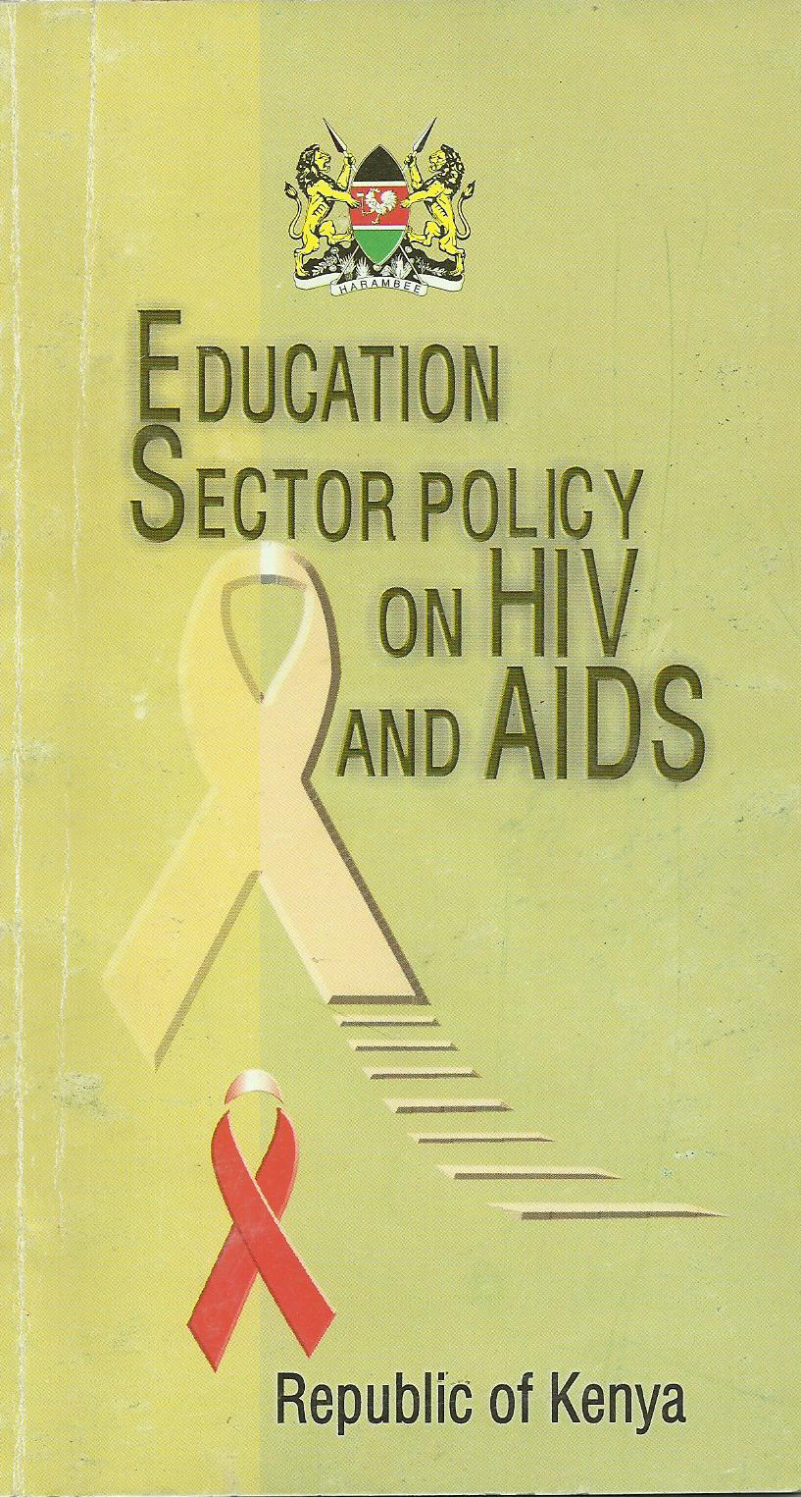

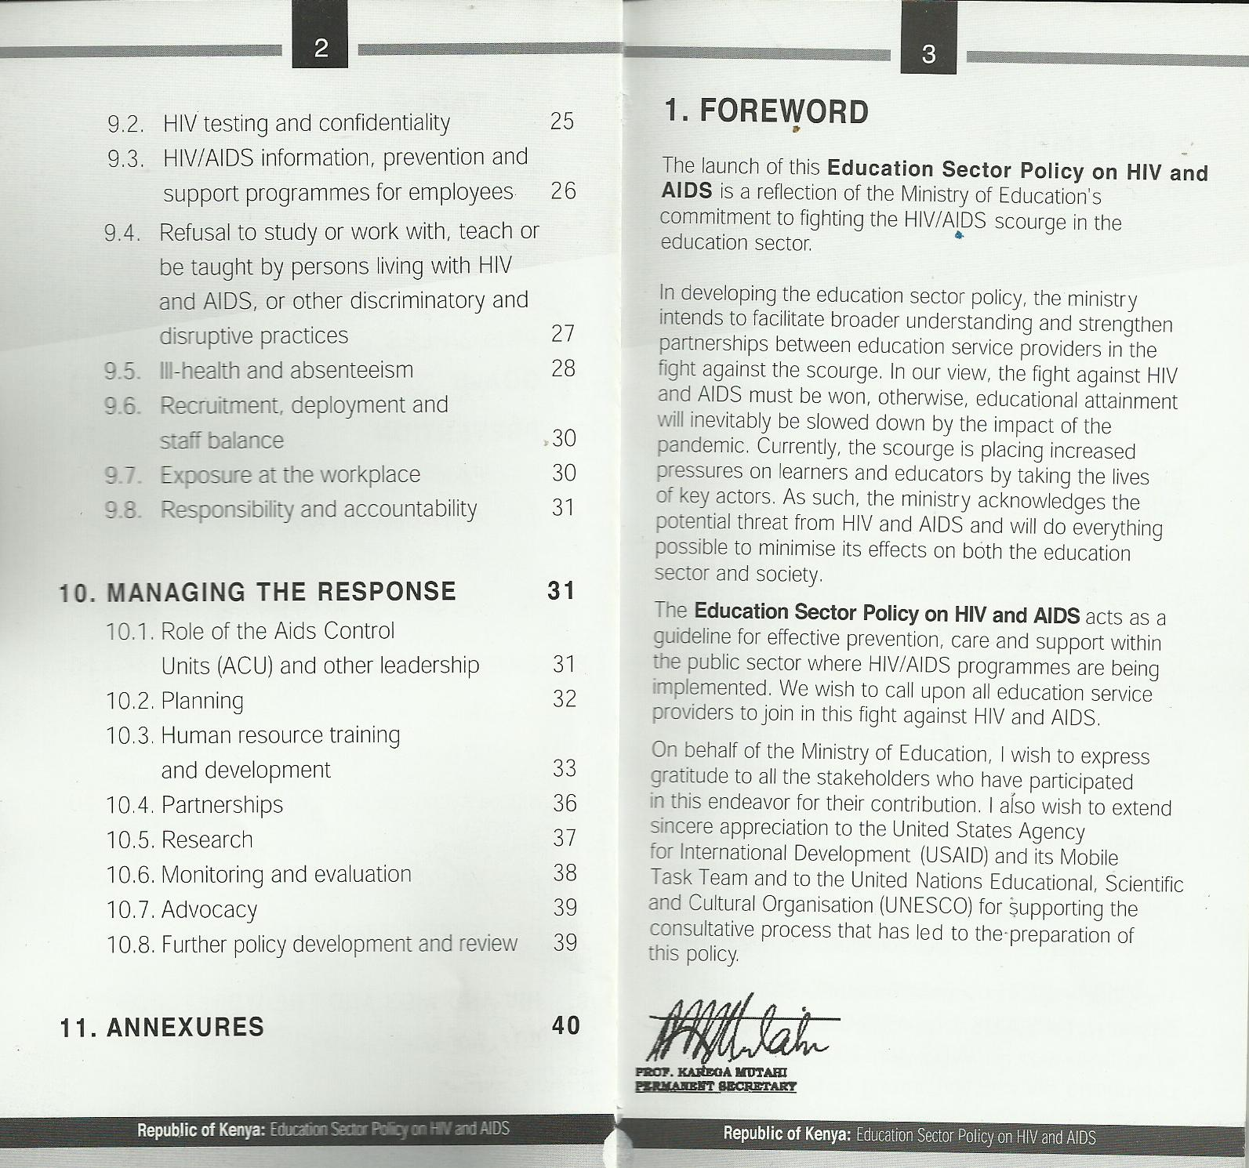

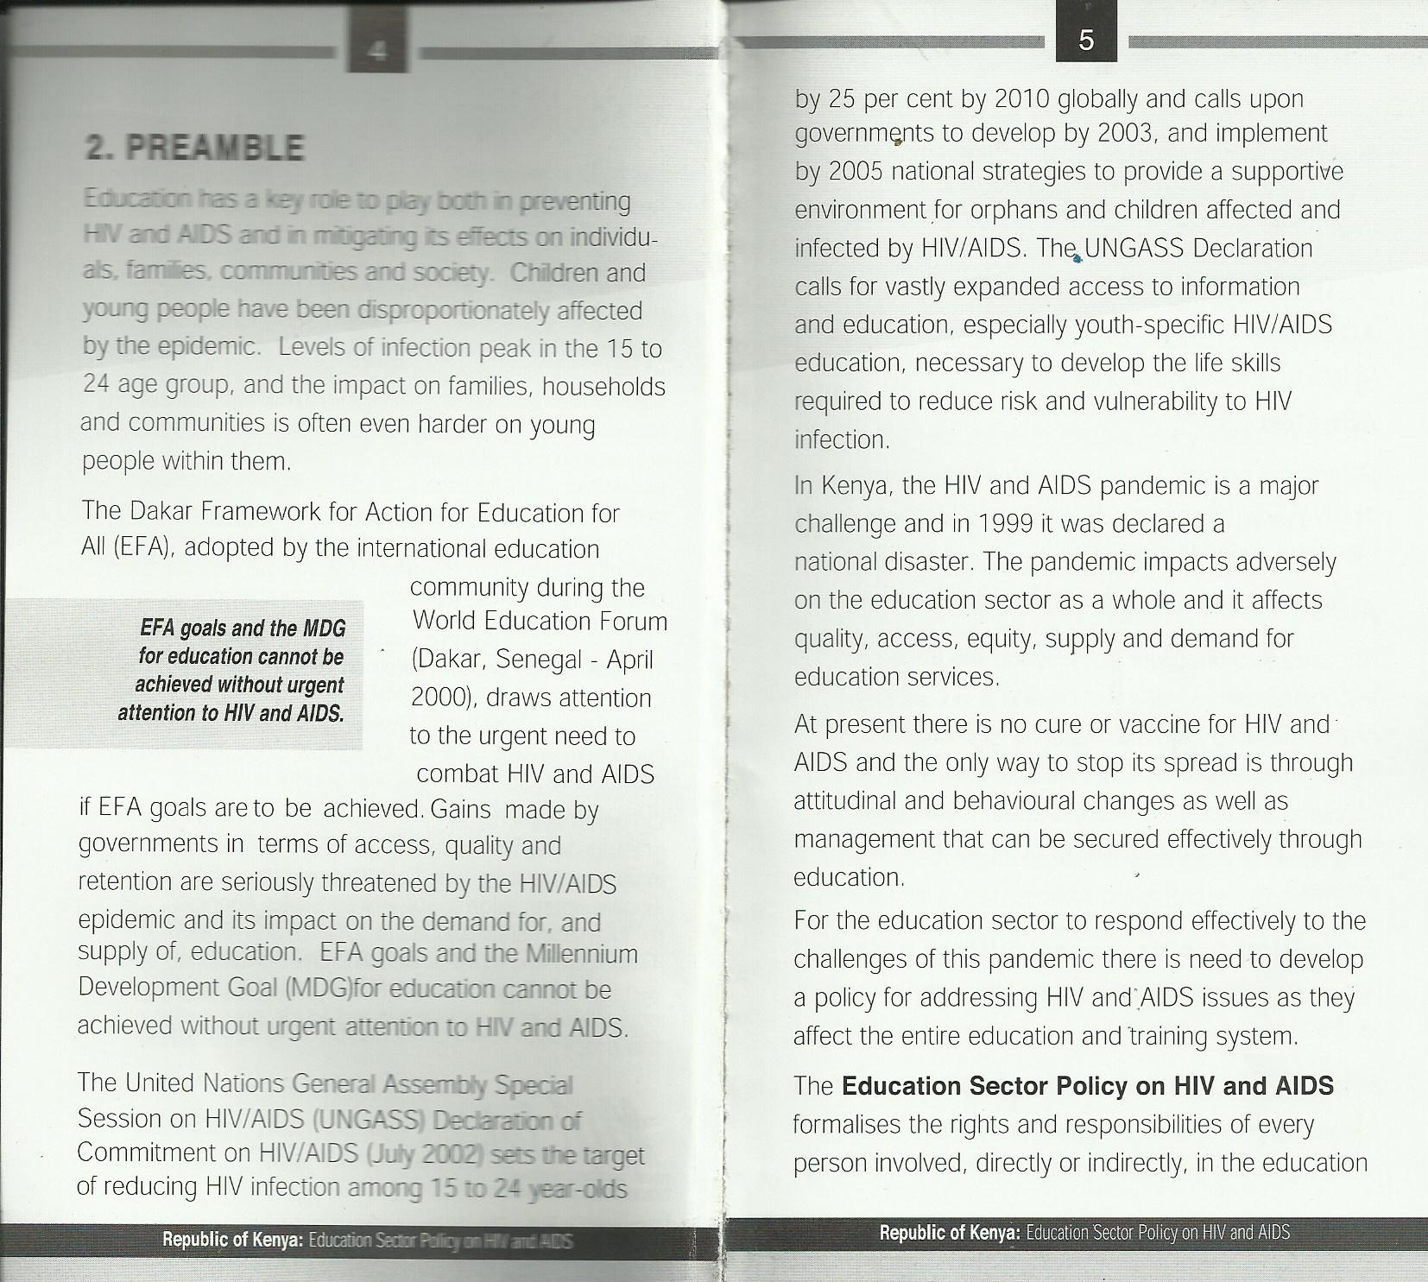

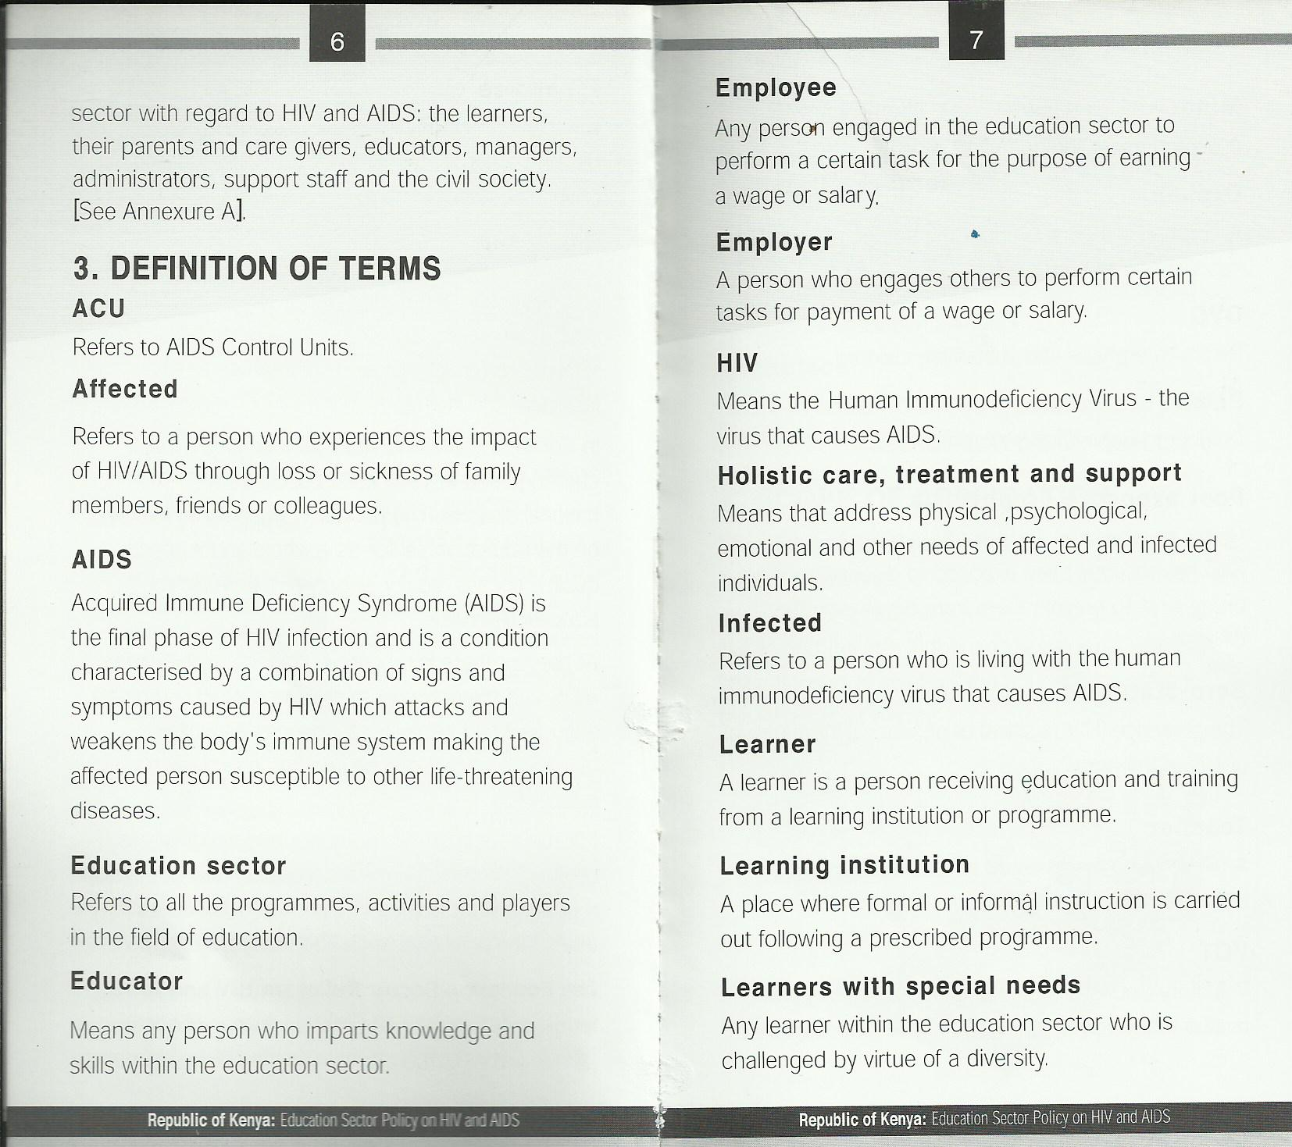

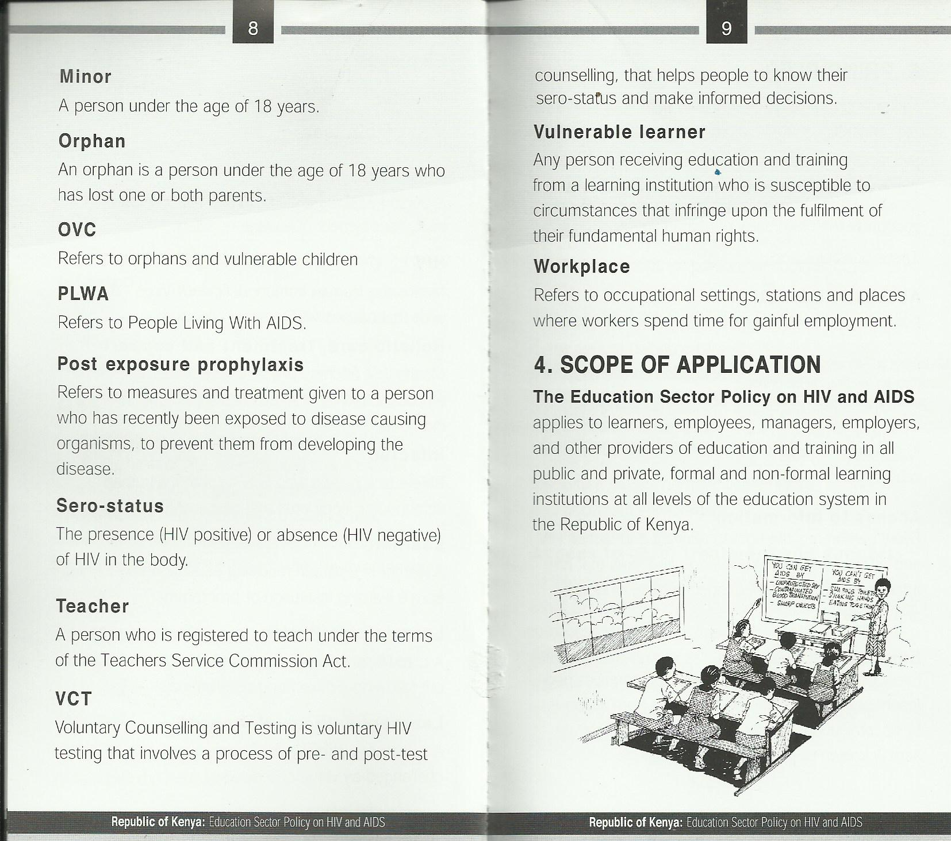

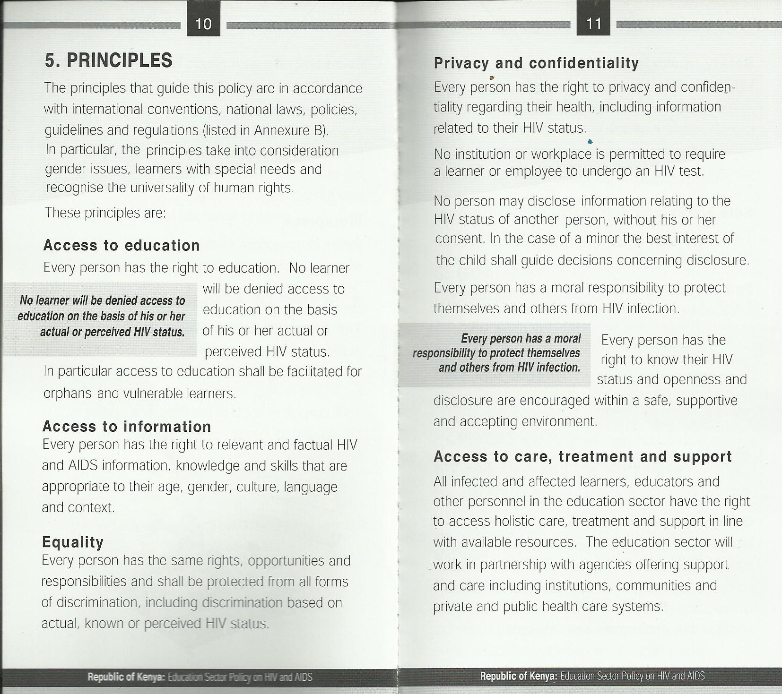

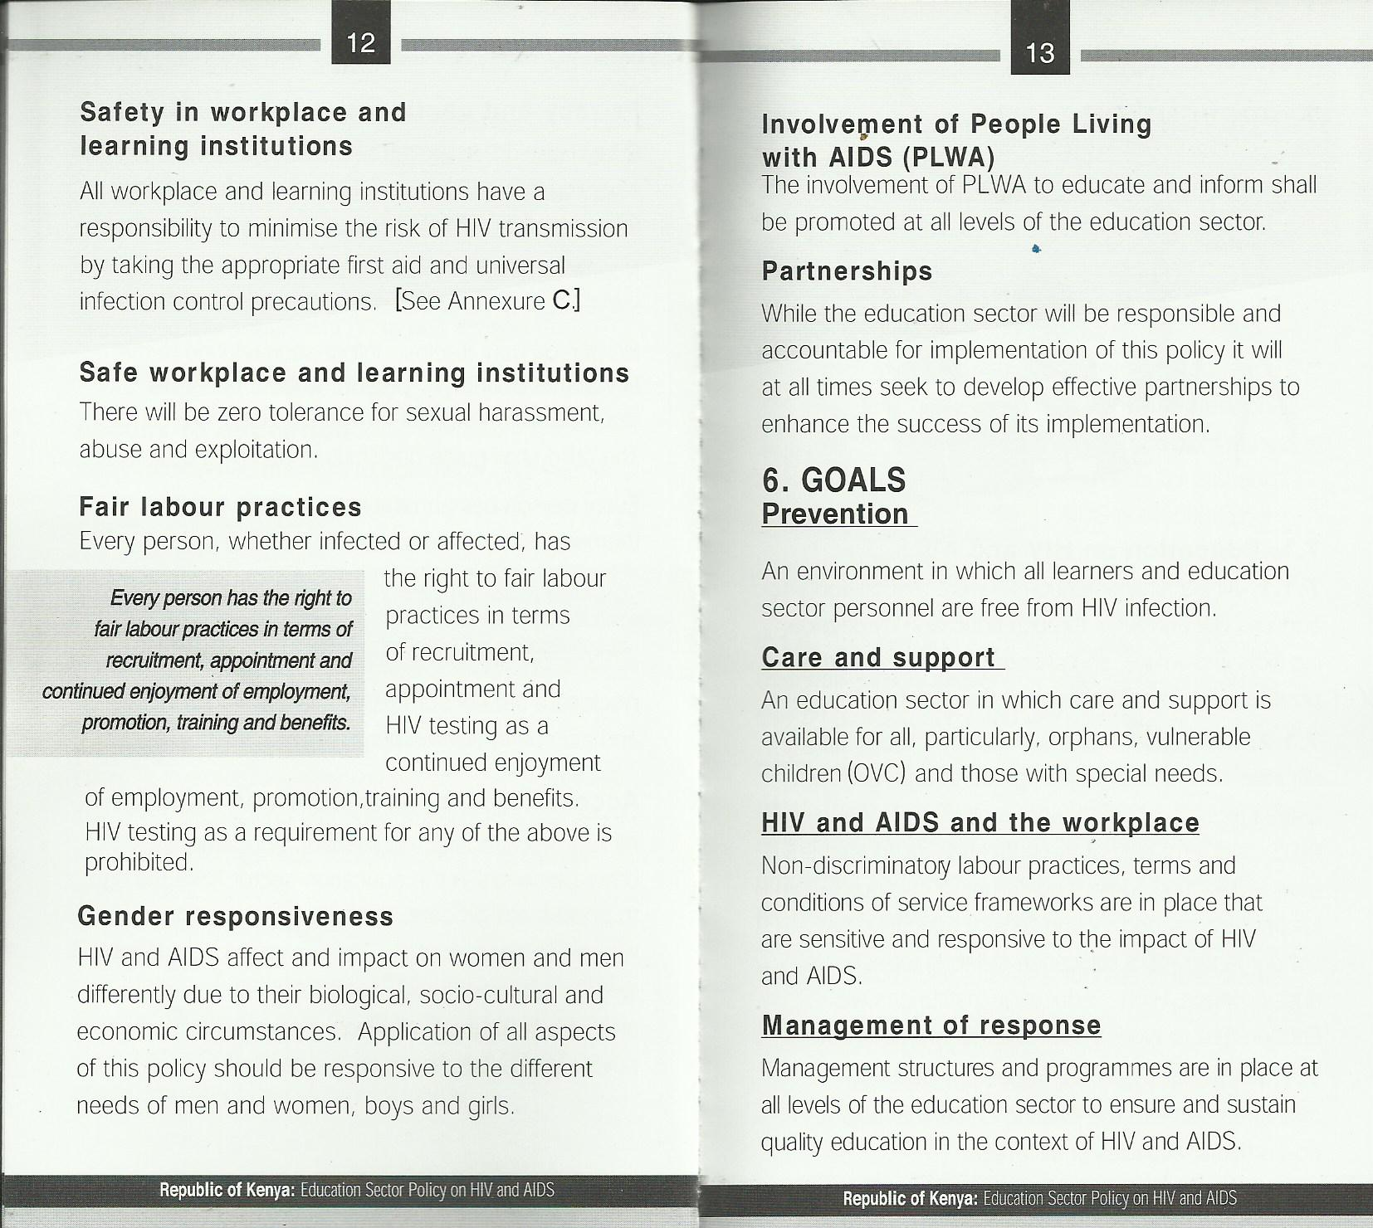

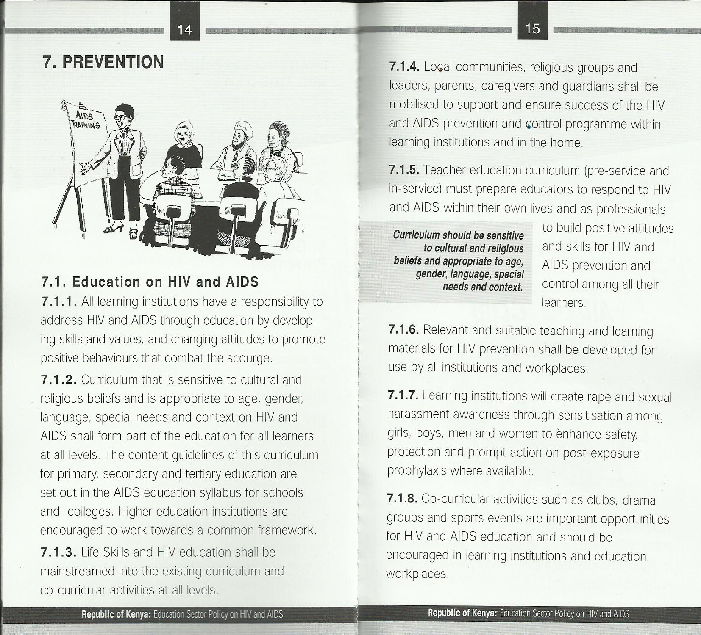

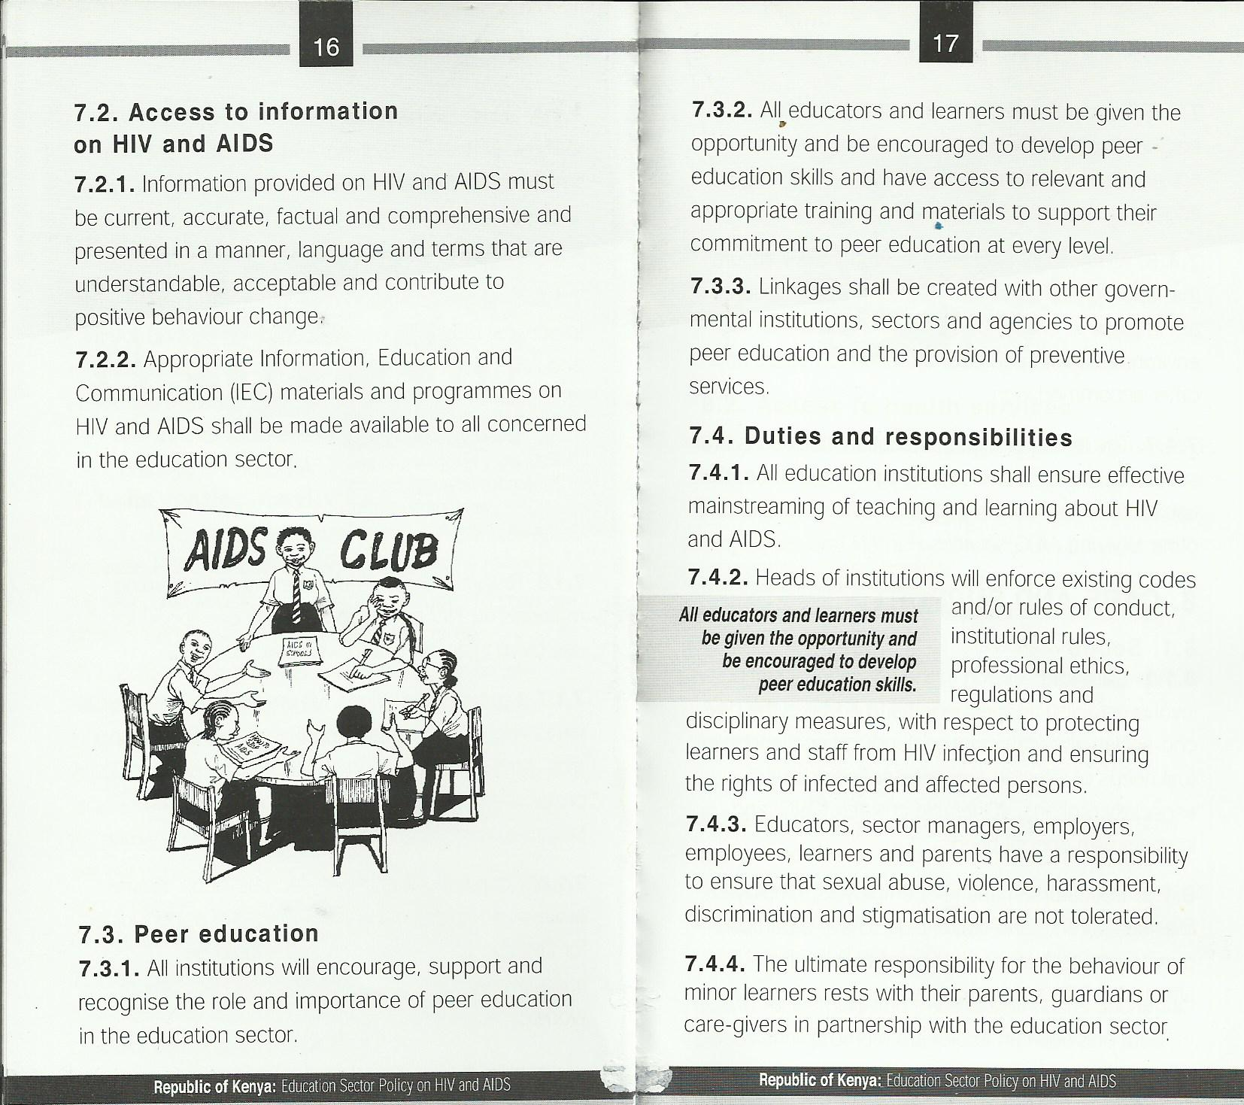

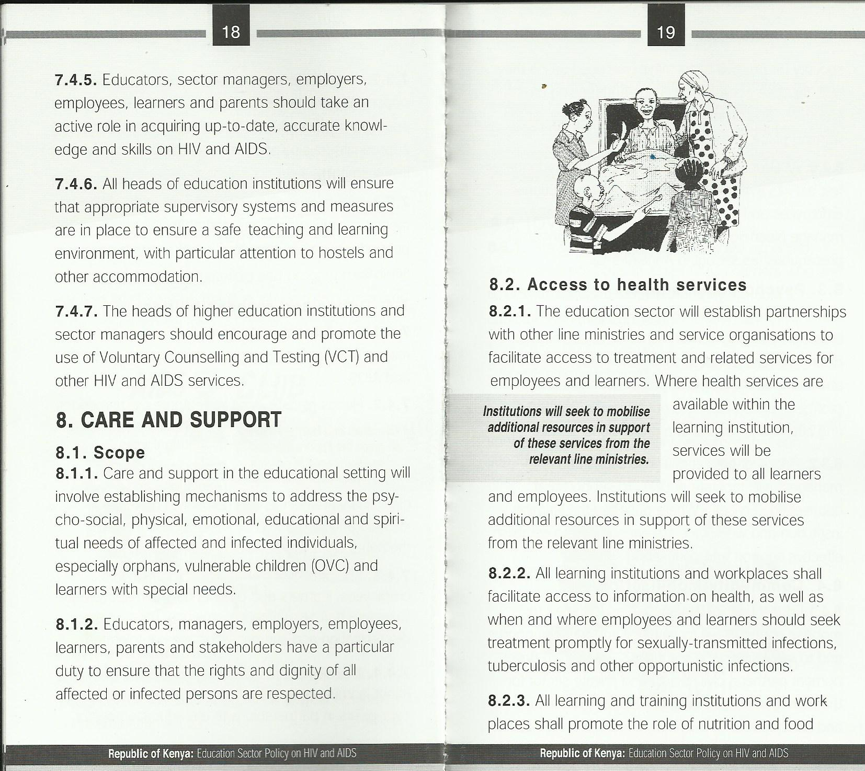

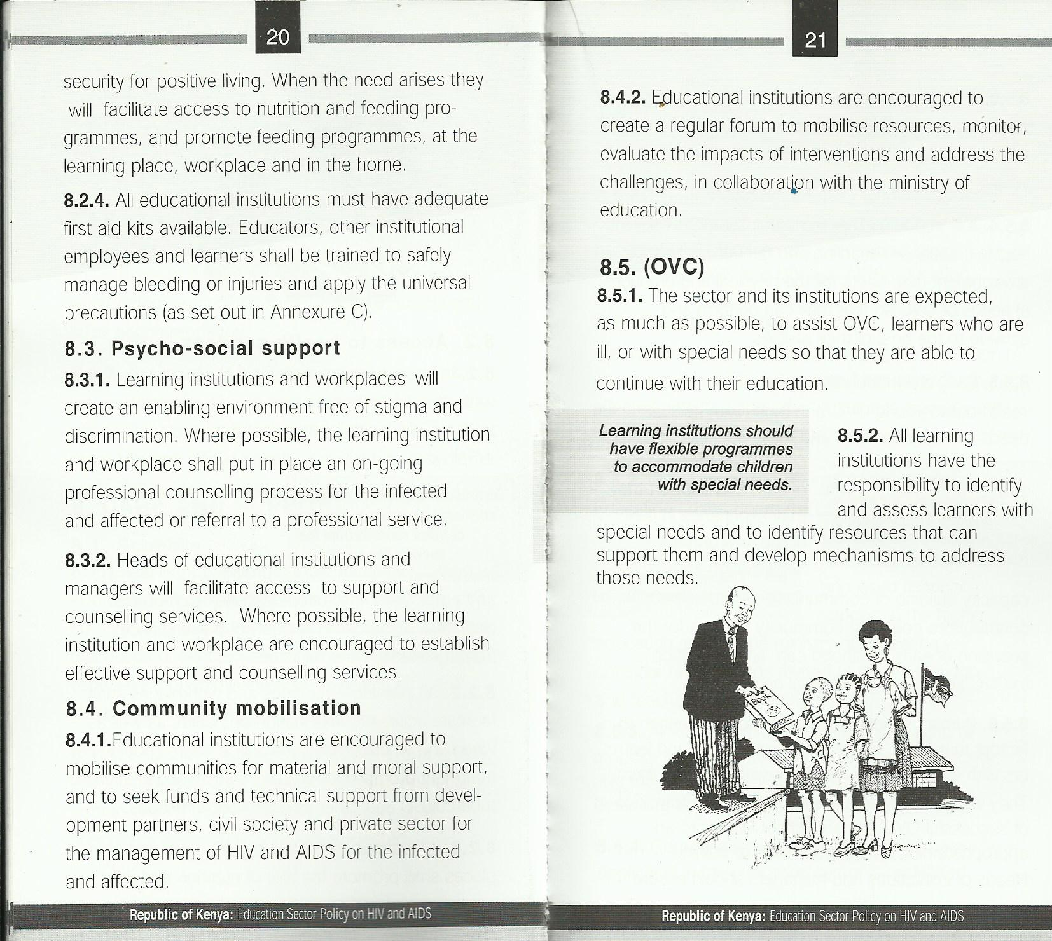

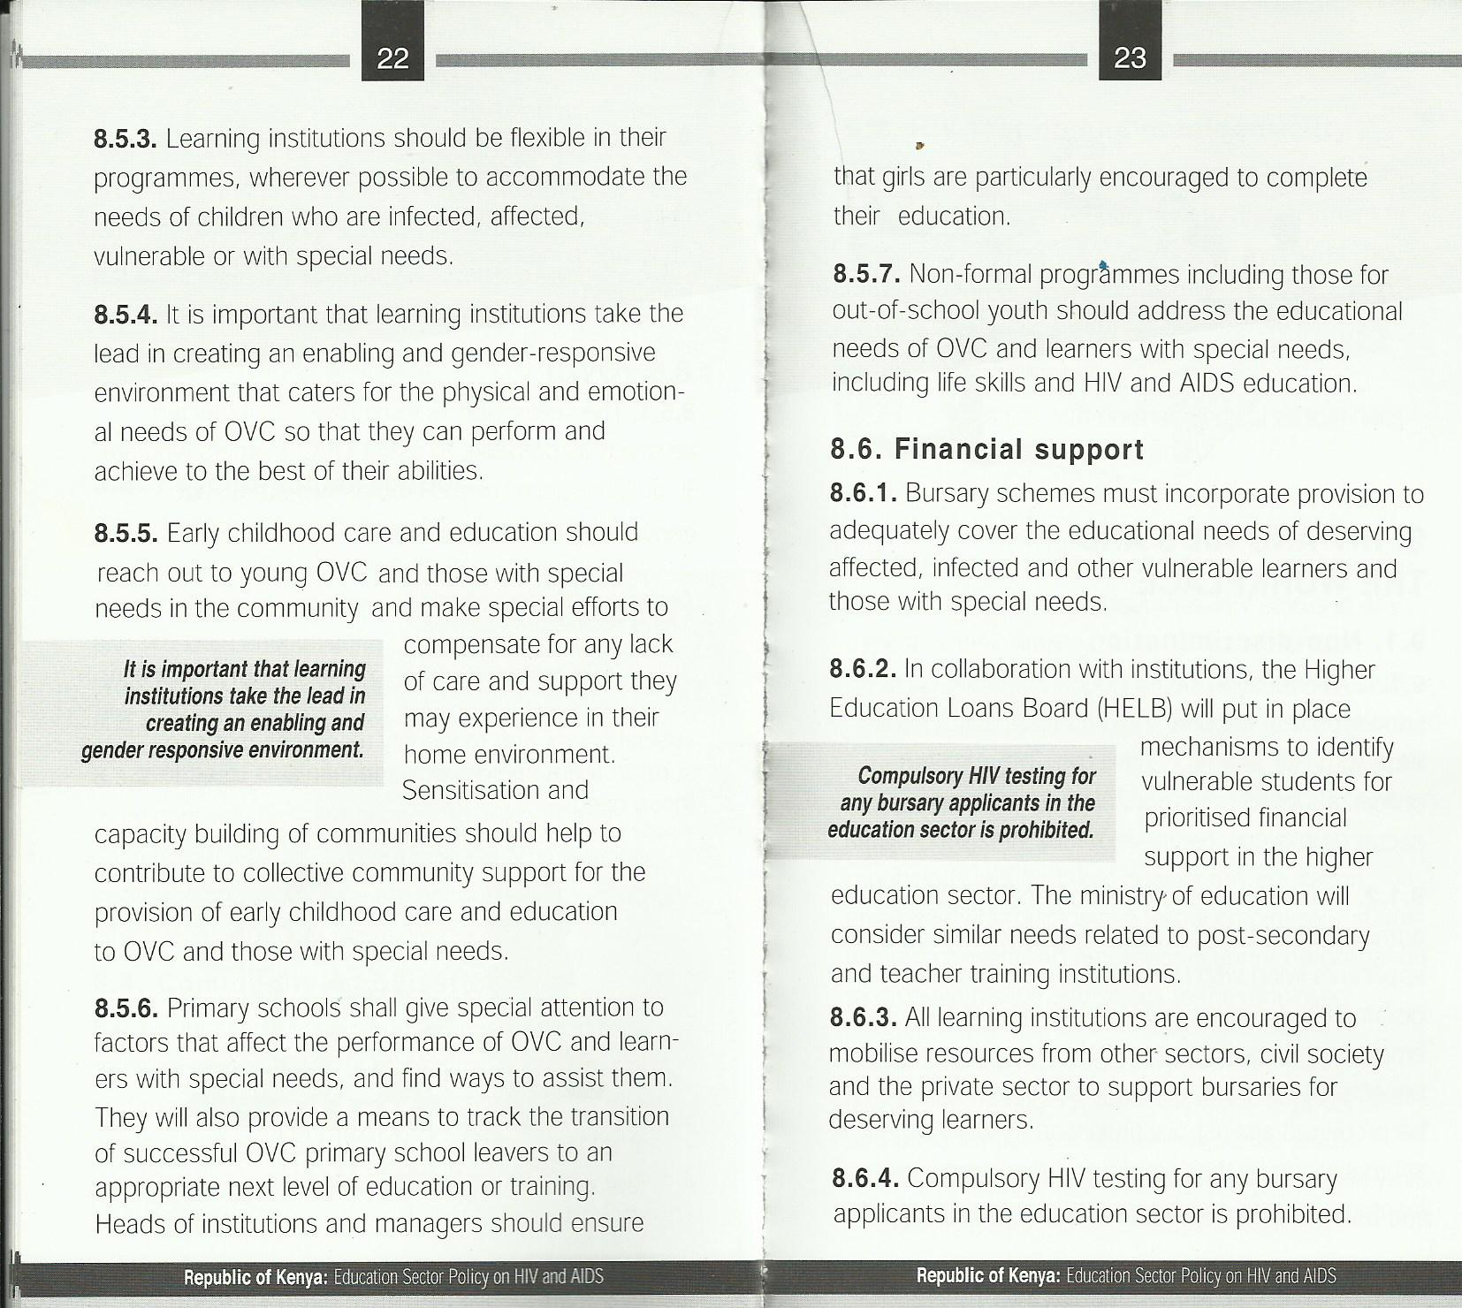

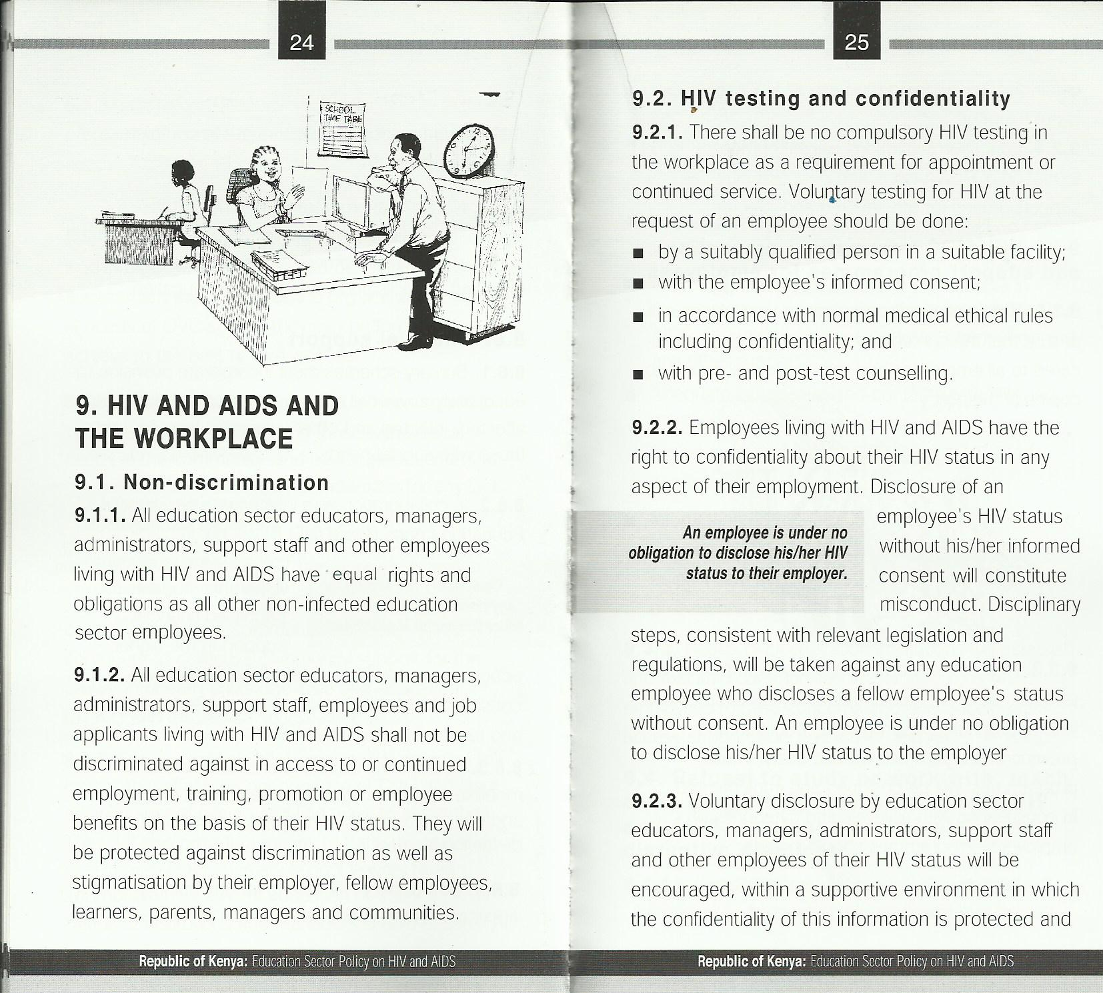

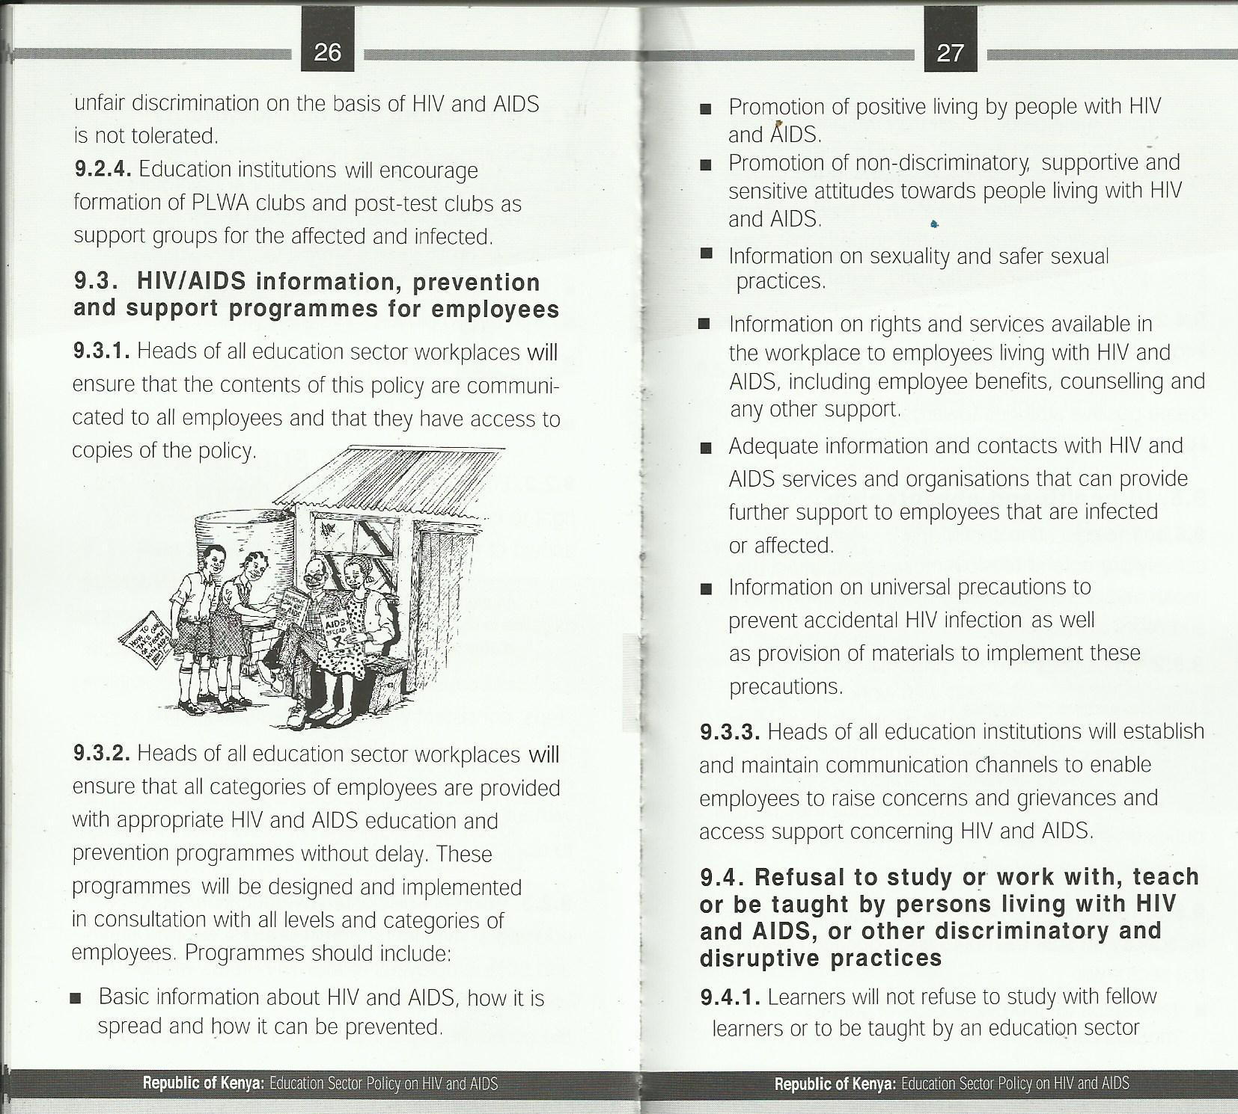

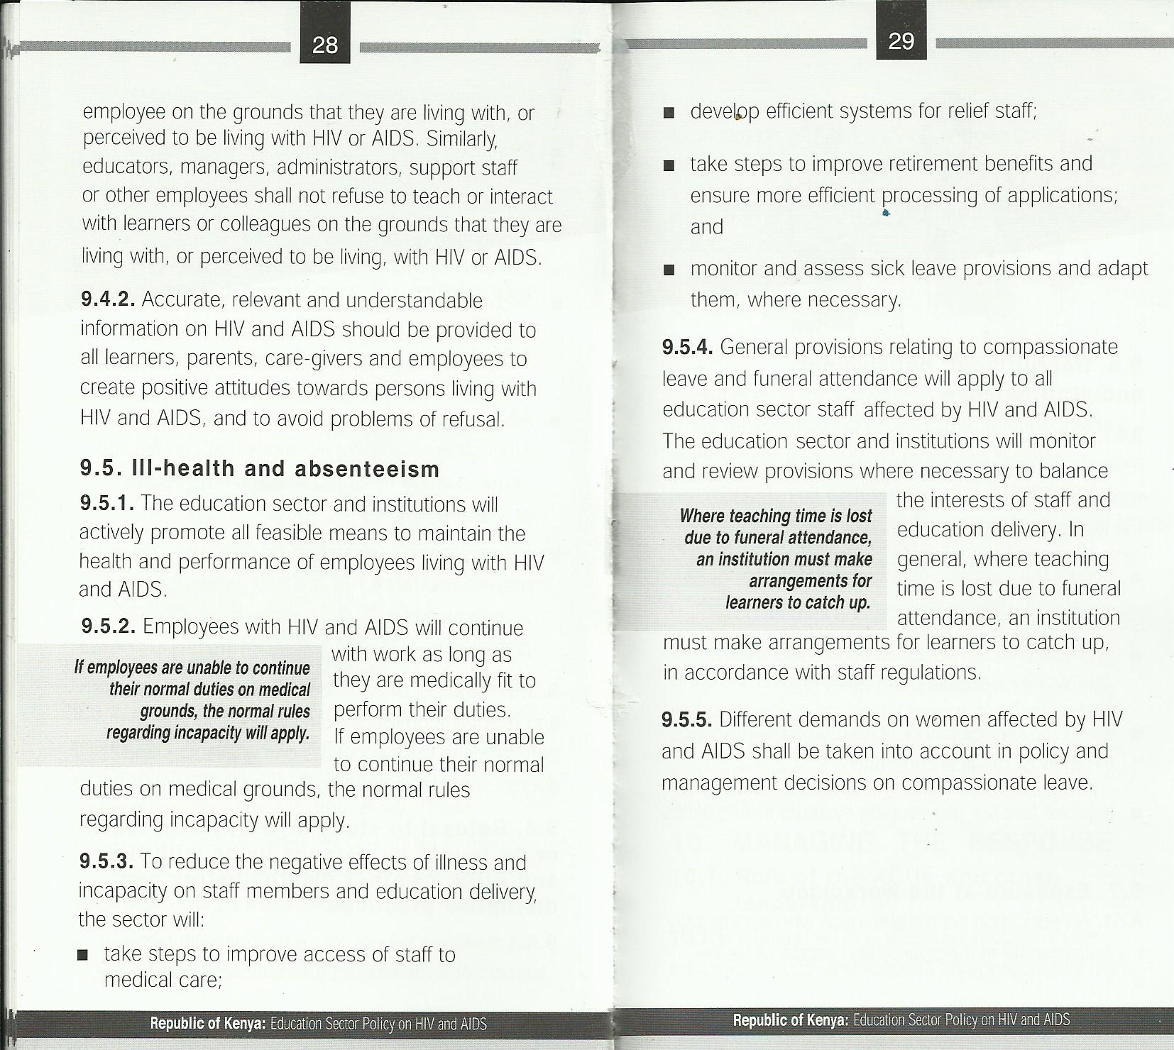

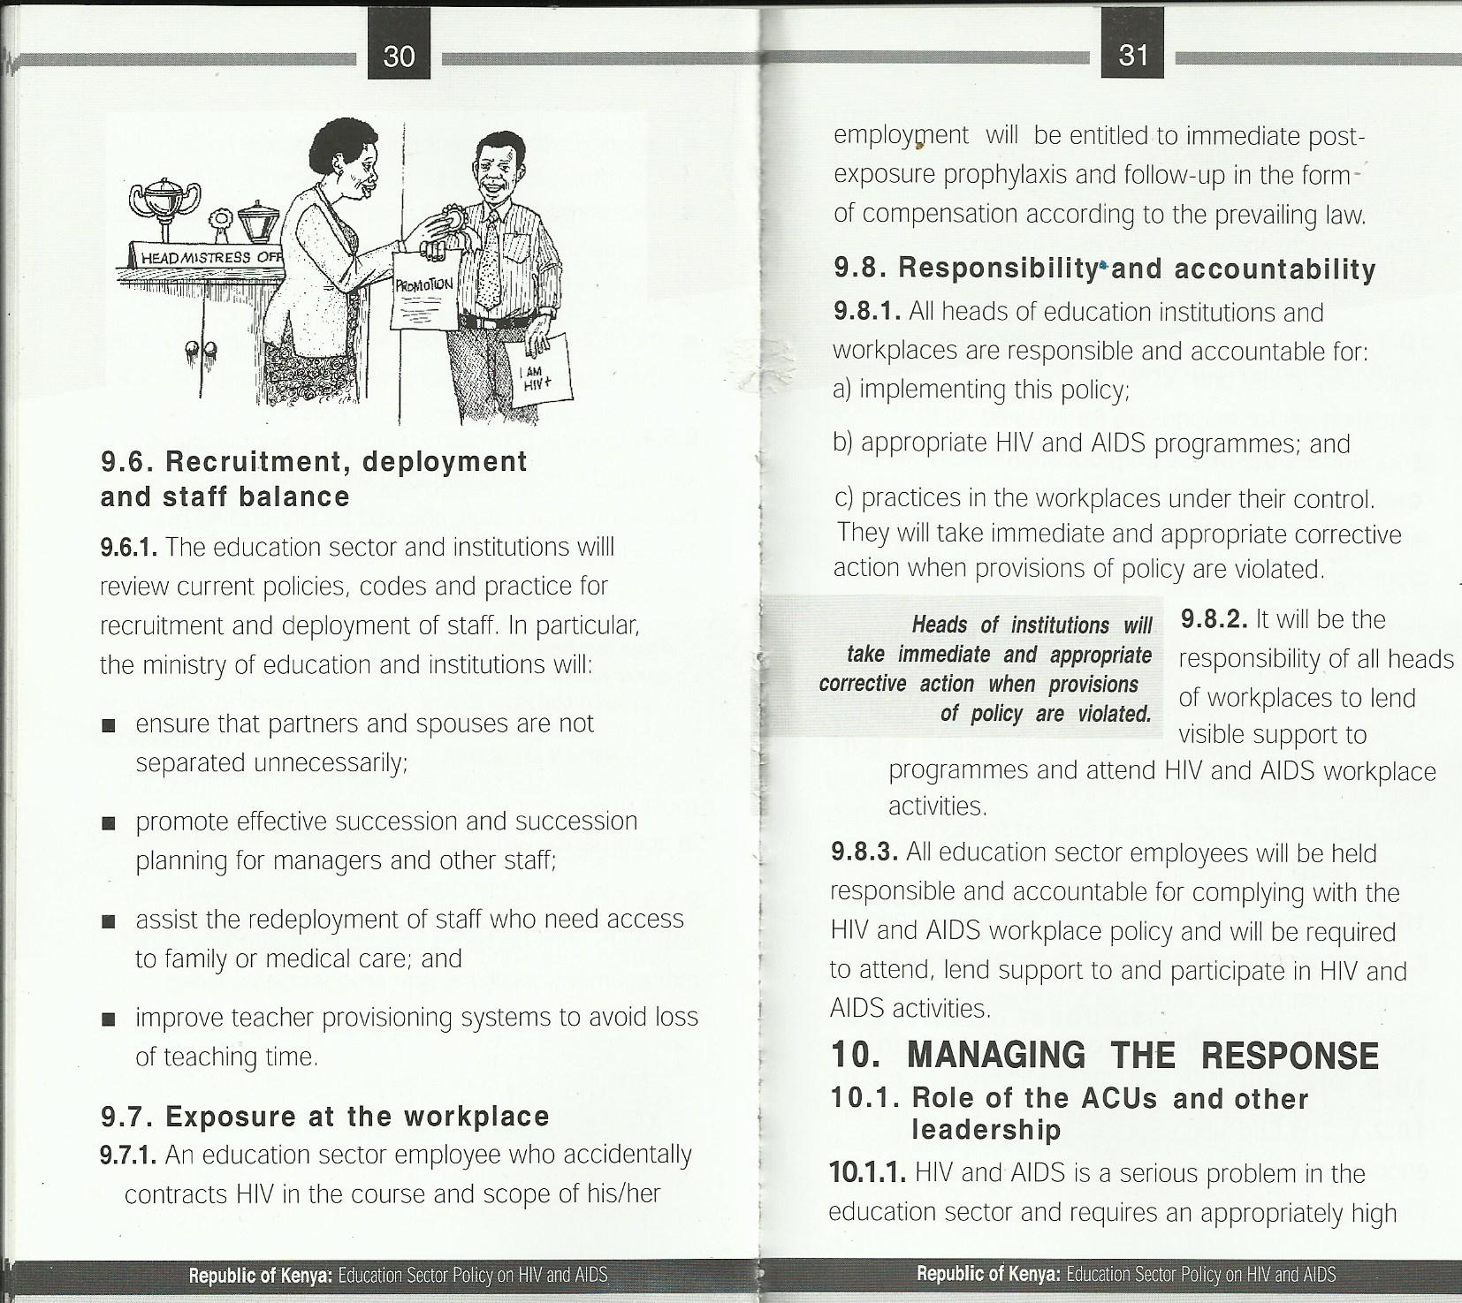

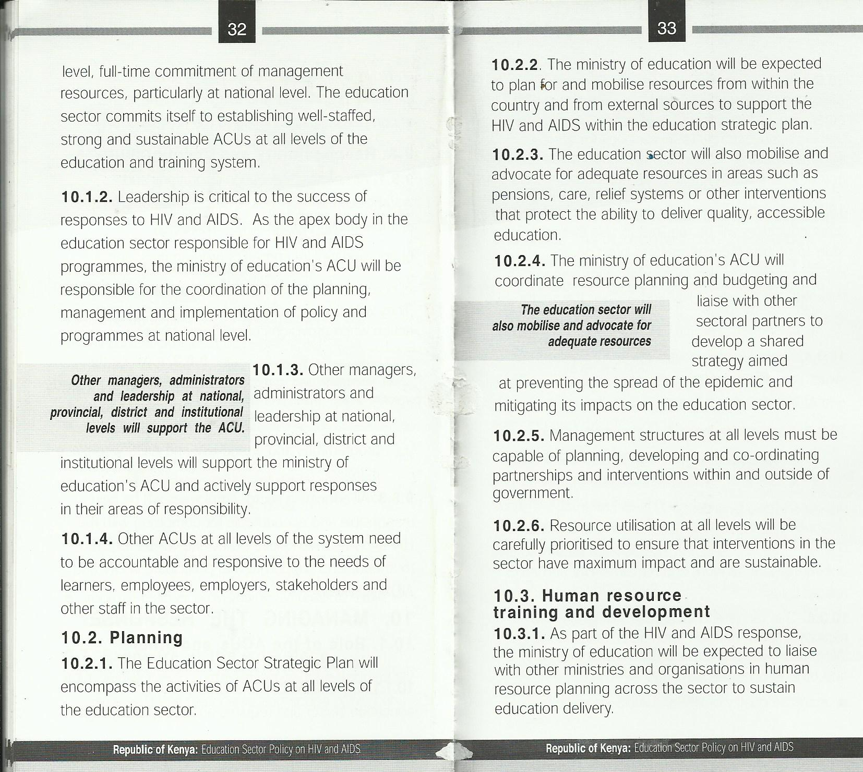

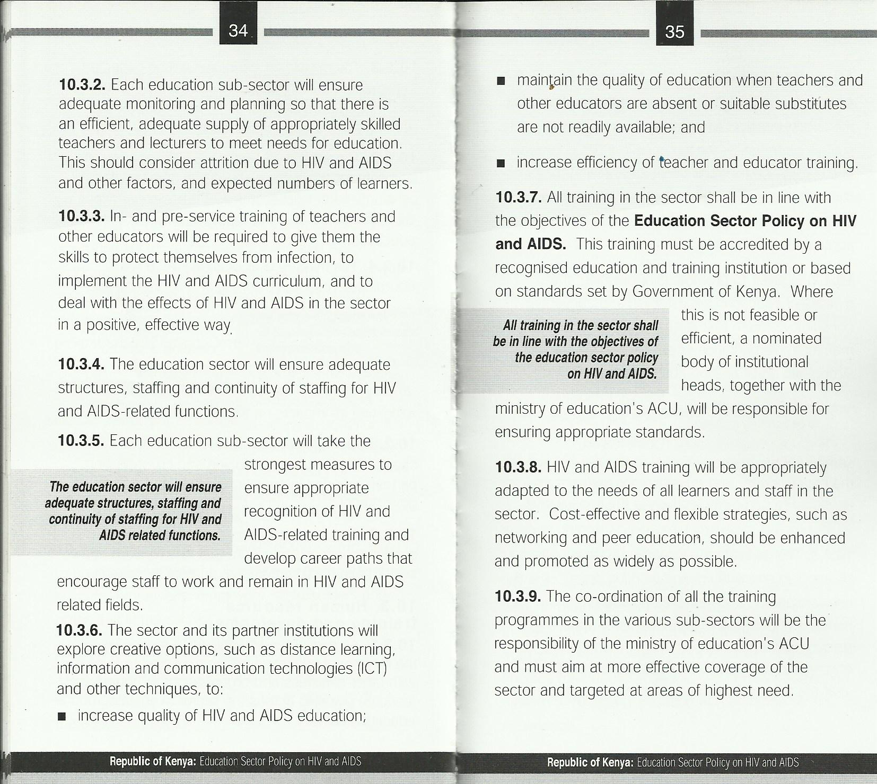

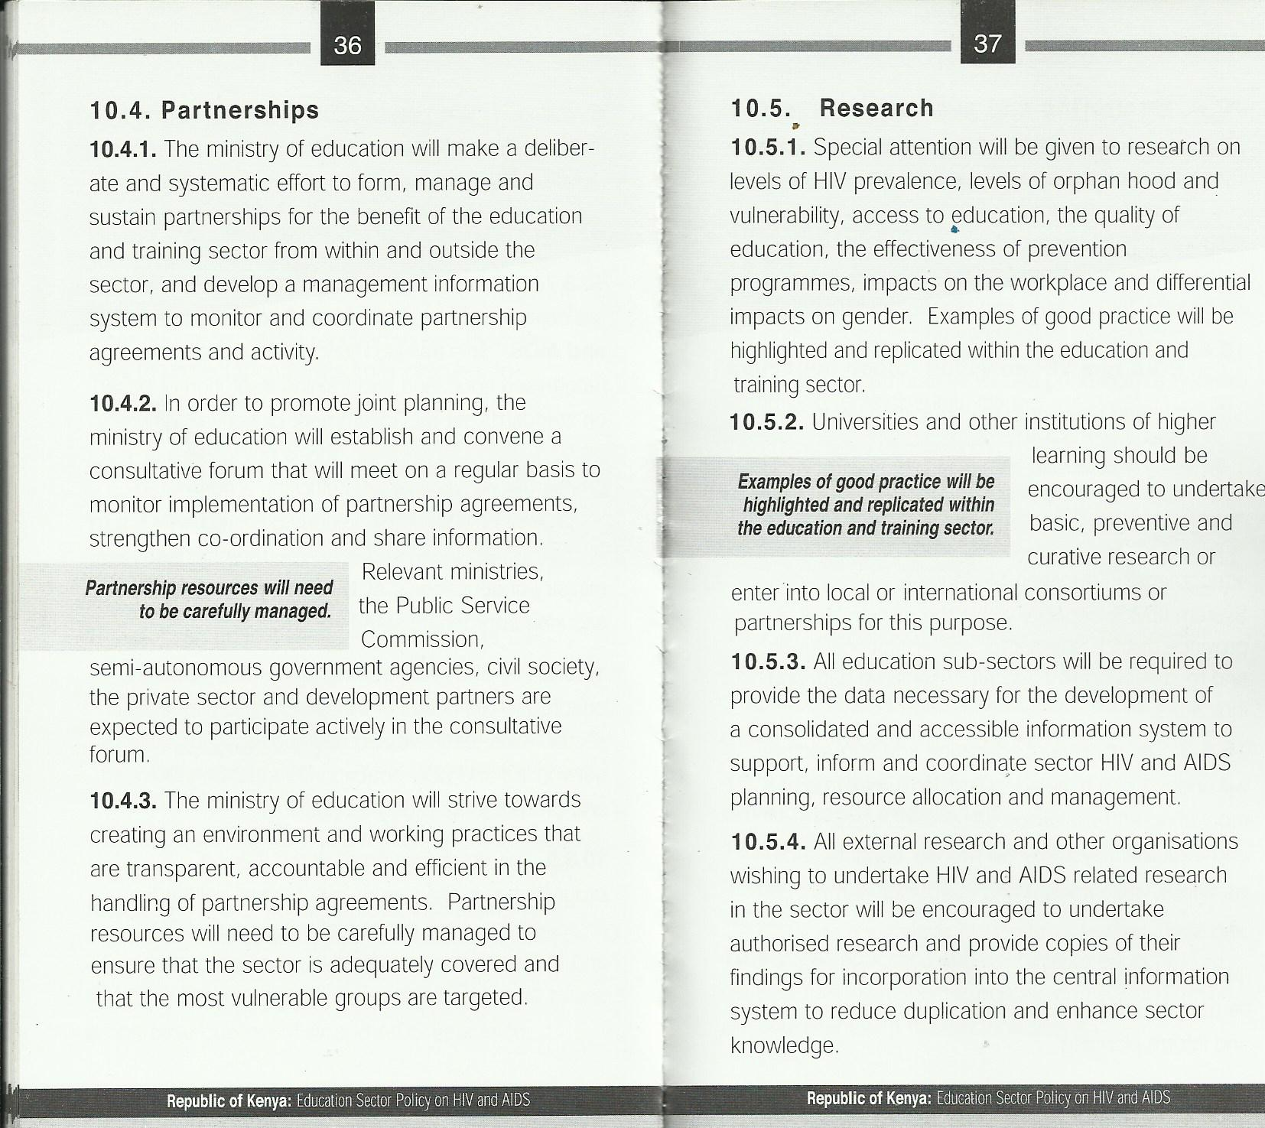

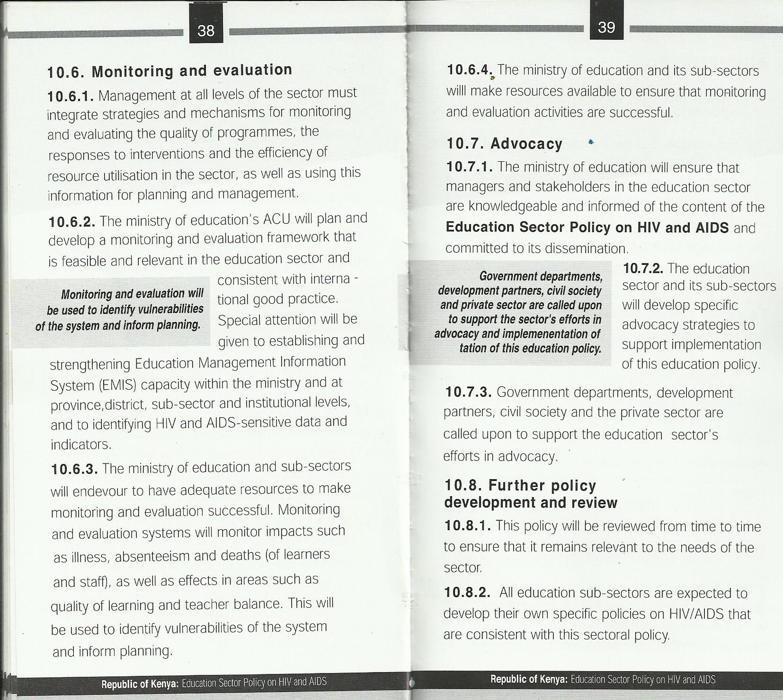

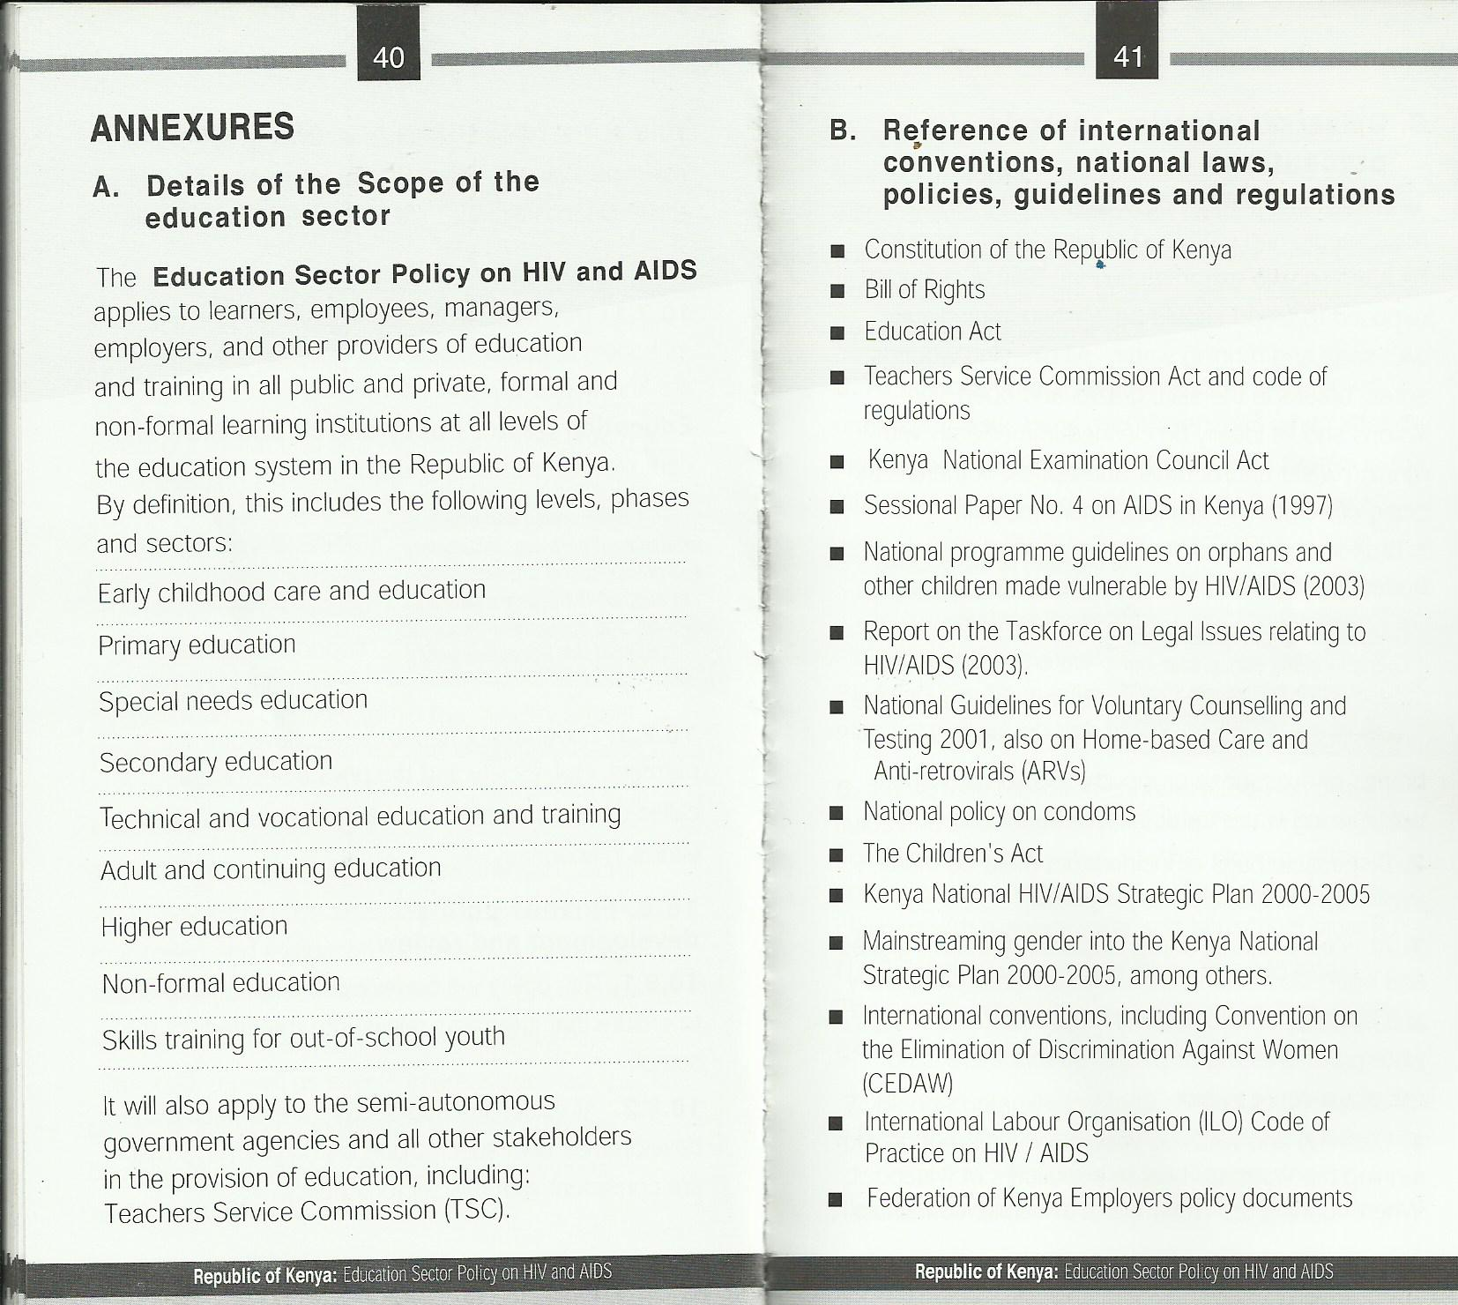





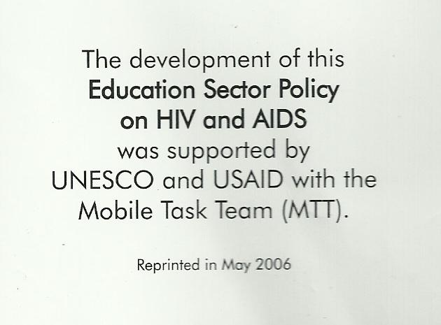

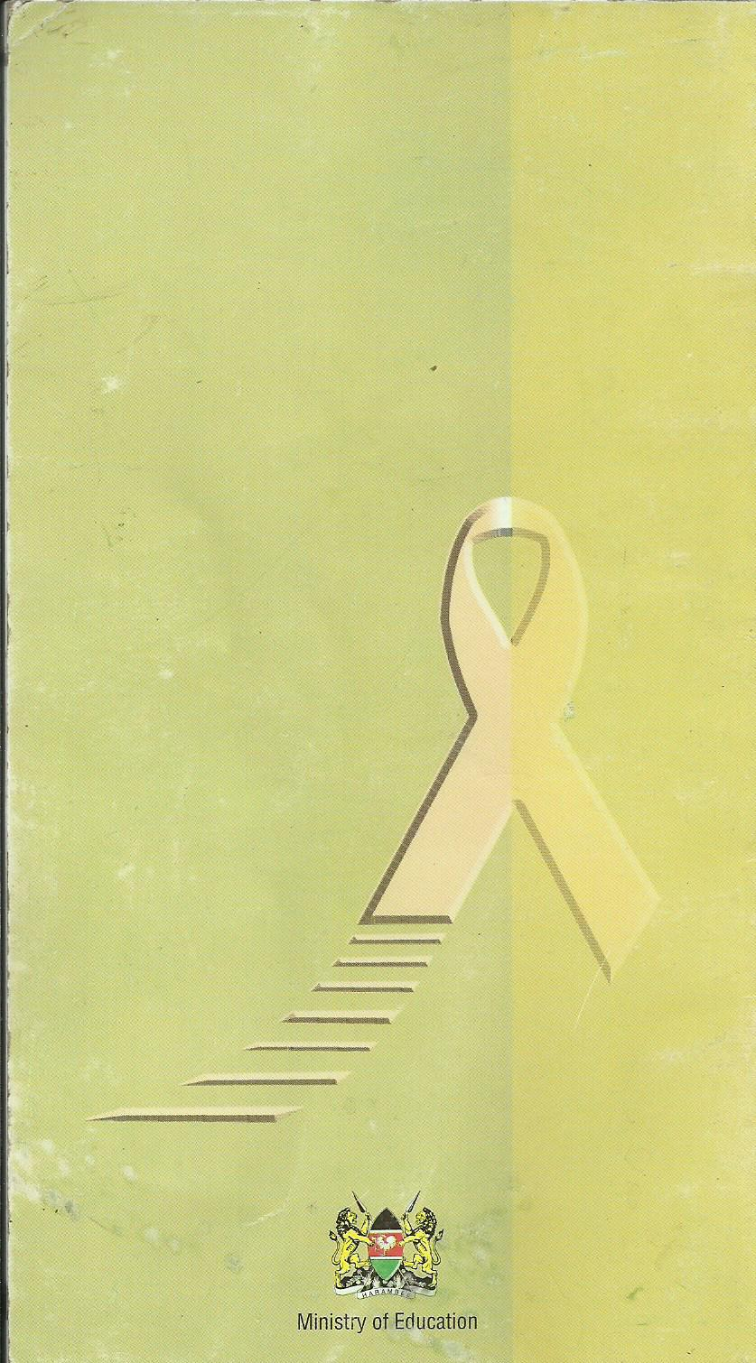

Appendix VI: Letter of Research Authorization


Appendix VII: RESEARCH CLEARANCE PERMIT

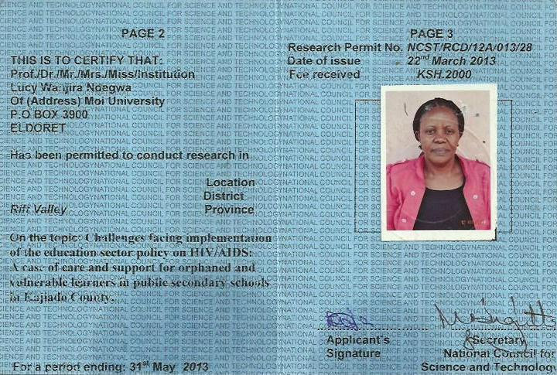

Appendix VIiI: Location of Kajiado County
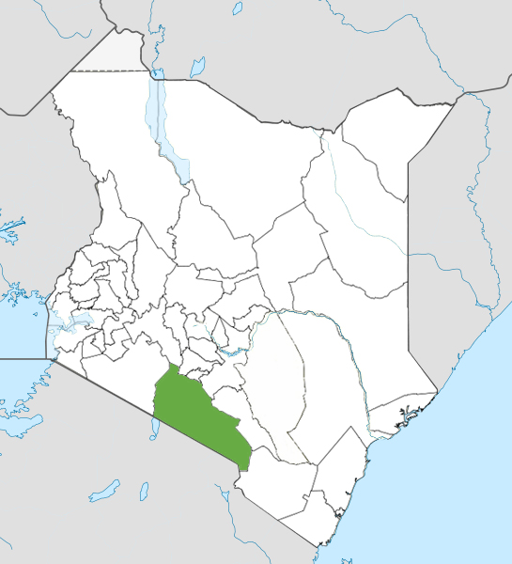
Source:wikipedia.org

