TEACHERS’ PERCEPTION ON THE EFFECTIVENESS OF KENYA SECONDARY SCHOOLS HEADS ASSOCIATION (KSSHA) ACTIVITIES: A CASE OF SECONDARY SCHOOL TEACHERS IN MBOONI EAST DISTRICT

BY

FRED WAMBUA MWONGELA

A PROJECT REPORT SUBMITTED IN PARTIAL FULFILMENT OF THE REQUIREMENT FOR THE AWARD OF MASTER OF PHILOSOPHY DEGREE IN EDUCATION MANAGEMENT AND POLICY STUDIES

DEPARTMENT OF EDUCATIONAL MANAGEMENT AND POLICY STUDIES
SCHOOL OF EDUCATION

MOI UNIVERSITY
ELDORET

NOVEMBER, 2014

DECLARATION
This research project is my original work and has not been submitted for any award in any other university, no part of this work may be reproduced without permission from the author or Moi University.

______________________________________
FRED WAMBUA MWONGELA Date
Reg. No.: EDU/PGEM/9048/10
Declaration by supervisor
This project has been submitted for examination with my approval as the University supervisor

__________________________________________
DR. ZACHARY KOSGEI Date
Lecturer,
Department of educational management and policy studies,
Moi University
Declaration from the head of department
This project has been submitted for examination with my approval as the head of the department.
___________________________________________ ______________________
DR JOSEPH LELAN Date

ABSTRACT
The main purpose of this study was to establish secondary school teachers’ perception towards KSSHA activities. The objectives of the study were to determine secondary school teachers’ perception towards their Principals’ capacity to implement school curriculum, supervise school staff, manage school finances and motivate school staff after attending KSSHA conferences. Secondary schools in Kenya invest a lot in KSSHA national annual conferences in terms of money and time hence the need for this study. The independent variable of the study was Principals’ effectiveness after attending KSSHA conferences while the dependent variable was teachers’ perception on the effectiveness of their Principal after attending the conferences. The study covered secondary schools of Mbooni East District and was hinged on the theory of human resource management as espoused by De Cenzo, Robbins and Owens (1987). The researcher used simple random sampling technique to get the schools and the respondents. Descriptive statistics was used for data analysis. The findings of the study were that collaborative management style is more productive in a professional environment than one of ‘command and control.’ Capacity building among staff varied considerably. On school budgeting, results revealed 30% low, 32% moderate, 38 % high before conference. Varying results were observed after conference, 40% said high, 36% moderate while 24% said low. The study concluded that communication is the lifeblood of any organization. The study recommended, among other recommendations, on the need for school Principals to identify strategies for implementing curriculum development by enhancing decision-making process among staff. A study on how motivational factors influence performance among schools was suggested.

DEDICATION

I dedicate this project to my wife Janet and daughter Catherine for the profound moral support and patience they provided during the entire period of undertaking this project.

ACKNOWLEDGEMENT

I would like to thank the entire Moi University and particularly members of the leadership and policy studies fraternity for the support they gave me while undertaking this project. I would also like to very sincerely thank Dr. Zachary Kosgei my project supervisor for tirelessly guiding me through the project.

TABLE OF CONTENTS
ABSTRACT iii
DEDICATION iv
ACKNOWLEDGEMENT v
LIST OF TABLES x
LIST OF FIGURES xi
CHAPTER ONE…………………………………………………………………………………..1
INTRODUCTION 1
1.1 An Overview 1
1.2 Background of the Study 1
1.2.1 The Concept of Teacher Association 2
1.2.2 The concept of perception 3
1.3 Statement of the Problem 4
1.4 Purpose of the Study 4
1.5 Objectives of the Study 5
1.5.1 Objectives 5
1.5.2 Research Questions 5
1.6 Significance of the Study 6
1.7 Scope and Limitations of the Study 6
1.7.1 Scope 6
1.7.2 Limitations 6
1.8 Theoretical Framework and Conceptual Framework 7
1.8.1 Theoretical framework 7
1.8.2 Conceptual Framework 8
1. 9 Definition of Key Terms 10

CHAPTER TWO 11
LITERATURE REVIEW 11
2.0 Introduction 11
2.1 Review of the Related Literature 12
2.1.1Curriculum Implementation 12
2.1.2 Staff Supervision 16
2.1.3 Motivation of Staff 18
2.1.4 Management of School Finances 39
2.2 Critical Review 40
2.3 Summary 42
CHAPTER THREE 45
RESEARCH METHODOLOGY 45
3.0 Introduction 45
3.1 Research Design 45
3.2 Location of the Study 45
3.3 Study Population 46
3.4 Sample and Sampling Techniques 46
3.5 Research Instruments 46
3.6 Validity and Reliability of the Research Instruments 46
3.6.1 Validity 46
3.6.2 Reliability 47
3.7 Data Collection Process 47
3.7 Data Analysis Procedures 47
CHAPTER FOUR 49
PRESENTATION, ANALYSIS AND INTERPRETATION OF DATA 49
4.0 Introduction 49
4.1 Profile of the Respondents 50
4.1.1 Gender 50
4.1.2 Age Bracket 52
4.1.3 Education Level 53
4.1.4 Teaching experience 54
4.2 Capacity to implement curriculum after conference 56
4.2.1 Collaboration among members of staff 56
4.2.2 Curriculum implementation programs 58
4.2.3 Modeling effective instruction in school 60
4.2.4 Ability to provide Feedback 61
4.2.5 Ability to provide suggestions 63
4.2.6 Teaching mechanism in subjects of specialization 64
4.3 Capacity to supervise school staff after the conference 65
4.3.1 Ability to adhere to the syllabus 65
4.3.2 General supervision 66
4.3.3 Support structures of classroom concerns 68
4.3.4 Demonstration of knowledge on curricula issues 69
4.3.5 Assistance on curricular implementation 70
4.3.6 Effective timetable implementation and planning 71
4.4 Capacity to manage school finances after the conference 71
4.4.1 School budgeting 72
4.4.2 Resource mobilization for school development 73
4.4.3 General school financial management 74
4.5 Capacity to motivate school staff after the conference 76
4.5.1 Fair treatment of staff 76
4.5.1 Freedom to set departmental goals 80
4.5.3 Staff involvement to solve work-related problems 81

CHAPTER FIVE 83
SUMMARY OF MAJOR FINDINGS, CONCLUSIONS AND RECOMMENDATION 83
5.0 Introduction 83
5.1 Summary 83
5.2 Conclusions 84
5.3 Recommendations 85
5.4 Suggestions for Further Research 87
REFERENCES 88
APPENDIX 1: QUESTIONNAIRE FOR DEPUTY PRINCIPALS 90
APPENDIX 2: QUESTIONNAIRE FOR TEACHERS 99

LIST OF TABLES

Table 4.1: Respondents experience 58
Table 4.2: General supervision (before conference) 58
Table 4.3: General supervision (before conference) 58
Table 4.4: Ability to teach in subjects of specialization 64
Table 4.5: General supervision by Principals (before) 66
Table 4.6: Assistance on curricular implementation 70
Table 4.7 School financial management (before conference) 74
Table 4.8 Staff motivation mechanisms (before conference) 78
Table 4.9: Freedom to set departmental goals 80

LIST OF FIGURES

Figure 4.1 Respondents gender 50
Figure 4.2: Distribution of respondents by age 52
Figure 4.3: Education level 53
Figure 4.4 Support on collaboration 57
Figure 4.5 Modeling effective instruction 60
Figure 4.6 Principals ability to provide feedback 62
Figure 4.7 Ability to provide suggestions 63
Figure 4.8 Adherence to syllabi 65
Figure 4.9 Support on classroom concerns 68
Figure 4.10 Knowledge on curricula issues 69
Figure 4.11 Effective timetable implementation 71
Figure 4.12 Principals ability on school budgeting 72
Figure 4.13 Resource mobilization 73
Figure 4.14 Fair Treatment of staff 76
Figure 4.15 Staff involvement in problem-solving 82

CHAPTER ONE

INTRODUCTION

1.1 An Overview
This chapter contains the background of the study, the statement of the problem, the purpose of the study, the objectives of the study, the research questions, the significance of the study, the limitations of the study, scope of the study, the theoretical framework, the conceptual framework and the definition of terms used in the study.

1.2 Background of the Study
Kenya Secondary School Heads Association (KSSHA) is a professional organization comprising about 7000 members drawn from both public and private secondary schools in the republic of Kenya. It was established in the late sixties with the purpose of providing professional advice to its members.
The objectives of KSSHA include: establishing sound co-operative liaison with the ministry of education, science and technology, universities and other bodies as well as employers interested in recruiting the services of students leaving schools; formulating and publicizing agreed policies concerning administrative and educational problems with which heads of institutions may from time to time be concerned with; organizing regular exchange of opinions and experiences on all matters concerning the teaching profession, nationally and internationally; participating in making educational policies in liaison with the ministry of education, science and technology; getting involved in the running of co-curricular activities in collection and disbursement of funds from the zonal to national levels; supervising and accounting for activity funds collected at all levels and promoting education standards in the country.

1.2.1 The Concept of Teacher Association
While responding to the question why bother attending professional conferences, Doyle, (2012) said that the most direct answer to this question has to do with becoming and remaining a professional in the discipline. Professionalism requires everybody to become and remain active in the field of study. They do that by maintaining membership in their professional national and regional associations. He also observed that conferences provide opportunities to listen to the work of others, present one’s research, access the most current information in the discipline, organize programs and interest groups and become part of a network of lifelong professional and personal friends.
According to Doyle (2012), many benefits from conference attendance are hard to quantify. For example, many experts agree that the top benefit of conference attendance is networking value because at conferences, attendees find many organization contacts facing the same challenges as that of the attendee. He was quick to note that although networking was undoubtedly the most important aspect of a conference, it was the toughest for which to quantify any value. He advised those who intent to attend conferences and propose the idea for approval to focus on what they would specifically bring back to the organization as payback for the investment instead of how much they want to attend the event. He also advised those who intent to attend conferences look for the session content to ensure that it is relevant to the individual’s organization, best practices to check whether there would be training in areas that would benefit the individual’s organization, and check whether attendees would be trained on specials kills to help them overcome current and future challenges in their organizations.

1.2.2 The concept of perception
Pomerantz (2013) defines perception as the process by which organisms interpret and organize sensation to produce a meaningful experience of the world. They further observed that when a person is confronted with a situation or stimuli, he/she interprets the stimuli into something meaningful based on prior experiences. However, what an individual interprets or perceives may be substantially different from reality.
According to Assael (1995), the perception process follows four stages: stimulation, registration, organization and interpretation .He asserted that a person’s awareness and acceptance of the stimuli play an important role in the perception process and that receptiveness to the stimuli is highly selective and may be limited by a person’s existing beliefs, attitudes, motivation and personality. He further observed that individuals will select the stimuli that satisfy their immediate needs and may disregard stimuli that may cause psychological anxiety. He defined social perception as the way an individual sees others and how others perceive an individual. He says that social perception is accomplished through various means such as classifying an individual based on a single characteristic and evaluating a person’s characteristics by comparison to others, perceiving others in ways that reflect a perceiver’s own attitudes and beliefs, judging someone on the basis of one’s perception of the group to which that person belongs, causing a person to act erroneously based on another person’s perception, or controlling another person’s perception of oneself.

1.3 Statement of the Problem
Kenya Secondary Schools Heads Association (KSSHA) activities have been drawing a lot of reactions from secondary school teachers ever since its inception. Schools spent a lot of funds to sponsor their Principals. For instance, in the year 2012 every secondary school in Kenya, however small, spent Kshs.106,000 (one hundred and six thousand) on both Provincial and National conferences. Professional conferences, KSSHA conferences being some, are staff development or professional development activities that provide opportunities to the delegates to interact and share experiences regarding their work as secondary school Principals. A secondary school Principals’ work involves implementation of school curriculum, staff supervision, motivation, and management of school finances (Savage & Armstrong, 2000). Despite the efforts made to advance the activities of KSSHA, its effectiveness may be challenged by perceptions with regard to curriculum implementation, school supervision, management of school finances and staff motivation. This study therefore attempted to establish the perception of secondary school teachers on the effectiveness of KSSHA activities in which all secondary schools in Kenya heavily invest.

1.4 Purpose of the Study
The main purpose of this study therefore was to establish teachers’ perception on the effectiveness of Kenya Secondary Schools Heads Association (KSSHA) activities as a capacity development activity for secondary school Principals in Mbooni East District.

1.5 Objectives of the Study

1.5.1 Objectives
The study was guided by the following objectives:
- To determine secondary school teachers’ perception on their Principals’ capacity to implement school curriculum after the conference.
- To establish secondary school teachers’ perception on their Principals’ capacity to supervise school staff after the conference.
- To determine secondary school teachers’ perception on their Principals’ capacity to manage school finances after the conference.
- To establish secondary school teachers’ perception on their Principals’ capacity to motivate school staff after the conference.

1.5.2 Research Questions
The study was guided by the following questions:
- What is the secondary school teachers’ perception towards their Principals’ capacity to implement school curriculum after the conference?
- What is the secondary school teachers’ perception towards their Principals’ capacity to supervise school staff after the conference?
- What is the secondary school teacher’s perception towards their Principals’ capacity to prudently manage school finances after the conference?
- What is the secondary school teachers’ perception towards their Principals’ capacity to motivate school staff after the conference?

1.6 Significance of the Study
This study is important because it may be used by future researchers to conduct further research and the recommendations may be useful by future organizers of conferences to improve on their effectiveness.

1.7 Scope and Limitations of the Study

1.7.1 Scope
This study was conducted in Mbooni East District. It sought to determine the perception of secondary school teachers towards their Principals’ capacity to effectively implement school curriculum, supervise school staff, manage school finances and motivate school staff after attending KSSHA conferences. It was conducted in the year 2014.

1.7.2 Limitations
To collect data, questionnaires were used. This is a limitation because as a research instrument, a questionnaire gives a self report. It is therefore difficult to establish the veracity and truthfulness of the responses.
This is a cross sectional type of study. This is a limitation in that it collects data over a snap shot period and perception change with time.

1.8 Theoretical Framework and Conceptual Framework

1.8.1 Theoretical framework
This study was hinged on the theory of human resource management as espoused by De Cenzo, Robbins and Owens (1987).The central postulate of this theory is that proper management of staff invariably translates into enhanced productivity or effectiveness on their part. The key concepts housed by this theory are: acquisition; development; motivation and maintenance of staff. As an equation, it comes out thus:
P=f(A,D,M&Ma)
The personnel function of staff acquisition is carried out on the basis of pre entry qualifications, that is, pre service training and other relevant experiences. Staff development however, involves well planned activities intended to enhance teachers’ productivity through on the job training programs. Staff development activities are also well documented motivators. Besides, well developed workers (teachers included) are easier to maintain for the overall success of an organization. Put otherwise, it does not suffice to acquire, deploy and assign tasks to new staff. Rather it is imperative that they are constantly developed among other management practices to increase their effectiveness as they face the reality and expectations of the teaching profession.
Expected therefore, is proper management of staff development programs by head teachers and other education managers with a view to enhancing teachers’ effectiveness .Given the thrust of this theory, the researcher posits that well developed teachers are better prepared to cope with current and emerging instructional challenges compared to their less developed colleagues.

1.8.2 Conceptual Framework
In the conceptual framework, the impact of Principal’s attendance of kssha national annual conference which is the independent variable and his/her perceived ability to implement school curriculum, motivate staff, supervise staff and manage school finances were reviewed. It is believed that attendance of the conference makes the Principal more effective in curriculum implementation, staff supervision, motivation and financial management. This in turn influence teachers’ perception in favor of the conference and its effectiveness.

Independent Variable
Curriculum implementation

Dependent variable
KSSHA
Activities
Staff supervision
Finance management

- Stakeholders support
- Presenters
Staff Motivation

Intervening variable
Figure 1.1 Conceptual Framework
Source: Author

1. 9 Definition of Key Terms

Association: an organization of persons having a common interest: such an organization of people has a common purpose and having a formal structure.
Capacity: The actual or potential ability of schools and staff to perform, yield, or effectively deliver quality programs in their respective schools.
Supervision: to oversee (a process, work, workers,) during execution or performance or to have the oversight and direction of an organization (school). Also entails the action or process of watching and directing (by the Principal) what staff in the school does or how something is done.
Effectiveness: Refers to a teacher’s capacity to perform his/her roles as expected.
Implementation: is the carrying out, execution, or practice of a plan, a method, or any design for doing something. Implementation is the action that Principals do (after the KSSHA activities) in the respective schools.
Manage: refers to the ability (in this context of school Principals) to have control of school programs, to take care of and make decisions and offer direction on effective school management.
Motivate: The internal condition that activates behavior and gives it direction. The psychological process that gives behavior purpose and direction. The set of forces that causes people to engage in one behavior rather than some alternative behavior.

CHAPTER TWO

LITERATURE REVIEW

2.0 Introduction
This chapter contains four main parts namely, introduction, review of related literature, critical review and the summary. The review of literature involves the systematic identification, location and analysis of documents containing information related to the research problem being investigated.

From the literature reviewed it is overwhelmingly evident that professional development is a critical necessity in today’s educational environment. Teachers are facing a quickly changing environmental including new technology, new research about teaching and new political pressures to perform. Teachers are being held accountable as never before for student achievement, particularly with the no child left behind legislation (2002). In addition the legislation requires highly qualified teachers (Bush, 2002).
In the review of literature on “effective” professional development, it becomes apparent that there is little consensus on the term “effective” (Guskey, 2003). In some cases effective means what teachers like (Salpeter, 2003); in others it means professional development that causes achievement gains in students, (Kent, 2004); while in yet others, it connotes a change in teachers’ behaviors (Wenglinsky, 2002). All three of these definitions seem to be shades of a similar concept. If teachers enjoy their staff development sessions, they are more likely to implement. Implementation changes teachers’ behavior and if the implementations are done according to “best practices”, student achievement is affected positively.
Teachers preference that were noted repeatedly in the reviewed literature are “just in time”, hands on, collegial, time, effective, (Salpeter, 2003; Barnett, 2004; Boudah, 2003).
Teachers rate professional development as effective if they have time to practice and prepare for implementation, if the subject is relevant to their situation and if they feel they have support, (Kant, 2004; Salpeter, 2003; Lee, 2005; Barnett, 2004).

2.1 Review of the Related Literature

The review of literature explores various aspects including: Curriculum Implementation Staff Supervision;Motivation of Staff-The nature and Importance of Motivation; Motivation theories: The scientific management approach; The human relations approach; Need Theories of Motivation; Maslow’s Hierarchy of Needs Theory; Alderfer’s ERG Theory; Herzberg’s Dual-Structure Theory; Evaluation of the Theory; The Expectancy Theory; Adams’ Equity Theory; Motivation; Critical Review and a summary.

2.1.1Curriculum Implementation
While writing about what school Principals need to know about curriculum and instruction, Gene Bottoms observed that educational accountability has changed nearly everything that superintendents and local school boards no longer can be satisfied with Principals who simply place teachers in the classroom, provide textbooks and get students to attend school. He also noted that schools and school leaders are increasingly being judged on their progress in teaching most students to the standards that only the best students were expected to meet in the past. He further noted that school leaders need to understand the big ideas that should be taught in the core curriculum.
According to Gene (2009), school leaders need not be experts but they should know enough to determine whether students are being taught the body of knowledge, the understandings and the skills that they are expected to learn in the core curriculum. He further emphasized that leaders need to know that covering everything and learning nothing does not work. They need to be able to help teachers identify the things that students should learn in greater depth. He further argued that leaders need to know what students are supposed to learn and the standards they are supposed to meet in determining whether teachers’ exams and assessment guides are appropriate to measure high school work. He said they need to know about assessment to be able to lead teams of teachers who are working together to develop grading guides and common exams .He further observed that assessments can help teachers measure their own effectiveness as well as student learning.
While writing about what school leaders need to know about instructional practices, Pomerantz, (2013) opined that school leaders should have a working knowledge of research-based, student-centered instruction such as the Socratic method, project-based learning, cooperative learning, research studies, integration of technology into instructional strategies, and integration of academic and career/technical studies. They also need to understand the conditions that will enable teachers to use these methods. They must be able to recognize whether teachers are using instructional strategies effectively. They should know how to help teachers learn new instructional methods, how to gauge the time it will take for teachers to master new techniques and how to network teachers as they implement new approaches. They need to understand the amount of time it takes to plan effectively because good instruction requires good planning. They should know enough about teaching and learning to be able to identify teachers who are doing the best job of raising students’ achievement. They should be to determine why students learn more in these teachers’ classrooms. He observed that exemplary teachers can deliver model lessons and invite other teachers to observe instruction in the classroom. They should also understand the school and classroom conditions that contribute to higher expectations and they need to be able to recognize whether such a culture exists in a classroom and to assist teachers (through mentors or other approaches) to expect more of students.
While writing about what school leaders need to know about organizing a school for greater student learning, Gene Bottoms suggested that it may be necessary to create small learning communities in which teachers work together to teach a group of students. He argued that they should be able to build an organizational structure that will allow teams of teachers to connect what they are teaching and to develop ways to make learning more meaningful to more students. They should be able to create an organizational structure that promotes higher achievement. They can assign a team leader, a department chairperson or an interdisciplinary leader to head each team of teachers. The team leaders should be teachers who have bought into the concepts of higher standards, better teaching and more advanced learning. The Principals need to meet with their team leaders to sustain the focus on curriculum, instruction and student learning.
While writing about what school leaders need to know about supporting teachers with continuous opportunities for growth and development, Gene Bottoms noted that effective leaders provide opportunities for teachers to strengthen their subject-matter knowledge while learning new research-based, student-centered instructional strategies. He opined that the best staff development combines content knowledge and instructional methods. He argues that successful leaders know the value of providing a mentor for each new teacher during the first three years. These leaders assign the best teachers as mentors and schedule a series of learning experiences for new teachers. He also argues that school leaders should be willing to make follow-up an integral part of staff development with teams of trained teachers being allowed to try new strategies, refine their skills and share their knowledge with other teachers.
While writing about how school leaders can balance the pressing need for ongoing school improvement with the heavy demands of non-instructional issues and emergencies, Gene Bottoms noted that many non-instructional situations are the result of low quality instruction and the school’s inability to teach all students equally. He observed that successful Principals lead teams composed of assistant Principals, team leaders, department heads and others who share a common point of view on raising student achievement. He also opined that school leaders need to know how to delegate effectively and to involve school teams in an overall effort to change w hat is taught, how it is taught and what is expected of students .He suggested that leaders need to understand how to use data to promote higher standards and the viewpoint that effort matters. He argues that leaders who make data driven decisions can produce powerful changes and that teachers who have access to disaggregated data will have a difficult time arguing with the numbers. He concluded by asserting that many strategies are available to improve instruction. They include raising expectations, providing demanding content, planning staff development, forming study groups and promoting team participation in conferences. He also asserted that school leaders must be the chief learners and the models for higher performance. He advised that it was not enough for a school leader to know what works but they must know what is needed now and what will be needed in the future to make continuous improvement.

2.1.2 Staff Supervision
According to Linda and Brunton (2010), Supervision in a non-technical sense implies being watched over or being externally managed. However, supervision is primarily a tool to support the management of practice, therefore a key part of staff support systems and a leader or manager’s role. Where successful it should provide practitioners with a route through which to raise any professional queries, to discuss career progression, to clarify roles, responsibilities and work tasks, to support performance management and to build their confidence in supporting children’s development…It should also be an opportunity for practitioners to raise any concerns that they might have about children in their care and to receive support to help them deal with difficult or challenging situations at work.

Effective supervision provides support, coaching and training for the practitioner and promotes the interests of children. Supervision should foster a culture of mutual support, teamwork and continuous improvement which encourages the confidential discussion of sensitive issues. Supervision should provide opportunities for staff to discuss any issues particularly concerning children’s development or well-being, identify solutions to address issues as they arise and receive coaching to improve on their personal effectiveness.
To be an effective supervisor, a line manager needs to consider how he or she will organize sessions in advance and only change the arrangements in exceptional circumstances, ensure that meetings are well structured allowing both the supervisor and the supervisee to contribute to the meeting, select an appropriate place for the meeting that is free from interruptions, cover all the areas included within the supervision policy and record the meeting accurately and provide a copy to the supervisee.
For everyone to gain maximum benefit from supervision, it is essential that supervisees prepare for each meeting by reviewing notes and thinking about the issues to be discussed, are ready to share their thoughts and ideas in the meeting, talk openly about what has gone well and what has been challenging, are prepared to plan and undertake training and other development activities as agreed with their supervisor and read and agree with the notes from the meeting and carry out any required actions.
The process of supervision is a time-consuming one therefore it is essential that its outcomes provide` value for money’. It is important that every supervisory meeting results in an agreed written record of what has been discussed and what actions should be taken next. How this record is compiled will depend on the preferences of the individual supervisor and the circumstances of the working environment. Notes can be taken by the supervisor and then written up at a later date, or a handwritten record of the meeting can be completed as the meeting progresses. The record should include points for action with clear timescales and identified responsibilities. Whichever method is used, it is essential that the supervisor and the supervisee agree on the content as an accurate record of the meeting, preferably by both individuals signing and retaining a copy of the notes for future reference.

2.1.3 Motivation of Staff
- Introduction
An issue which usually generates a great deal of attention from most managers, administrators and those involved in Human Resource Management is the issue of how to successfully motivate employee. While it is true that aspects like staff recruitment, controlling, managing, leading, and many more are of great importance to the success of an organization, Employee Motivation is generally considered a core element in running a successful business.

b) The nature and Importance of Motivation
Managers and scholars alike have long been inspired in attempting to find out why some employees tend to work harder than others. The study of motivation helps managers understand this variance in performance. Furthermore, knowledge of what motivates people allows managers to take ‘constructive steps’ to improve their employees’ work performance.

Before understanding the different type of motivation, we need to examine closely the nature of motivation. The term motivation derives from the Latin word movere, meaning, ‘to move’. This means that no one can understand a person’s motivation until that person ‘behaves or literally moves’. Kreitner describes motivation as ‘the psychological process that gives behavior purpose and direction’, while Moorhead and Griffin explain motivation as ‘the set of forces that causes people to engage in one behavior rather some alternative behavior.
According to an article entitled ‘Need-based Perspective on Motivation’ by Moorhead and Griffin, job performance depends on three main factors: Motivation, Ability and Environment. In order for an employee to reach a higher level of performance, he/she must ‘want to do the job’ (motivation),’be able to do the job’ (ability),and ‘must have the materials, resources, and equipment to do the job’ (environment).For this reason, the following relationship can be established:
Performance=Motivation + Ability + Environment
Deficiency in any one of these factors will result in a lower level of job performance. Managers always need to ensure that these three conditions are met.
Of all the three factors, it is generally accepted that motivation is the most difficult factor to manage. This is mainly due to the fact that human’s attitude/behavior is full of complexities and thus difficult to manage. As for other two factors, an employee has been recruited with the awareness that he/she has the skills and capacity needed to perform the tasks as well as the fact that resources are readily available. If the manager feels that the employee lacks training of some sort, he/she can be sent to training programs to learn those skills. If the person is not suitable for the level, he/she can be directed to work at lower jobs. On the other hand, if resources are not available, i.e. the environment factor, the manager can take action to ensure that they become available. For example, if an employee needs a photocopier, he/she can formulate request to the management team and ask for one .For this reason, it is quite clear that the most challenging job for every employer is how to motivate their employees to strive their best to work for the organization.
c) Motivation theories:
One early view of motivation from the concept of Hedonism is the idea ‘that people seek pleasure and comfort and try to avoid pain and discomfort’. This philosophy, which argues that pleasure is the ‘ultimate importance and is the most important pursuit in humanity’, dominated and shaped early thinking of human motivation. Even if this theory seems reasonable as far it applies to the current society, there are still many kinds of behavior that it cannot explain. For instance, why do recreational athletes train themselves very hard willingly and regularly while hedonism suggests people are always seeking to relax? And why do volunteers spent their time working untiringly to collect money for charity events? As experts eventually realize that the concept of hedonism is very limited and does not adequately explain the view of human behavior, other perspective of motivation stood out.
d) The scientific management approach
The scientific management approach strongly emphasizes the belief that people are motivated by money. Fredrick W. Taylor, thee supporter of this approach assumed that employees are ‘economically motivated’ and will work hard to earn as much money as they can. Researchers, however, soon found out that human behavior is far more complex and cannot simply be explained by the assumption of the scientific management theory.

e) The human relations approach.
The human relations approach suggested that employees are motivated by social factors other than money, in other words, they respond to their social environment at work. Job satisfaction is assumed to be the crucial motive in improving employees’ performance. The development of mass laws hierarchy of needs theory, which is our main next topic of our discussion, has played a vital role in helping scientists answer to questions facing the human behavior.

f) Need Theories of Motivation
Need theories represent the ‘starting point’ for most contemporary thought on motivation. This theory argues that humans are motivated by ‘deficiencies’ in one or more important needs or needs categories. Human beings then try harder to satisfy those needs and thus become motivated. The two best known new need theories are Mass laws hierarchy of needs and Alderfer’s ERG theory.

i) Maslow’s Hierarchy of Needs Theory
The hierarchy of needs, developed by Abraham Maslow in the 1940s, was arguably the most famous need theory-famous probably because it was so straight forward and ‘intuitively appealing’ to those interested in work behavior.
Maslow, who labeled human beings as ‘wanting’ animals, asserted that people have ‘innate’ desire to satisfy a predictable five step hierarchy of needs. This needs have been categorized in a order of importance, if the most basic needs as the foundation of the hierarchy. The three sets of needs at the bottom of the hierarchy can be grouped as ‘deficiency needs’ which must be satisfied in order or a person to be comfortable ,while the top two sets can be named ‘growth needs’, which focus on the growth and development of an individual.
Having looked at the basic concept of Maslow’s hierarchy of needs theory, we are going to examine each one of the five needs closely.
ii) Physiological needs: These needs refer to the desire to fulfill physical satisfaction such as water, sleep, food, air and sex. These needs are considered the most important needs because without them human beings cannot survive. No other needs would be of any importance if physiological have not been satisfied.
iii) Safety needs: Maslow’s Theory states that human beings strive to meet these needs once the physiological needs are satisfied. It is about individual safety-being away from evil and threats. It is also believed that most modern employees are able to fulfill these needs through earning an income or depending on an employment benefits. Maslow asserts that individuals who have ‘prolonged deprivation of physiological and safety needs’ may become ‘seriously maladjusted’.
iv) Love/Belongingness needs: One the physiological and safety needs are satisfied, human beings tend to focus on the needs for love affection. People endeavor to obtain a sense of belonging with others. This category of needs is very powerful motivator of human behavior
v) Esteem needs: A person who wishes to be a highly valued individual in the society always desires for high self esteem. This self esteem needs derive from self-respect, which in turn comes from being accepted and respected by the society. It is essential for those who are considered the people to help achieve an organization’s targeted objectives to be able to fulfill this category of needs. Once again, according to Maslow, esteem needs to be met from individuals to move to higher level needs.
vi) Self actualization needs: The fifth and the final category at the top of Maslow’s Hierarchy of needs are the needs for self actualization. This means ‘realizing our full potential and becoming all that we can be’. In other words, it involves to the need to become more and more what we are, and to become everything that we are capable of becoming, which makes self actualization an open ended category.
Achieving all of the above characteristics is almost an impossible task. After all, it is still debatable whether an organization should have more or fewer self-actualized managers. On the one hand, these type of managers will play an important role in breaking barriers to creativity and providing new initiatives as to where the organization should be heading. On the other hand, too many ‘unconventional nonconformists’, i.e. self actualized individuals can also provoke chaos in one organization.
g) Alderfer’s ERG Theory
Another very important theory of motivation is the ERG theory which s developed by Yale Psychologist Clayton Alderfer. The ERG theory-E stands for Existence needs, R for Relatedness needs and G for Growth needs-as many aspects that are very similar to those of Maslow’s Hierarchy of needs although there are still a number of very important differences between the two.
For Alderfer’s ERG theory, the existence category is similar to Maslow’s Physiological and safety needs, while Maslow’s Love and self esteem needs are placed relatedness needs category. Finally, the growth category is similar to the self-actualization and self esteem needs of Maslow’s theory.
The ERG theory, in contrast to the hierarchy need theory emphasizes that more than one kind of need may motivate a person at the same time. Also, an even more important difference between the two theories is that the ERG includes two main components: The satisfaction-progression Component and Frustration-Regression Component.
The satisfaction-progression component explains that after an individual has satisfied one category of needs, he then moves on to the next level. This concept agrees with that of hierarchy of needs’ theory. The frustration-Regression Component, on the other hand, argues that if an employee is not able to satisfy a higher level of needs, he becomes frustrated’ and eventually ‘regresses’ to the previously satisfied level.
To illustrate, we are going to look at an example. Nick Hernandez Has satisfied his basic needs at the relatedness level which he has a lot of friends and social relationships. As a result, he is now trying to satisfy his growth needs through ding his best to progress to a higher position in hi career. However, due to organizational constraints (e.g. few challenging jobs, few chances to demonstrate his ability and potential), he does not have the opportunity to advance to a higher position. Consequently, according to ERG theory he grows frustrated, and such frustration eventually causes his previous level of needs-his relatedness needs-to dominate his thoughts. This means that once again Nick has the desire to make more friends and develop more social relationships.

h) Other Important Needs
Having succinctly discussed the two main theories, we would like to specifically three very pivotal individual needs: the needs for a. achievement, b. affiliation and c. power
i) The Need for Achievement
This need is the individual desire of accomplishing goals or tasks more effectively than in the past. People who have a high for achievement are likely to set challenging goals and take risks with decision making. Suppose, for example that nearly sales manager of a company, has set a goal to increase sales of the business from 1% to 50%.The first goal is certainly too easy while the last is impossible to achieve. However, a target somewhere in the middle would be an ideal one.15% or 20% might represent reasonable and reachable target. This goal is what is called for high achievement.
ii) The Need for Affiliation
Individuals also experience the need for affiliation which refers to the need for ‘human companionship’. People with high need for affiliation most likely want to be approved by others and are usually concerned about others feelings. They tend to act and think as they believe to be expected by others specifically to those whom they long for friendship. Researchers recognize that people with high need for affiliation are most attached to job at sales and teaching positions where there is a lot of interpersonal contact.

iii) The Need for Power
The third individual need is the need for power: ‘the desire to control ones environment including financial, material, informational and human resources’. Not everyone experiences this kind of need, some people can spend a lot of time searching for power while some will try to avoid it if possible.
If three conditions can be met, people with high need for power can be very successful in management jobs. First, they must avoid seeking personal interests for power and think for the goods of the whole organization. Second, they must have a fairly low need for affiliation. This is because a desire to obtain power may force an individual to ‘alienate’ other people. Finally, they have to be able to control the limits of their desire for power if it has a negative impact on organizational or interpersonal relationships.
i) Herzberg’s Dual-Structure Theory
In the late 1950s and early 1960s, Fredrick Herzberg developed what would be a very famous theory known as the dual-structure theory originally called the ‘two-factor’, in influencing managers’ decisions on employee motivation.
Herzberg and his associates started by asking 200 accountants and engineers in Pittsburg to recall times they felt satisfied and motivated by their jobs and times they felt dissatisfied and de motivated. He then went on to ask them to describe the reasons behind those good and bad feelings. Surprisingly, Herzberg found that ‘entirely different’ factors are related to the employees’ feelings about their jobs. For instance, those who stated that they were not satisfied because their jobs were ‘low paid’ would not necessarily intensify ‘high pay’ as a cause of satisfaction and motivation.
Those people instead claimed that factors such as recognition or achievement were some of the main cause of job satisfaction and motivation. These findings led Herzberg to conclude the traditional view in job satisfaction and dissatisfaction, motivation and un-motivation was ‘incorrect’. The theorist insisted that ‘the opposite of job satisfaction is not job dissatisfaction but, rather no job satisfaction: and similarly, the opposite of job dissatisfaction is not job satisfaction but no job dissatisfaction’. These two different dimensions led to him naming his theory ‘dual-structure’ theory.
In addition, Herzberg claimed that the primary factors that cause satisfaction and motivation are called motivation factors, such as achievement and recognition. The presence of these factors results in job satisfaction and motivation, while the absence leads to feeling of ‘no satisfaction’ rather the dissatisfaction. The other set of factors is called Hygiene factors, which refer to things such as job security, pay and working conditions. Without these factors, people will be dissatisfied: and if they are present there will be feelings of ‘no dissatisfaction’, rather than satisfaction.
Evaluation of the Theory
Due to its fast gain in popularity, the dual-structure theory has been studied and analyzed by scientists more than most other theories in organizational behavior. One criticism to this theory is that the original sample of the accountants and engineers may not ‘represent the general working population’. Skeptics argue that the theory does not take into account the individual differences .In addition, further research has found that one factor, for example salary may influence satisfaction in one sample and dissatisfaction in another and that individuals age and organizational level has a huge impact on the outcome of any on factor. Finally, the theory does not clearly identify the relationship between satisfaction and motivation. Such criticism obviously led to the shrinking popularity of the theory by organizational behavior researchers. Nonetheless, its early esteem would has a place and role to play in the field of organizational motivation,
J) The Expectancy Theory
Both Maslow’s and Herzberg’s motivation theory have been criticized for generalizing about human motivation. Our practical experience can show that the same people were motivated by different things at different times and that different people are motivated by different things at the same time. The expectancy theory, first proposed by victor H. Vroom in the 1960s,somehow focuses on highly personalized rational choices that an individual makes when dealing with the prospect of having to work hard to achieve rewards. ’Expectancy’ refers to the ‘subjective probability’ that will result in another. Individual perception is therefore an essential part of expectancy theory.

According to the expectancy model, people’s motivation strength increases as their perceived effort-performance and performance-reward probabilities increase. Although the two terms may sound very complicated, they can easily be understood through simple examples. For instance, how strong can you be motivated to study if you expect to score poorly on your tests no matter how hard you study(low effort –performance probability) and when you know that the tests will not be graded(low performance-reward probability)?In contrast, your motivation to study will increase if you know that you can score well on the tests with just a little hard work (high effort-performance probability) and that your grades will be significantly improved(high performance-reward probability).Employees are no different to students-they are motivated to work harder when they believe their hard work will lead them to achieve personally valued rewards.
If employee contributions are based on their expectations, managers can take steps to try to cultivate favorable expectations among their employees. When people can expect personally valued rewards, they will undoubtedly work harder to try to accomplish their tasks. A good manager will listen to his/her employees, learn from his experience and try to discover what rewards certain employees value. By so doing, the manager can potentially enhance their employees’ willingness to put more efforts into their work.
k) Adams’ Equity Theory
Regarded as one of the ‘justice’ theories, Equity theory was first developed in 1962 by John Stacey Adams. It attempts to explain the satisfaction that derives from the fairness and equality that a manager brings to his/her employees. Equity theory places value on fair treatment, which is believed to be major motivational factor among employees.

An individual will consider that he is treated fairly when he feels that the ‘ratio of his inputs to his outcomes’ is the same to other people around him. In this case, it would be acceptable for an employee who has much more work experience and who is a more senior colleague to receive higher compensation/salary for his/her job. On the other hand, if an employee feels that another individual who has the same qualifications and provides the same amount of efforts is earning more recognition or compensation, he will feel he’s treated unfairly and thus perform at a lower level of his tasks.
An employee who feels he is over-compensated may increase his effort. However, he may also change the perceptions of his inputs and feels a sense of superiority, which may lead him decreasing his efforts instead.
However, just like other motivation theories, Equity theory has its own criticisms. Critics argue that argue that a number of ‘demographic and psychological variables’ affect people’s perceptions of equality. In other words, what a manager feel is equal may be considered unfair by his employees. Secondly, because much of the research supporting the prepositions of this Equity theory has been conducted in laboratory settings, some people may believe that it does not apply to the practical situations. Finally, skeptics have also argued that employees might perceive equity/inequity not only in terms of their relationships with their colleagues, but also with the overall system. This means that, for instance, an employee may view his inputs and outputs are relatively similar compared to his colleagues, yet may feel that the system as a whole is unfair.
Nevertheless, Adam’s Equity theory reminds us that people are hugely concerned of the way they are treated in their surrounding environment, team and system. For this reason, they must be managed, controlled, and treated fairly.
l) Types of Motivation
Now that we have studied a number of very important motivation theories, we can turn our attention to the types of motivation that managers can take into consideration in order to successfully motivate their employees.

i) Money and Motivation
‘No one works for free, nor should they’. Pursuing money with hard work to provide security and comfort for oneself and their family is not the same pursuing money with a negative motive. Obviously, employees want to earn fair wages and salaries, and employers want them to know this is what there are getting for their hard work. Unsurprisingly, this all leads to the fact that employees and employers would all view money as the fundamental incentive for satisfactory job performance.
According to Perry and his colleagues, two general suggestions can be provided to managers:
- Financial incentive are very important but their effective also depends on organizational conditions
Difference in organizational conditions contributes to possibility and effectiveness of various monetary incentives. Therefore, to ensure the success the implementation of any changes to existing incentives plans, companies are recommended to study those environment conditions.
- Group incentives systems can also be very effective in private sector settings
Team –based or small-group incentives are described as rewards for individuals’ hard work as a team. In general, its effectiveness depends on the characteristics of its reward system, the organization, the team and the individual team members. Research suggests that equally divided small-group incentives maintain high level of productivity. If, as acknowledged by many scholars and theorists, is not the single most important motivation factor, what are the other types of motivation? Next sections attempt to explain the most common types of motivation that good managers can take into account.
ii) Motivation Through Job Design
Considering the fact that the average adult spends half of their waking lifetime at work, to effectively motivate them no longer relies on the importance of money or other material objects. As jobs are the central feature of ‘modern existence’, feelings of having a challenging and interesting work can attach people to their jobs whereas a boring and tedious job, on the other hand, can become a serious obstacle to motivating people, not to mention the effect it has on an individual’s physical and mental health. This is when job design comes in to deepen a good manager’s understanding and persuade them to adopt different approaches of dealing with employee mediation rather than the typical approach of motivating people through financial means.
There are two main strategies a manager can take to motivate employee namely, fitting people to jobs and fitting jobs to the people. To avoid continual dissatisfaction and reinforce motivation, three alternatives with proven track records include realistic job previews, job rotation, and limited exposure, each of which explains how a manager could fit the right people to the right jobs.
iii) Realistic Jobs Previews: Managers commonly make unrealistically high expectations in recruits to persuade them into accepting a position. Dissatisfaction often appears in this kind of circumstances when high expectations of the jobs are brought down to earth by terrible or boring work. Realistic job previews-giving out honest information of what works involve in the job-have been useful in this kind of situation. Research has been done on two groups of telephone operators whose jobs are ultimately repetitive and boring. By giving out realistic job review to the first group of telephone operators before getting hired, they actually had fewer thoughts of resigning and in contrast, another telephone operators group was given the “good news only” job review film before they got hired was found to have a higher thought of resigning from their jobs would prove that realistic job previews could be useful in reducing staff turnover.
Iv) Job rotation: Job rotation is an alternative to eliminating job boredom. It refers to the action of periodically moving people from one specialized job to another. It can help neutralizing the boredom barrier in highly specialized jobs, but of course, it should be noted that balance is needed to achieve its ultimate effects. Frequency of rotating jobs cannot be too high or it will lead to unsatisfactory outcomes instead.
Another way to deal with a tedious job is to limit the individual’s exposure to it. This technique is called ‘contingent time off’ (CTO), it is about establishing a challenging yet fair daily performance standard, and letting employees go home if standard is met.CTO plan was implemented in a large manufacturing plant where employees were employees were producing about 160 units a day with 10 percent rejects: “…if the group at 200 units with three additional good units for each defective units, then they could leave the work site for the rest of the day. Within a week of implementing this CTO intervention, the group was producing 200= units with an average of 1.5 percent rejects. These employees, who had formerly put in an 8hour day, were now working an average of 6.5 hours a day and importantly, they increased their performance by 25%.”Some employees find the CTO plan extremely motivating.
Fitting jobs to people:
This second strategy is for managers to consider changing the job itself instead of the people. Two techniques are provided in this field: job Enlargement and Job Enrichment.
v) Job Enlargement: Job enlargement is the process of combining two or more specialized tasks in the workflow sequence into a single job. For instance, a clerk working in an insurance moderate degree of complexity and freshness can be introduced in this manner. However, critics claim that having two or more typically boring tasks do not necessarily help making a job challenging. Besides, job enlargement has as well been criticized by organized labor that it is a tricky tactic for adding more work in getting the same amount of salary. For one condition, if pay and performance are kept in balance, boredom barrier can be reduced a bit by job enlargement. Vi) Job Enrichment: In general terms, job enrichment is to redesign a job to increase its motivating potential, in other words, it is to increase the challenge of one’s work. Unlike job enlargement, this is about building more complexity into jobs by introducing planning and decision-making responsibility that is normally carried out at higher levels.
According to experts, jobs can be enriched by upgrading the five core dimensions of work:
- Skill variety: the degree to which jobs are completed with a variety of different activities in the use of ones different skills and talents.
- Task identity: The degree to which a job is done from beginning to end with a visible outcome. Task significance: The degree to which jobs involve significant impact on other people whether they are from the organization or the world at large.
- Autonomy: The degrees to which jobs provide significant freedom, independence, and discretion to the individual in completing their work by letting them schedule the work and determine the procedures to be used.
Job Feedback: The degree to which clear and direct feedback is provided to the individual when completing their work activities.
Flexible work schedules can be introduced in several types, such as compressed workweeks (40 hours in les s than 5days), permanent part time (less than 40-hour workweeks), and job sharing (corresponding schedule that allows two or more part timers to share a single full-time job).
For all these years, employees have been working under the standard of the 40-hour, five days workweek. These flexible work schedule represent a significant adjustment to individual needs and circumstances.
Note that, however, not all employees will respond positively to enriched jobs. A Company’s claims department employee whose job is normally to type only the client’s name and address on the claim form may be asked to add in works of typing in the claim description and disposition.
Personal traits and motives influence the connection between core job characteristics and desired outcomes. Only those who have necessary knowledge and skills plus the desire for personal growth can be successfully motivated by enriched work. Job enrichment can effectively work when it is carefully planned, when management is committed to its success, and when employees truly desire additional challenge to their jobs.
vii) Motivation through Rewards
Employees, volunteers who donate their time and efforts for good causes, expect causes; expect to receive rewards of some sort for their contributions. Managers have found that rewards play a significant role in motivating employees to work harder and longer. This section, therefore, attempts to identify the numerous types for rewards that can be administered by managers. There are two types of rewards: and Intrinsic. Extrinsic rewards are external outcomes granted to someone by others, such as money, employee benefits, promotions, recognition, status symbols, and praise. In other words, this kind of reward is reward is provided by another person or by organizational system to individuals.
In contrast, intrinsic reward derives internally from individuals and can be experienced through their work, such as the feelings of competency, sense of accomplishment, personal development and self-esteem. The importance of being self –administered offers great advantages and power of “motivating from within”. As a 50-year –old Steve Schifer, who works at a small copper kettle manufacturer in northern Ohio, once said,’ It gets in your blood and you can’t get rid of it, it’s something you can create with your hands and no one else can’.
There are four ways in which extrinsic rewards can be administered in order to improve job performance and efficiency.
Motivation is an unlikely outcome if the reward does not satisfy individual needs. Since different people have different needs, what they expect to be rewarded from their work is also different. Some people tend to focus more on high wages, while others would prefer to be promoted to a higher position in the organization.
An employee tends to work harder if they believe their efforts will lead to rewards. According to the expectancy theory, an employee will not endeavor for a reward if they perceive it as unattainable. For example, a company has promised to pay for the leading salesperson to go on a trip for two to Hawaii. This will only prompt those who feel they have a good chance of winning it to work hard and try to sell as many of their products as possible. Those who believe the reward is highly unlikely to achieve will not be motivated to tray any harder.
Rewards must be fair and equitable. For instance, if the reward is a bonus payment of 100$, so each member, considering other things equal, should be rewarded with the same amount of money. In contrast, inequity will lead to jealousy and dissatisfaction in work.
The manager can increase staff motivation by providing rewards to those who ‘give that little extra’ hard work. Schemes that can be used to reward employee based on their performance include profit sharing, annual bonus, and stock purchase.
viii) Motivation through Quality-of-work-life innovations
One of the world authorities on this subject has once described Quality-of-work life (QWL) as “a process by which an organization attempts to unlock the creative potential of its people of its people by involving them in decisions affecting their work lives.” in other words, QWL program are flexible work schedules, participative management, and workplace democracy. The common characteristics of these three categories is that they give employees a degree of control over their own work lives, or to say that every step and decision they make does not only affect the comp[any but also themselves, which leads to another kind of employees motivation.
a) Flexible Work Schedules
The standardized and normal work life starts from 8 am to 5 pm, 40 hours a week: things started to be different when Flexible work schedule were introduced. Flextime is a work-scheduling plan that offers employees the chance to determine their own arrival and departure times within specified limits. All employees must be present during a fixed time .Supposed an eight-hour day is required, the early bird can choose to arrive at 7.am, take a half an hour lunch break, and leave work at 3.30.pm, on the other hand, people who like to come late can decide to come in at 9.am and leave at 5.30pm.
b) Participative Management
By years of research and implementation, management scholars have tried hard to determine which part of management should be appropriate for employees to participate in, and fortunately, one scholar came up with the final answer of the four key areas of participative management. Employees are allowed to participate in (1) setting goals (2) making decisions, (3) solving problems, and (4) designing and implementing organizational changes. Employee motivation and performance are said to have significant improvement via personally involved in one or more of the management areas. Participative management connects employees to their companies, making them more dedicated to their jobs.
To achieve the ultimate effect of participative management, some barriers are need to be overcome:
- Every level of management may resist employee participation because they do not believe in its underlying philosophy.
- To believe that its short-run costs outweigh its long-term benefits can end this program from the start.
- Fear that participative management might threaten the authority and power over some part of management.
- Managers who lack experience with consensual decision-making might fight the process.

Participative management is more than just a new motivation method, it involves great planning and a good background work is often needed to make sure that supportive climate exits.
c) Workplace Democracy
Generally, workplace democracy covers all efforts to increase employee self-determination. This could be achieved through providing stocks and shares to employees. Letting the employees own part of the company’s stock does not necessarily mean that they can take control over the company, but as stockholders, employees will be more dedicated to their work to increase the company’s profitability. The harder they work, the greater their stock dividends will be. Another way would be to ask employees to manage the company. However, this concept has raised a lot of questions from scholar and managers and is higher debatable.

2.1.4 Management of School Finances
The Education Act and the Secondary Schools Heads Manual recognizes school heads as the financial controllers and accounting officers, responsible for all school revenue and expenditure management. According to the Institute of Policy Analysis and Research (2007), this responsibility necessitates regular capacity building programs to improve their knowledge and skills on accounting and book-keeping procedures, supervision of accounts staff, budgeting, expenditure management and tendering procedures.
According to the Education Act (1980), one of the key roles of secondary school head is the management of financial resources provided by the government, parents, well wishers and development partners.

2.2 Critical Review

A galaxy of scholars have studied and reported strong association between participation in staff development programs (after pre service training) with teachers’ effectiveness.
In recent years, there has been growing recognition that teachers are the most important factor in student achievement (Carey, 2004; Haycock, 1998). Support for this perspective comes from landmark study on teacher quality in Tennessee. Sanders and Rivers (1996) used student achievement data for all teachers across the state of Tennessee to determine how “effective” teachers were, 40 then tested and followed specific students over several years. They found that student who performed equally well in second grade, but had different teachers over the next 3 years, performed equally by year 5.Fifth grades who had “effective” teachers in third, fourth, and fifth grades under the “ineffective” teachers scored much lower (the 29th percentile, a 54 point difference) by the end of fifth grade. Similarly, Sanders and Rivers found that in 1 year, the most effective teachers could boost the scores of their low achieving students an average of 39 percentile point compared to similar low achieving students who had ineffective teachers.
Generally speaking, staff development programs (SDP) in Kenyan primary school have been correlated to teachers’ effectiveness by a host of government documents (GOK 1999) and scholarly works of education researchers notably Ngala (1997) and Orlosky et al (1984).
Granted Kenyan teachers participate in staff development for a plethora of reasons anticipated social mobility, pecuniary benefits, among others. However, Kenyan education system being examination oriented (Orora, 1988), many teachers perceive staff development programs as an instrument for enhancing their effectiveness in instructional duties.
Management studies of staff development is an essential personal function for managers, head teachers included. Teachers’ productivity is largely contingent on personnel management practices (Ngala 1997). Teachers facilitate the acquisition of requisite skills, knowledge and attitude necessary for the fulfillment of the aims and objectives of education (Paise and Paisey 1989).
According to Ngala, other factors held constant there exists a positive correlation between staff development and pupil academic achievement in KCPE national examinations. Some works on achievements correlates have also associated pupils ‘academic achievements with teachers’ effectiveness, for example, Muya and Karagu (1982).
Claims on teacher mismanagement are galore. In Kenya, for example, teachers continue to bewail inept management practices by head teachers. In the world education stage, a survey in America revealed that 60% of the teachers under study report lack of staff development programs among their management problems (Chubb and Moe, 1989).
The chairman, Kenya federation of employees aptly put it that management should involve the development of people and not the direction of things (GOK 1980). A galaxy of scholars has reported strong association between participation in staff development programs (after pre service training) with teachers’ effectiveness. They include Sayer (1989), Shiundu and Omulando (1986) among others.
They have however, not studied teachers’ perception of the effectiveness of KSSHA national annual conferences. This study will therefore seek to establish teachers’ perception on the effectiveness of KSSHA national annual conference as a capacity building activity for Principals.

2.3 Summary

The chapter has reviewed literature on curriculum implementation, staff supervision, staff motivation and the management of school finances.
On curriculum implementation, school Principals need to know that school boards and other stakeholders are no longer satisfied with Principals put teachers in classrooms, provide textbooks and get students to attend school. Instead, the Principals are being judged on their progress in teaching most students to the standards that only the best students were expected to meet in the past. They also need to know enough to determine whether students are being taught what they are expected to learn, assessment to be able to lead teams of teachers developing common exams, research-based and student-centered instruction, how to help teachers learn new instructional methods, know enough about teaching and learning to be able to identify the best teachers, know how to organize a school for greater student learning, know about supporting teachers with opportunities for professional growth and development.
On staff supervision, it has been noted that supervision is a tool that supports management and that if properly applied, it provides the supervisees with a route to raise professional queries, discuss career progression, clarify roles, responsibilities and work tasks, support performance management and build their confidence in supporting children’s development. It has also been noted that effective supervision provides support, coaching and training of practitioners and promotes the interests of children. Effective supervisors organise their sessions in advance, ensure their meetings are structured, appropriately select the venue of meeting, cover all areas in supervision policy, record meeting appropriately and provide a copy to the supervisee. To gain maximally from supervision, the supervisee should adequately prepare for the meeting. Supervision is time consuming and therefore should provide value for money.
On motivation of staff, it has been noted that motivation is derived from the Latin word movere which means to move. It is also described as the psychological process that gives purpose and direction to behavior. It is noted that performance depends on three main factors; Motivation, Ability and Environment. It has also been noted that motivation is the most difficult to manage. Motivation theories include Hedonism, the scientific management approach, the human relations approach, the need theories of motivation such as Maslow’s Hierarchy of needs and Alderfer’s ERG theory. Other theories of motivation discussed in this chapter are Herzberg’s Dual-Structure theory, Expectancy theory and Adam’s Equity theory. Types of motivation used by managers include money, job design, realistic job previews, job rotation, job enlargement, job enrichment, rewards, quality of work life innovations, flexible work schedules, participative management and work place democracy.
On management of school finances, it has been noted that both the Education Act and the Secondary Schools Heads Manual recognizes the school head as the financial controller and accounting officer responsible for all school revenue and expenditure management. This responsibility makes it necessary for the school head to undertake regular capacity building programs.

CHAPTER THREE

RESEARCH METHODOLOGY

3.0 Introduction
This chapter sets out the various stages and phases that the researcher followed while conducting the study. It is suitable for the collection, measurement and analysis of the data. In this section the researcher identifies the procedures and techniques to be used in the collection, processing and analysis of data. Specifically, the following subsections were included: research design, target population, data collection measurements, data collection procedures and finally data analysis.

3.1 Research Design
This study used descriptive survey research design. The design seeks to ascertain respondents’ perspectives or experiences on a specified subject in a predetermined structured manner. The design also offers a snapshot of a current situation or a condition. This was chosen because qualitative data was gathered. It is also suitable because data was collected from a vast geographical area.

3.2 Location of the Study
Mbooni East District is in Makueni County. It borders West district to the West, Makueni district to the south, Mwala district to the north and Kitui district to the east. The district has semi arid climatic conditions and the main economic activity is mixed farming. The district has 120 primary schools, 42 secondary schools and one university college.

3.3 Study Population
Mugenda and Mugenda (1999), defines target population as that group of individuals, or events or subjects to which a researcher wants to generalize the findings. This study targeted 420 secondary school teachers and 42 deputy Principals in Mbooni East District, Makueni County.

3.4 Sample and Sampling Techniques
Mbooni East District has 420 teachers spread in 42 secondary schools. The researcher used simple random sampling technique to get 21 secondary schools and 5 teachers per school. The researcher also collected data from the deputy Principals of the sampled schools.

3.5 Research Instruments
The study used two questionnaires, one for teachers and another for deputy Principals. A questionnaire was used because of the large number of respondents and the researcher wanted to capture the perceptions of the respondents.

3.6 Validity and Reliability of the Research Instruments

3.6.1 Validity
Validity refers to the degree to which an instrument measures what it purports to measure. The validity of the questionnaires was measured through face and content validity. The content validity was established by the use of experienced researchers of Moi University.

3.6.2 Reliability
According to Borg Call (1986), reliability of a research instrument refers to the degree at which test scores are free from measurement error. i.e. the internal consistency or stability of the measuring device over time. To ensure that the research instruments are valid and reliable, a pilot study was conducted in two schools in the neighboring District of Mbooni West. For the test to give acceptable scores i.e. a reliability coefficient of 0.7 and above is always acceptable.

3.7 Data Collection Process
The researcher sought for a research permit from the Ministry of Education (MoE). He also visited the DEO, Mbooni East and West to inform them of his research undertakings in the districts.
The questionnaires were distributed to the selected respondents for filling in and were collected after three days from the day of distribution.

3.7 Data Analysis Procedures
The data collected was analyzed as shown in Table 3.1.
Table 3.1 Data Analysis Procedures
Objective | Independent variable | Dependent Variable | Data analysis Technique
To determine secondary school teachers’ perception towards their Principals’ capacity to implement the school curriculum after the conference | Attendance of the KSSHA annual national conference and its effectiveness. | Principal’s capacity to implement school curriculum. | Descriptive statistics
To establish secondary teachers’ perception towards their Principals’ capacity to supervise school staff after the conference. | Attendance of the KSSHA annual national conference and its effectiveness | Principal’s capacity to supervise school staff. | Descriptive statistics
To determine secondary school teachers’ perception towards their Principals’ capacity to manage school finances after the conference. | Attendance of the KSSHA annual national conference and its effectiveness | Principal’s capacity to manage school finances | Descriptive statistics
To establish secondary school teachers’ perception towards their Principals’ capacity to motivate school staff after the conference. | Attendance of the KSSHA annual national conference. | Principal’s capacity to motivate staff. | Descriptive statistics.

CHAPTER FOUR

PRESENTATION, ANALYSIS AND INTERPRETATION OF DATA

4.0 Introduction

This chapter gives the result of the study. This study derived data from two main sources, namely; primary and secondary data. The primary data comprised field research, using the questionnaires. The study was also strengthened by comprehensive review of related literature, which provided understanding on secondary school teachers’ perception on the effectiveness of Kenya Secondary School Heads Association (KSSHA) national annual conference as a capacity development activity for secondary school Principals. Both the primary and secondary data yielded adequate and valuable information which is mutually complementary. The data from the field were analyzed and presented in cross tabulation, frequency distributions and percentage.

Response rate
The total number of targeted respondents was 126 (105 teachers and 21 deputy Principals). In the field research, the questionnaires were given to the entire 126 respondents. Out of this number 125 responded. With respect to study, the response achieved was 99.2% of the target. Although the field research did not meet the 100% response, the data collected was still within the descriptive research in which 10% of the population is usually adequate provided the central limit theorem rule is met (Kothari, 2004), and therefore attains the necessary validity. In certain circumstances, the reported results are based on fewer cases due to the fact that some respondents did not answer all the questions. In other words, the results indicate the percentage of the actual respondents to a particular question rather than the percentage of the total sample. The analysis of results are presented and discussed based on each research question.

4.1 Profile of the Respondents

The general information of interest in the study focused on: Gender; Age bracket; Highest level of education; number of schools taught, years of experience working as a teacher, number of years at the current school, category of teaching subjects, number of years serving under current Principal. These factors are considered important as they were employed as moderators to the study’s objectives. The findings are discussed in the sub-sections below:

4.1.1 Gender

The study sought to establish the gender of respondents. Respondents were thus asked to indicate their gender. The results are given in Figure 4.1.
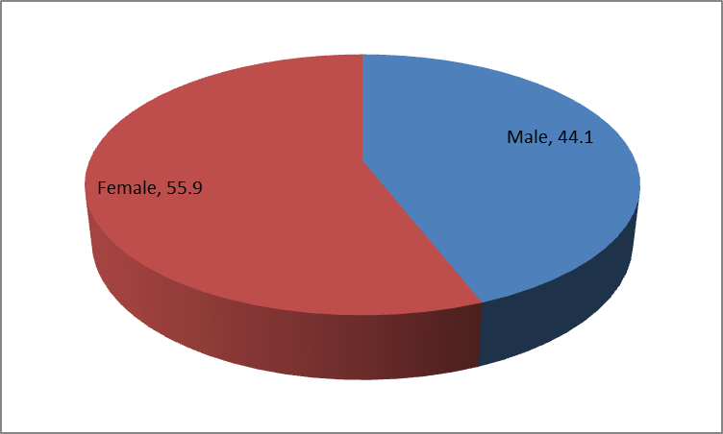

Figure 4.1 Respondents gender

The study found 55.9% of the respondents were female while 44.1% were males. Majority of the respondent were females. The gender aspect is critical to this study and moving forward, incorporating gender responsiveness in the context of effectiveness of Kenya Secondary School Heads Association (KSSHA) national annual conferences as a capacity development activity for secondary school Principals may be vital to the achievement of larger key education objectives. As such, it appears that education policy makers increasingly emphasizing the need for programme planning and evaluation in improving the effectiveness of such conferences.

In establishing carefully planned capacity development programmes in post-primary education, the idea of gender responsiveness is critical. According to Raghavan (2009), gender-responsive programming promotes greater equity by (1) ensuring that the overall needs and interests of both genders are met, (2) effectively incorporating life skills-based strategies for preparing the next generation to make “life-career” decisions, (3) closing potential achievement gaps between the sexes and (4) ensuring access to programmes for upper-level education/college/university-readiness (Raghavan, 2009). The implication for this is that it can contribute to institutionalizing gender mainstreaming in the education system as a whole, and also to achieving and promoting further gender equality in the process of learning/teaching and in education outcomes, either academic or vocational within the Kenya Secondary School Heads Association (KSSHA) national annual conferences.

4.1.2 Age Bracket

The study sought to find out the respondents’ age. Data on the same were collected, analyzed and the findings presented in Figure 4.2 below.

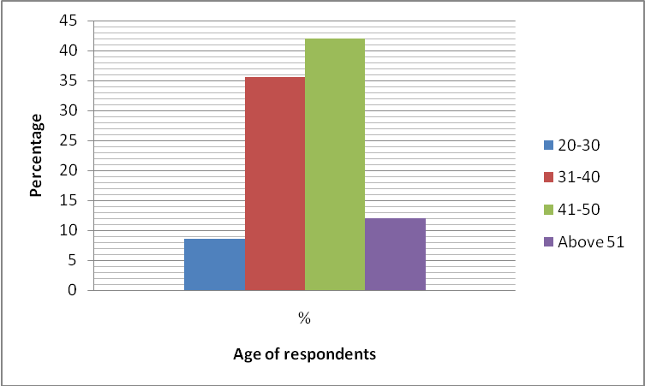

Figure 4.2: Distribution of respondents by age

The results in Figure 4.2 indicate that those in the age bracket of 20-20 years were 8.5%, 31-40 years were 35.5%, 41-50 years were 42% and those above 51 years were 12%. Overall, majority are aged between 31-50 years. Although reports such as United Nations Population Fund (NFPA-Kenya, 2012) indicate that seventy-five per cent of Kenya’s population is less than 30 years of age; it appears that age distribution in the selected schools for the study differs significantly.

In line with secondary school teachers’ perception on the effectiveness of Kenya Secondary School Heads Association (KSSHA) national annual conference as a capacity development activity; the age distribution is of value in the process of meeting the needs of educational aspects in development, such as academic, career, and personal require experts at all levels. Experts agree that professional capacity development programs should be “comprehensive in scope developmental in nature and thus such a varying age bracket would also be important in terms of secondary school teachers’ in life situations.

4.1.3 Education Level
The study sought to establish the education level of the respondents. Data on this question were collected, analyzed. Figure 4.3 presents findings.
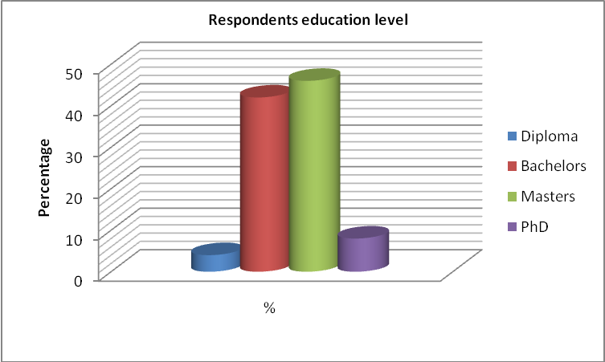

Figure 4.3: Education level

From Figure 4.3, education level of varied considerably. Master degree holders were 42%, and 46% with Bachelor’s degrees. Those with PhD s were 8% while 4% had Diplomas. The results indicated that majority of the teachers had quite a considerable educational background and had gained the requisite experiences to understand the study concept. The reason could also be associated with the fact that secondary schools in

Kenya are currently looking for professionals as a standard practice. In recent years, there has been a tremendous growth of both public and private educational institutions in Kenya. It appears many are taking advantage of these opportunities.

4.1.4 Teaching experience
The study sought to establish the teaching experience of the respondents. Data on various aspects to this question was collected, analyzed and results are displayed in Table 4.1.
CHARACTERISTICS | PERCENTAGE (%)
Number of schools taught
1 | 35.9
2 | 24.1
3 | 13.6
More than 3 | 26.4
TOTAL | 100
Years of experience
1-2 | 5.2
3-4 | 32.4
5-6 | 30.8
Above 6 | 31.6
TOTAL | 100
Years in current school
1-2 | 30
3-4 | 42
5-6 | 22
Above 6 | 6
TOTAL | 100
Number of years under current Principal
1-2 | 36
3-4 | 18
5-6 | 33.5
Above 6 | 12.5
TOTAL | 100
Category of teaching subjects
Sciences /Mathematics | 36.5
Humanities | 42
Technical | 18
Others | 3.5
TOTAL | 100
Table 4.1 Respondents Experience

From the results in Table 4.1, 35.9% had taught in one school, 24.1% in two schools, 13.6% in three schools while 26.4% had taught in more than three schools. Regarding number of years in teaching profession, 5.2% reported 1-2 years, 32.4% between 3-4 years, 30.8% between 5-6 years while 31.6% above six years. The results indicate majority had knowledgeable experience of their duties and roles and school issues. The results agree with a study by Lewis (1999) indicating that length of service greatly determines the extent and nature of employees attitudes toward the various sub-components of organizational programs.

On number of years respondents had taught in current school, the study found that 30% had taught between 1-2 years, 42% between 3-4 years, 22% between 5-6 years. Only 6% had taught for more than six years in their current respective schools. On the other hand, 36% reported serving under one Principal between 1-2 years, 18% between 3-4 years, 333.5% between 5-6 years while 12.5% above 6 years. Regarding subject category, 36.5% reported teaching sciences/mathematics, 42% humanities, 18% technical subjects. Only 3.5% mentioned others.

4.2 Capacity to implement curriculum after conference
The first objective of this study sought determines secondary school teachers’ perception on their Principals’ capacity to implement school curriculum after the conference.

4.2.1 Collaboration among members of staff
The study sought to establish school Principals’ support on collaboration among members of the staff. Results are given Figure 4.4.
Collaborative management style is more productive in a professional environment than one of ‘command and control.’ Recognition of staff matters but that it must be sincere and timely. The family and health of employees must and should come first and when managers honor that, staff will be more productive, more loyal, and more involved in the success of the mission and vision of the organization.
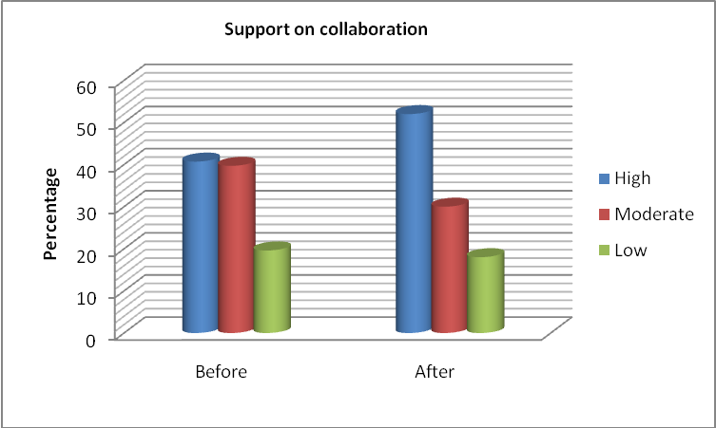

Figure 4.4 Support on collaboration

From the results in Figure 4.4, 40.7% reported high on school Principals’ support for collaboration, 39.7% moderate while 19.6% said low before conference. On the other hand, 52% reported high, 30% moderate whereas 18% said low after conference. A positive school culture makes a huge difference to staff and, consequently, to students. As the New Teacher Center points out, teacher working conditions are student learning conditions. Ignoring staff morale in the push for increased test scores will improve neither of those. The Principal must be the leader of this effort to boost morale and must do so in collaboration with staff. How staff members in a given school set about increasing the level of trust between Principals and teachers will depend to a great degree upon individual circumstances: school size, stability, history, existing relationships among administrators, and so on.

4.2.2 Curriculum implementation programs
The study further sought information on a number of aspects regarding school Principals’ capacity to implement school curriculum after the conference. A three-point Likert scale was used to rate the response. [H-High; M-Moderate; L-Low].

Table 4.2: General supervision

 | Before conference |  |  | After conference
 | H M |  | L (%) H M L %
Soliciting opinion from staff members | 45 | 40 | 15 |  | 52 43.6 4.4
Capacity building among staff | 54.6 | 15.4 | 30 |  | 60 18 22
Praising staff for a job well done | 37.5 | 12.5 | 50 |  | 42.6 16.5 40.9
Ability to relay current information | 52 | 20 | 28 |  | 48 20.8 31.2

From the results, soliciting opinion from staff members was assessed (before conference) with 45%, 40% and 15% who said high, moderate and low respectively. Capacity building among staff varied considerably, with 54.6% high, 15.4% moderate and 30% low. Praising staff for a job well done response was high (37.5%), moderate (12.5%) and low (50%). Moreover, ability to relay current information had 52% who noted high, 20% said moderate while 28% said low.

After conference; soliciting opinion from staff members was assessed (before conference) with 52%, 43.6% and 4.4% who said high, moderate and low respectively. Capacity building among staff varied considerably, with 60% high, 18% moderate and 22% low. Praising staff for a job well done response was high (42.6%), moderate (16.5%) and low 40.9%). Moreover, ability to relay current information had 48% who noted high, 20.8% said moderate while 31.2% said low. From the results, it is evident ability to relay current information dropped.

While most of the above suggestions have been framed in terms of what Principals and other administrators can do, teachers’ role in developing trust with administrators should not be overlooked. Clearly, teachers’ levels of receptivity to and support for Principals’ efforts to improve trust make a difference in how effective they can be. The responsibility for building trust among teachers falls on the shoulders of Principals and teachers alike. Principals can and should take an active role in creating the necessary conditions for teacher relationships that are both collegial and congenial (Sergiovanni, 2012).

According to Tschannen-Moran and Hoy (1998), however, “the behavior of teachers is the primary influence on trust in colleagues” (pp. 348–349). If relationships between teachers are to change significantly, teachers themselves must work to identify barriers to trust within the faculty and take the initiative to improve, repair, and maintain relationships; this may be attributed to varying responses on appraisals for well don jobs and capacity building.

Some places to begin:

Where the appraisal system is poorly communicated, both the staff (teacher) and may enter these discussions with low confidence levels. This is due to a lack of ‘rules’ as to how to go about the appraisal process and a lack of understanding of the expected outcomes. As this process is infrequent, it is viewed by the employee as an opportunity to discuss remuneration, promotion prospects and other issues related to the employee. This means the discussion is dominated by employee content rather than what the manager needs the employee to do for the next year. This leads to vague definition of performance goals and perpetuates the system of poorly defined and executed appraisals.

4.2.3 Modeling effective instruction in school
The study sought respondents rating on of school Principals’ ability to model effective instruction in the school.
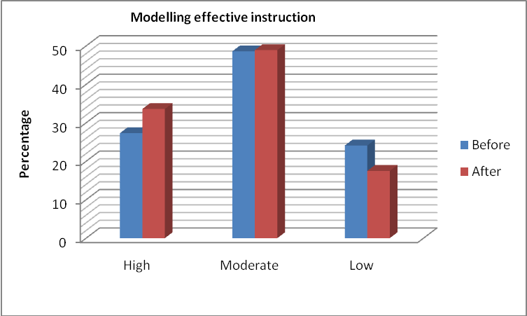

Figure 4.5 Modeling effective instruction

Results revealed 27.3%, 48.6% and 24.1% reporting high, moderate and low respectively before conference. However, 33.6%, 48.9% and 17.5% reported high, moderate and low respectively after conference on school Principals’ ability to moderate effective instruction among staff members.

A survey conducted Gene (2010) identified problems including a lack of communication in a professional manner by stakeholders, including parents and teachers; teachers who were perceived to be “collecting a paycheck” instead of providing challenging classroom instruction; low morale and school spirit; frustration and distrust; and interpretation of policies differently at each school. Indeed, it appears school leaders role in working on knowledge on modeling effective instruction is still a work in progress. This could be attributed to a clear understanding of conditions that will enable teachers to use these methods. The need to understand the amount of time it takes to plan effectively because good instruction requires good planning (Gene, 2010).

4.2.4 Ability to provide Feedback
Further investigation and analysis was done to rate the extent to which school Principal gave feedback to members of staff.
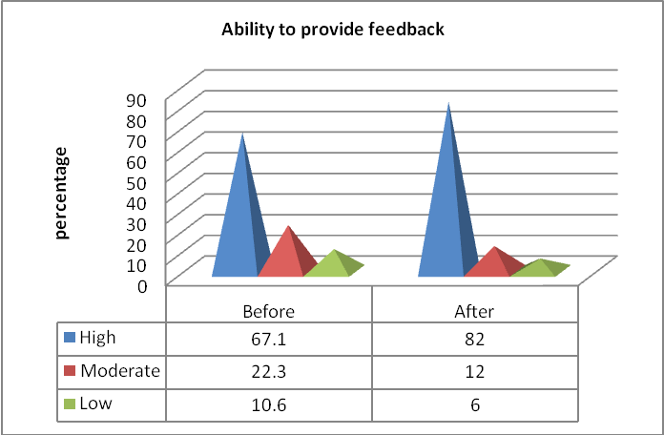

Figure 4.6 Principals ability to provide feedback

From the results in Figure 4.6, Principals’ ability to provide feedback scored high (67.1%), moderate (22.3%) and low (10.6%) before conference. The rating changed considerably after conference at 82% who said high, 12% said moderate while 6% said low.

Communication is the lifeblood of any organization. The need for effective internal communication systems is particularly crucial when organizations, such as schools, are operating in a turbulent environment of rapid and sustained change. Schools must be innovative to be able to respond and adapt to the challenges presented by such changes. It is now increasingly evident that those organizations which promote good internal communication reap positive dividends in meeting these challenges. However, there is a need for hard data on the nature, structure, flow and practice of communication to ensure that the most effective systems are put in place and are working to the optimal level. From the results, the varying trend in the ability to provide feedback could be due to lapses in methods of investigation, the communication audit.

4.2.5 Ability to provide suggestions
Respondents were asked to rate school Principal’s ability to give suggestions to the members of staff.

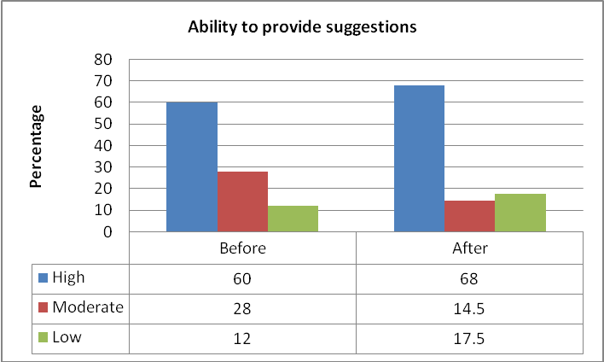

Figure 4.7 Ability to provide suggestions

Results revealed relatively low shift before and after conference with 60% and 68% high before and after respectively; 28% and 14.5% before and after said moderate respectively whereas 12% and 17.5% said low before and after conference respectively. Effective leaders provide opportunities for teachers to strengthen their subject-matter knowledge while learning new research-based, student-centered instructional strategies.

Although the ability to provide suggestions is relatively effective, there are gaps related to school Principals’ willingness to make follow-up an integral part of staff development with teams of trained teachers being allowed to try new strategies, refine their skills and share their knowledge with other teachers.

4.2.6 Teaching mechanism in subjects of specialization
The study also sought information on school Principals’ ability to teach their subjects of specialization.

Table 4.4: Ability to teach in subjects of specialization

Characteristic |  | H M L (%)
Before conference |  | 45 20 35
After conference |  | 48 36 16

Ability to teach in subjects of specialization scored high (45%), with 20% moderate and 35% low response. Conversely, 48%, 36% and 165 noted high, moderate and low respectively after conference. There are many useful ways of measuring performance which take account of the school’s circumstances and seek to measure the value added dimension. The Principal has a role to decide which key indicators they wish to monitor and make arrangements for the Principal to provide the appropriate data at suitable times. School improvement is most likely to be sustained over time, when a school establishes a positive culture and commitment to professional growth; but most importantly, the ability of Principals to teach in subjects of specialization may act as a benchmark to identify and address areas for improvement in their (staff) work.

4.3 Capacity to supervise school staff after the conference
The second objective sought to establish secondary school teachers’ perception on their Principals’ capacity to supervise school staff after the conference. Various aspects on the same were analyzed and results presented in the sections underneath.

4.3.1 Ability to adhere to the syllabus
Respondents were asked to rate school Principal’s effectiveness in ensuring that teachers adhere to the syllabi.
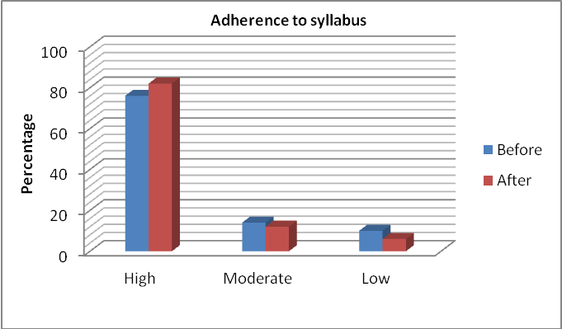

Figure 4.8 Adherence to syllabi

On adherence to syllabi, the study revealed 82% and 76% who said high before and after conference respectively; 12% and 14% moderate before and after respectively. Those who said low were 6% and 10% before and after conference respectively. While the core purpose of the Principal is to provide professional leadership and management for the school; be the leading professional in the school; work with others to secure the commitment of wider community to the school; and create a productive learning environment that is engaging and fulfilling for all pupils, drawing on the support of the school community- ability to adhere to the syllabus is a key factor.

4.3.2 General supervision
The study further sought information on a number of aspects regarding supervision by school Principal. A three-point Likert scale was used to rate the response.
[H-High; M-Moderate; L-Low]

Table 4.5: General supervision by Principals

 | Before conference |  |  | After conference
 | H M |  | L(%) | H M L
Monitoring and checking lessons | 60 | 5 | 15 |  | 80 6 14
Maintaining conducive learning environment | 45 | 35 | 20 |  | 36.5 32 31.5
Engaging colleagues on classroom activities | 45.8 | 36.2 | 18 |  | 48 42 10
Support for teacher concerns | 42 | 33.5 | 24.5 |  | 58 36 6
Before conference, monitoring and checking lessons show 60% high, 55 moderate and 15% low. Maintaining conducive learning environment revealed 45% high, 35% moderate and 20% low. Engaging colleagues on classroom activities had 45.8%, 36.2% and 18% for high, moderate and low rating respectively. Support for teacher concerns was rated high (58%), moderate (36%) and low (6%).

After conference, monitoring and checking lessons show 80% high, 6 moderate and 12% low. Maintaining conducive learning environment revealed 36.5% high, 32% moderate and 31.5% low. Engaging colleagues on classroom activities had 48%, 42% and 6% for high, moderate and low rating respectively. Support for teacher concerns was rated high (42%), moderate (33.5%) and low (22.5%).
High stress levels for both Principals and staff also become a factor. They both know they will be judged on the outcome of the appraisal and the fallout is often destructive rather than constructive. The reasoning behind this is that there are rarely any pre-defined measures or objectives and the employee review is not based on any considered evaluation criteria. The staff’s remuneration and future are at stake and the goodwill of the managers future resources are also at stake. This leads to high stress in the case of both individuals and this is a poor emotional state in which to have a thorough discussion about employee performance. These factors may challenge the ability to engage colleagues on classroom activities.
From the results, maintaining conducive learning environment revealed 45% high, 35% moderate and 20% low before conference and 36.5% high, 32% moderate and 31.5% low after conference. School culture defines how teachers teach, how students learn, how people in the school system get along together and how much success is achieved in attaining school goals through the school head’s instructional leadership. Dean (2002: 10) regards school culture as a strong undercurrent, which flows beneath the surface, giving meaning to and shaping the daily choices and priorities of school activities. Results reveal existing gaps regarding engaging colleagues on classroom activities and support for classroom concerns. It is therefore essential that school leaders transform their school culture in order to enhance teaching and learning so that they become ingrained parts of daily school life.

4.3.3 Support structures of classroom concerns
The study sought to establish support for classroom concerns. Results are presented below.
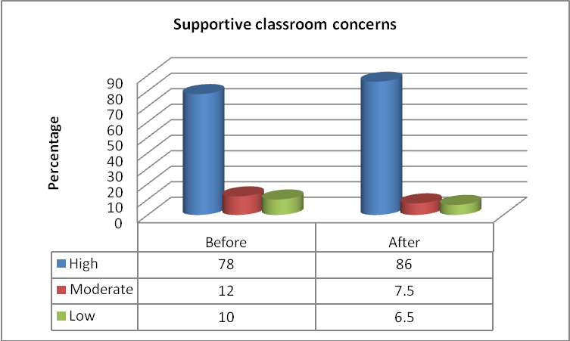

Figure 4.9 Support on classroom concerns

Regarding supportive structures on classroom concerns, 78%, 12% and 10% reported high, moderate and low respectively before conference. On the other hand, 86%, 7.5% and 6.5% reported high, moderate and low respectively after conference. Support structures of classroom concerns can provide an opportunity for practitioners to raise any concerns that they might have about children in their care and to receive support to help them deal with difficult or challenging situations at work. Nevertheless, the extent of such programs may be attributed to effective supervision, coaching and training which could explain the varying trends in the responses. Supervision should provide opportunities for staff to discuss any issues particularly concerning students ‘development or well-being, identify solutions to address issues as they arise and receive coaching to improve on their personal effectiveness (Linda and Brunton,2010).

4.3.4 Demonstration of knowledge on curricula issues
The study sought to establish clear demonstration of knowledge on curricula issues. Results are given in Figure 4.10.
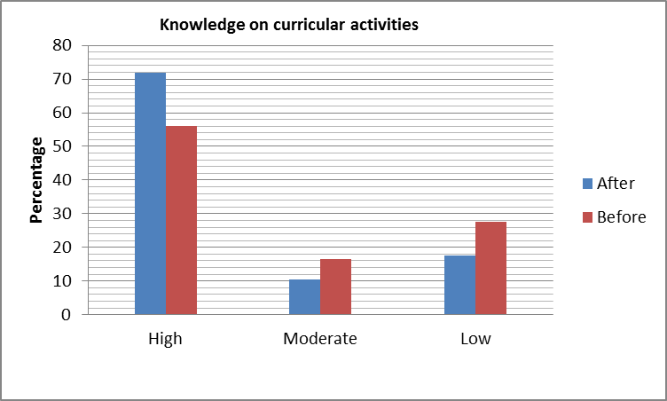

Figure 4.10 Knowledge on curricula issues

Results in Figure 4.10 show 56%, 16.5% and 27.5% high, moderate and low respectively (before conference); 72%, 10.5% and 17.5% said high, moderate and low respectively (after conference). School leaders need not be experts but they should know enough to determine whether students are being taught the body of knowledge, the understandings and the skills that they are expected to learn in the core curriculum. The results could be attributed to the nature of assessment which influence measure on effectiveness as well as student learning.

4.3.5 Assistance on curricular implementation

Table 4.6: Assistance on curricular implementation

Characteristic |  | H M L (%)
Before conference |  | 65.2 22 12.8
After conference |  | 75 22.5 2.5

On assistance on curricular implementation before conference, results revealed rating at high (65.2%), moderate (22%) and low (12.8%). Results show 75% high, 22.5% moderate and 2.5% low after conference. Exemplary teachers can deliver model lessons and invite other teachers to observe instruction in the classroom. They should also understand the school and classroom conditions that contribute to higher expectations and they need to be able to recognize whether such a culture exists in a classroom and to assist teachers (through mentors or other approaches) to expect more of students. As observed earlier, capacity building can provide an effective strategy for assistance on curricular implementation.
It has been found out that teachers do not for the most part, provide training or practice in critical thinking, problem solving, decision making or other process skills. In fact, the view that teachers should devote attention and time to teaching students how to think around concepts is popular among many educators today (Savage & Armstrong, 2000). It could be that conferences provide a good platform on curricular implementation, although more training is needed owing to the response who rated ‘moderate’ at 22% and 22.55 before and after the conference respectively.

4.3.6 Effective timetable implementation and planning
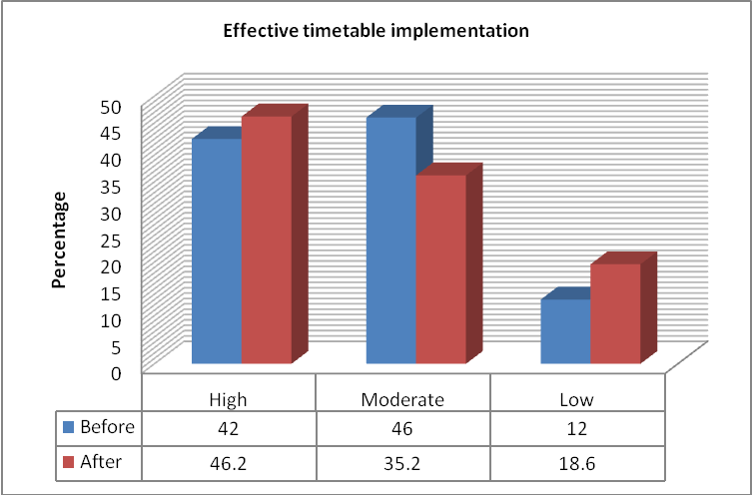

Figure 4.11 Effective timetable implementation
Results show 42% said high, 46% moderate while 12% low before conference. However, 46.5% said high, 35.2% moderate while 18.6% low after conference. Gene Bottoms noted that effective leaders provide opportunities for teachers to strengthen their subject-matter knowledge while learning new research-based, student-centered instructional strategies. He opined that the best staff development combines content knowledge and instructional methods.

4.4 Capacity to manage school finances after the conference
The third objective of the study sought to determine secondary school teachers’ perception on their Principals’ capacity to manage school finances after the conference. Results on various aspects are discussed as follows:

4.4.1 School budgeting
The study sought to establish the nature of school Principals’ capacity to budget for the school.

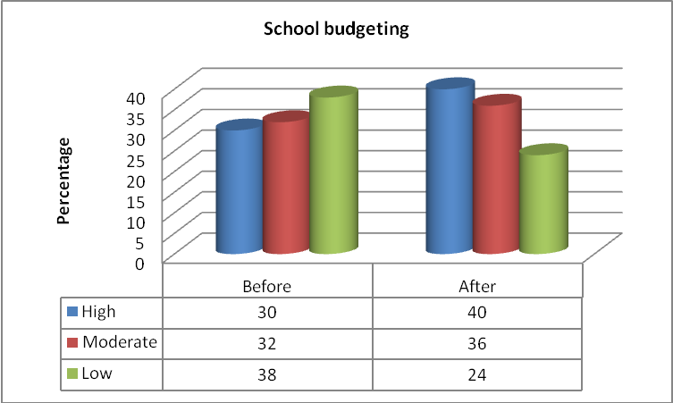

Figure 4.12 Principals ability on school budgeting

On school budgeting, results revealed 30% low, 32% moderate, 38 % low before conference. Varying results were observed after conference, 40% said high, 36% moderate while 24% said low. According to the Institute of Policy Analysis and Research (2007), this responsibility necessitates regular capacity building programs to improve their knowledge and skills on accounting and book-keeping procedures, supervision of accounts staff, budgeting, expenditure management and tendering procedures.

4.4.2 Resource mobilization for school development
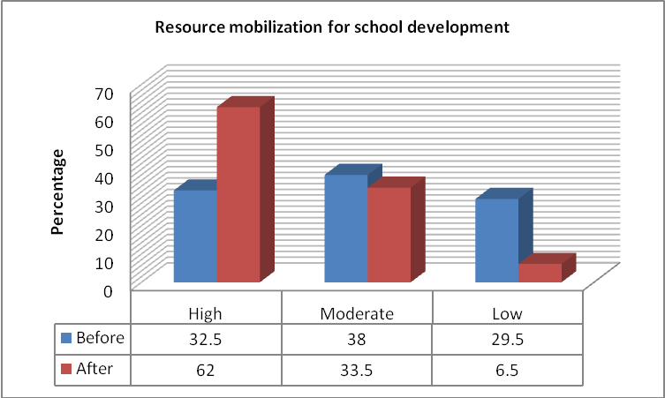
Figure 4.13 Resource mobilization

On Principals’ ability to mobilize resources for school development, results revealed 32.5% high, 38% moderate, 29.5% low before; whereas after conference, 62% said high, 33.5% moderate while 6.5% said low. Generally, schools or a financial service provider use a financial management software package. Keeping the accounts involves, therefore, a data entry process so that all your necessary reports are easily generated. In small schools, it can be tempting to save money by doing the data entry yourself, but this is neither a safe nor sensible practice.

Organizations require financial management solutions that balance functionality with ease of use. They require solutions that are flexible to accommodate customizations and expandable to meet future needs and accommodate growth. The best financial management solutions go beyond the basics of planning, budgeting, accounting, and managing cash flow, so organizations can extract added value from financial data to help decision-makers better guide operations. They need the ability to explore their own data to extract insights for strategic planning and to provide reliable financial forecasts. It could be that the existing gaps in adopting an integrated, adaptable software solution that can quickly and easily provide multiple iterations of forecasts and budgets, enable user-defined forecast rules are insufficient and thus an implication for the varying responses.

4.4.3 General school financial management
Further investigation on school financial management was done using a three-point Likert scale to rate the responses; [H-High; M-Moderate; L-Low].
 | Table 4.7 School financial management:
 |  | Before conference |  |  | After conference
 |  | H M |  | L (%) | H M L (%)
Capacity to collect fees from parents |  | 77.5 | 10 | 12.5 | 80.6 16.9 2.5
There is effective resource management |  | 78 | 15 | 7 | 68 20 12
Proper accounting of expenditure |  | 80 | 5 | 10 | 80 4 16
Effective school budgeting |  | 10 | 12 | 78 | 22 36.5 41.5
Source: Author

On whether Principal shows capacity to collect fees from parents, results showed 77.5% who said high, 10% said moderate while 12.5% said low before conference. On effective resource management, 78% said high, 15% said moderate while 7% said low. Proper accounting of expenditure (receipts) accounted for high (80%), moderate (5%) and low (10%). Principal ability to display effective school budgeting was rated at low (78%), moderate (12%) and 10% high.

After conference, results on whether Principal shows capacity to collect fees from parents, results showed 80.6% high, 16.9% said moderate while 2.5% said low. On effective resource management, 68% said high, 20% said moderate while 12% said low. Proper accounting of expenditure (receipts) remained the same for high (80%), moderate (4%) and low (16%). Principal ability to display effective school budgeting was rated at low (41.5%), moderate (36.5%) and 22% high.

From the results, it’s clear that the conference effectively played a key role on the Principals’ to display effective school budgeting. Proper accounting of expenditure (receipts) seems to have had an insignificant change even after the conference, revealing existing gaps in school financial management systems.

Principals play the most crucial role in ensuring schools’ effectiveness and performance. Without the necessary skills and competencies, many heads are overwhelmed by this enormous task. In most of the developing countries, Principals have hardly any formal managerial and leadership training and most of them are appointed on the basis of their teaching record other than their leadership potentials. Induction and support are usually limited and Principals have to adopt a pragmatic approach of leadership. Despite their poor managerial and leadership training, Principals often work in poorly equipped public secondary schools with inadequately trained subordinate staff in the finance department (Kaosa, 2010).

4.4 Capacity to motivate school staff after the conference
The fourth objective of the study sought to establish secondary school teachers’ perception on their Principals’ capacity to motivate school staff after the conference.

4.5.1 Fair treatment of staff
The study sought a rating from the teachers concerning school Principal fair treatment of different members of staff. Results are presented below. Employees, volunteers who donate their time and efforts for good causes, expect causes; expect to receive rewards of some sort for their contributions. Managers have found that rewards play a significant role in motivating employees to work harder and longer. This section, therefore, attempts to identify the numerous types for rewards that can be administered by managers.
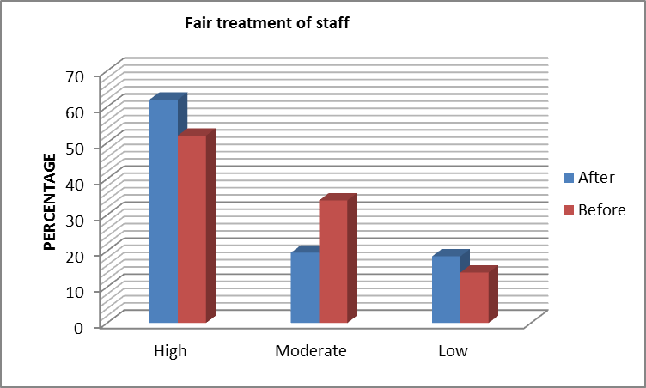

Figure 4.14 Fair Treatment of staff

From Figure 4.14, results show majority (52%) said high, 34% said moderate while 14% said low before conference. On the other hand, 62% said high, 19.5% moderate while 18.5% said low after conference.
Considering the fact that the average adult spends half of their waking lifetime at work, to effectively motivate them no longer relies on the importance of money or other material objects. As jobs are the central feature of ‘modern existence’, feelings of having a challenging and interesting work can attach people to their jobs whereas a boring and tedious job, on the other hand, can become a serious obstacle to motivating people, not to mention the effect it has on an individual’s physical and mental health. This is when job design comes in to deepen a good manager’s understanding and persuade them to adopt different approaches of dealing with employee mediation rather than the typical approach of motivating people through financial means.
Schools are judged as successful if purposeful teaching and learning occur. However, the type of environment conducive to teaching and learning is often not achieved because of the interplay of internal and external factors that tend to create a negative or positive perception of learning amongst students. Harris (2007: 1) notes that the experience of school leaders, teachers and students in recent decades has been affected directly by a range of external factors, which have fundamentally altered the character and nature of schooling.

Although results show fair treatment of staff show some improvement, the percentage of those who noted moderate (34% before conference) and 19.5% after conference) revela some organizational gaps. In this regard, a supportive and positive culture of teaching and learning is needed to effect reforms that can result in school effectiveness.
4.5.2 Staff motivation mechanisms
A three-point Likert scale was used to rate respondents rating on a number of aspects regarding school Principals’ capacity to motivate school staff after the conference: [H-High; M-Moderate; L-Low].

 | Table 4.8 Staff motivation mechanisms
 |  | Before conference |  | After conference
 |  | H M | L (%) | H M L
 |  | 68 10 | 22 | 72 14.6 13.4
Principal assigns extra work for performance |  | 58 30 | 12 | 58 36 6
Principal makes staff work more interesting  Principal encourages staff promotion  Staff involved in decision-making |  | 64 14  52 27.4  50.6 12.9 | 22  20.6  36.5 | 52 20 28  36 28.2 35.8  60 14 26
Source: Author

Before conference; Principal rewards staff for hard work scored high with 68% high, 10% moderate and 22% low. Regarding Principal ability to assign extra work to improve performance, 58% said high, 30% moderate while 12% low. Based on Principals’ ability to make staff work more interesting, 64% rated high, 14% moderate and 22% low. On whether a Principal encourages staff promotion, 52% rated high, 27.4% moderate while 20.6% said low. Staff involvement in decision-making was ranked at 50.6% high, 12.9% moderate and 35.5% low.

After conference; Principal rewards staff for hard work scored high with 72% high, 14.6% moderate and 13.4% low. Regarding Principal ability to assign extra work to improve performance, 52% said high, 20% moderate while 28% low. Based on Principals’ ability to make staff work more interesting, 64% rated high, 14% moderate and 22% low. On whether a Principal encourages staff promotion, 36% rated high, 28.2% moderate while 35.8 % said low. Staff involvement in decision-making was ranked at 60% high, 14% moderate and 26% low.

From the results’ ability to make staff work more interesting and encourage staff promotion scored low after conference. The Elton Report (1989, cited in Bowora and Mpofu, 2000:113), notes that the most effective schools seem to be those that succeed in creating a positive atmosphere for teaching and learning based on a sense of community and shared values. Nkobi (2008: 472) argues that school heads as instructional leaders play a fundamental role to ensure the quality of education by improving teacher competencies for enhanced learner performances. The indirect effect of school effectiveness on student outcomes actually has a direct impact on instructional leadership because cultural dimensions tend to influence effective learning (Van der Westhuizen, Mosoge and van Vuure: 2004: 705).

Staff motivation organization attempts to unlock the creative potential of its people of its people by involving them in decisions affecting their work lives. The standardized and normal work life starts from 8 am to 5 pm, 40 hours a week: things started to be different when Flexible work schedule were introduced. Flextime is a work-scheduling plan that offers employees the chance to determine their own arrival and departure times within specified limits. All employees must be present during a fixed time. To achieve the ultimate effect of participative management, some barriers are need to be overcome and decision-making process that included staff members could be a major factor as well.

4.5.3 Freedom to set departmental goals
Further investigation was made to establish respondents rating on school Principal allowing members of the staff to set goals for their departments.

Table 4.9: Freedom to set departmental goals

Characteristic |  | H M L (%)
Before conference |  | 40 32 28
After conference |  | 60 32.5 7.5

Before conference, the rating ffreedom to set departmental goals was at 40% high, 32% moderate and 28% low. After conference, results revealed a shift to 60% high, 32.5% moderate and 7.5% low.
Byrnes and Baxter (2006:1) assert that there is a pull between their roles as managers and visionary leaders that school heads today experience as they find themselves balancing the expectations of the school board, teachers, students, parents, and the central administration.
Van der Westhuizen, Mosoge and Van Vuuren (2004:705) argue that a number of school headss have been rendered ineffective by the wide-range of changes taking place in the education system. Against such a changing scene in schools and the accountability issues discussed above, heads of high schools have to embrace their roles as change agents and instructional leaders in order to develop a school culture and classroom practices that value student and instructional diversity. School Principal’s ability to allow members of the staff to set goals for their departments seems to be one way to respond to the changing face of schooling discussed above.

4.5.4 Staff involvement to solve work-related problems
The researcher in this question sought to establish respondents rating on how school Principal on involved members of staff in solving problems related to their work. However change, even organizational change is a choice.
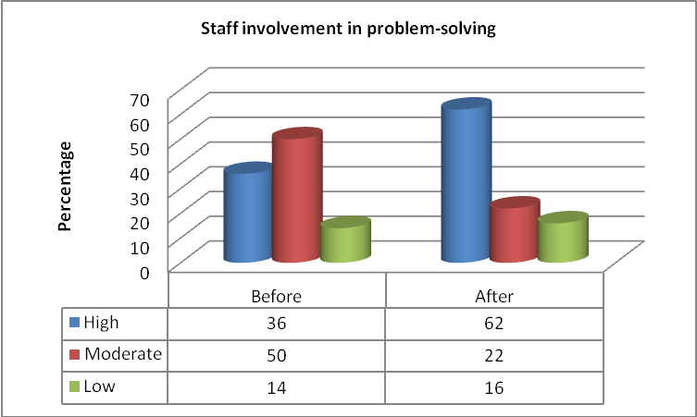

Figure 4.15 Staff involvement in problem-solving

Figure 4.15 indicates majority (50%) said moderate, 36% high while 14% reported low staff involvement before conference. However, 62% said high, 22% moderate and 16% low after conference. Organizational change efforts can bring about a range of outcomes: some intended, such as organizational survival and profitability, and some unintended, such as heightened levels of organizational change cynicism among employees.
Principals can encourage their staff to adopt a participatory style of management (information sharing, involvement in decision making), especially in those workplaces where employees are more likely to embrace the opportunities for involvement in problem-solving. Direct staff involvement in any organizational change is critical to proper implementation. When change is in the planning stages, a list of departments that will be affected by the alterations should be compiled. Every person affected by the change, will make decisions that influence the success and sustainability of your change. To enable sustainable change Principals may need to recognize the type of decisions made during change, where they are made within departments, and create a structure of involvement that facilitates decision-making at the right level, by the right people, at the right time.

CHAPTER FIVE

SUMMARY OF MAJOR FINDINGS, CONCLUSIONS AND RECOMMENDATION

5.0 Introduction
This chapter presents a summary of major findings derived from the previous chapter, conclusions, recommendations and suggestions for further research based on the results of the study. The findings were thematically based on the objectives of the study.

5.1 Summary
The purpose of this study was to establish secondary school teachers’ perception on the effectiveness of Kenya Secondary School Heads Association (KSSHA) national annual conference as a capacity development activity for secondary school Principals.
The summary of the study was informed by the objectives below:
- To determine secondary school teachers’ perception on their Principals’ capacity to implement school curriculum after the conference.
- To establish secondary school teachers’ perception on their Principals’ capacity to supervise school staff after the conference.
- To determine secondary school teachers’ perception on their Principals’ capacity to manage school finances after the conference.
- To establish secondary school teachers’ perception on their Principals’ capacity to motivate school staff after the conference.

Collaborative management style is more productive in a professional environment than one of ‘command and control.’ Capacity building among staff varied considerably, with 54.6% high, 15.4% moderate and 30% low. An appraisal for well done jobs response was high. Although the ability to provide suggestions is relatively effective, there are gaps related to school Principals’ willingness to make follow-up an integral part of staff development with teams of trained teachers being allowed to try new strategies, refine their skills and share their knowledge with other teachers.

On school budgeting, results revealed 30% low, 32% moderate, 38 % low before conference. Varying results were observed after conference, 40% said high, 36% moderate while 24% said low. On Principals’ ability to mobilize resources for school development, results revealed 32.5% high, 38% moderate, 29.5% low before; whereas after conference, 62% said high, 33.5% moderate while 6.5% said low. Generally, schools or a financial service provider use a financial management software package.

5.2 Conclusions
The implication of the present study should be a strengthened motivation for empirical focus and methodological developments in assessing teachers’ perception on the effectiveness of Kenya Secondary Schools Heads Association (KSSHA) national annual conferences; and especially within the context of implementation of school; staff supervision; management of school finances and staff motivation. A second implication should be a critical stand in relation to existing challenges and arguments of the role of KSSHA; while putting perception into consideration.

From the summary, the study established the following conclusions:
Communication is the lifeblood of any organization. The need for effective internal communication systems is particularly crucial when organizations, such as schools, are operating in a turbulent environment of rapid and sustained change.

School leaders need not be experts but they should know enough to determine whether students are being taught the body of knowledge, the understandings and the skills that they are expected to learn in the core curriculum.

Organizations require financial management solutions that balance functionality with ease of use. They require solutions that are flexible to accommodate customizations and expandable to meet future needs and accommodate growth.

Organizational change efforts can bring about a range of outcomes: some intended, such as organizational survival and profitability, and some unintended, such as heightened levels of organizational change cynicism among employees.

5.3 Recommendations
Recommendations made in this section were derived from the conclusions about the study findings as presented in the previous section and focus on the direct interventions. It is the view of the researcher that the recommended solutions could help develops a strong and effective Kenya Secondary School Heads Association (KSSHA).
In effect, the following suggestions were made after research findings and discussions:
- Support: There is need for school Principals to identify strategies for implementing curriculum development by enhancing decision-making process among staff. In some cases, school Principals feel threatened to adopt programs practices from other institutions and prefer their own-grown programs which may not be effective in the long run. Therefore, Principals should be trained in curriculum implementation and planning to better understand what it entails so that they don’t feel threatened from borrowing best practices from other institutions.
- Organisational capacity plays an important contribution in any program implementation process. There is need for Principals to enhance decision-making process, change management and culture change in c\schools to ensure that service delivery relating to matters of supervision are well coordinated and effective. At the same time, appropriate institutional structures that ensure multidisciplinary teamwork among staff should be considered.
- Training: The significance of finance management is schools can be achieved through appropriate institutional measures that ensure that Principals, staff members, students and parents, including the community work towards a common interest. Therefore, the government should create mechanisms that enhance trust while implementing school resource mobilization programs. Moreover, there is need for implementing a more holistic approach to building awareness and training on the importance of effective financial management among school administrators.
- Policy: The study highlighted a number of gaps related to staff motivation. Moving forward, the government and education stakeholders should come up with initiatives to improve access to facilities and equipment to ensure effective programs in all schools. Existence of plans for availability of safe spaces and physical settings in schools should be re-evaluated as a measure to motivate teachers and assure a conducive working environment.

5.4 Suggestions for Further Research
The researcher recommends key areas as follow-ups to the current study. In effect, the following suggestions were made after research findings and discussions:
- The need for inclusive approach in training techniques is a critical component. The study identified certain gaps and therefore a study on how training affects implementation of school programs is required.
- A study on financial management vis-s-vis training is needed in other Counties for comparison purposes. A study on how motivational factors influence performance among schools is also needed.

REFERENCES

Atsenga M (2002) Factors affecting the teaching of oral communication in English language in secondary schools of Kakamega and Vihiga districts of Kenya. Unpublished M.Ed Thesis,Egerton University,Njoro.
Chubb J, Moe J (1990). Politics, markers and America’s schools, Washington D.C.:The Brooks Institution. P11
DeCenzo D, Robbins S (1982). Personnel/Human Resource Management, New Delhi: Prentice Hall of India.
Fuller B (1986). Raising school Quality in Developing Countries: What investments Boost learning, p.20.Washngton D.C.: The World Bank.PP34
Githae M (1996). A study of mental health states of students in secondary schools in Nyandarua District. Unpublished PGDE Report, Egerton University, Njoro.
Government of Kenya (1999). Totally intergrated quality education and training. Nairobi: Government Printers.
Indoshi FC (1992). “Implementation of Agriculture curriculum in Eldoret Municipality” Unpblished M Phil thesis Moi niversity,Eldoret.
Karugu A.M. (1982). Primary school of leadership in Kenya:a study of teachers view on promotion. Nairobi: Bureau of educational research, Kenyatta University p41.
Mugenda A and Mugenda D (1999). Research Methods; Quantitative qualitative research ; Nairobi ;Act Press.
Muya M (1994). “Proper management of teachers”,Daily nation,.Nairobi,Janary 21.
Nceeri D (1996). An investigation into the methods used in teaching business education in Samburu District. Unpublished PGDE Report Egerton University, Njoro.
Ngala BJAF (1997). Management of teachers by head teachers and its influence on pupil academic achievement: a case a study of Eldoret municipality primary schools in Kenya ,pp.92 103, Unpblished MPhil thesis Moi University,Eldoret.
Nyangarora L (1996). Factors affecting economics in Nyamira district of Kenya, Unpublished PGDE Report, Egerton University, Njoro.
Oriosky et al. (1984). Education Administration Today. Colmn bus: Charles E.Merril Publishing Company. Pp 73
Owens R (1987) Effective Management in Primary Schools ,Oxford: Allan Blackwell Ltd
Pomerantz, J. R. (2013). Perception: Overview". In: Lynn Nadel (Ed.), Encyclopedia of Cognitive Science, Vol. 3, London: Nature Publishing Group, pp. 527–537.
Sayer J (1989). Managing Schools. London: Hodder & Stoughton Publishers. P 74.
Shiundu J.S., Umulando S. J (1991). Curriculum: Theory and Practice in Kenya, p.232 Nairobi: Oxford University Press. P 232.
Wekesa G.W. (1993). The impact of head teachers’ instructional leadership on student academic achievement, Unpublished PhD dissertation, Teachers college, Columbia University.

APPENDIX 1: QUESTIONNAIRE FOR DEPUTY PRINCIPALS

Instructions. Please mark with an (x) or (tick) in the box with the appropriate response. Mark one box only.

PART A: GENERAL INFORMATION
- What is your gender?
Male [ ] Female [ ]
- In which age bracket can you be categorized?
20 – 30 [ ] 31 – 40 [ ]
41 – 50 [ ] 51 – 60 [ ]
- Highest level of education attained.
Diploma [ ] Bachelors [ ]
Masters [ ] PHD [ ]
- How many schools have you taught?
One [ ] Two [ ]
Three [ ] More than three [ ]

5. How many years of experience do you have working as a teacher?
1-10 [ ] 11-20 [ ]
21-30 [ ] 31-40 [ ]
6. How many years experience do you have working as a teacher at this school?
0-2 [ ] 3-4 [ ]
5-6 [ ] Above 6 [ ]

7. How many years did you spend as a classroom teacher before you became a deputy Principal?
0- 2 [ ] 3-4 [ ]
5-6 [ ] Above 6 [ ]
8. How many years did you spend as a class room teacher before you became a head of department?
0-2 [ ] 3-4 [ ]
5-6 [ ] Above 6 [ ]

9. In which category do your teaching subjects fall?
Sciences and Mathematics [ ] Humanities [ ] Technical[ ] Others [ ]

11. How many years experience do you have working as a deputy Principal at this school?
0-2 [ ] 3-4 [ ]
5-6 [ ] Above 6 [ ]

12. How long have you served as a teacher under the current Principal?
0-2 [ ] 3-4 [ ]
5-6 [ ] Above 6 [ ]

PART B: CURRICULUM IMPLEMENTATION
- How do you rate your school Principal on supporting collaboration among members of the staff?
Before conference | After conference
- High [ ]  - Moderate [ ]  - Low [ ] | - High [ ]  - Moderate [ ]  - Low [ ]

- How do you rate your school Principal on soliciting of opinions from the members of staff?
Before conference | After conference
- High [ ]  - Moderate [ ]  - Low [ ] | - High [ ]  - Moderate [ ]  - Low [ ]

- How do you rate your school Principal on the encouragement of capacity building among the members of staff?
Before conference | After conference
- High [ ]  - Moderate [ ]  - Low [ ] | - High [ ]  - Moderate [ ]  - Low [ ]

- How do you rate your school Principal on praising members of staff for a job well done?
Before conference | After conference
- High [ ]  - Moderate [ ]  - Low [ ] | - High [ ]  - Moderate [ ]  - Low [ ]

5. How do you rate your school Principal on ability to provide current information to the members of staff?
Before conference | After conference
- High [ ]  - Moderate [ ]  - Low [ ] | - High [ ]  - Moderate [ ]  - Low [ ]

6. How do you rate your school Principal on modeling effective instruction in the school?
Before conference | After conference
- High [ ]  - Moderate [ ]  - Low [ ] | - High [ ]  - Moderate [ ]  - Low [ ]

7. How do you rate your school Principal on giving feedback?
Before conference | After conference
- High [ ]  - Moderate [ ]  - Low [ ] | - High [ ]  - Moderate [ ]  - Low [ ]
8. How do you rate your school Principal on giving suggestions to the members of staff?
Before conference | After conference
- High [ ]  - Moderate [ ]  - Low [ ] | - High [ ]  - Moderate [ ]  - Low [ ]

9. How do you rate your school Principal on teaching his/her subjects of specialization?
Before conference | After conference
- High [ ]  - Moderate [ ]  - Low [ ] | - High [ ]  - Moderate [ ]  - Low [ ]

PART C: STAFF SUPERVISION
- How do you rate your school Principal on ensuring that teachers adhere to the syllabi?
Before conference | After conference
- High [ ]  - Moderate [ ]  - Low [ ] | - High [ ]  - Moderate [ ]  - Low [ ]

- How do you rate your school Principal on checking of teachers’ lesson notes and giving of advice where necessary?
Before conference | After conference
- High [ ]  - Moderate [ ]  - Low [ ] | - High [ ]  - Moderate [ ]  - Low [ ]

3. How do you rate your school Principal on maintaining school climate that is conducive to teaching and learning?
Before conference | After conference
- High [ ]  - Moderate [ ]  - Low [ ] | - High [ ]  - Moderate [ ]  - Low [ ]

4. How do you rate your Principal on regular evaluation of teachers’ instructional methods and makes contributions without being judgmental?
Before conference | After conference
- High [ ]  - Moderate [ ]  - Low [ ] | - High [ ]  - Moderate [ ]  - Low [ ]

5. How do you rate your school Principal on talking with teachers as colleagues and discussing class room activities with them?
Before conference | After conference
- High [ ]  - Moderate [ ]  - Low [ ] | - High [ ]  - Moderate [ ]  - Low [ ]
6. How do you rate your school Principal on supporting classroom concerns of teachers?
Before conference | After conference
- High [ ]  - Moderate [ ]  - Low [ ] | - High [ ]  - Moderate [ ]  - Low [ ]

7. How do you rate your Principal on demonstration of knowledge of curricular issues?
Before conference | After conference
- High [ ]  - Moderate [ ]  - Low [ ] | - High [ ]  - Moderate [ ]  - Low [ ]

8. How do you rate your school Principal on assisting teachers in curriculum implementation?
Before conference | After conference
- High [ ]  - Moderate [ ]  - Low [ ] | - High [ ]  - Moderate [ ]  - Low [ ]

9. How do you rate your school Principal on teaching his/her subjects of specialization?
Before conference | After conference
- High [ ]  - Moderate [ ]  - Low [ ] | - High [ ]  - Moderate [ ]  - Low [ ]

10. How do you rate your school Principal on ensuring that the right subjects appear on the school time table?
Before conference | After conference
- High [ ]  - Moderate [ ]  - Low [ ] | - High [ ]  - Moderate [ ]  - Low [ ]

PART D: SCHOOL FINANCE MANAGEMENT
1. How do you rate your school Principal on his/her capacity to budget for the school?
Before conference | After conference
- High [ ]  - Moderate [ ]  - Low [ ] | - High [ ]  - Moderate [ ]  - Low [ ]

2. How do you rate your school Principal on his/her capacity to mobilize resources for school development?
Before conference | After conference
- High [ ]  - Moderate [ ]  - Low [ ] | - High [ ]  - Moderate [ ]  - Low [ ]

3. How do you rate your school Principal on his/her capacity to collect school fees from parents/guardians?
Before conference | After conference
- High [ ]  - Moderate [ ]  - Low [ ] | - High [ ]  - Moderate [ ]  - Low [ ]

4. How do you rate your school on ensuring that school funds are only spend on purposes for which they were budgeted.
Before conference | After conference
- High [ ]  - Moderate [ ]  - Low [ ] | - High [ ]  - Moderate [ ]  - Low [ ]

5. How do you rate your school Principal on ensuring that every expenditure incurred in the school is explained by a payment voucher?
Before conference | After conference
- High [ ]  - Moderate [ ]  - Low [ ] | - High [ ]  - Moderate [ ]  - Low [ ]

PART E: STAFF MOTIVATION
- How do you rate your school Principal on fair treatment of different members of staff?
Before conference | After conference
- High [ ]  - Moderate [ ]  - Low [ ] | - High [ ]  - Moderate [ ]  - Low [ ]

2. How do you rate your school Principal on rewarding of staff with what they value so that they work harder to improve their performance?
Before conference | After conference
- High [ ]  - Moderate [ ]  - Low [ ] | - High [ ]  - Moderate [ ]  - Low [ ]

3. How do you rate your school Principal on assigning members of staff challenging work in order to motivate them?
Before conference | After conference
- High [ ]  - Moderate [ ]  - Low [ ] | - High [ ]  - Moderate [ ]  - Low [ ]

4. How do you rate your school Principal on ability to make the work of members of staff interesting?
Before conference | After conference
- High [ ]  - Moderate [ ]  - Low [ ] | - High [ ]  - Moderate [ ]  - Low [ ]

5. How do you rate your school Principal on working for the promotion of the members of staff?
Before conference | After conference
- High [ ]  - Moderate [ ]  - Low [ ] | - High [ ]  - Moderate [ ]  - Low [ ]

6. How do you rate your school Principal on involving of members of staff in the making of decisions that affect their work and the school?
Before conference | After conference
- High [ ]  - Moderate [ ]  - Low [ ] | - High [ ]  - Moderate [ ]  - Low [ ]

7. How do you rate your school Principal on allowing members of the staff to set goals for their departments?
Before conference | After conference
- High [ ]  - Moderate [ ]  - Low [ ] | - High [ ]  - Moderate [ ]  - Low [ ]

8. How do you rate your school Principal on involving of members of staff in solving problems related to their work?
Before conference | After conference
- High [ ]  - Moderate [ ]  - Low [ ] | - High [ ]  - Moderate [ ]  - Low [ ]

9.How do you rate your school Principal on allowing and encouraging members of staff to participate in the designing and implementing of school changes?
Before conference | After conference
- High [ ]  - Moderate [ ]  - Low [ ] | - High [ ]  - Moderate [ ]  - Low [ ]

Thank you
End

APPENDIX 2: QUESTIONNAIRE FOR TEACHERS

Instructions: Please mark with an (x) or (tick) in the box with the appropriate response. Mark one box only.

PART A: GENERAL INFORMATION
- What is your gender?
Male [ ] Female [ ]
- In which age bracket can you be categorized?
20 – 30 [ ] 31 – 40 [ ]
41 – 50 [ ] 51 – 60 [ ]
- What is your highest level of education?
Diploma [ ] Bachelors [ ]
Masters [ ] PHD [ ]
- How many schools have you taught?
One [ ] Two [ ]
Three [ ] More than three [ ]

- How many years of experience do you have working as a teacher?
0-2 [ ] 3-4 [ ]
  - [ ] Above 6 [ ]
- .How many years experience do you have working as a teacher at this school?
0-2 [ ] 3-4 [ ]
5-6 [ ] Above 6 [ ]
7. In which category do your teaching subjects fall?
Sciences and Mathematics [ ] Humanities [ ] Technical [ ] Others [ ]

8. How long have you served as a teacher under the current Principal?
0-2 [ ] 3-4 [ ]
5-6 [ ] Above 6 [ ]
PART B: CURRICULUM IMPLEMENTATION
- How do you rate your school Principal on supporting collaboration among members of the staff?
Before conference | After conference
- High [ ]  - Moderate [ ]  - Low [ ] | - High [ ]  - Moderate [ ]  - Low [ ]

- How do you rate your school Principal on soliciting of opinions from the members of staff?
Before conference | After conference
- High [ ]  - Moderate [ ]  - Low [ ] | - High [ ]  - Moderate [ ]  - Low [ ]

- How do you rate your school Principal on the encouragement of capacity building among the members of staff?
Before conference | After conference
- High [ ]  - Moderate [ ]  - Low [ ] | - High [ ]  - Moderate [ ]  - Low [ ]

- How do you rate your school Principal on praising members of staff for a job well done?
Before conference | After conference
- High [ ]  - Moderate [ ]  - Low [ ] | - High [ ]  - Moderate [ ]  - Low [ ]

5. How do you rate your school Principal on ability to provide current information to the members of staff?
Before conference | After conference
- High [ ]  - Moderate [ ]  - Low [ ] | - High [ ]  - Moderate [ ]  - Low [ ]

6. How do you rate your school Principal on modeling effective instruction in the school?
Before conference | After conference
- High [ ]  - Moderate [ ]  - Low [ ] | - High [ ]  - Moderate [ ]  - Low [ ]

7. How do you rate your school Principal on giving feedback?
Before conference | After conference
- High [ ]  - Moderate [ ]  - Low [ ] | - High [ ]  - Moderate [ ]  - Low [ ]

8. How do you rate your school Principal on giving suggestions to the members of staff?
Before conference | After conference
- High [ ]  - Moderate [ ]  - Low [ ] | - High [ ]  - Moderate [ ]  - Low [ ]

9. How do you rate your school Principal on teaching his/her subjects of specialization?
Before conference | After conference
- High [ ]  - Moderate [ ]  - Low [ ] | - High [ ]  - Moderate [ ]  - Low [ ]

PART C: STAFF SUPERVISION
- How do you rate your school Principal on ensuring that teachers adhere to the syllabi?
Before conference | After conference
- High [ ]  - Moderate [ ]  - Low [ ] | - High [ ]  - Moderate [ ]  - Low [ ]

- How do you rate your school Principal on checking of teachers’ lesson notes and giving of advice where necessary?
Before conference | After conference
- High [ ]  - Moderate [ ]  - Low [ ] | - High [ ]  - Moderate [ ]  - Low [ ]

3. How do you rate your school Principal on maintaining school climate that is conducive to teaching and learning?
Before conference | After conference
- High [ ]  - Moderate [ ]  - Low [ ] | - High [ ]  - Moderate [ ]  - Low [ ]

4. How do you rate your Principal on regular evaluation of teachers’ instructional methods and makes contributions without being judgmental?
Before conference | After conference
- High [ ]  - Moderate [ ]  - Low [ ] | - High [ ]  - Moderate [ ]  - Low [ ]

5. How do you rate your school Principal on talking with teachers as colleagues and discussing class room activities with them?

Before conference | After conference
- High [ ]  - Moderate [ ]  - Low [ ] | - High [ ]  - Moderate [ ]  - Low [ ]

6. How do you rate your school Principal on supporting classroom concerns of teachers?
Before conference | After conference
- High [ ]  - Moderate [ ]  - Low [ ] | - High [ ]  - Moderate [ ]  - Low [ ]

7. How do you rate your Principal on demonstration of knowledge of curricular issues?
Before conference | After conference
- High [ ]  - Moderate [ ]  - Low [ ] | - High [ ]  - Moderate [ ]  - Low [ ]

8. How do you rate your school Principal on assisting teachers in curriculum implementation?
Before conference | After conference
- High [ ]  - Moderate [ ]  - Low [ ] | - High [ ]  - Moderate [ ]  - Low [ ]

9. How do you rate your school Principal on teaching his/her subjects of specialization?
Before conference | After conference
- High [ ]  - Moderate [ ]  - Low [ ] | - High [ ]  - Moderate [ ]  - Low [ ]

10. How do you rate your school Principal on ensuring that the right subjects appear on the school time table?
Before conference | After conference
- High [ ]  - Moderate [ ]  - Low [ ] | - High [ ]  - Moderate [ ]  - Low [ ]

PART D: SCHOOL FINANCE MANAGEMENT
1. How do you rate your school Principal on his/her capacity to budget for the school?
Before conference | After conference
- High [ ]  - Moderate [ ]  - Low [ ] | - High [ ]  - Moderate [ ]  - Low [ ]

2. How do you rate your school Principal on his/her capacity to mobilize resources for school development?
Before conference | After conference
- High [ ]  - Moderate [ ]  - Low [ ] | - High [ ]  - Moderate [ ]  - Low [ ]

3. How do you rate your school Principal on his/her capacity to collect school fees from parents/guardians?
Before conference | After conference
- High [ ]  - Moderate [ ]  - Low [ ] | - High [ ]  - Moderate [ ]  - Low [ ]

4. How do you rate your school on ensuring that school funds are only spend on purposes for which they were budgeted.

Before conference | After conference
- High [ ]  - Moderate [ ]  - Low [ ] | - High [ ]  - Moderate [ ]  - Low [ ]

5. How do you rate your school Principal on ensuring that every expenditure incurred in the school is explained by a payment voucher?
Before conference | After conference
- High [ ]  - Moderate [ ]  - Low [ ] | - High [ ]  - Moderate [ ]  - Low [ ]

PART E: STAFF MOTIVATION
- How do you rate your school Principal on fair treatment of different members of staff?
Before conference | After conference
- High [ ]  - Moderate [ ]  - Low [ ] | - High [ ]  - Moderate [ ]  - Low [ ]

2. How do you rate your school Principal on rewarding of staff with what they value so that they work harder to improve their performance?
Before conference | After conference
- High [ ]  - Moderate [ ]  - Low [ ] | - High [ ]  - Moderate [ ]  - Low [ ]

3. How do you rate your school Principal on assigning members of staff challenging work in order to motivate them?

Before conference | After conference
- High [ ]  - Moderate [ ]  - Low [ ] | - High [ ]  - Moderate [ ]  - Low [ ]

4. How do you rate your school Principal on ability to make the work of members of staff interesting?
Before conference | After conference
- High [ ]  - Moderate [ ]  - Low [ ] | - High [ ]  - Moderate [ ]  - Low [ ]

5. How do you rate your school Principal on working for the promotion of the members of staff?
Before conference | After conference
- High [ ]  - Moderate [ ]  - Low [ ] | - High [ ]  - Moderate [ ]  - Low [ ]

6. How do you rate your school Principal on involving of members of staff in the making of decisions that affect their work and the school?
Before conference | After conference
- High [ ]  - Moderate [ ]  - Low [ ] | - High [ ]  - Moderate [ ]  - Low [ ]

7. How do you rate your school Principal on allowing members of the staff to set goals for their departments?

Before conference | After conference
- High [ ]  - Moderate [ ]  - Low [ ] | - High [ ]  - Moderate [ ]  - Low [ ]

8. How do you rate your school Principal on involving of members of staff in solving problems related to their work?
Before conference | After conference
- High [ ]  - Moderate [ ]  - Low [ ] | - High [ ]  - Moderate [ ]  - Low [ ]

9. How do you rate your school Principal on allowing and encouraging members of staff to participate in the designing and implementing of school changes?
Before conference | After conference
- High [ ]  - Moderate [ ]  - Low [ ] | - High [ ]  - Moderate [ ]  - Low [ ]

Thank you
End

